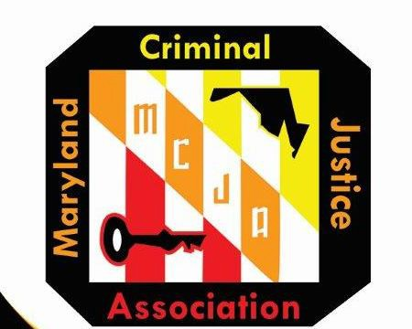
MCJA 2024 Fall Training Conference – October 26-28, 2026
Holiday Inn – Ocean City 6600 Coastal Highway, Ocean City, MD 21842

VENDOR SPONSORSHIP FORM
Registration and Payment Due By: October 2,2026. Select all boxes that apply below.

Vendor Booth - Circle One
One Booth - One 6 ft. table & 2 chairs and 1 set of meal tickets $500
Two Booths - Two 6 ft. tables & 2 chairs and 1 set of meal tickets $950
NOTE: Meal tickets include Reception, Tuesday Breakfast and Tuesday Lunch Only
Website Link
Link from MCJA Website to Vendor Website (4 months)
$150

Vendor Advertising
Vendor Insert or Giveaway in Participant Bag
$250

Vendor Advertising
Business Card in Program
$350

Vendor Recognition as Luncheon Sponsor
Vendor Booth, Banner, Full-Page Ad & Link to Vendor Website
$2000
Vendor Recognition as Dinner Sponsor
Vendor Booth, Banner, Full Page Ad and Link to Vendor Website
$3000

Vendor Program Ad - Circle One Extra Vendor Meals Front Inside Cover $400 Welcome Reception – Monday, October 26th $23* Back Inside Cover $400 Breakfast – Tuesday, October 27th $27*
Back Outside Cover $450 Lunch – Tuesday, October 27th $40*
½ Page $500 *prices subject to change
Full Page $600
*Need hotel accommodations, contact the hotel directly for MCJA discounted rates by September 25,2026.

Company Insert and Advertisement Deadlines and Requirements:

- All company inserts for participant conference bags must be received by October 2, 2026. Inserts for conference bags are to be mailed to: Nicole Ebb (President), 8502 Side Saddle Court, Randallstown MD 21133
- All company camera-ready logos, ads and/or banner for inclusion in program/conference must be received by October 2, 2026. Website link to company site will be available for 4 months after the conference. Vendor sponsorship which includes a banner display must be delivered/mailed to the address under the previous step and arrangements for pickup/return provided.

VENDOR INFORMATION:

Company Name: Address
City, State, Zip

Attendee’s Name: Phone #: e-mail:
Additional Attendee:_________________________________________________________________________________________________________________________

METHOD OF PAYMENT:

Check or money order to be made payable to MCJA. Mail registration form and payment to: Nicole Ebb (MCJA President), 8502 Side Saddle Court, MD 21133

Credit Card Payment: E-mail registration form with credit card information below to Nicole Ebb at nebb@baltimorecountymd.gov
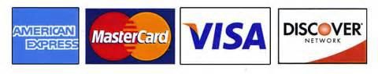
(Circle One) Visa Mastercard American Express Discover
Card #: Expiration Date: / /
Security/CVV#: Billing Postal Code:

Questions? Email Nicole Ebb, nebb@baltimorecountymd.gov

