**Support Three Village Special Education PTA**

All proceeds will be allocated to our Special Education Senior Scholarships and   
Teacher Grants that support Students with Special Needs across the District.

***What is Fun Pasta?*** Fun Pasta is healthy fun pasta shaped like the holidays, sports, and more. The wide variety of products will appeal to everyone in the family! Please order by   
November 29, 2020 to ensure delivery before the holidays.

<https://www.funpastafundraising.com/shop/three-village-septa>

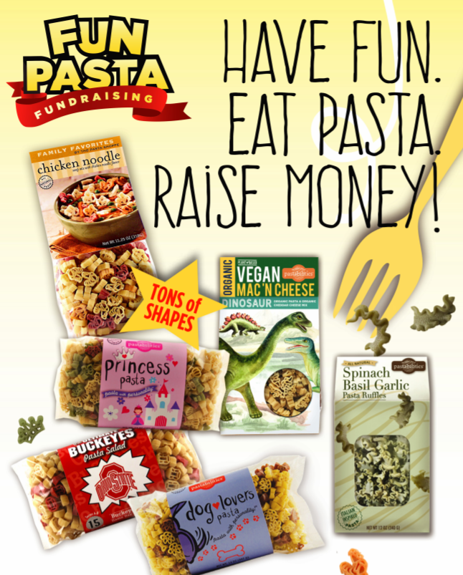

**Thank you for your support!**

Any questions, please contact Karen Roughley (karenroughley@hotmail.com)