Write a C program to simulate the following Non-preemptive CPU scheduling algorithms to find turnaround time and waiting time. a) FCFS b) SJF
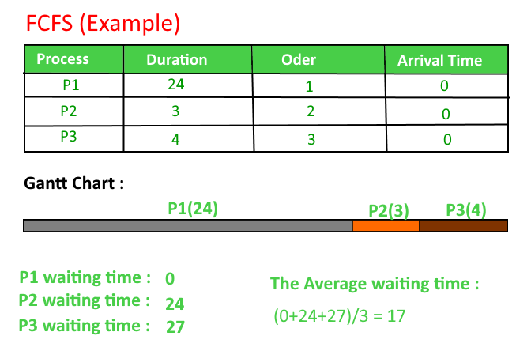
Algorithm
1- Input the processes along with their burst time (bt).
2- Find waiting time (wt) for all processes.
3- As first process that comes need not to wait so
waiting time for process 1 will be 0 i.e. wt[0] = 0.
4- Find waiting time for all other processes i.e. for
process i ->
wt[i] = bt[i-1] + wt[i-1] .
5- Find turnaround time = waiting_time + burst_time
for all processes.
6- Find average waiting time =
total_waiting_time / no_of_processes.
7- Similarly, find average turnaround time =
total_turn_around_time / no_of_processes.

C PROGRAM
// C program for implementation of FCFS
// scheduling
#include<stdio.h>
// Function to find the waiting time for all
// processes
void findWaitingTime(int processes[], int n,
int bt[], int wt[])
{
// waiting time for first process is 0
wt[0] = 0;

// calculating waiting time
for (int i = 1; i < n ; i++ )
wt[i] = bt[i-1] + wt[i-1] ;
}

// Function to calculate turn around time
void findTurnAroundTime( int processes[], int n,
int bt[], int wt[], int tat[])
{
// calculating turnaround time by adding
// bt[i] + wt[i]
for (int i = 0; i < n ; i++)
tat[i] = bt[i] + wt[i];
}

//Function to calculate average time
void findavgTime( int processes[], int n, int bt[])
{
int wt[n], tat[n], total_wt = 0, total_tat = 0;

//Function to find waiting time of all processes
findWaitingTime(processes, n, bt, wt);

//Function to find turn around time for all processes
findTurnAroundTime(processes, n, bt, wt, tat);

//Display processes along with all details
printf("Processes Burst time Waiting time Turn around time\n");

// Calculate total waiting time and total turn
// around time
for (int i=0; i<n; i++)
{
total_wt = total_wt + wt[i];
total_tat = total_tat + tat[i];
printf(" %d ",(i+1));
printf(" %d ", bt[i] );
printf(" %d",wt[i] );
printf(" %d\n",tat[i] );
}
int s=(float)total_wt / (float)n;
int t=(float)total_tat / (float)n;
printf("Average waiting time = %d",s);
printf("\n");
printf("Average turn around time = %d ",t);
}

// Driver code
int main()
{
//process id's
int processes[] = { 1, 2, 3};
int n = sizeof processes / sizeof processes[0];

//Burst time of all processes
int burst_time[] = {10, 5, 8};

findavgTime(processes, n, burst_time);
return 0;
}

OUTPUT
Processes Burst time Waiting time Turn around time
1 10 0 10
2 5 10 15
3 8 15 23
Average waiting time = 8.33333
Average turn around time = 16

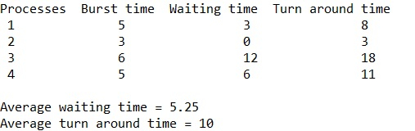

Shortest job First
Given process, the burst time of a process respectively and a quantum limit; the task is to find and print the waiting time, turnaround time and their respective average time using Shortest Job First Scheduling preemptive method.
What is the shortest job first scheduling?
Shortest job first scheduling is the job or process scheduling algorithm that follows the nonpreemptive scheduling discipline. In this, scheduler selects the process from the waiting queue with the least completion time and allocate the CPU to that job or process. Shortest Job First is more desirable than FIFO algorithm because SJF is more optimal as it reduces average wait time which will increase the throughput.
SJF algorithm can be preemptive as well as non-preemptive. Preemptive scheduling is also known as shortest-remaining-time-first scheduling. In Preemptive approach, the new process arises when there is already executing process. If the burst of newly arriving process is lesser than the burst time of executing process than scheduler will preempt the execution of the process with lesser burst time.
What is the Turnaround time, waiting time and completion time?
- Completion Time is the time required by the process to complete its execution
- Turnaround Time is the time interval between the submission of a process and its completion.
Turnaround Time = completion of a process – submission of a process
- Waiting Time is the difference between turnaround time and burst time
Waiting Time = turnaround time – burst time

AIM

To implement the c program for shortest job first scheduling algorithm

ALGORITHM

1. Start the process

2. Declare the array size

3. Get the number of elements to be inserted

4. Select the process which have shortest burst will execute first

5. If two process have same burst length then FCFS scheduling algorithm used

6. Make the average waiting the length of next process

7. Start with the first process from it’s selection as above and let other process to be in queue

6. Calculate the total number of burst time

7. Display the values

8. Stop the process

PROGRAM:

#include<stdio.h>
int main()
{

int n,j,temp,temp1,temp2,pr[10],b[10],t[10],w[10],p[10],i;

float att=0,awt=0;

for(i=0;i<10;i++)
{
b[i]=0;w[i]=0;
}

printf("enter the number of process");
scanf("%d",&n);
printf("enter the burst times");

for(i=0;i<n;i++)
{
scanf("%d",&b[i]);
p[i]=i;
}
for(i=0;i<n;i++)
{
for(j=i;j<n;j++)
{
if(b[i]>b[j])
{
temp=b[i];
temp1=p[i];
b[i]=b[j];
p[i]=p[j];
b[j]=temp;
p[j]=temp1;
}
}
}
w[0]=0;
for(i=0;i<n;i++)
w[i+1]=w[i]+b[i];
for(i=0;i<n;i++)
{
t[i]=w[i]+b[i];
awt=awt+w[i];
att=att+t[i];
}
awt=awt/n;
att=att/n;
printf("\n\t process \t waiting time \t turn around time \n");
for(i=0;i<n;i++)
printf("\t p[%d] \t %d \t\t %d \n",p[i],w[i],t[i]);
printf("the average waitingtimeis %f\n",awt);
printf("the average turn around time is %f\n",att);
return 1;
}

OUTPUT:
enter the number of process 5
enter the burst times
2 4 5 6 8

process waiting time turn around time
p[0] 0 2
p[1] 2 6
p[2] 6 11
p[3] 11 17
p[4] 17 25
the average waitingtime is 7.200000
the average turn around time is 12.200000

