Unit-II

Concurrent Programming

Monitors :
Definition: monitors are defined as the construct of programming language, which helps in controlling shared data access.

Characteristics of Monitors.
- Inside the monitors, we can only execute one process at a time.
- Monitors are the group of procedures, and condition variables that are merged together in a special type of module.
3. If the process is running outside the monitor, then it cannot access the monitor’s internal variable. But a process can call the procedures of the monitor.
4. Monitors offer high-level of synchronization
5. Monitors were derived to simplify the complexity of synchronization problems.
6. There is only one process that can be active at a time inside the monitor.

Components of Monitor
There are four main components of the monitor:
- Initialization
- Private data
- Monitor procedure
- Monitor entry queue
Initialization: – Initialization comprises the code, and when the monitors are created, we use this code exactly once.
Private Data: – Private data is another component of the monitor. It comprises all the private data, and the private data contains private procedures that can only be used within the monitor. So, outside the monitor, private data is not visible.
Monitor Procedure: – Monitors Procedures are those procedures that can be called from outside the monitor.
Monitor Entry Queue: – Monitor entry queue is another essential component of the monitor that includes all the threads, which are called procedures.

Advantages of Monitor
It makes the parallel programming easy, and if monitors are used, then there is less error-prone as compared to the semaphore.

Deadlock concept :
Deadlock is a situation where a set of processes are blocked because each process is holding a resource and waiting for another resource acquired by some other process. ... A similar situation occurs in operating systems when there are two or more processes that hold some resources and wait for resources held by other(s).
Traffic example of Deadlock
Following is the simple traffic example in our day today life

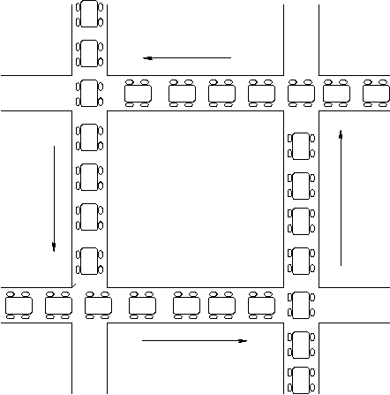
Example of Deadlock in Operating System
A deadlock happens in operating system when two or more processes need some resource to complete their execution that is held by the other process.
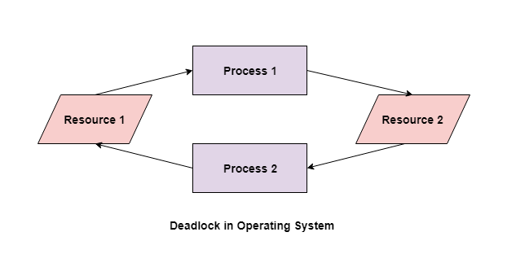
In the above diagram, the process 1 has resource 1 and needs to acquire resource 2. Similarly process 2 has resource 2 and needs to acquire resource 1. Process 1 and process 2 are in deadlock as each of them needs the other’s resource to complete their execution but neither of them is willing to relinquish their resources.

Necessary conditions for Deadlocks

Following are the four necessary conditions for deadlock
- Mutual Exclusion
There should be a resource that can only be held by one process at a time. In the diagram below, there is a single instance of Resource 1 and it is held by Process 1 only.

- Hold and Wait
A process can hold multiple resources and still request more resources from other processes which are holding them. In the diagram given below, Process 2 holds Resource 2 and Resource 3 and is requesting the Resource 1 which is held by Process 1.
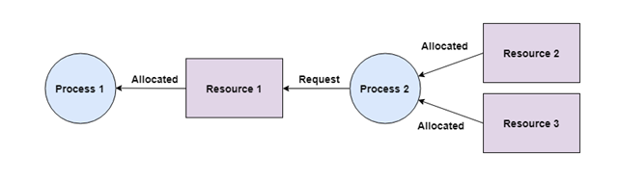
- No Preemption
A resource cannot be preempted from a process by force. A process can only release a resource voluntarily. In the diagram below, Process 2 cannot preempt Resource 1 from Process 1. It will only be released when Process 1 relinquishes it voluntarily after its execution is complete.
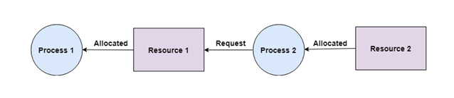

- Circular Wait
- A process is waiting for the resource held by the second process, which is waiting for the resource held by the third process and so on, till the last process is waiting for a resource held by the first process. This forms a circular chain. For example: Process 1 is allocated Resource2 and it is requesting Resource 1. Similarly, Process 2 is allocated Resource 1 and it is requesting Resource 2. This forms a circular wait loop.
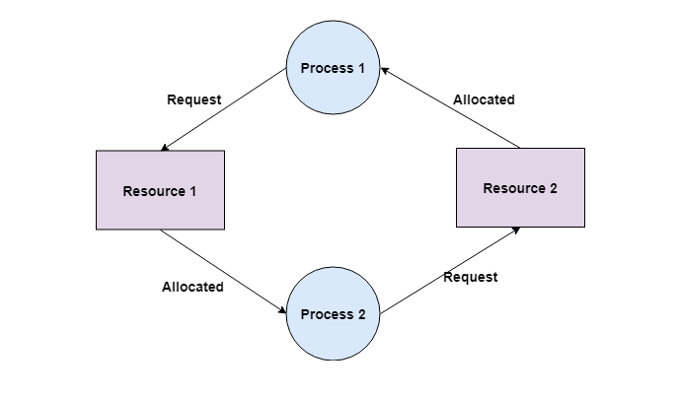
- Deadlock Prevention
It is very important to prevent a deadlock before it can occur. So, the system checks each transaction before it is executed to make sure it does not lead to deadlock. If there is even a slight chance that a transaction may lead to deadlock in the future, it is never allowed to execute

- Deadlock Detection
A deadlock can be detected by a resource scheduler as it keeps track of all the resources that are allocated to different processes. After a deadlock is detected, it can be resolved using the following methods −
All the processes that are involved in the deadlock are terminated. This is not a good approach as all the progress made by the processes is destroyed.
Resources can be preempted from some processes and given to others till the deadlock is resolved.
.

Deadlock Avoidance
It is better to avoid a deadlock rather than take measures after the deadlock has occurred. The wait for graph can be used for deadlock avoidance. This is however only useful for smaller databases as it can get quite complex in larger databases.
Banker’s Algorithm is used to resource allocation and deadlock avoidance that determine to safety by simulating the allocation for predetermined maximum possible amounts of all resources, then makes an “s-state” check to test for possible activities, before deciding whether allocation should be allowed to continue.
Banker’s Algorithm is named because it is implemented in the banking sector, and main objective of using this algorithm is to check that loan can be sanctioned or not to clients.
Deadlock Recovery
When a detection algorithm determines that a deadlock exists then there are several available alternatives. There one possibility and that is to inform the operator about the deadlock and let him deal with this problem manually.
Another possibility is to let the system recover from the deadlock automatically. These are two options that are mainly used to break the deadlock.

Memory Management

Basics of Memory Management
Memory Management is the process of controlling and coordinating computer memory, assigning portions known as blocks to various running programs to optimize the overall performance of the system.
It is the most important function of an operating system that manages primary memory. It helps processes to move back and forward between the main memory and execution disk. It helps OS to keep track of every memory location, irrespective of whether it is allocated to some process or it remains free.
Main Memory refers to a physical memory that is the internal memory to the computer. The word main is used to distinguish it from external mass storage devices such as disk drives. Main memory is also known as RAM. The computer is able to change only data that is in main memory. Therefore, every program we execute and every file we access must be copied from a storage device into main memory.
All the programs are loaded in the main memory for execution. Sometimes complete program is loaded into the memory, but some times a certain part or routine of the program is loaded into the main memory only when it is called by the program, this mechanism is called Dynamic Loading, this enhance the performance.

Process Address Space
The process address space is the set of logical addresses that a process references in its code. For example, when 32-bit addressing is in use, addresses can range from 0 to 0x7fffffff; that is, 2^31 possible numbers, for a total theoretical size of 2 gigabytes.
The operating system takes care of mapping the logical addresses to physical addresses at the time of memory allocation to the program. There are three types of addresses used in a program before and after memory is allocated –
  - Symbolic addresses : The addresses used in a source code. The variable names, constants, and instruction labels are the basic elements of the symbolic address space.
  - Relative addresses: At the time of compilation, a compiler converts symbolic addresses into relative addresses.
  - Physical addresses: The loader generates these addresses at the time when a program is loaded into main memory.

Virtual and physical addresses are the same in compile-time and load-time address-binding schemes. Virtual and physical addresses differ in execution-time address-binding scheme.
The set of all logical addresses generated by a program is referred to as a logical address space. The set of all physical addresses corresponding to these logical addresses is referred to as a physical address space.
The runtime mapping from virtual to physical address is done by the memory management unit (MMU) which is a hardware device. MMU uses following mechanism to convert virtual address to physical address.
- The value in the base register is added to every address generated by a user process, which is treated as offset at the time it is sent to memory. For example, if the base register value is 10000, then an attempt by the user to use address location 100 will be dynamically reallocated to location 10100.
- The user program deals with virtual addresses; it never sees the real physical addresses.

Static vs Dynamic Loading
The choice between Static or Dynamic Loading is to be made at the time of computer program being developed. If you have to load your program statically, then at the time of compilation, the complete programs will be compiled and linked without leaving any external program or module dependency. The linker combines the object program with other necessary object modules into an absolute program, which also includes logical addresses.
If you are writing a Dynamically loaded program, then your compiler will compile the program and for all the modules which you want to include dynamically, only references will be provided and rest of the work will be done at the time of execution.
At the time of loading, with static loading, the absolute program (and data) is loaded into memory in order for execution to start.
If you are using dynamic loading, dynamic routines of the library are stored on a disk in relocatable form and are loaded into memory only when they are needed by the program.
Swapping
Swapping is a method in which the process should be swapped temporarily from the main memory to the backing store. It will be later brought back into the memory for continue execution.
Backing store is a hard disk or some other secondary storage device that should be big enough in order to accommodate copies of all memory images for all users. It is also capable of offering direct access to these memory images.
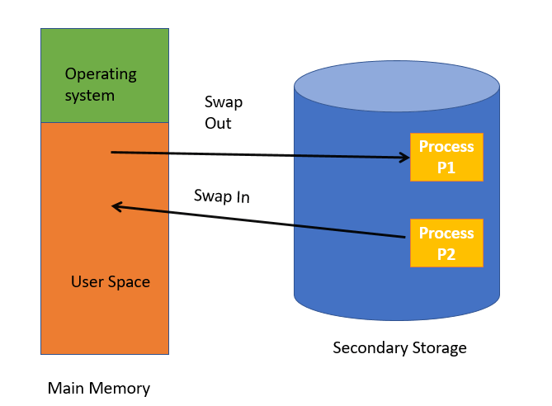

Benefits of Swapping
Here, are major benefits/pros of swapping:
It offers a higher degree of multiprogramming.
Allows dynamic relocation. For example, if address binding at execution time is being used, then processes can be swap in different locations. Else in case of compile and load time bindings, processes should be moved to the same location.
It helps to get better utilization of memory.
Minimum wastage of CPU time on completion so it can easily be applied to a priority-based scheduling method to improve its performance.
Contiguous Memory allocation
Memory Management Techniques are basic techniques that are used in managing the memory in operating system. Memory Management Techniques are basically classified into two categories:
(i) Contiguous
(ii) Non-contiguous
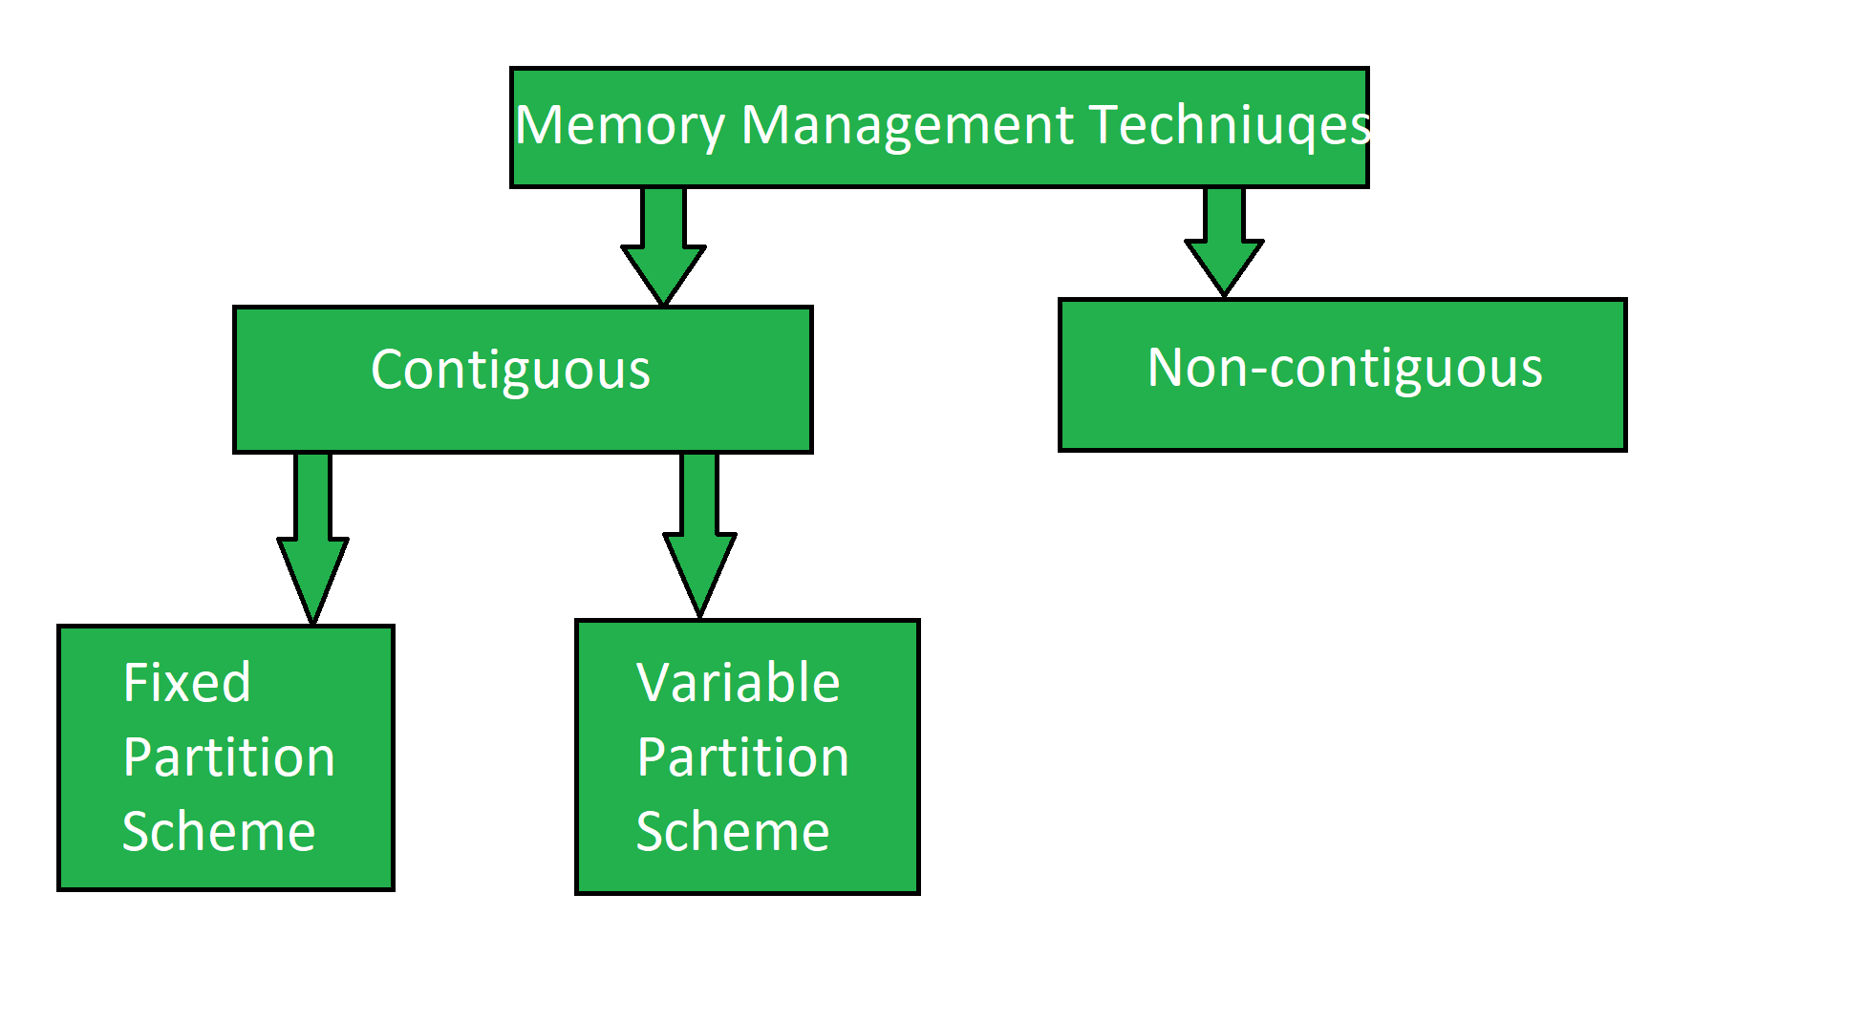
Contiguous Memory Management Techniques:
In this technique, memory is allotted in a continuous way to the processes. It has two types:
Fixed partition Scheme
In the fixed partition scheme, memory is divided into fixed number of partitions. Fixed means number of partitions are fixed in the memory. In the fixed partition, in every partition only one process will be accommodated. Degree of multi-programming is restricted by number of partitions in the memory. Maximum size of the process is restricted by maximum size of the partition. Every partition is associated with the limit registers.

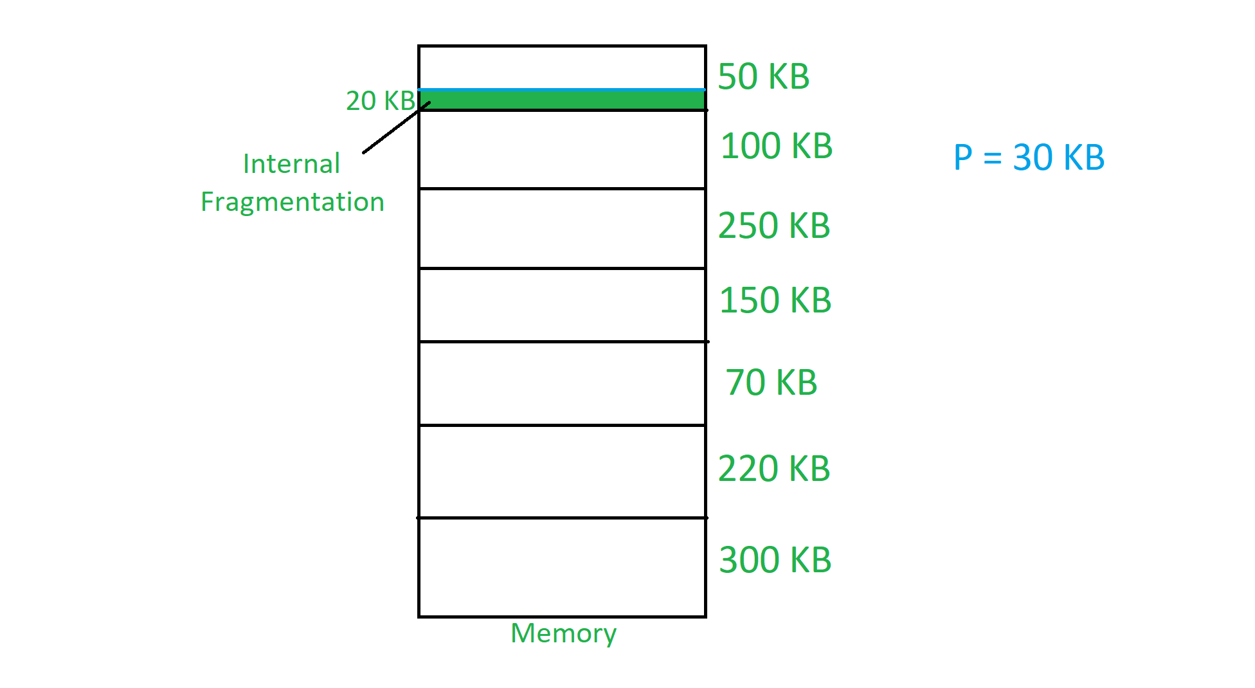

Internal Fragmentation is found in fixed partition scheme.
To overcome the problem of internal fragmentation, instead of fixed partition scheme, variable partition scheme is used.
Variable Partition Scheme
In the variable partition scheme, initially memory will be single continuous free block. Whenever the request by the process arrives, accordingly partition will be made in the memory. If the smaller processes keep on coming then the larger partitions will be made into smaller partitions.
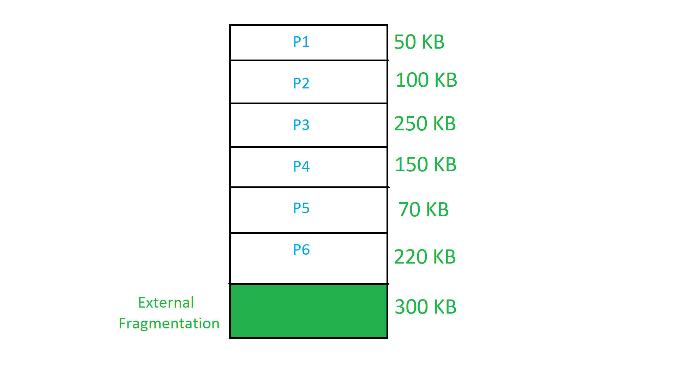
External Fragmentation is found in variable partition scheme.
To overcome the problem of external fragmentation, compaction technique is used or non-contiguous memory management techniques are used.
Memory Compaction
Moving all the processes toward the top or towards the bottom to make free available memory in a single continuous place is called as compaction. Compaction is undesirable to implement because it interrupts all the running processes in the memory.

Memory Allocation Algorithms
Popular algorithms used for allocating the partitions to the arriving processes are-


1. First Fit Algorithm-

- This algorithm starts scanning the partitions serially from the starting.
- When an empty partition that is big enough to store the process is found, it is allocated to the process.
- Obviously, the partition size has to be greater than or at least equal to the process size.
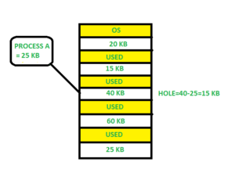

2. Best Fit Algorithm-

- This algorithm first scans all the empty partitions.
- It then allocates the smallest size partition to the process.
- Allocate the process to the partition which is the first smallest sufficient partition among the free available partition. It searches the entire list of holes to find the smallest hole whose size is greater than or equal to the size of the process.

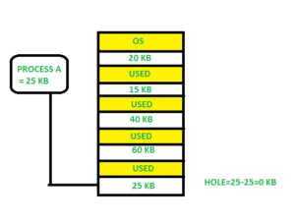

3. Worst Fit Algorithm-

- This algorithm first scans all the empty partitions.
- It then allocates the largest size partition to the process.
- Allocate the process to the partition which is the largest sufficient among the freely available partitions available in the main memory. It is opposite to the best-fit algorithm. It searches the entire list of holes to find the largest hole and allocate it to process.
