Page Replacement Algorithms FIFO

In an operating system, memory management is a crucial topic. It provides ways to of memory when requested by a program. It also automatically deallocates memory from a program when it is no longer used by a program.
There are various techniques used in memory management. One such method is paging. In paging, page replacement algorithms play an important role and decide which page to keep in the main memory when a new page comes in.
First-in, first-out (FIFO) is the simplest among page replacement algorithms. In this tutorial, we’ll cover FIFO thoroughly.

2. General Idea
Let’s first discuss some background of page replacement algorithms.
Page replacement algorithms come under the paging technique. Paging in the operating system is mainly used for virtual memory management. Paging is a method that allows a computer to retrieve and store data from the secondary memory (e.g. HDD or drum memory) into the main memory (RAM). The data which is extracted from the secondary memory is termed as a page in memory management.
Page replacement algorithms like FIFO are used when there is a new page request, and there is not enough space in the main memory to allocate the new page.
Hence, a page replacement algorithm decides which page it should replace so that it can allocate the memory for the new page. The steps of a page replacement can be summarized in a flowchart:
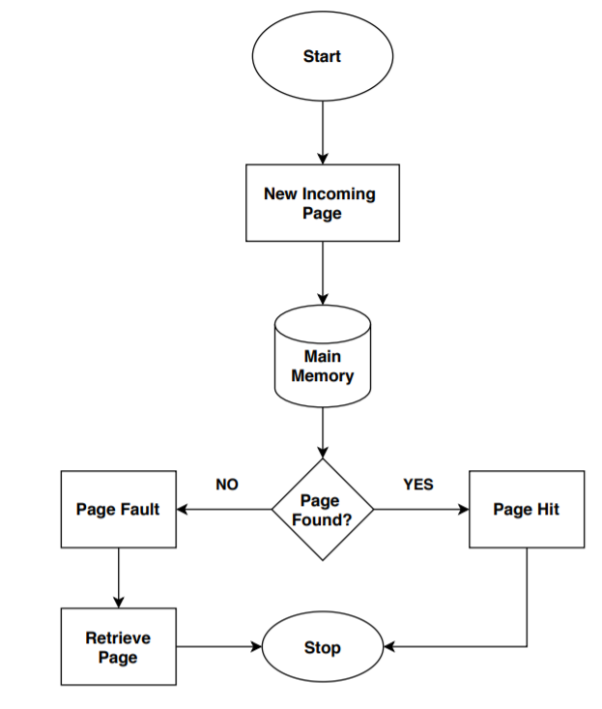
First-in, first-out (FIFO) algorithm has a simple approach to this problem. We keep track of all the pages by using a queue in the main memory. As soon as a page comes in, we’ll put it in the queue and continue. In this way, the oldest page would always be in the first place of the queue.
Now when a new page comes in and there is no space in the memory, we remove the first page in the queue, which is also the oldest one. It repeats this process until the operating system has page flow in the system.

3. Page Fault
A Page fault is another important concept in page replacement algorithms. A page fault occurs when a page requested by a program is not present in the main memory.
A page fault generates an alert for the operating system. The operating system then retrieves the page from the secondary or virtual memory to the main memory. All the processes run in the background.
Generally, this takes a few milliseconds; still, it has a significant impact on the performance of the operating system. A high number of page faults can slow down the whole system. Although page faults are common in modern days operating systems, a large number of page faults may cause the program to crash or terminate unexpectedly.

The effectiveness of a page replacement algorithm is measured with the number of page fault it generates. The more effective the page replacement algorithm is, the less the number of page faults generated by the algorithm.

An Example
In this section, we’ll take an example and run the FIFO page replacement algorithm on it.
We’re taking page reference strings: in our example. Also, we’re considering the capacity of the queue is . Initially, our queue is empty. Now let’s fill the queue with pages and apply a FIFO algorithm:
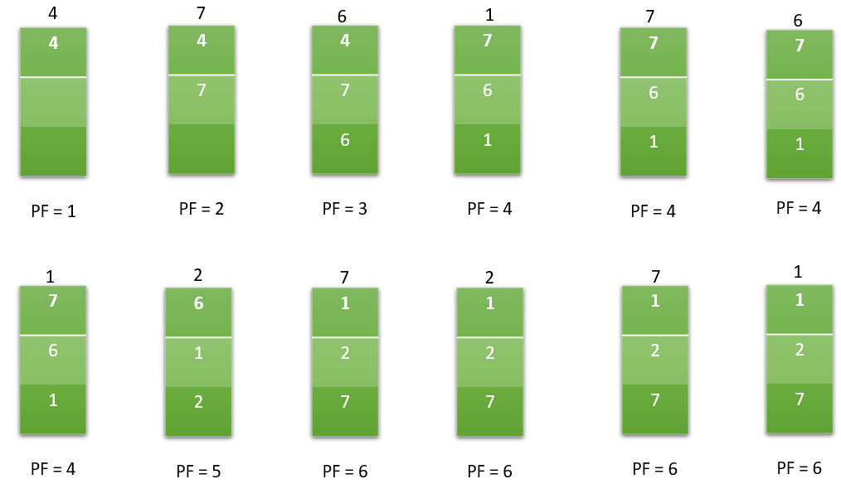
Here the number on top of each table represents the reference number of new incoming pages. While doing this process, we’re also calculating the number of page faults.
In our example, the total number of page faults that occurred using the FIFO page replacement algorithm is .

C program
#include<stdio.h>

int main()
{
int reference_string[10], page_faults = 0, m, n, s, pages, frames;
printf("\nEnter Total Number of Pages:\t");
scanf("%d", &pages);
printf("\nEnter values of Reference String:\n");
for(m = 0; m < pages; m++)
{
printf("Value No. [%d]:\t", m + 1);
scanf("%d", &reference_string[m]);
}
printf("\nEnter Total Number of Frames:\t");
{
scanf("%d", &frames);
}
int temp[frames];
for(m = 0; m < frames; m++)
{
temp[m] = -1;
}
for(m = 0; m < pages; m++)
{
s = 0;
for(n = 0; n < frames; n++)
{
if(reference_string[m] == temp[n])
{
s++;
page_faults--;
}
}
page_faults++;
if((page_faults <= frames) && (s == 0))
{
temp[m] = reference_string[m];
}
else if(s == 0)
{
temp[(page_faults - 1) % frames] = reference_string[m];
}
printf("\n");
for(n = 0; n < frames; n++)
{
printf("%d\t", temp[n]);
}
}
printf("\nTotal Page Faults:\t%d\n", page_faults);
return 0;
}

