Priority Scheduling Algorithm
In the Shortest Job First scheduling algorithm, the priority of a process is generally the inverse of the CPU burst time, i.e. the larger the burst time the lower is the priority of that process.
In case of priority scheduling the priority is not always set as the inverse of the CPU burst time, rather it can be internally or externally set, but yes the scheduling is done on the basis of priority of the process where the process which is most urgent is processed first, followed by the ones with lesser priority in order.

Processes with same priority are executed in FCFS manner.

The priority of process, when internally defined, can be decided based on memory requirements, time limits ,number of open files, ratio of I/O burst to CPU burst etc.

Whereas, external priorities are set based on criteria outside the operating system, like the importance of the process, funds paid for the computer resource use, makrte factor etc.

Types of Priority Scheduling Algorithm
Priority scheduling can be of two types:

Preemptive Priority Scheduling: If the new process arrived at the ready queue has a higher priority than the currently running process, the CPU is preempted, which means the processing of the current process is stoped and the incoming new process with higher priority gets the CPU for its execution.
Non-Preemptive Priority Scheduling: In case of non-preemptive priority scheduling algorithm if a new process arrives with a higher priority than the current running process, the incoming process is put at the head of the ready queue, which means after the execution of the current process it will be processed.

Example : 1- First input the processes with their burst time
and priority.
2- Sort the processes, burst time and priority
according to the priority.
3- Now simply apply FCFS algorithm.
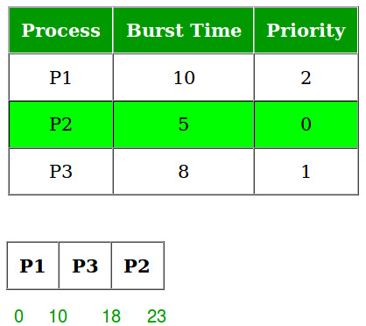

C program
#include <stdio.h>
int main()
{

int bt[20],wt[20],p[20],tat[20],priority[20];
float avwt=0,avtat=0;

int i,j,n,temp,key;

printf("\nEnter the number of the processes: ");

scanf("%d",&n);

for(i=0;i<n;i++)

{

printf("\nEnter the burst time and priority of the process P[%d]: ",i);

scanf("%d",&bt[i]);
scanf("%d",&priority[i]);
p[i]=i;

}

for(i=0;i<n;i++)
{
key=i;
for(j=i+1;j<n;j++)
{
if(priority[j]<priority[key])
{
key=j;
}
}
temp=bt[i];
bt[i]=bt[key];
bt[key]=temp;

temp=priority[i];
priority[i]=priority[key];
priority[key]=temp;

temp=p[i];
p[i]=p[key];
p[key]=temp;
}

wt[0]=0;
tat[0]=bt[0];
avtat=tat[0];

for(i=1;i<n;i++)
{

wt[i]=wt[i-1]+bt[i-1];

tat[i]=tat[i-1]+bt[i];

avwt+=wt[i];

avtat+=tat[i];

}

avwt=avwt/n;
avtat=avtat/n;

printf("\n\nPROCESS\t\twaiting time\tburst time\tTurnaround time\n");

printf("\n");

for(i=0;i<n;i++)
{

printf("P[%d]\t\t%d\t\t%d\t\t%d\n",p[i],wt[i],bt[i],tat[i]);

}

printf("\n\nAverage waiting time: %.2f",avwt);
printf("\n\nAverage Turn around time is: %.2f",avtat);
printf("\n");

return 0;

}

