Paul and Ruth Lemp Memorial Community Garden Gardener’s News Bulletin April 24, 2022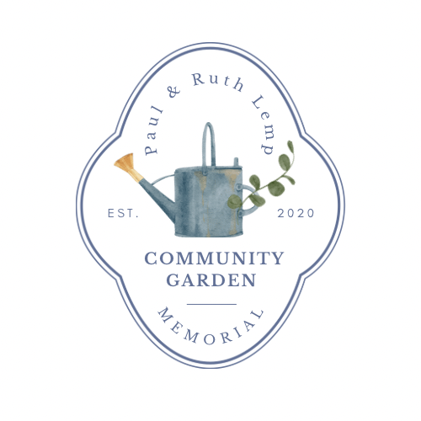
This is a quickee Bulletin with just some quick notes in Bullet form:

FORGET-ME-NOT NURSERY, at Indian, is our sponsoring nursery this year. Their Grand-opening is this coming Friday, April 28, at 10 :00 am. If we forgot to give you your $10 gift Card when you filled out your paperwork and paid your fees, please get back to me. I’ll set-up a time for you to pick them up in the Church Narthex/Lobby..

ORGANIC FERTILIZER: We will once again have Organic Fertilizer Packets for each VEGO-BED. They will be available the day we have our grand opening. We are still looking towards mid-May, and will inform you via Email or text.

NEW VEGO BEDS: The new short beds have arrived and as soon as the ground is ready, we will be calling for an assembly party. The new tall beds are still on back-order. As of this writing, we have 6 New Tall Vego-Beds still available.

