Paul and Ruth Lemp Memorial Community Garden

Gardener’s News Bulletin

June 10, 2024

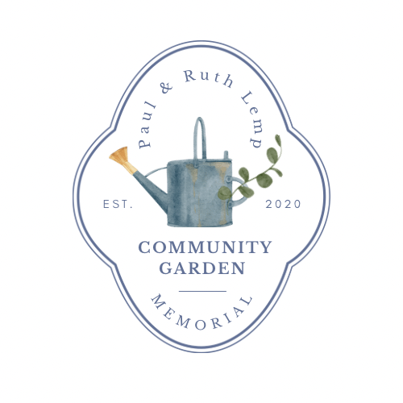

**Garden Beds available**

Yes, we still have six beds available due to reservation cancellations, or un-planned medical situations that have forced the gardeners to release their Vego-Garden Beds. Two of the beds are new ones, recently installed against the North Fence, and should be good producers due to the maximum sun they receive. These beds are mid-size and perfect for growing TALL Plants, such as Pole Beans and Peas. They can be tied to the fence for support! The other beds are a mix of shorts and talls:

Numbers 4, 23, and 27 are short beds; Bed Number 28 is a tall bed, and Bed Numbers 52 and 54 are the new beds. We will be dedicating the unused beds to the LSSA Foodbank next week if not taken. If you want an additional bed, please contact Dan: dan.lavonne.g@gmail.com

**Heat and Watering Warning**

John Denver sang “Sunshine on our shoulders makes us happy”. It also heats up the garden beds much faster than you realize. Plants grow fast and need water, especially if you planted seeds, which scream for moisture. Don’t depend on the rain. Today, all of the beds were pretty dry. The forecast at this time is possible rain showers on Tuesday and Wednesday, but you can’t depend on that because the weather in the Gulf of Alaska can cause rapid changes in our local forecasts. If it is a sunny day, you should always check your beds, and the best time to water is in the morning. It gives your plants an added boost to soak up the moisture all day long.