Welcome
Please stand as you are able.
Welcome to Worship at Christ Our Savior Lutheran Church.
Where we are Inspired by God’s Love to Praise, Nurture and Serve and where we live out that calling when we Reach Out, Serve, and Incite Miracles.
The grace of our Lord Jesus Christ, the love of God, and the communion of the Holy Spirit be with you all.
And also with you.
CONFESSION AND FORGIVENESS
Words are in the PowerPoint
GATHERING HYMN
KYRIE

canticle of praise
Minister

Prayer of the Day

WORD
You may be seated.

The readings are in the PowerPoint, or can be picked up in printed form at the entrance of the sanctuary.

First reading
psalm
second reading

kid’s message

Gospel Acclamation
Please stand as you are able

GOSPEL
SERMON
You may be seated.

HYMN OF THE DAY

CREED
Please stand as you are able.
I believe in God, the Father almighty, creator of heaven and earth.
I believe in Jesus Christ, God’s only Son, our Lord, who was conceived by the Holy Spirit, born of the virgin Mary, suffered under Pontius Pilate, was crucified, died, and was buried; he descended to the dead. On the third day he rose again; he ascended into heaven, he is seated at the right hand of the Father, and he will come to judge the living and the dead.
I believe in the Holy Spirit, the holy catholic church, the communion of saints, the forgiveness of sins, the resurrection of the body, and the life everlasting. Amen.

PRAYERS OF INTERCESSION
Let us pray for the church, the world, and all in need.
Each petition of the prayers ends with the words
Lord, in your mercy. Hear our prayer.

Sharing of the PEACE
The peace of Christ be with you always.
And also with you

Announcements
OFFERING
An offering is gathered for the mission of the church, including the care of those in need. Offering plates are passed around, or you can give online through our website.

OFFERING PRAYER
GREAT THANKSGIVING
Please stand as you are able.

It is indeed right, our duty and our joy, that we should at all times and in all places give thanks and praise to you...we praise your name and join their unending hymn:

Words of Institution
LORD’S PRAYER
Our Father, who art in heaven,
hallowed be thy name,
thy kingdom come, thy will be done,
on earth as it is in heaven.
Give us this day our daily bread;
and forgive us our trespasses
as we forgive those who trespass against us;
and lead us not into temptation,
but deliver us from evil.
For thine is the kingdom,
and the power, and the glory,
forever and ever. Amen.

COMMUNION
You may be seated; the ushers will direct you forward.
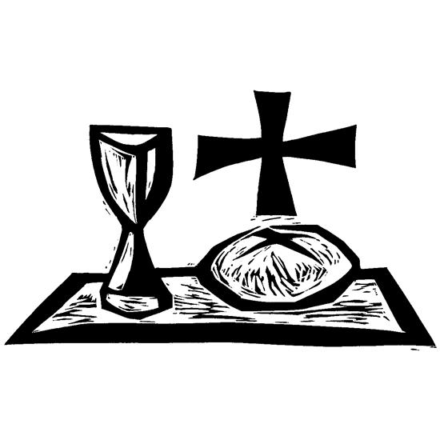
At COSLC, everyone is welcome to receive communion. If you prefer a blessing, cross your arms over your chest at the railing. White grape juice is available in the center ring of the tray and red wine in the outer rings. The bread is not gluten-free, but gluten-free wafers may be requested from the servers.

LAMB OF GOD

POST COMMUNION PRAYER

BLESSING
Please stand as you are able

SENDING HYMN

DISMISSAL

POSTLUDE

