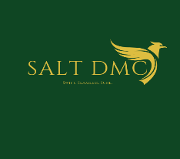

Agent: Outbound Agency Code: FNF-IN251020NG-1Q
Att: Korea Operator Date: 21 Oct 2025

●Cherry Blossom 7D6N on Mar, Apr 2026 7-35pax●
ITINERARY
DATE | 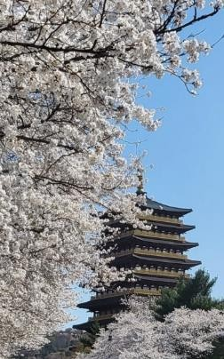  ITINERARY | HOTEL | MEAL
Day 1 | 01★ARR Incheon A/P & Transfer to Busan★ ARR Incheon A/P [T.B.A]  Meeting with guide at Incheon A/P  Transfer to Seoul Station, go to Busan Station by KTX [Bullet Train ticket included, 2.5 hours] | Busan | ★Indian (D)★ L: No  D: Indian Meal
Day 1 | Transfer to hotel & Check in  ACCOM … … BUSAN | Busan | ★Indian (D)★ L: No  D: Indian Meal
Day 2 | 02★Gyeongju UNESCO Trip★ Transfer to Gyeongju (1.5 hours by car) Bulguksa Temple & Seokulam Grotto Cherry blossom spots in Gyeongju  Donggung Palace & Wolji Pond (Night Illumination) | Busan | ★Indian (B/L/D)★ B: Hotel  L: Indian Meal D: Indian Meal
Day 2 | Transfer to hotel  ACCOM BUSAN  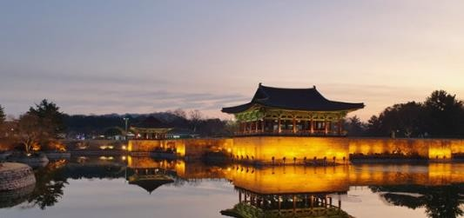 | Busan | ★Indian (B/L/D)★ B: Hotel  L: Indian Meal D: Indian Meal
Day 3 | 03★Busan City Tour & ARR Seoul★ Haedong Yonggungsa Temple  Blue Line Skycapsule  BIFF Street & Jagalchi Seafood Market | Seoul | ★Indian (B/L/D)★ B: Hotel  L: Indian Meal D: Indian Meal
Day 3 | Transfer to Busan Station, go to Seoul Station by KTX [Bullet Train ticket included, 2.5 hours]  Transfer to hotel  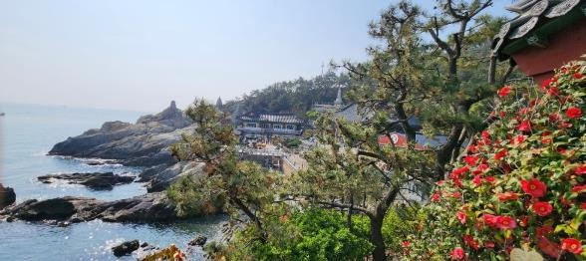  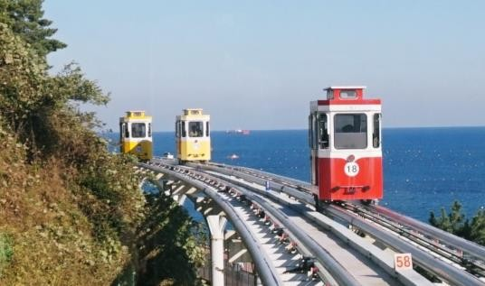  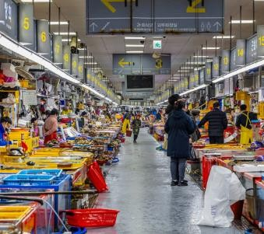  ACCOM SEOUL | Seoul | ★Indian (B/L/D)★ B: Hotel  L: Indian Meal D: Indian Meal

Day 4 | 04★Seoul City Tour★  Wearing hanbok go to Gyeongbok palace (Closed on Tue)  (If weather permit, we enjoy Royal palace gate guard performance) Insadong Culture Street | Seoul | ★Indian (B/L/D)★ B: Hotel  L: Indian Meal D: Indian Meal
Day 4 | Namsangol Hanok Village  Namsan N Seoul tower (Include cable car & Exclude lift) Myeongdong Market (free shopping)  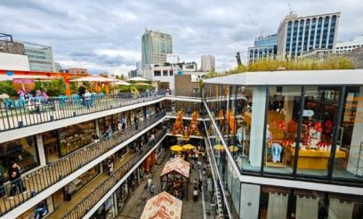  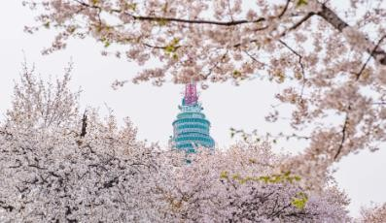  ACCOM … … SEOUL | Seoul | ★Indian (B/L/D)★ B: Hotel  L: Indian Meal D: Indian Meal
Day 5 | 05★Nami Island & Petite France★ Transfer to Chuncheon  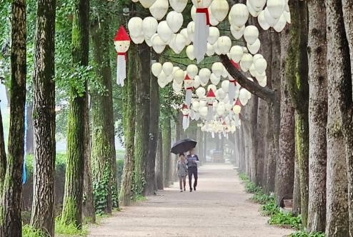  Nami Island with Ferry ride Petite France & Italian Village Transfer to Seoul | 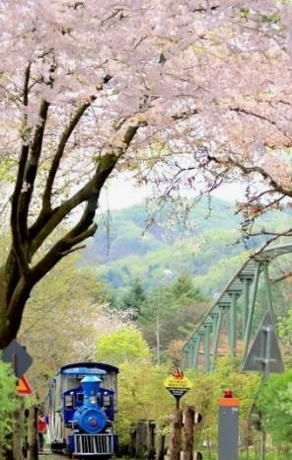  Seoul | ★Indian (B/L/D)★ B: Hotel  L: Indian Meal D: Indian Meal
Day 5 | ACCOM SEOUL |  | ★Indian (B/L/D)★ B: Hotel  L: Indian Meal D: Indian Meal
Day 6 | 06★Gangnam Tour & Han river Cruise★  COEX Starfield & Starlight library  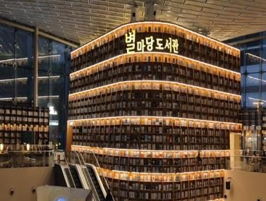  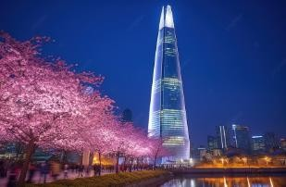  Lotte Tower (Exclude observatory) & Lake Seokchon | Seoul | ★Indian (B/L/D)★ B: Hotel  L: Indian Meal D: Indian Meal
Day 6 | 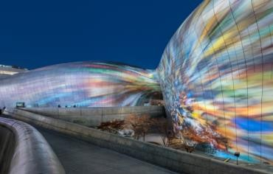  Gwangjang Market & Dongdaemun Market Night stroll at Cheonggye Stream ACCOM SEOUL  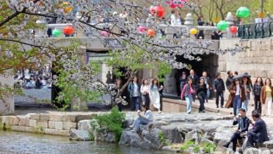 | Seoul | ★Indian (B/L/D)★ B: Hotel  L: Indian Meal D: Indian Meal
Day 7 | 07★Departure★ Check-out |  | ★(B)★  B: Hotel L / D : No
Day 7 | Transfer to Incheon A/P [T.B.A] |  | ★(B)★  B: Hotel L / D : No

●Notices●
Include | - Accommodation(TWN sharing)
Include | - Mineral water one bottle / pax / day
Include | - 6 International Breakfasts at Hotel + 5 Indian Lunches + 6 Indian Dinners
Include | - Transfer / Toll / Petrol / Driver
Include | - Main entrance fee
Include | -1 English-speaking Guide & 1 Driver
Include | - Include tipping
Exclude | - International & Domestic air ticket & insurance
Exclude | - Personal expenses / medical expenses
Important notice | - Child rate (under 12Yrs) TWN Sharing ' 100% / Extra Bed ' 75% / No Bed ' 50% / Infant (Under 24Months) 0% / Under 9 Pax No child rate
Important notice | - The itinerary can be changed depending on local situation
Important notice | - Breakfast cannot be replaced with outside breakfast pack & cannot be refunded. As for early morning departure in the last day, breakfast is not provided.
Important notice | - Tour fare must be fully paid before group arrival at Korea.
Important notice | - Cancel Fee:  *30 days before departure: 50%  *15 days before departure: 80%  *Departure date or later: 100%
Important notice | - If requested by customer or schedule delayed by 10hr+, surcharge of USD 100 / whole group / hour for bus tour shall be paid directly by customer. Driving guide tour surcharge will be USD 50 / whole group / hour.
Important notice | - Tour time from 09:00am – 19:00pm
Important notice | - For use of car or driver between 11pm – 7pm, USD 50 / Group (even in 10hours) / hour shall be charged.
Important notice | - OCT, Christmas, New Year will Surcharged 20%

●Hotel List●
Area | Grade | Hotel List
Seoul | Economy 3* | MD Doksan, Park Habio, Intercity, Friendly DH hotel, M Felice, The ricenz or SML
Seoul | Good 3* | Hamilton hotel, Seoul N Dongdeamun, SR hotel, IBC hotel or SML
Seoul | Economy 4* | Amid hotel, Milliore Myeongdong, Olympic parktel, Kensington or SML
Seoul | Good 4* & Economy 5* | Courtyard by Namdaemun hotel, Fourpoint by sheraton or Novotel or SML
Seoul | Good 5* | Four Season hotel, Lotte hotel, Sofitel hotel or SML
Jeju | Economy 3* | Pearly hotel, MS hotel, N hotel,Park side hotel, Sun land hotel or SML
Jeju | Good 3* | LNL hotel, Air city hotel, Pacific hotel, The one hotel or SML
Jeju | Economy 4* | Ramada hamdeck or SML
Jeju | Good 4* & Economy 5* | Maison glad hotel or SML
Jeju | Good 5* | Lotte hotel or SML
Busan | Economy 3* | Adela hotel or SML (Free upgrade for Adela)
Busan | Good 3* | Adela hotel or SML (Free upgrade for Adela)
Busan | Economy 4* | Adela hotel, Youngmu Paradise or SML
Busan | Good 4* & Economy 5* | Shilla Stay hotel or SML
Busan | Good 5* | Lotte hotel or SML

