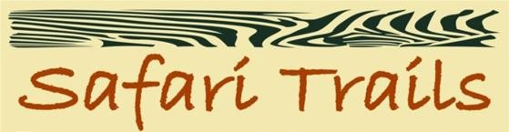
STL SEAT-IN-COACH ITINERARIES 2025/26 WITH SOPA LODGES

KENYA ITINERARY 1 – 6 NIGHTS/ 7 DAYS

Departure Every TUESDAY

Day 1: Amboseli Sopa Lodge Day 2: Amboseli Sopa Lodge
Day 3: Four Points by Sheraton Hurlingham Day 4: Masai Mara Sopa Lodge

Day 5: Masai Mara Sopa Lodge
Day 6: Lake Nakuru Sopa Lodge Day 7: Departure
Click here for detailed itinerary. COST:

Season | Nov to 21 Dec’25 | 22 Dec’25 to  01 Jan’26 | 02 Jan’26 to  31 Mar’26,  June’26 | April to May’26 | Jul to Oct’26
Per person sharing | 1610 | 1935 | 1495 | 1310 | 2085
Single Room Supp | 250 | 310 | 250 | 195 | 340

KENYA ITINERARY 2 – 3 NIGHTS/ 4 DAYS

Departure Every TUESDAY
Day 1: Amboseli Sopa Lodge Day 2: Amboseli Sopa Lodge
Day 3: Four Points by Sheraton Hurlingham Day 4: Departure

Click here for detailed itinerary.

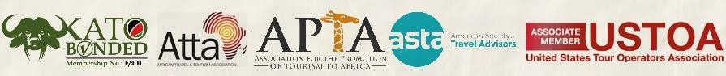

COST:
Season | Nov to 21 Dec’25 | 22 Dec’25 to  01 Jan’26 | 02 Jan to 31 Mar’26,  June’26 | April to May’26 | Jul to Oct’26
Per person sharing | 680 | 800 | 770 | 640 | 765
Single Room Supp | 130 | 140 | 130 | 115 | 140

KENYA ITINERARY 3 – 4 NIGHTS/ 5 DAYS

Departure Every THURSDAY

Day 1: Four Points by Sheraton Hurlingham Day 2: Masai Mara Sopa Lodge
Day 3: Masai Mara Sopa Lodge Day 4: Lake Nakuru Sopa Lodge Day 5: Departure
Click here for detailed itinerary.

COST:
Season | Nov to 21 Dec’25 | 22 Dec’25 to  01 Jan’26 | 02 Jan to 31 Mar’26,  June’26 | April to May’26 | Jul to Oct’26
Per person sharing | 1170 | 1495 | 1020 | 900 | 1440
Single Room Supp | 160 | 130 | 235 | 160 | 235

KENYA ITINERARY 4 – 6 NIGHTS/ 7 DAYS

Departure Every TUESDAY

Day 1: Samburu Sopa Lodge Day 2: Samburu Sopa Lodge
Day 3: Four Points by Sheraton Hurlingham Day 4: Masai Mara Sopa Lodge
Day 5: Masai Mara Sopa Lodge Day 6: Lake Nakuru Sopa Lodge Day 7: Departure
Click here for detailed itinerary.

COST:
Season | Nov to 21 Dec’25 | 22 Dec’25 to  01 Jan’26 | 02 Jan to 31 Mar’26,  June’26 | April to May’26 | Jul to Oct’26
Per person sharing | 1730 | 2085 | 1580 | 1430 | 2065
Single Room Supp | 220 | 165 | 290 | 220 | 290

INCLUSIONS:
- Accommodation during the safari on full board basis
- Accommodation in Nairobi on bed and breakfast basis
- Transport and Game drives on shared basis using a 7- seater Safari 4x4 land cruiser with a pop up roof for easy game viewing
- Current Park Fee
- Meet and greet services
- Bottled mineral water during safaris
- Services of an English speaking driver/ guide

OPTIONAL EXTRAS:
- Hot Air Balloon Safari in Masai Mara - US $480 per person
- Visit to Masai Village in Masai Mara - US $25 per person
- Pre/ Post Tour accommodation in Four Points by Sheraton Hurlingham - US $ 150 per single/ double on bed and breakfast basis
- Airport transfers in Nairobi - US $30 per person

NOTES:
- Prices are based on minimum 2 Pax travelling together.
- Rates are in US$ per person, & subject to change without prior notice.
- Child below 12 years sharing with 02 adults will pay 60% of the adult cost.
- Recommended Tips for Driver / guide are $7 - $10 per person per day.
- All Safari Vehicles are NON/AC, they are meticulously designed with open roofs to provide an immersive and authentic safari experience.
- Safari Vehicles have limited luggage space hence soft duffle bags are highly recommended

CURIOUS CONTINENT GLOBAL MARKETING PVT LTD
2E/21,Ground Floor,Jhandewalan Extenstion , New Delhi -110055

Phone: 93114 66300
Email: support@curiouscontinent.com

