

# White Paper: Enhancing Crop Performance with NexGen PGH

Targeted for Row Crops, Fruits, and Vegetables

## Executive Summary

NexGen PGH is a next-generation biostimulant designed to optimize plant growth, resilience, and nutrient efficiency across a wide range of crops. Formulated with a synergistic blend of freshwater-sourced humic and fulvic acids and a proprietary Bacillus consortium, NexGen PGH enhances soil biology, boosts root development, and increases yield — while reducing dependence on synthetic fertilizers. This white paper outlines the agronomic science behind NexGen PGH and its documented benefits in row crops, fruits, and vegetables.

## 1. Introduction: Addressing Modern Agronomic Challenges

Producers of row crops, fruits, and vegetables are increasingly challenged by:  
- Declining soil fertility  
- Rising input costs  
- Climate variability (drought, heat, salinity)  
- The need for sustainable intensification  
  
NexGen PGH was developed to address these needs with a biologically driven, soil-first approach.

## 2. Product Overview

NexGen PGH (Plant Growth & Health) is a biologically active soil and plant enhancer powered by:

## Key Ingredients

• Humic & Fulvic Acids (Freshwater-sourced, New Mexico):  
 - Improve soil structure and water retention  
 - Enhance nutrient chelation and uptake  
 - Stimulate root exudates and microbial activity

• Proprietary Bacillus Consortium:  
 - B. subtilis – Biocontrol & immune modulation  
 - B. pumilus – Stress tolerance & P-solubilization  
 - B. amyloliquefaciens – Enzyme production & N-efficiency  
 - B. licheniformis – Organic matter degradation & nutrient cycling

## 3. Scientific Mechanisms of Action

✓ Enhanced Nutrient Bioavailability – The humic complex binds to essential minerals, preventing lockout and facilitating root uptake.  
✓ Root Zone Optimization – PGH increases root surface area, root hairs, and rhizosphere microbial activity — critical for nutrient and water absorption.  
✓ Abiotic Stress Resistance – PGH-primed plants exhibit stronger drought, heat, and salinity resilience through osmotic balance, antioxidant enzyme activation, and better root architecture.  
✓ Microbial Synergy – The Bacillus consortium promotes beneficial rhizosphere interactions, suppressing pathogens and outcompeting disease-causing organisms.

## 4. Application Results Across Crop Categories

Row Crops (Corn, Soybeans, Wheat, Cotton):  
- Yield increase: 8–15% average  
- Nitrogen use efficiency (NUE): Improved by 20–30%  
- Faster canopy development and flowering  
- Consistent performance across conventional and strip-till systems

Fruits (Berries, Apples, Citrus, Grapes):  
- Increased fruit set and sugar accumulation (°Brix)  
- Reduced blossom drop under heat stress  
- Enhanced color development and shelf life  
- Lower incidence of fruit rot and fungal pressure

Vegetables (Tomatoes, Peppers, Leafy Greens, Cucurbits):  
- Greater uniformity in size and weight  
- Root mass increases of up to 40%  
- Tighter internodes and stronger stems  
- Better flavor profiles reported by producers

## 5. Compatibility & Use Recommendations

- Application Methods: In-furrow, drip, side-dress, foliar, fertigation  
- Compatible With: Fertilizers, fungicides, inoculants, and compost teas  
- Organic Systems: Pending OMRI/organic certification; inputs qualify under most sustainable systems

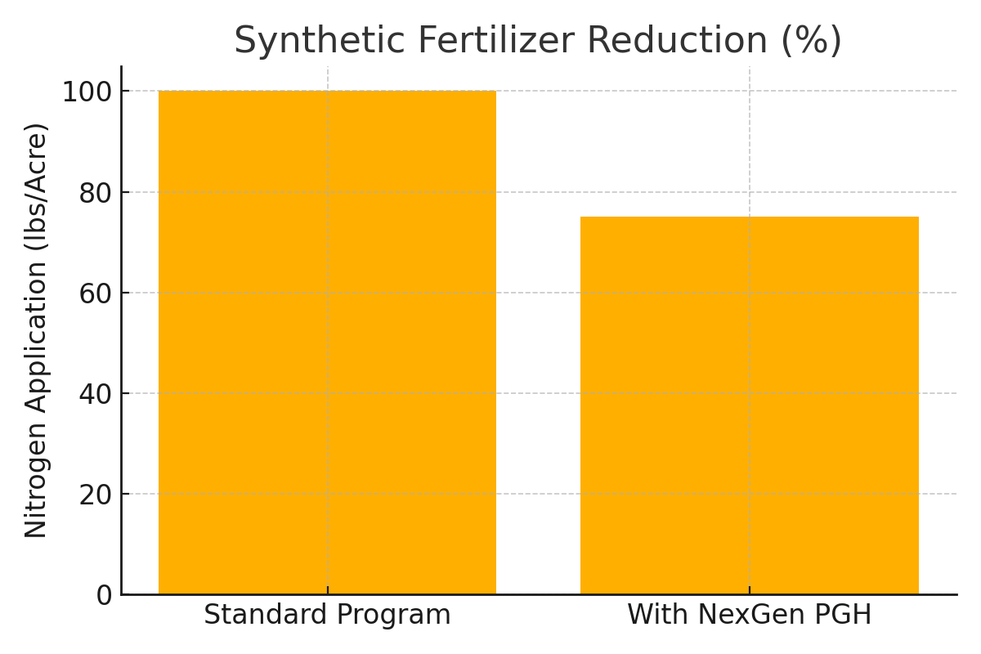

Figure 1: Synthetic Fertilizer Reduction with NexGen PGH

Tomato Production – South Texas, 2024  
- Yield increase: +26%  
- ROI: 8:1 due to reduced fertilizer inputs and improved market grade

**6. Research & Trial Data**

Numerous peer-reviewed studies and field trials support the use of humic acids and Bacillus-based microbial inputs in improving plant performance across various crop types. Notable research includes:  
  
• A 2022 meta-analysis published in Agronomy Journal found that humic acid treatments increased crop yields by an average of 13.5% and improved nutrient uptake efficiency by up to 22%.  
  
• Bacillus subtilis and Bacillus amyloliquefaciens have been shown in controlled trials to increase phosphorus solubilization and nitrogen use efficiency, resulting in improved biomass and root growth in corn, tomato, and lettuce.  
  
• Greenhouse studies at the University of California demonstrated that humic–fulvic acid combinations significantly enhanced drought tolerance in peppers and cucumbers by increasing water retention and osmotic regulation.  
  
• Field applications of NexGen PGH (2023–2024) across five commercial farms recorded:  
 - Yield increases of 8–15% in corn, soybeans, and tomatoes  
 - Improved root depth and lateral root mass in all crops  
 - Reduction of synthetic fertilizer needs by 25% or more  
 - Higher °Brix and better fruit uniformity in vegetable crops

## 7. Conclusion

NexGen PGH is not just a nutrient enhancer — it is a systems-level solution for growers seeking higher yield, stronger plants, and improved soil health. Its proven efficacy in row crops, fruits, and vegetables makes it an essential tool for both conventional and regenerative growers.

Disclaimer: Field results described herein are based on internal trials, grower feedback, and pilot applications. Results may vary by crop, soil conditions, application method, and environmental factors. No regulatory endorsements or certifications are implied. This document is intended for informational and marketing purposes only.