

# How NexGen Biologix Wastewater Treatment Works

NexGen Biologix uses naturally derived Bacillus strains as probiotics for wastewater treatment, a smarter alternative to traditional chemical and mechanical approaches. These specialized microbes break down fats, oils, grease (FOG), sludge, and other organic matter to improve water quality, reduce odors, and eliminate the need for expensive dredging.

## How It Works

Our wastewater solutions introduce a blend of Bacillus strains directly into the system. Once there, the bacteria begin producing enzymes that break down carbohydrates, proteins, and fats into simpler forms, which are then consumed by the microbial community. This process stabilizes the system, improves effluent quality, and restores hydraulic retention time (HRT).

## Why Bacillus Microbes Work

Unlike chemical treatments that only mask symptoms or mechanical dredging that delay the problem, Bacillus microbes target the root cause: the buildup of organic solids and nutrient overloads. These microbes produce enzymes that actively digest waste materials and improve system health over time.

## Proven Results from Field Trials

Numerous case studies show that Bacillus-based bioaugmentation leads to:

* Up to 70% reduction in BOD and COD
* 60–80% reduction in H2S and odor levels
* Significant reduction in sludge volume
* Elimination of annual mechanical dredging in treated systems

## Cost Savings and ROI

NexGen’s approach not only improves water quality—it saves money. By reducing the need for chemicals, cutting odor complaints, and minimizing sludge disposal costs, Bacillus bioaugmentation offers a sustainable, low-maintenance path to regulatory compliance and long-term savings.

## Case Study: Lagoon Sludge Reduction & ROI

A municipality using a NexGen WWT Bacillus-based biological for lagoon sludge digestion experienced significant performance improvements and cost savings:

* 53% sludge reduction in Lagoon 1
* 24% sludge reduction in Lagoon 2
* 3.71 million gallons of hydraulic capacity restored
* 12.3 days of increased hydraulic retention time (HRT)
* Total savings: $185,700 vs. mechanical dredging
* Annual treatment cost: $24,700
* ROI: 7.5 to 1

This example illustrates the financial and operational advantage of switching to bioaugmentation with Bacillus. NexGen WWT solutions are the same product used in this case study, reducing sludge volume, restoring retention time, and eliminating the need for costly dredging.

## Visual Impact of NexGen WWT Treatment

Figure 1. Sludge Reduction After Bacillus Treatment

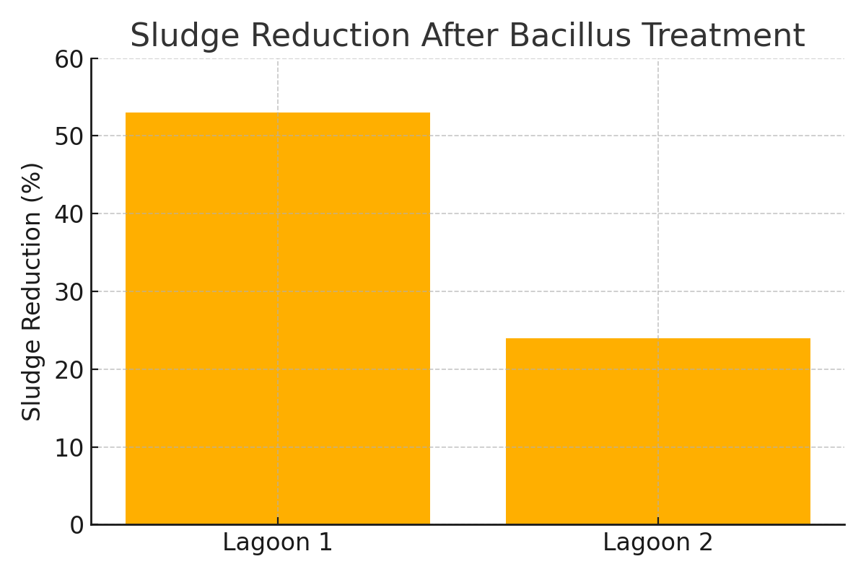

Figure 2. Cost Savings from Bacillus Wastewater Treatment

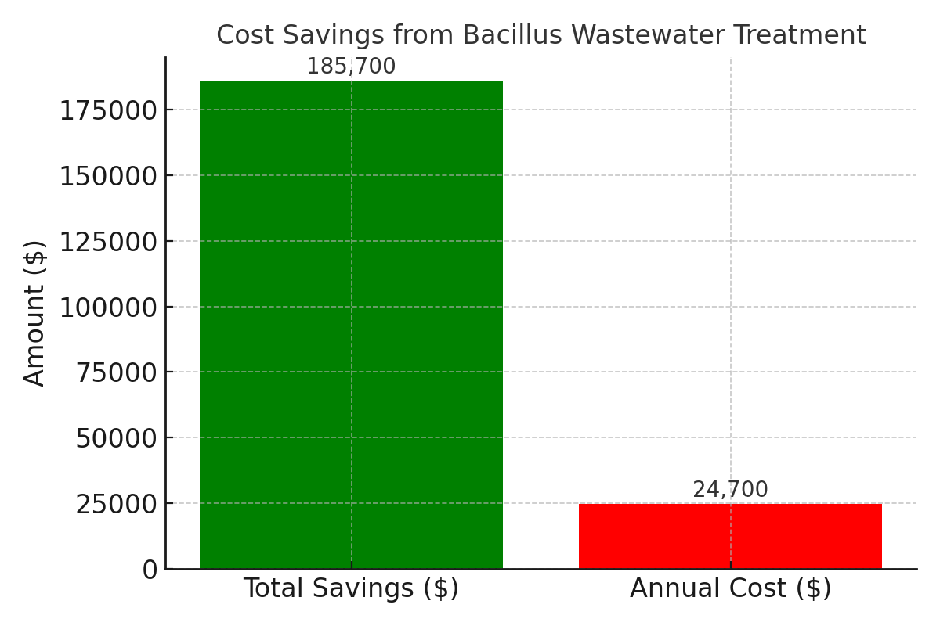

## Conclusion

NexGen Biologix’s Bacillus-based wastewater treatment is a science-backed, cost-effective alternative to chemicals and dredging. It restores biological balance, improves system efficiency, and protects the environment all while increasing ROI.

Disclaimer: Field results described herein are based on internal trials, third-party studies, and customer feedback. Performance may vary depending on system design, flow rate, and site-specific conditions. This document is intended for informational and marketing purposes only.