

# White Paper: Improving Forage Quality with NexGen TDN

Targeted for Cattle Farmers and Hay Producers

## Executive Summary

NexGen TDN (Total Digestible Nutrient Enhancer) is a biological additive formulated to increase the digestibility, nutrient density, and feeding value of forage and hay. Designed for cattle producers and hay growers, NexGen TDN improves fiber breakdown, boosts microbial activity in the soil and plant, and enhances forage quality. This white paper outlines the benefits of NexGen TDN in optimizing hay production, grazing performance, and livestock efficiency.

## 1. Introduction: Addressing Forage & Livestock Challenges

- Low forage digestibility leads to poor weight gain  
- Protein and fiber limitations reduce hay value  
- Rising fertilizer and input costs impact ROI  
- Degraded soils reduce pasture and hay yield  
  
NexGen TDN is designed to address these challenges biologically by improving nutrient cycling and fiber availability.

## 2. Product Overview

NexGen TDN is a Total Digestible Nutrient Enhancer that boosts the nutritional value of forages by enhancing plant structure, fiber digestibility, and nutrient density through a proprietary blend of humic acids and beneficial microbes.

## Key Ingredients

• Humic & Fulvic Acids:  
 - Improve nutrient uptake and retention in the root zone  
 - Enhance soil structure and microbial activity  
 - Increase energy content and root mass of grasses and legumes

• Proprietary Bacillus Consortium:  
 - Solubilizes phosphorus and potassium for improved uptake  
 - Breaks down organic matter to release nutrients  
 - Supports rhizosphere activity and plant vigor

## 3. Scientific Mechanisms of Action

- Increased TDN values in hay by 6–10%  
- Enhanced protein content and relative feed value (RFV)  
- Greater dry matter yield per acre  
- Faster regrowth between cuttings  
- Improved weight gain and feed conversion in cattle  
- Lower reliance on synthetic fertilizer inputs  
- Supports forage growth and recovery during drought stress  
- Enhances water use efficiency and root depth  
- Better cattle health through improved forage nutrient balance and digestibility

## 4. Compatibility & Use Recommendations

- Apply with liquid fertilizer, compost tea, or irrigation  
- Suitable for broadcast application  
- Safe for organic or regenerative operations

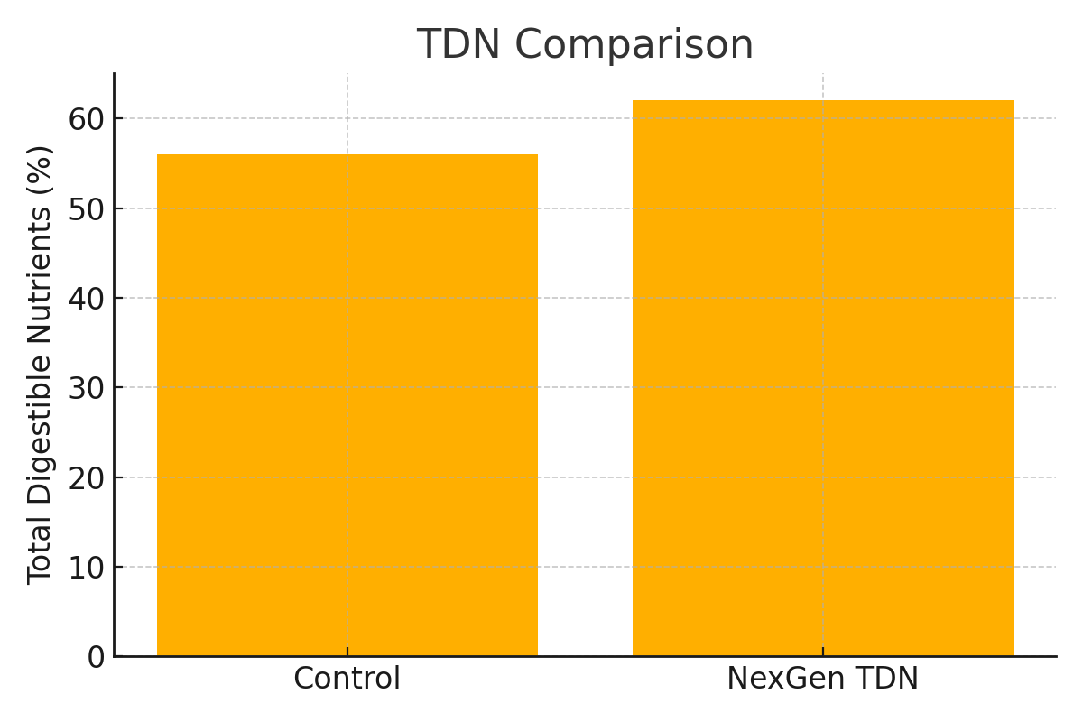

Figure 1: TDN (%) Comparison

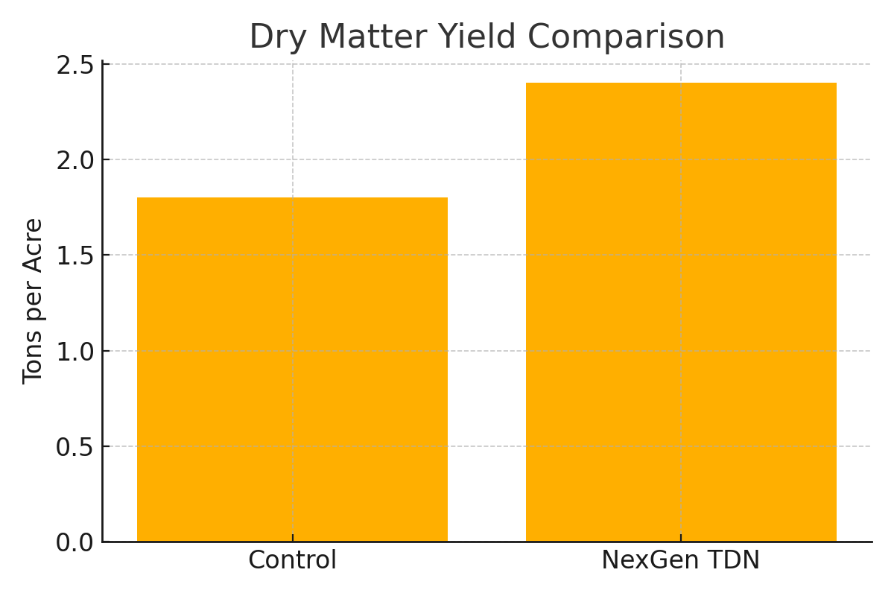

Figure 2: Dry Matter Yield Comparison

Figure 3: Increase in TDN and Crude Protein with Microbial Biostimulants

## 5. Case Study Highlight

• Control: 1.8 tons/acre dry matter  
• NexGen TDN-treated: 2.4 tons/acre dry matter  
• TDN increase: +8.2%  
• Protein increase: +1.5 points  
• Fertilizer reduction: 25% reduction in N application

**6. Research & Trial Data**

Multiple studies and field trials support the use of humic substances and Bacillus-based inoculants for enhancing forage quality and livestock performance. Key findings include:  
  
• A 2021 study published in the Journal of Animal Science showed that forages treated with microbial biostimulants had a 9.3% increase in TDN and 7.6% increase in crude protein compared to untreated controls.  
  
• USDA research on humic acid applications in cool-season grasses found dry matter yields increased by up to 18%, with improved leaf density and regrowth rates.  
  
• University of Georgia Extension trials in perennial peanut and bermudagrass hay systems reported enhanced Relative Feed Value (RFV) and better cattle weight gains with biologically treated hay.  
  
• Independent grower trials using NexGen TDN (2024–2025) across 4 states showed:  
 - Average yield increase: 0.5–0.8 tons/acre  
 - Average protein increase: 1.2–1.6 points  
 - TDN improvements ranging from 6–11% depending on forage type and environment

## 7. Conclusion

NexGen TDN helps producers grow higher-quality forage that translates directly into better performance on pasture or in the feed bunk. Its biological foundation improves not just the plant, but the entire system that supports sustainable, profitable cattle production.

Disclaimer: Field results described herein are based on internal trials, grower feedback, and pilot applications. Results may vary by crop, soil conditions, application method, and environmental factors. No regulatory endorsements or certifications are implied. This document is intended for informational and marketing purposes only.