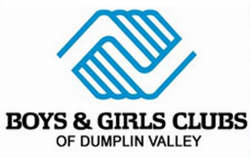
Youth Development Professional

Boys & Girls Clubs of Dumplin Valley is a youth development organization located in Jefferson & Cocke counties. The mission of the Boys & Girls Clubs of Dumplin Valley is to enable all young people, especially those who need us most, to reach their full potential as productive, responsible and caring citizens; preparing them for the future while allowing them to enjoy their childhood.
The Club offers tested, proven and nationally recognized programs with three priority outcome areas: Good Character & Citizenship, Healthy Lifestyles and Academic Success. BGCDV offers every child a safe place to learn and grow, ongoing relationships with positive adult role models, life enhancing programs, hope, and opportunity.
The Youth Development Professional is a frontline, part time position. The Youth Development Professional is responsible for implementing educational, safe, engaging and fun activities with youth.
Responsibilities Include
- Implement programs and activities that encourage youth engagement. Staff may work in specific areas of the Club and are asked to cross train to work in all areas of the Club. Able to meet the needs of youth al all ages and backgrounds.
- Attend Club programs, field trips, and special events. Support grant funded programs. Follow TN DOE licensing regulations.
- Supervise and monitor program areas to ensure the safety of Club members, including walking around and actively monitoring areas under supervision.
- Be a positive role model for youth. Provide positive behavior reinforcement and mentoring. Provide discipline and guidance to youth as needed.
- Work collaboratively with a team of Club professionals and volunteers.
- Other duties as needed.
Preferred Skills
- Excellent written and verbal skills; proficient in Microsoft Office
- Ability to lift and move up to 40 pounds
- Ability to remain active and engaged for six hours or more
Requirements
- 18+ years
- High school diploma or GED
- Must pass local, state and national criminal background checks
- Must pass drug screens
- CPR Certified or the ability to become certified

