Cumberland Trail
Fire District #4
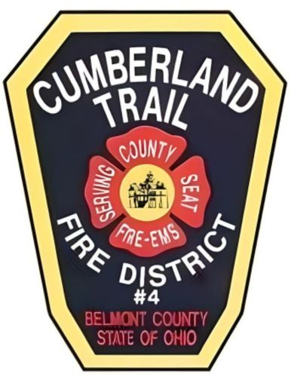
Fulltime Firefighter
Training Manual
Index
Section 1: Fire District History
Section 2: Fire District Organization
Section 3: Policies
Section 4: Vacation, Personal and Sick Time
Section 5: Health Insurance, and Pension Information
Section 6: Fire Department Operations
Section 7: PPE and SCBA
Section 8: Engine Operations
Section 9: Truck Operations
Section 10: Rescue Operations
Section 11: EMS Operations
Section 12: Saving Our Own
Section 13: Out of Classification Guide
Section 14: Driver/Operator Checklist
Section 15: Skill Sheet

Mission Statement
The mission of the Cumberland Trail Fire District #4 is to provide the highest level of public safety services to all citizens through preservation of life and property. We will promote public safety through the education of our citizens and personnel. While using quality people and equipment to foster community relationships that will allow us to maintain the highest level of professionalism.

Vision Statement

We, the Cumberland Trail Fire District #4, will strive to be role models in our community and leaders’ in our vocation. We will provide quality services by investing in training, education, staffing, and state of the art technology. We are dedicated professionals and will continue to present quality care and protection to all we serve while maintaining and pursuing a progressive future.

Core Values
PROFESSIONAL EXCELLENCE
To ensure the best possible service to the Fire District citizens the Cumberland Trail Fire District supports continuous training and encourages professional development.
INTEGRITY
Committed to honest and ethical behavior all while holding ourselves accountable to our values.
INNOVATION
Committed to seeking out and implementing innovation and progressive thinking to address change effectively and efficiently to benefit those we serve during the duration of our mission due to the constancy of change in our community and the demographics that affect us daily.
COMMUNITY SERVICE AND INVOLVEMENT
Fulfilling our responsibility and deepening our involvement in the community we serve by being obligated and involved in our community beyond our call to duty. Having dedication in not allowing a request or inquiry to go unanswered.
HEALTH AND SAFETY
Ensuring that we are devoted to providing the best health and safety programs for our members well-being and operational readiness so that we are essential in fulfilling our mission.
TEAM WORK AND LEADERSHIP
Well function teams are more effective than individuals working separately. We believe that all individuals have the capacity to lead and the organization values leadership

Introductory Statement
This Cumberland Trail Fire District #4 manual serves as a guide for new fulltime employees. All job pertinent information will be included in the following sections. This info shall be learned as well as necessary skill completion before the end of probationary period. This information and the skills that follow are crucial to being successful while functioning as a fulltime firefighter at CTFD. At the end of probation, each full-time firefighter will be proficient and knowledgeable on the following topics and operations.

