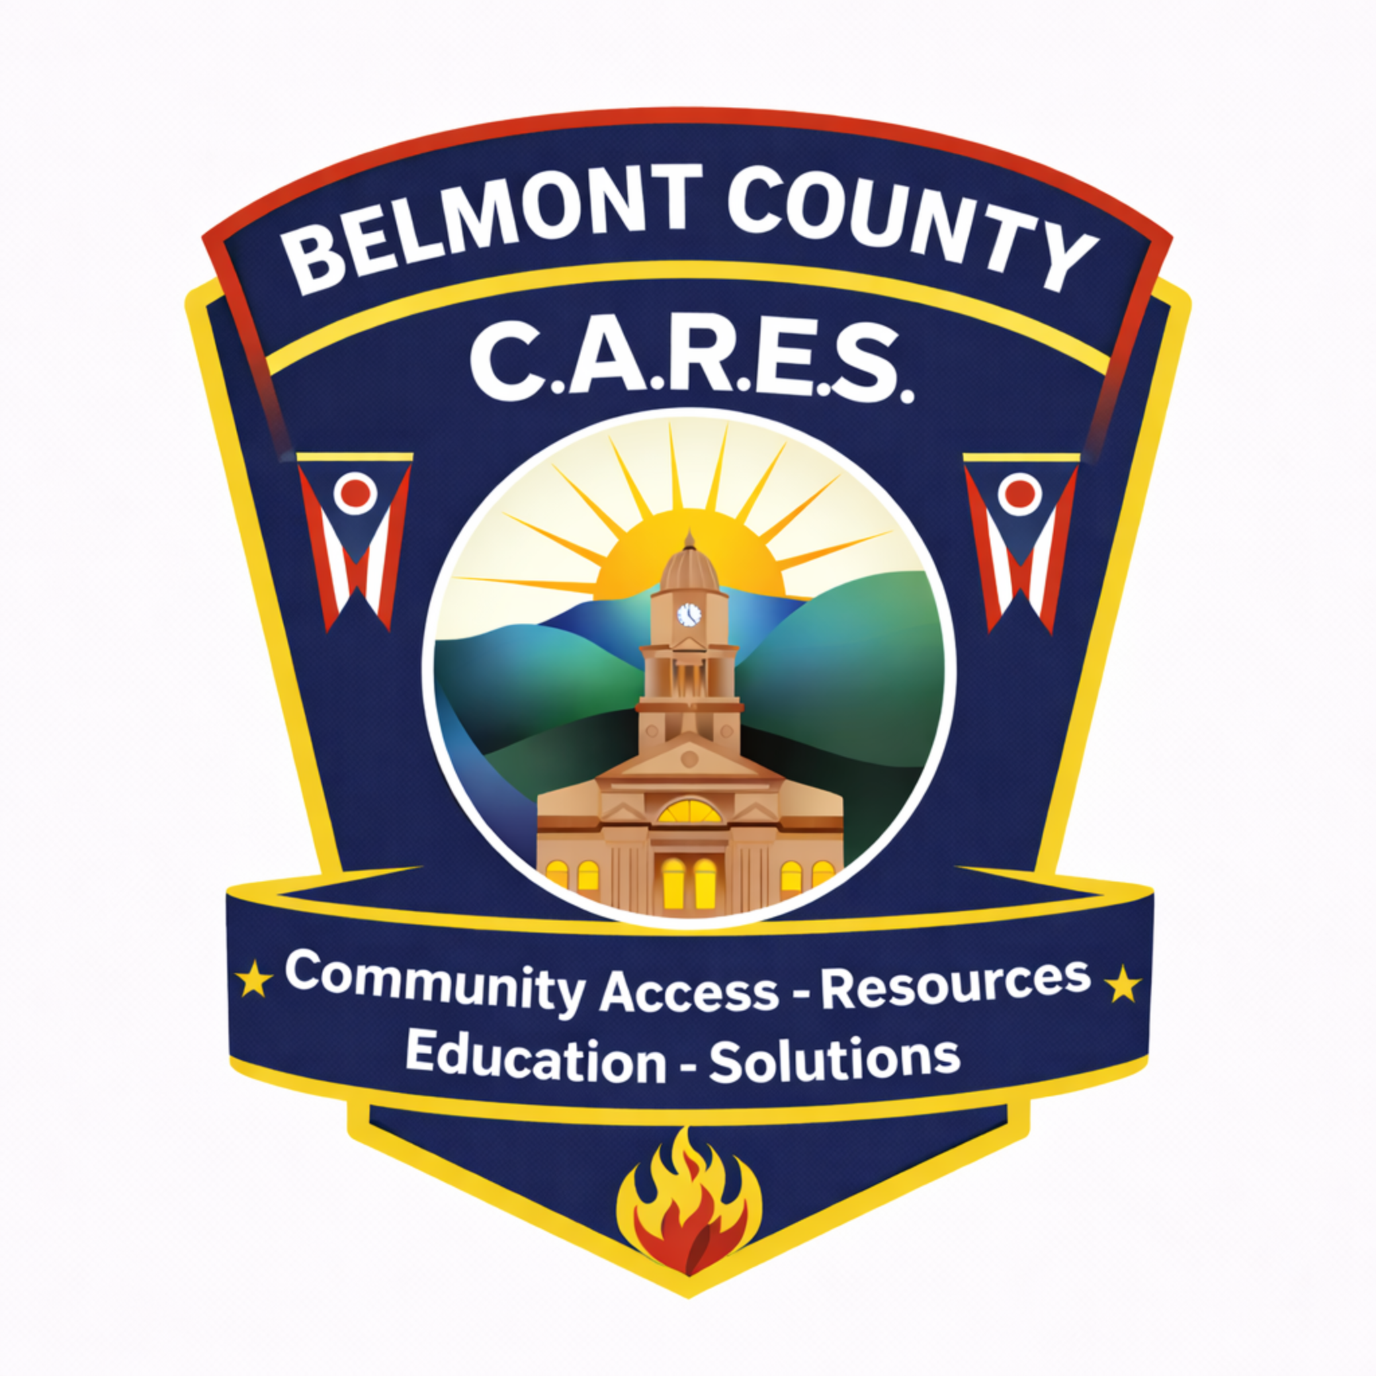
Belmont County CARES Program
Community Access • Resources • Education • Solutions
2025 Year-End Report
Prepared for: Belmont County Board of Commissioners, community partners, and stakeholders

In partnership with:
  Belmont County Board of Commissioners | 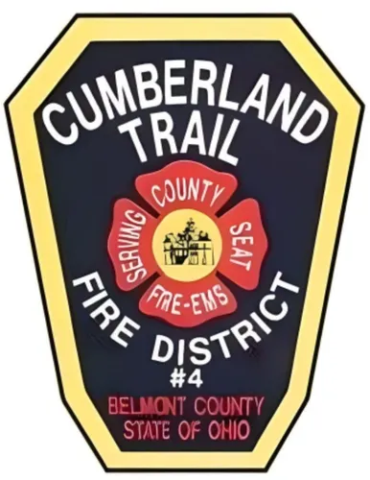  Cumberland Trail Fire District |   Mental Health & Recovery Board
  Senior Services of Belmont County | 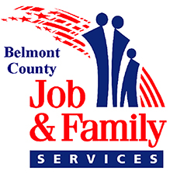  Belmont County Job & Family Services | 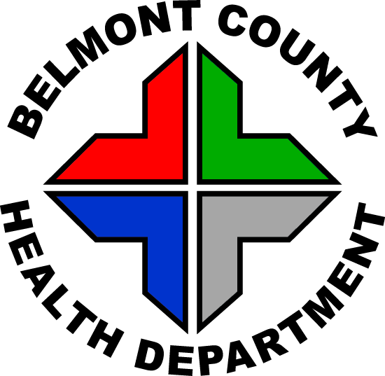  Belmont County Health Department

Executive Summary
The Belmont County CARES (Community Access, Resources, Education, and Solutions) Program is a countywide community paramedicine initiative designed to bridge gaps between emergency services, healthcare systems, behavioral health providers, and community resources. CARES provides structured, proactive follow-up for high-risk residents whose needs often fall between systems and require coordinated intervention.
In 2025, CARES experienced growth in key tracked activity measures compared to 2024. CARES recorded 1,543 total patient interactions, including phone calls, virtual contacts, and in-person visits. Referrals into the CARES office totaled 1,013 across all agencies, and in-person visits increased from 687 (2024) to 745 (2025). These trends reflect increased reliance on CARES as a countywide point of access for non-emergent but high-risk needs and increased utilization by partner agencies. These totals reflect a high-touch follow-up workload that sits outside traditional emergency response and is sustained over time.
Mental health and crisis-related encounters continued to increase and remain a significant driver of CARES workload. In 2024, CARES also expanded clinical capability through Nurse Practitioner (NP) integration and in 2025 formalized a partnership with WVU Wheeling Hospital to support post-discharge follow-up for Belmont County residents. This report summarizes program operations, service volume, and system value for county leadership and stakeholders.
In 2025, CARES secured a grant from the Community Foundation for the Ohio Valley to purchase portable vital sign monitors and field bags to strengthen in-home assessment capability for the CARES team.
Without CARES, many of these needs would likely go unaddressed until they escalate, increasing reliance on 911 response, emergency departments, and higher-acuity services.

Key 2025 Takeaways
- 1,543 total patient interactions (all contact types)
- 745 in-person visits
- 5,002 phone calls (carrier-billed) totaling 17,632 minutes
- 1,013 referrals received
- 208 mental health interactions

What Is Community Paramedicine?
Community paramedicine is a healthcare delivery model that expands the role of EMS clinicians beyond emergency response to provide proactive, non-emergency, home-based services. In this model, trained EMS clinicians conduct in-home assessments, provide education, identify barriers to care, and coordinate follow up with healthcare and community partners.
The CARES Program uses community paramedicine to reach residents who often fall between systems, including those with chronic disease, behavioral health needs, limited transportation, complex medication regimens, and unstable social situations. CARES meets residents where they are, identifies risks early, and connects them to the right level of care before problems escalate.
The goal is simple and practical: improve access and continuity of care, strengthen transitions after hospitalization, and reduce avoidable escalation to 911 response, emergency departments, and repeat hospitalizations. CARES does not replace existing services. It strengthens the county’s overall system by filling the gaps between EMS, hospitals, clinics, behavioral health providers and community resources.
CARES is the county’s structured follow-up and coordination resource, designed to help high risk needs get addressed earlier and more consistently.

Why it matters in Belmont County
- Provides care and follow-up where barriers (transportation, mobility, access) prevent clinic-based care
- Supports residents with chronic disease, complex medication regimens, and unstable home environments
- Provides structured follow-up and coordination for behavioral health and crisis-related needs
- Improves transitions after hospital discharge by reinforcing medication adherence, follow-up appointments, home safety, and linkage to services
- Identifies home-based risks that clinical settings may not see (living conditions, fall hazards, food insecurity, lack of support, missed medications)
- Complements EMS and partner agencies by providing sustained follow-up that emergency response systems are not designed to maintain

Program Overview and How CARES Works
The CARES Program operates through Cumberland Trail Fire District and serves residents throughout Belmont County. CARES functions as a connector and stabilizing resource, complementing existing services by addressing gaps in care. Referrals are received from EMS, hospitals, behavioral health providers, county agencies, family members, and self-referrals.

Operational workflow
- Intake and triage: referral received, initial risk/priority assessed, follow-up assigned.
- Contact and scheduling: outreach conducted by phone and/or home visit scheduled based on urgency and need.
- In-home assessment: clinical and social determinants evaluated in the home environment.
- Intervention and coordination: education, resource deployment, referrals, and care coordination initiated.
- Follow-through: ongoing engagement until needs are met and the case is closed, or the patient is transitioned to the appropriate long-term service.

Core service lines
- Chronic disease support and education (CHF, COPD, diabetes, hypertension)
- Mental health engagement and crisis follow-up
- Mental health crisis response coordination with Coleman Health Services (crisis situations)
- Post-hospital discharge follow-up and transition support
- Harm reduction and substance use response support (naloxone distribution and linkage pathways)
- Home safety and prevention interventions (smoke detectors, fall risk education)
- Resource navigation and partner referrals (transportation, utilities, equipment, home health, hospice)
- Community education and prevention programming (CPR trainings and outreach)

2025 Program Metrics and Year-over-Year Growth
The table below summarizes key program totals for 2024 and 2025. These figures provide a year-over-year view of program volume and highlight increasing utilization in key tracked areas.
Category | 2024 Total | 2025 Total
Total patient interactions | — | 1,543
In-Person Visits | 687 | 745
Phone Calls (Carrier-billed) | — | 5,002
Phone Minutes (Carrier-billed) | — | 17,632
Referrals received | — | 1,013
Mental Health Interactions | 100 | 208
NP related orders placed | — | 65
Overdose Kits Delivered | 55 | 68
Smoke Detectors Installed | 120 | 48
CPR Training | 9 | 10
Note: Phone call totals for 2025 are based on cell carrier billing records. A carrier-based 2024 phone call total was not compiled for this report.

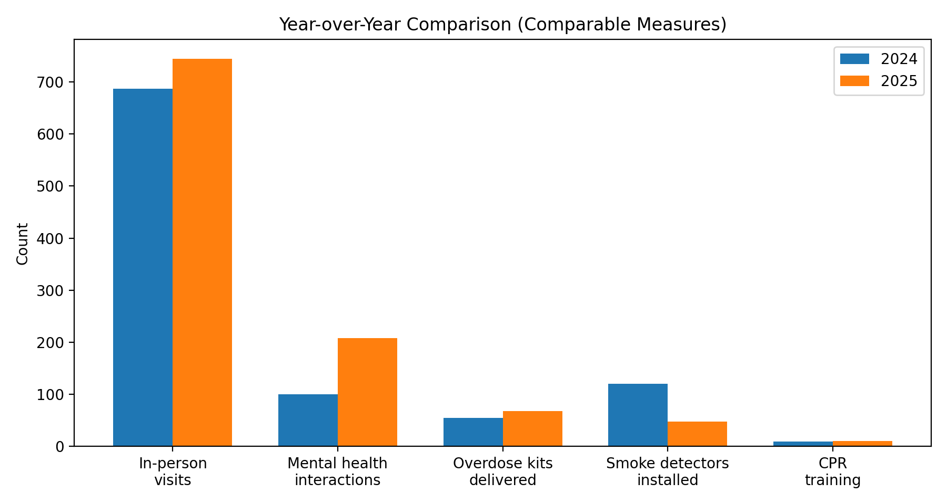
Note: Chart reflects only measures with comparable 2024 and 2025 tracking.

2025 Program Metrics and Year-over-Year Growth (continued)
These totals reflect services delivered through CARES encounters across multiple contact types. In 2025, CARES completed 745 in-person visits and recorded 5,002 phone calls totaling 17,632 carrier-billed minutes, demonstrating substantial follow-up workload outside of in-home contact. CARES also recorded 1,013 referrals received and 208 mental health interactions, reinforcing the program’s role as a primary access point for high-risk needs, particularly behavioral health.
Clinical and prevention actions remained a core part of CARES operations in 2025, including 65 NP-related orders placed to support appropriate levels of care, 68 overdose kits delivered, 48 smoke detectors installed, and 10 CPR trainings. Several 2024 measures were tracked using different methods or were not compiled in a comparable format; therefore, year-over-year comparisons in those categories are limited. The 2025 totals demonstrate growing reliance on CARES and the breadth of services delivered countywide.

Mental Health and High-Risk Population Engagement
Mental health-related encounters remained a significant driver of CARES workload in 2025 and continued to increase compared to 2024. CARES frequently engages individuals experiencing behavioral health crises, substance use concerns, and complex psychosocial situations that require follow-up beyond an initial emergency response.
CARES receives frequent referrals related to mental health emergencies from both law enforcement and Fire/EMS, in addition to partner agencies and self-referrals. This work is resource-intensive and often involves individuals with limited engagement in traditional behavioral health systems or significant barriers to care. CARES provides rapid outreach, in-home assessment when appropriate, and coordination with Coleman crisis services and behavioral health providers, and continued follow-up to support stabilization and linkage to ongoing care. Sustained engagement over time is a key differentiator of CARES and addresses a persistent gap in community behavioral health follow-up capacity.

Common behavioral health contributions from CARES
- Rapid follow-up after mental health emergencies and crisis events (often referred by law enforcement and Fire/EMS)
- Connection to counseling, psychiatry, and recovery resources through partner pathways
- Ongoing support for families and caregivers navigating complex behavioral health situations
- Coordination with the Mental Health and Recovery Board and other partners to align resources and next steps

Nurse Practitioner Clinical Capacity
In 2024, CARES expanded its clinical capacity through integration of a Nurse Practitioner (NP). The NP conducted in home clinical visits focused on chronic disease management, medication reconciliation, post-hospital discharge follow-up, symptom monitoring, and care coordination. This capability strengthens continuity between discharge and outpatient care, particularly for residents with transportation barriers, limited supports, or complex medication regimens.
The NP role is supported through county investment and partner collaboration. It functions as a practical extension of the CARES model by addressing issues earlier, closing care gaps, and supporting medically complex residents in the home setting.

Typical NP visit focus areas
- Medication reconciliation and education after discharge or medication changes
- Symptom checks and assessment to support timely escalation when needed
- Chronic disease monitoring and education (including vitals, symptom trends, self-management)
- Coordination with primary care, specialists, home health, and hospice when appropriate

Partnerships and Collaboration
CARES is built on a working partner network that drives referrals, aligns resources, and supports coordinated care plans. These collaborations allow CARES to respond quickly to complex situations where medical, behavioral health, and social needs overlap.

County and community partners
- Belmont County Board of Commissioners
- Belmont County Health Department
- Belmont County Mental Health and Recovery Board
- Senior Services of Belmont County
- Belmont County Job & Family Services
- EMS agencies and public safety partners across Belmont County

How CARES Is Used
CARES is most often utilized when residents fall between traditional systems of care and need structured follow-up to prevent escalation. Common referral drivers include mental health instability requiring follow-up, post-hospital discharge needs, chronic disease mismanagement, repeated non-emergent EMS contacts, and social barriers that directly impact health (transportation, utilities, equipment needs, limited supports).
These utilization patterns reflect identified community need rather than program-generated demand and help explain year-over-year growth in referrals and interactions.

What CARES Absorbs That Other Systems Do Not
CARES routinely manages workload that does not clearly fall under the responsibility of a single agency but cannot be ignored. This includes non-emergent but urgent situations, sustained mental health follow-up that EMS and law enforcement cannot maintain, residents who disengage from traditional care settings, after-hours concerns, and repeated community concern calls that fall below emergency thresholds.
By absorbing this workload, CARES supports earlier intervention and reduces downstream strain on emergency services, healthcare systems, and partner agencies.

Patient Demographics and Service Area
CARES primarily serves older adults and residents with chronic health conditions while continuing to respond to needs across all adult age groups. Working 2025 age distribution:
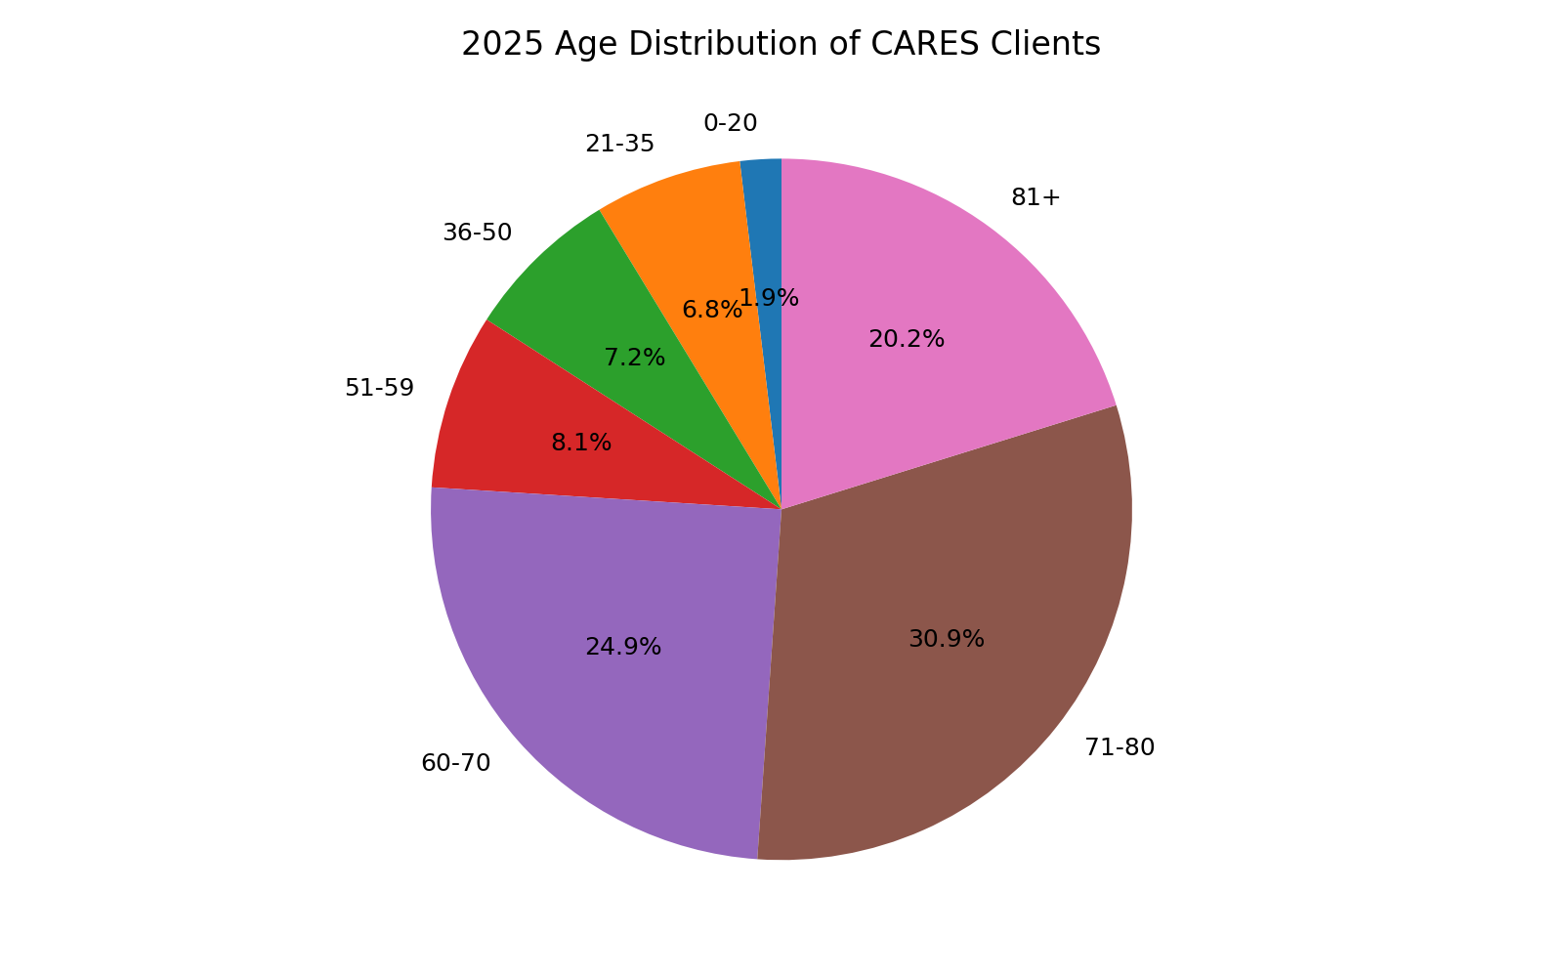

Notes
- Total clients in 2025: 1,338
- Age distribution reflects clients with age/DOB captured in 2025 (1,244)
- 76% of clients with age captured are age 60+

Prevention and Community Education
CARES maintains prevention-focused work alongside follow-up care. In 2025, prevention and harm-reduction services increased, including naloxone distribution, and CPR trainings. These services support home safety, reduce risk, and strengthen community preparedness.

Case Example
A resident in her 60s was referred to CARES by a local senior center due to concerns about stability, limited medical follow-up, and difficulty managing chronic conditions after the recent loss of her primary support person. The patient reported worsening depression and anxiety, had stopped several prescribed medications, and faced barriers to transportation and consistent primary care. CARES initiated structured follow-up and coordinated support with partner agencies to address food access, transportation barriers, and linkage to primary care and behavioral health services.
During the follow-up period, CARES maintained frequent contact while coordinating with Meals on Wheels, transportation providers, and scheduled behavioral health appointments. When the patient unexpectedly missed routine check-ins and multiple partner agencies were also unable to confirm contact, CARES escalated appropriately by coordinating a welfare check with local law enforcement. The patient was found to be experiencing an acute, high-risk behavioral health crisis and required immediate medical evaluation. CARES coordinated communication with the receiving facility, engaging hospital social work, and supported transition planning to connect the patient back to appropriate community supports.
Why this matters: This is not an isolated event. CARES provides the structured follow-up and coordination layer that ensures high-risk residents do not fall through the gaps between community services, public safety, and healthcare systems.

2026 Priorities
- Strengthen referral pathways and partner feedback loops
- Improve data visibility for internal management and reporting to stakeholders
- Continue high-volume behavioral health engagement and structured follow-up
- Maintain prevention programming including home safety interventions and CPR training

Acknowledgements
The Belmont County CARES Program is made possible through collaboration among county leadership, partner agencies, and community organizations. CARES acknowledges the ongoing support of the Belmont County Board of Commissioners, Cumberland Trail Fire District, and the many partners who contribute referrals, resources, and coordination to support Belmont County residents.

