Engine 232
Station 23-2 First Due Engine
Engine 232 is Station 23-2’s only fire apparatus. This engine is responsible for first due response to Station 23-2 district as well as second due to Station 23 district. Engine 232 responds on most mutual aid fires if staffing is appropriate.
Specs:
- 2014 Sutphen Custom Pumper
- Cummins Diesel Motor
- DEF System compliant
- Allison Automatic Transmission
- Onboard generator
- 1750 GPM Hale Pump
- 1000 Gallon Water Tank
- 20 Gallon Class A Foam Tank (Dry)
Hose line Compliments
- Off the Tailboard
  - 1000 Feet LDH 5 inch, Stortz connections
  - 400 Foot Pre-Connect 1-3/4 Attack Line (Orange)
  - 300 Foot 2-1/2 Supply line (White)
    - Dead Load (Not Connected)
- Cross lays
  - 200 foot 1-3/4 hand line w/ removable fog tip (Red)
    - When fog nozzle tip removed 7/8 smoothbore tip
  - 200 foot 1-3/4 hand line w 7/8 smoothbore tip (Blue)
  - 200 foot 2-1/2 hand line w/ 1-1/4 smoothbore tip(White)
  - 2 100 foot 2-inch-high rise kit w/ 1-1/16 smoothbore tip (Yellow)
- Front Bumper
  - 100 foot 1-3/4 hand line w/ fog nozzle (White)
- Hard Suction
  - 2 sections of 25-foot Hard Suction beside top hose bed
Pumping E232
- Place engine transmission in ‘Neutral’, set the parking brake, and allow the engine RPM to reach idle speed.
- Move Pump Shift Assembly control into ‘Neutral’ position and pause.
  - Lift Yellow Collar on actuator to move knob
- Move Pump Shift Assembly control into ‘Pump’ position.
  - Lift Yellow Collar on actuator to move knob
- Place engine transmission into designated pumping gear. Press D for Drive.
- Look and listen for indications that the pump is in gear.
- Dismount the apparatus and proceed with pumping operations.
Indications that 232 is in Gear
- OK to Pump Engage Light is lit on pump shift module
- Speedometer may change from 0 mph to 10-15 mph
- Depressing the accelerator slightly results in no RPM change or lurching of the apparatus
- Motor changes sound
- Drive shaft is rotating between the transmission and pump gear box
- Positive pressure indication on discharge gauge
“Operators need to become familiar with how their apparatus reacts when successfully placed into pump mode. The operator must know the sights and sounds for those times when light bulbs burn out or don’t work”

E232 Allison Pump Module/Pump Shift actuator
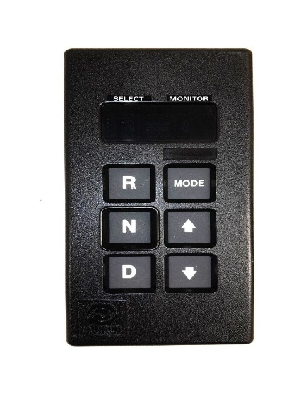
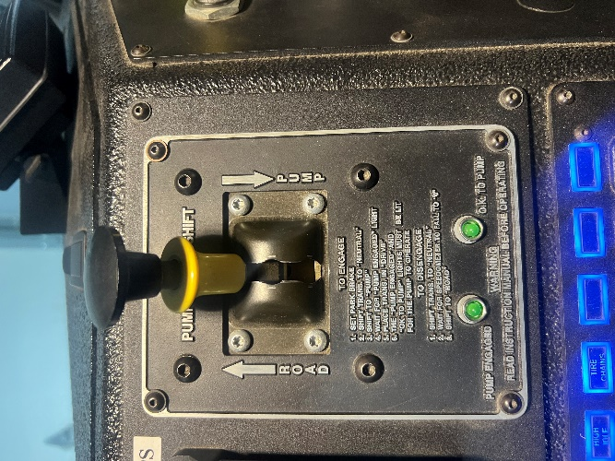

Trident Primer System
E232 has a Trident Air primer system for drafting. This system is easy to use and makes drafting much easier when compared to traditional priming systems.

Manual Trident Systems
Manual systems may be used on the main pump as well as individual intakes as previously described. The manual system requires the operator to physically engage the primer much like traditional rotary vane primers. Instead of a pull handle, the air primer has a push button controller to operate the primer. The operator simply depresses the desired primer button to engage the primer and releases the button to disengage the primer. Unlike traditional mechanical primers, there is no time limit when engaging the air primer.
Maintenance and Troubleshooting
All the customary troubleshooting options for drafting apply when using an air primer, i.e. leaking couplings, minimizing vertical lift, closing pump drains, etc. The air primer offers the advantage of overcoming imperfect drafting setups more readily than traditional rotary vane primers due to its unlimited engagement time. Theoretically the air primer can overcome more air trapped or infiltrating the drafting setup.
There is no routine maintenance intervention required by station personnel for the air primer. There are no fluids or moving parts to lubricate. The primer operation should be checked as part of routine pump inspections. The primer body has an integral strainer to reduce the potential for debris entering the primer body and obstructing the air inlets. If priming performance seems to be reduced or impaired the strainer should be checked for debris.
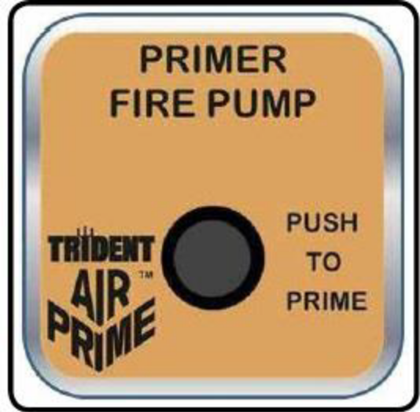

Key Points About Drafting Operations using Trident Air Prime
- Drafting is like painting your living room; it is all in the preparation.
- If the pumper is equipped with an electronic pressure governor, it must be in the RPM mode.
- Don’t put the pumper in pump gear until:
  - You are sure that your positioning is correct, and the wheel chock(s) is down.
  - The tank-to-pump valve is closed
  - You are certain that suction hose connections are airtight
  - You are sure all discharges, drains and bleeders are closed and capped
  - You have circulating line ready-Simple as using the deck gun
- It is especially important to not put the pump into gear prematurely if you do not have an intake control valve through which you can draft.
- Allowing the impeller to spin in a pump without water builds up heat and can ruin the impeller, clearance rings and mechanical seals.
- The Auto AirPrime is most efficient at about 1,000 RPM.
- Look for signs of water rising in the hard suction hose:
  - Hose is “dipping” from the weight of the water.
  - Hear the Auto AirPrime operating.
- Once you have completely transitioned to drafting, open the circulating line and cut the tank fill back - but make sure you refill your tank, you can flush if out later if you usually carry clean water
Pumping E233
- Place engine transmission in ‘Neutral’, set the parking brake, and allow the engine RPM to reach idle speed.
- Move Pump Shift Assembly control into ‘Neutral’ position and pause.
  - Lift Yellow Collar on actuator to move knob
- Move Pump Shift Assembly control into ‘Pump’ position.
  - Lift Yellow Collar on actuator to move knob
- Place engine transmission into designated pumping gear. Press D for Drive.
- Look and listen for indications that the pump is in gear.
- Dismount the apparatus and proceed with pumping operations.
Indications that 233 is in Gear
- OK to Pump Engage Light is lit on pump shift module
- Speedometer may change from 0 mph to 10-15 mph
- Depressing the accelerator slightly results in no RPM change or lurching of the apparatus
- Motor changes sound
- Drive shaft is rotating between the transmission and pump gear box
- Positive pressure indication on discharge gauge
“Operators need to become familiar with how their apparatus reacts when successfully placed into pump mode. The operator must know the sights and sounds for those times when light bulbs burn out or don’t work”

Manual Prime Operations
- Establishing the Prime:
  - Use the pump panel throttle to maintain approximately 1000 RPM.
  - Activate the priming pump by pulling the control handle located on the pump panel.
  - The Pump Intake Pressure Gauge begins to read below zero right away.
  - Within 10 to 20 seconds, you see and feel the hard suction stressing under the weight of water.
  - Within approximately 30 seconds the PDP begins to read slight intermittent pressures and a broken stream of water begins to discharge from the primer drain under the apparatus.
  - Continue priming until a constant stream of water discharges from the primer drain and PDP becomes constant, approximately 5 to 10 seconds more.
- Note:
  - If signs of prime do not occur within 30 seconds, do not continue to run the priming pump. Stop the pump and check for air leaks or possible pump trouble.
  - Priming pumps overheat and become damaged if operated longer than 45 seconds dry.

CTFD Engine Placement Considerations
This is a guideline for basics of engine placement for residential fire attack. Keep in mind all incidents are different, and a competent and confident engineer communicates with his company officer at all times.

Residential Attack:
- The driver/operator and company officer of the first arriving apparatus must observe conditions and determine the best apparatus position based on initial attack strategy and department policy.
- Pull the apparatus past the front of the building, if feasible, when arriving at an incident where no fire is evident (investigation mode). This position allows personnel on the apparatus to view three sides of the building.
- Consider the best access point for personnel and equipment entering the occupancy when parking the apparatus. This will allow personnel efficient access to the building to begin an investigation.
- Remain with the apparatus in the event connections for water supply or fire department connections need to be made or to assist in pulling attack hose lines and operating the pump.
- Even in the case of an alarm it is in the best interest of the crew to place the truck into pump and be ready for an active fire attack
- In many cases, pumpers may arrive before the first aerial apparatus. Pumping apparatus driver/operators must seek the best advantage for their apparatus while keeping in mind the needs of aerial apparatus that have yet to arrive. Blocking access for aerial apparatus can seriously jeopardize the outcome of an incident.
- Establishing water supply is a primary concern of the driver/ operator and company officer in the placement of the pumper. If a confirmed fire is located in an area of limited access, such as a narrow driveway or alley, the personnel of the first-arriving pumper should consider laying their own supply line.
- Another important consideration when determining the proper position for an attack pumper is the potential for structural collapse.

See attack line SOP to study E232 and E233 hose loads.

