The below section will cover operations involving Rescue 23. Rescue 23 is stationed at station 23 and cross manned by station 23’s first due engine crew. R23 is utilized for firefighting, auto extrication, hazmat, rope rescue, and ice/water rescue. This section will cover truck specifics, rescue and fire equipment, pumps, hose lines, responses, and procedures.
Rescue 23
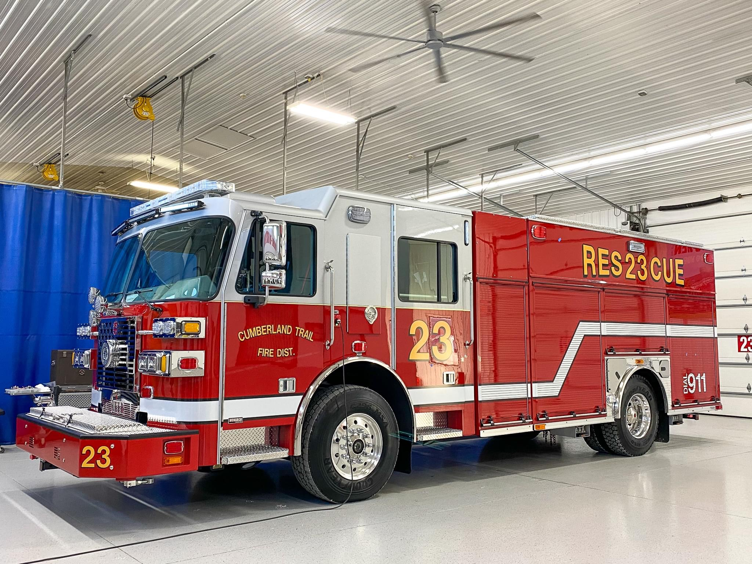

- 2022 Sutphen Monarch
- Enclosed Hale Pump 1500gpm
- Variety of fire and rescue equipment
- 750 Gallon tank
- Stationed at station 23
- Main response for Vehicle accidents, vehicle fires and rescue scenarios
- 4-point hitch for winch system
- On board floor dry hopper
- Remote controlled light tower

Firefighting Capabilities Hose and Nozzles
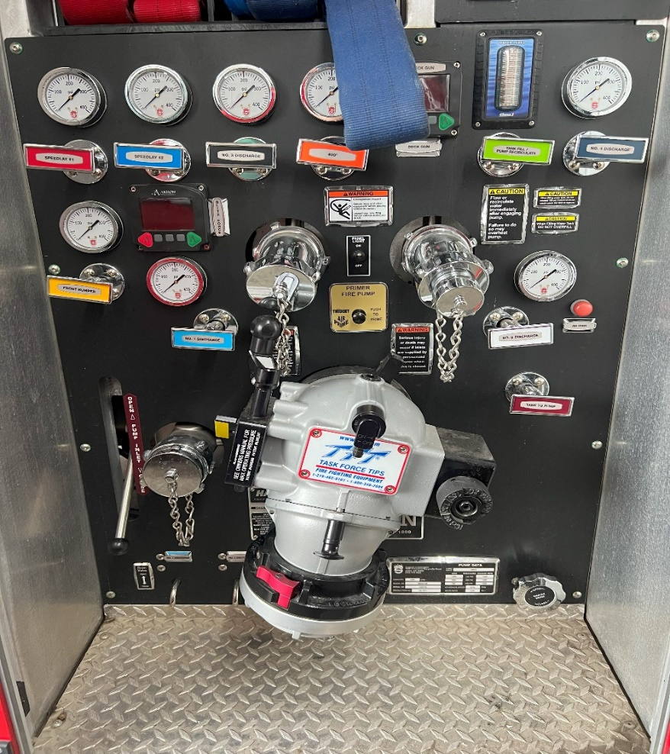

Rescue 23 | Location | Length | Diameter | Color | Nozzle | PDP | GPM
Car Fire Line | Front Bumper | 100' | 1 3/4" | White | Fog | 100 PSI | Selective
400' Attack Line | Left Rear Preconnect | 400' | 1 3/4" | Orange | 7/8" SB | 185 PSI | 175 GPM
Red Preconnect | Preconnect #1 | 200' | 1.75" | Red | Fog | 135 PSI | 150 GPM
Blue Preconnect | Preconnect #2 | 200' | 1.75" | Blue | 7/8" SB | 110 PSI | 160 GPM
Deck Gun | Top | - | - | - | 1 3/8" SB | Not to exceed 100PSI | 500 GPM+
2.5" Attack Line | Right Rear | 300' | 2.5" | White | 1 1/4" SB | - | -
Highrise Packs | Compartment | 200' | 2" | Yellow | 1 1/16" SB | 50 PSI at tip | 250 GPM
Blitzfire | Rear | Not | Preconnected | - | - | 125 PSI | 450 GPM
5" Supply Line | Rear | 800' | 5" | - | - | - | -

The above table shows the hose loads currently on R23 as well as the desired pressure to flow these lines. All preconnected handlines are a modified minute man lay with the nozzle wrapped to protect the bale. Below are videos and steps to correctly deploy and reload the above hose loads.

200’ 1-3/4 Cross-lay Deployment
- First, roll the hose compartment door up making the cross-lay accessible.
- Second, feed the Shoulder nozzle section onto your shoulder. The nozzle should hang at the stomach or waist. Remember to keep the hose load pressed together tight.
- Third, step away from the apparatus to allow the shoulder load to clear the poly tray.
- Next, using the large loop, pull the Drag section onto the ground completely clear of the poly tray. (The officer, backup FF or operator should grab the coupling from the ground and flake out the drag section.
- Finally, walk and deploy the shoulder section ending with the nozzle. If needed, drop the section, and flake out the remaining hose if space is limited to deploy.

200’ 1-3/4 Cross-lay Repack
- Begin repacking this load by sitting the poly tray on the side of the apparatus and dangling the pony section to the side of the truck.
- Next, start laying the drag section by placing a female coupling approximately 4 feet past the edge of the poly tray.
- Lay one more section flat stopping at the edges of the tray.
- On the next fold, place a large loop at the end of the tray to be used to deploy the drag section.
- Continue laying the 50-foot section ending with the male coupling on the top.
- Next, Connect the nozzle to the next section and begin packing the shoulder load by feeding the hose under the nozzle to the other end of the tray. On your next lay, wrap the hose over the nozzle and finish all remaining folds at the end of the tray.
- Flat load 1 more 50-foot section to both the shoulder and drag section.
- Next, connect the female and male coupling at the top of the shoulder and drag section.
- Then connect the female “dangle” section that you started with to the pony section.
- Finally, lift the poly tray back into the respective slot and dress the pony section on top of the load to allow easy and proper deployment.
https://youtu.be/ORLiEudkYxY

400-foot Attack Line Deployment
- To deploy the 400, the nozzleman addresses the nozzle load, and pulls the load, placing it on his shoulder until the nozzle sits at a comfortable position near his midsection. It is imperative that the nozzleman then steps away from the apparatus only a few feet and then stops to await the second member and keeps his hand on top of the load to prevent losing any hose.
- The next member shoulder loads the middle section in the same manner as the nozzle man. If no other members are available for the evolution, the second member, after clearing the middle load, turns and pulls the ear of the drag load and clears this load to the ground.
- If a third member is available to deploy the drag load, he has the option of pulling it out to the ground at the rear of the apparatus or pulling approximately half of the drag load out and inverting it so the hose will pay off his shoulder for a more efficient stretch.
- The 400’ line must be laid in a manner that dictates that the nozzle man is the last member to deploy his shoulder load.

400-foot Attack Line Repack
- To place the line back on the apparatus, the line is racked starting with a female being connected to the discharge. After one layer is placed in the hose bed, the next layer has a large ear to facilitate deploying the drag load. When this first 50’ is racked, leave the male end of the hose on top of the load.
- The next step, and a very vital step in this procedure, is to start with a male coupling and lay this coupling on the ground and rack the middle section ending with a female coupling on top at the rear.
- The next step is to place the nozzle on a male coupling and utilize a “wrap” while locating the nozzle in the hose bed to allow the efficient deployment of the nozzle load. After this 50’ is laid in the bed, leave the female coupling on top of the lay in same manner as packing the middle load.
- The next step is to return to the drag load and rack another 50’ to it leaving the male on top.
- Next members will add 50’ to the middle load and leave the female on top.
- The next step is to add the final 50’ of hose to the nozzle load and leave the female coupling on top.
- The final stage starts with last 50’ racked to the drag load and again leave the male coupling on top.
- The last section of hose to be racked will be the 50’ added to the middle section with its female coupling on top.
- To end the procedure, the couplings will be joined in this specific order to ensure the hose load is one continuous 400’ line from discharge outlet to the nozzle. The male coupling that was dangling to the ground from the middle section is hooked to the female coupling that is on top of the nozzle load.
- Finally, the female on top of the middle section is coupled to the male on top of the drag load to complete the procedure.

100’ 1 ¾” Front Bumper Trash Line
a. Deployment
i. To deploy E233, E232, and R23’s front bumper line, begin by unbuckling any securement straps or lifting the hose tray cover.
ii. The firefighter will then grab both the nozzle and the tail. iii. Next, the firefighter will advance the hose line ending with both 50’ sections flaked out.
b. Repacking
i. Begin repacking this hose load by connecting a female coupling to the discharge. If necessary, account for the bend near the female coupling if the apparatus has a lid to the tray.
ii. Next, simply perform a flat load for the first 50 feet, ending with the male coupling off to the side of the tray. iii. Connect the next 50’ to the male coupling forming a “tail”.
iv. Then flat load the last 50’ ending with the nozzle on top. v. Fold the tail on top of the load and secure with straps.

Rescue 23 Firefighting Equipment
Rescue 23 is set up to have most of the basic firefighting equipment on the operator side of the apparatus. Although R23 is not the first due for reported structure fires, it is a large possibility due to frequency of this apparatus being out, it may respond. Listed below is all firefighting equipment currently on Rescue 23.
Pump Compartment- Fittings, Fill sections, mallets, spanners, foam inductor, toolbox.
Operator Middle Compartment- Bolt cutters, Sledgehammers, axes, pry bars, shovel, Drivers pack, Dry chem, CO Extinguishers, R23 RIT pack, and a forcible entry bag.
Rear Compartment- Milwaukee chainsaw and chop saw, hydrant bag, foam pro pack, Highrise bag and high-rise racks.

Ground Ladders
Rescue 23 rear ladder compartment holds 3 ground ladders as well as pike poles/new York hooks. A 24-foot extension ladder, a 16-foot roof ladder with spring loaded hooks and an attic ladder are all stored in this compartment.

Rescue 23 Apparatus Placement
At any motor vehicle incident, the priority should be proper apparatus placement and size up of the scene. Ideally, medic units will arrive on scene and position past the incident. This allows them to transport without being blocked in and allows R23 to get closer to the incident to make access to equipment easier. Rescue 23 should stop at an appropriate distance and angle to deflect traffic from the incident.
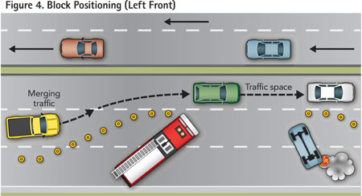

If time allows, an available firefighter should deploy road flares or traffic cones if applicable to the incident. Apparatus placement may differ due to incident type and the officer in charge’s decision.

Rescue 23 Auto Extrication Equipment
Cribbing
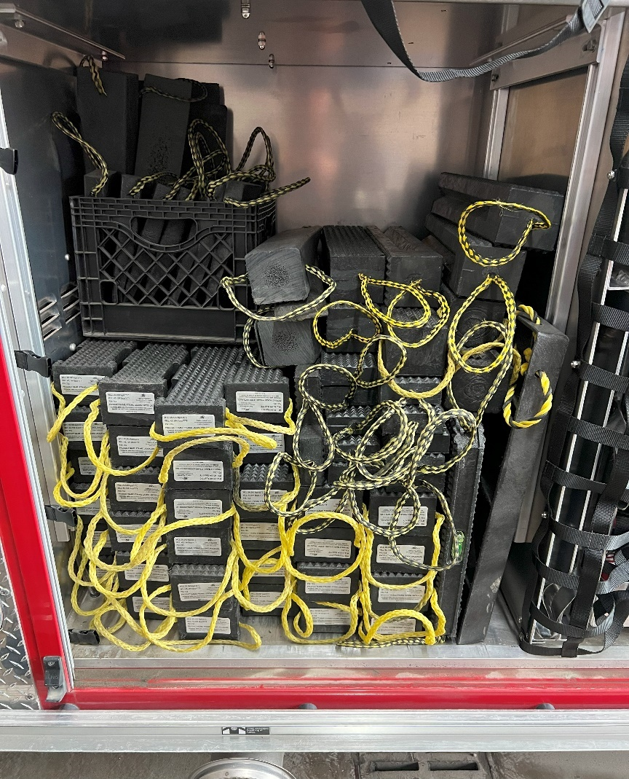
- R23 has a large complement of composite and timber cribbing. Cribbing ranges from 2x2, 4x4, 6x6, step chocks and respective wedges. This cribbing should be utilized anytime that a vehicle’s stability is compromised. Cribbing should also be in place anytime extrication is being performed.
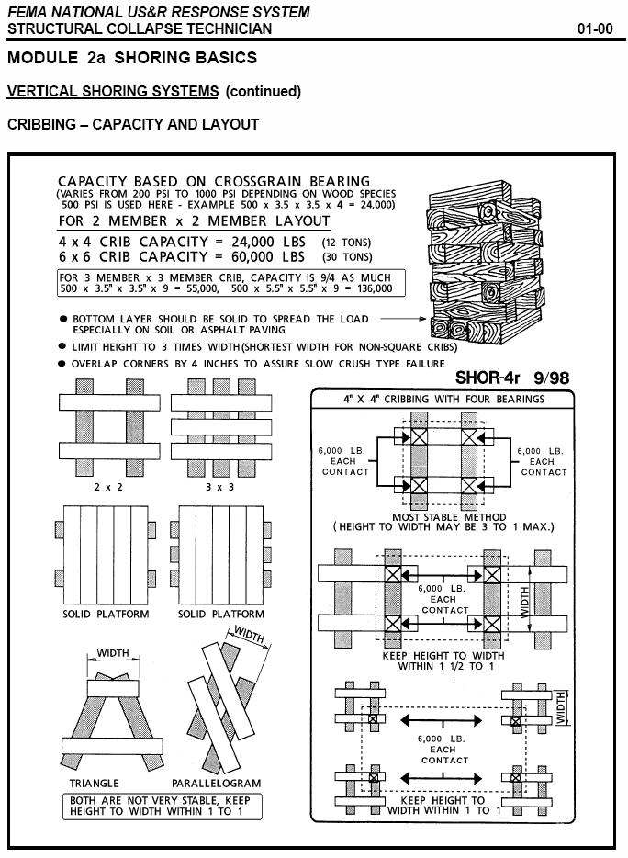
Struts
- Rescue 23 has a complement of Kodiak Struts that are used to stabilize vehicles during incidents. These struts are kept in the officer side front compartment mounted in brackets. Included with these struts are extensions, interchangeable heads, and ratchet straps. Below is a step-by-step process of setting up the Kodiak struts.
- Remove the struts and ratchets from R23 compartments.

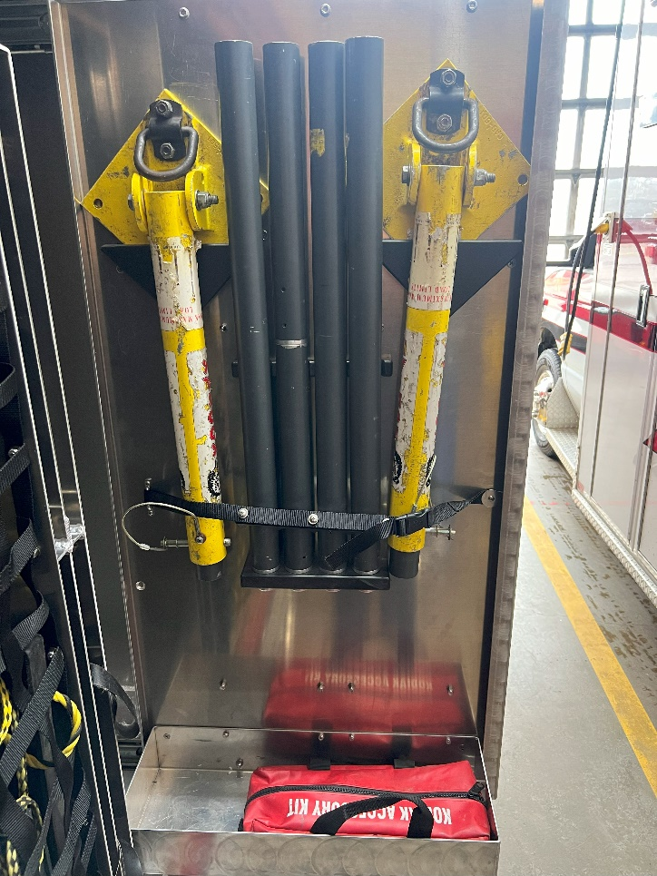
- Select the appropriate head for the strut and intended use.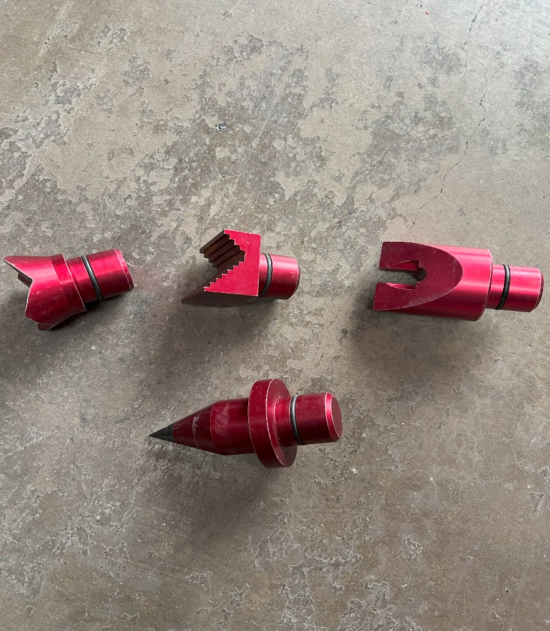

- Identify the appropriate location to place the strut for maximum stability.
- Place the base of the strut on the ground and lean the strut toward the vehicle to form a triangle.
- Make sure the head of the strut is being placed against a solid part of the vehicle (Frame).
- Once the ideal angle is formed, hook the ratchet into the base plate and then a solid part of the vehicle. The strap ideally will be parallel with the ground.
- Utilize the ratchet to pull the strut toward the car, tightening the strut and increasing stabilization.

Farm Jacks
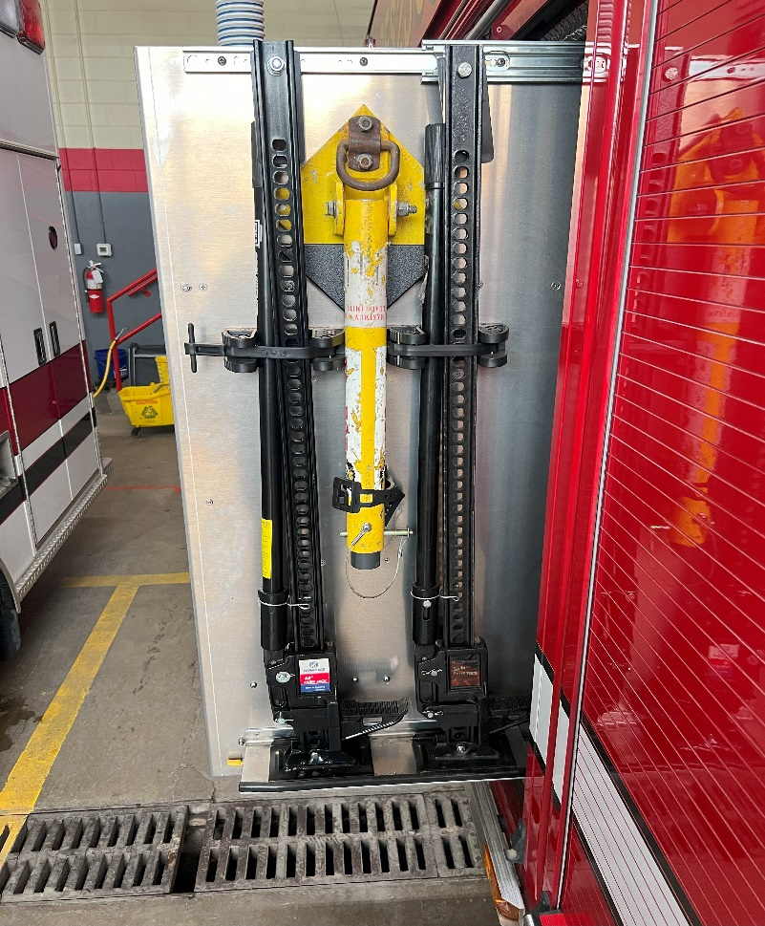
- A farm jack is a unique non-hydraulic rescue tool used for lifting.

- In addition to lifting, these jacks can also be used to spread doors from vehicles as a back up to hydraulic tools.
- Farm jacks are easily portable and can be deployed quickly.
- Currently on Rescue 23, there are two farm jacks secured on a slide out tray in the operator side front compartment.

Airbags
- Rescue 23 has 3 total genesis airbags that can be utilized for lifting.
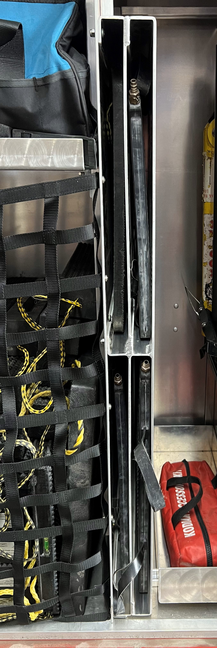

- These airbags are in vertical slot trays in the officer side compartment with the cribbing.
- There is also a black tool bag in the same compartment that has the airbag regulator, hoses and fittings.
- Retrieve an SCBA cylinder when utilizing airbags.
- The maximum operating pressure for R23 airbags is 145PSI.
- Lifting capacities vary per airbag.
- Remember to always operate airbags on a flat and clean surface.
- Utilize lifting pads.
- Lift an inch crib an inch!!!

Attached below is the step-by-step process of operating rescue 23’s airbags.
- Begin by removing all necessary equipment from the Rescue and moving it to the appropriate area for lifting. This equipment includes Airbags, airbag accessory bag, SCBA bottle, lifting pad and cribbing.
- Next, place your airbag on top of the lifting pad that is on a stable and clear area. This lifting point should be able to provide the most surface area contact between the airbag and object being lifted.
- Once the airbag is in place, attach the regulator to the SCBA bottle and the controller then open the bottle.
- Set the regulator to 145 PSI.
- Attach the airbag hoses to the controller and then the airbag. (utilize T valves)
- Using a coordinated lift, press the appropriate button to supply the airbag with air.
- Remember to crib as the object is being lifted to capture your progress.
- Once the desired lift is performed, shut off valves on the airbag fitting can be utilized to keep the bag inflated and moved the hoses to another airbag.
- To lower an object, simply reverse the above process.

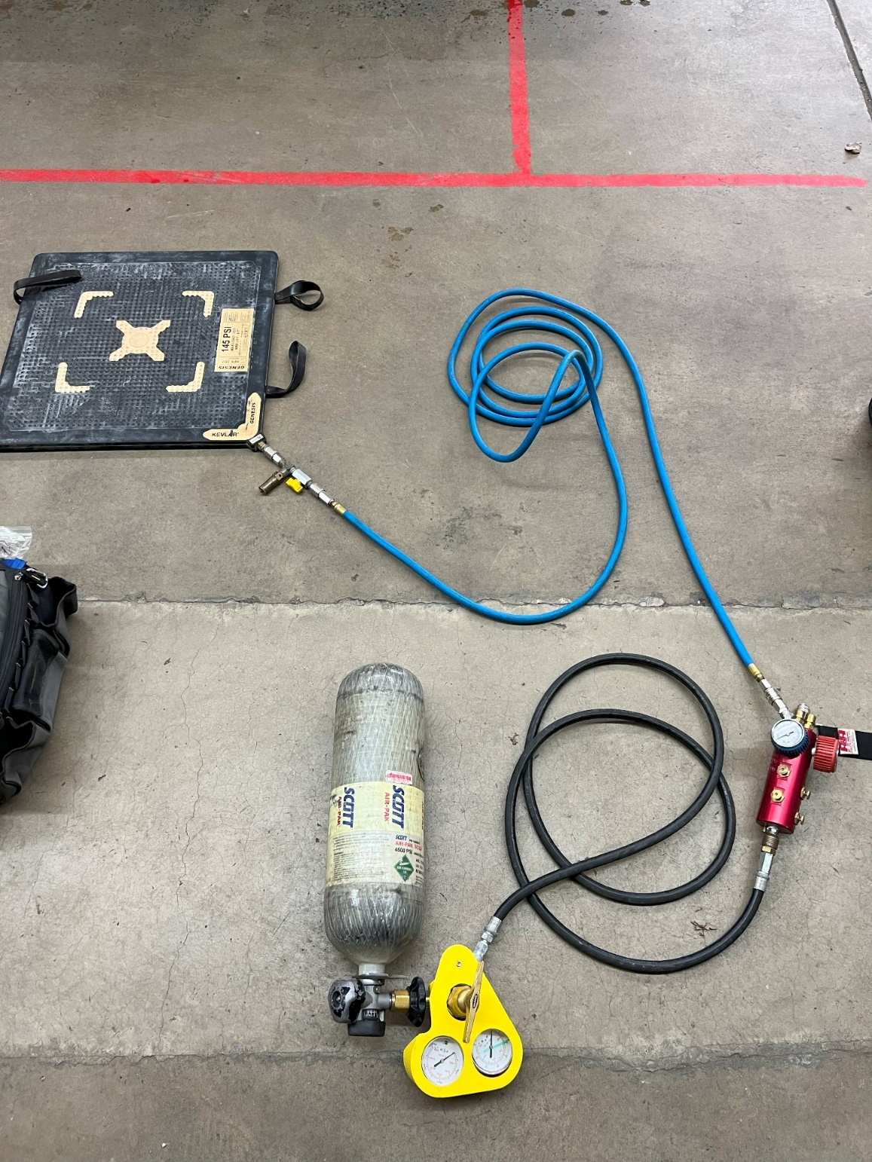
Controller
Airbag Supply Line
Shut Off Valve
Air Regulator
Supply Hose

Rescue 23 Winch System
- Stored in R23 front bumper compartment.
- Warn Zeon 8 model.
- 8MM Aircraft wire rope
- NEVER TO EXCEED 8000LBS
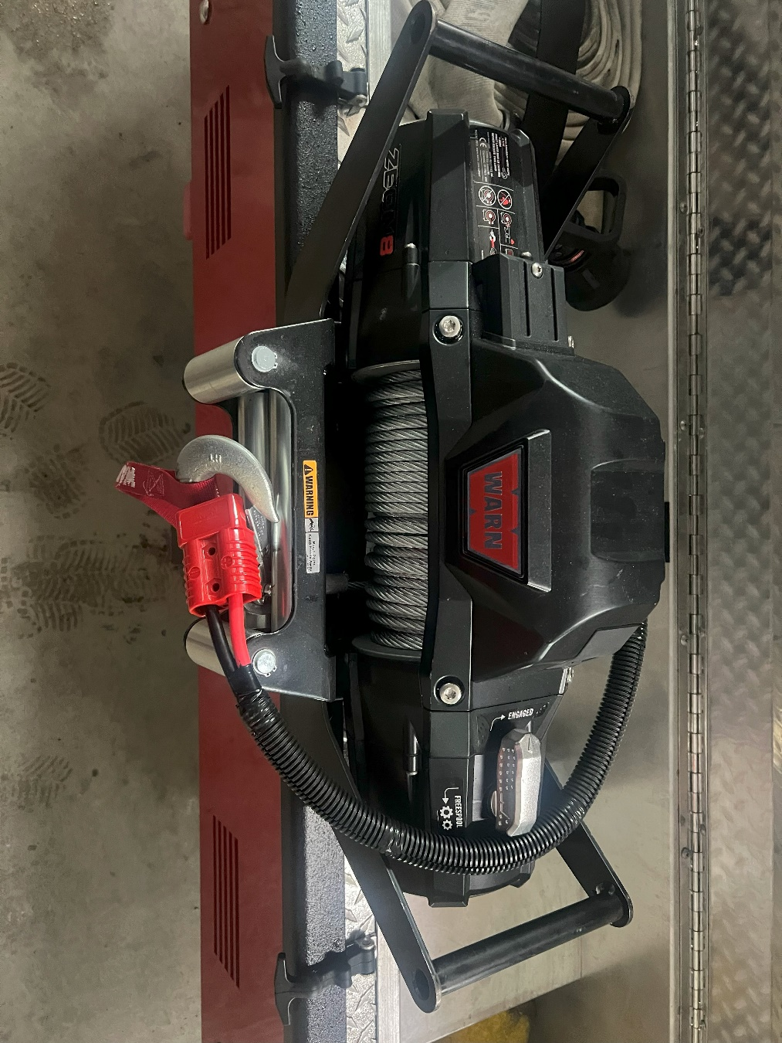
- 4 total hitch receivers (Front, Operator side, Officer, Rear.)
- The rear pan door compartment houses attachments for winch

Rescue 23 Genesis Hydraulics
Rescue 23’s primary tools for cutting and spreading during auto extrication are genesis hydraulic tools. R23 operator rear compartment holds one set of spreaders, cutters, small cutters, a combination tool, a powerplant, and 2 rams. There is also a bag with spreader and ram attachments in this compartment. These tools also have a backup powerplant kept in the rear compartment. All hydraulic tools have quick connected twist lock fittings. This allows the tools to be changed out while the hose lines are still under pressure. Tool maintenance is key to prolonging tool life and always keeping the tools operational. Routine maintenance is scheduled by CTFD. On Wednesday, power tools including the genesis tools shall be started, operated, fuel, hydraulic and oil levels checked. An inspection of the hose condition should also be performed. Tools should also be kept free of debris and cleaned after use. Step by step procedures to start the powerplant, charge the hydraulic line and operate hydraulic tools will be listed below. When hydraulic tools are in use, a hose line should be pulled and charged for fire protection.
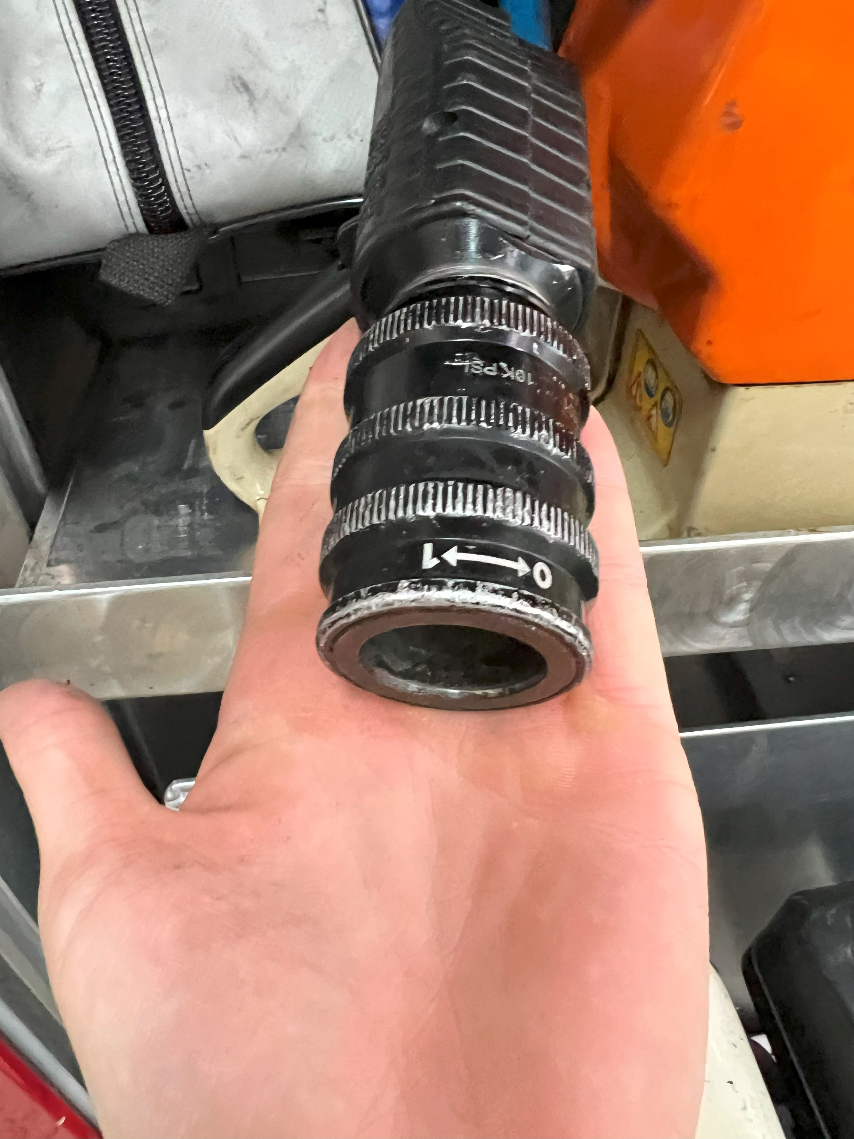

Female Connection
Male Twist Lock

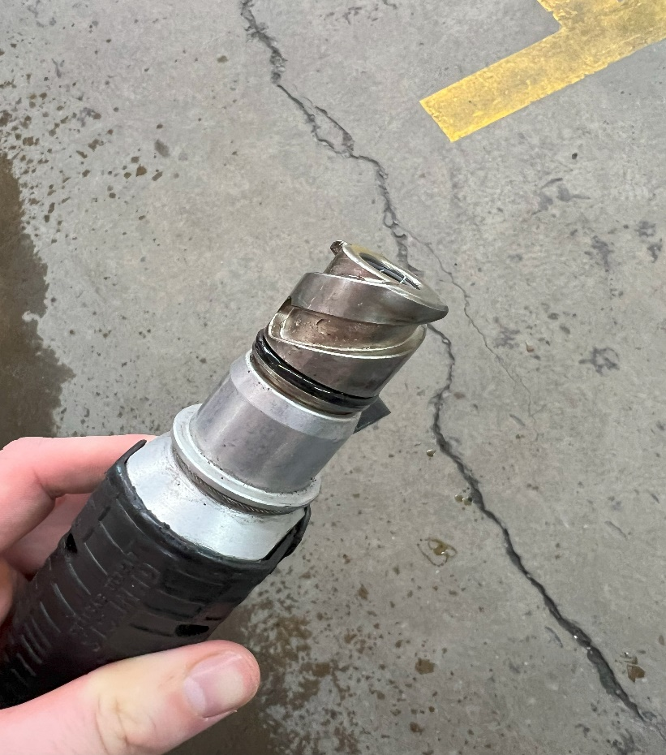

Spreader and Ram attachments
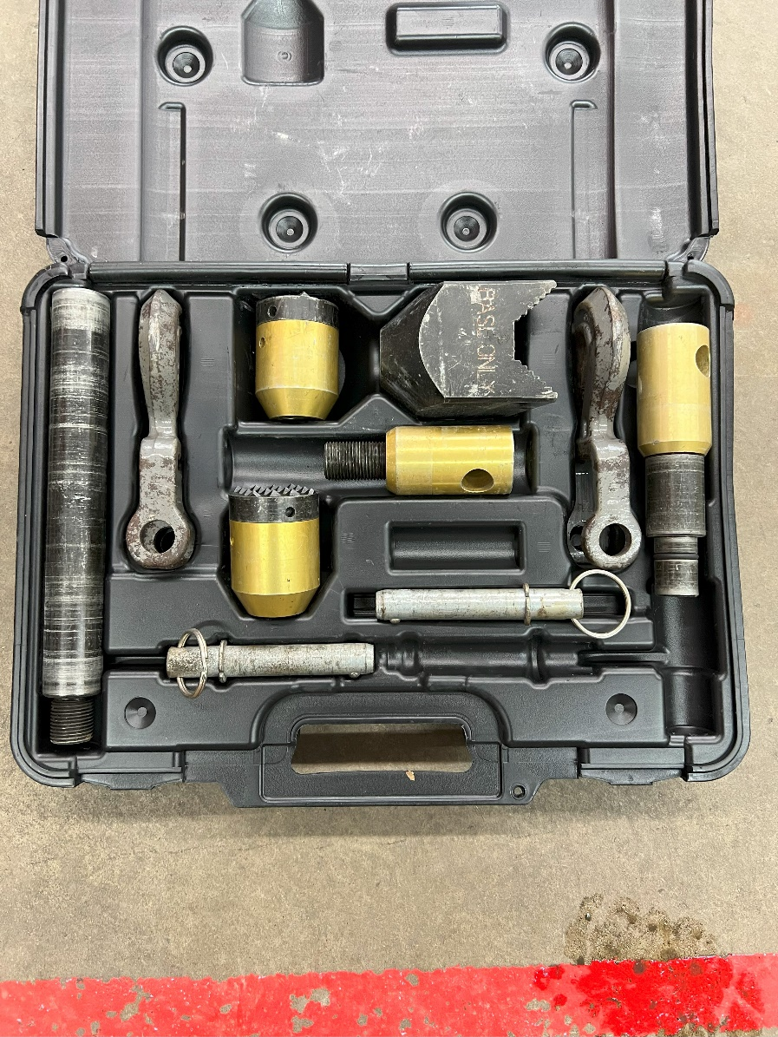
Begin by opening the compartment door and removing the powerplant, hoses, and appropriate tool.
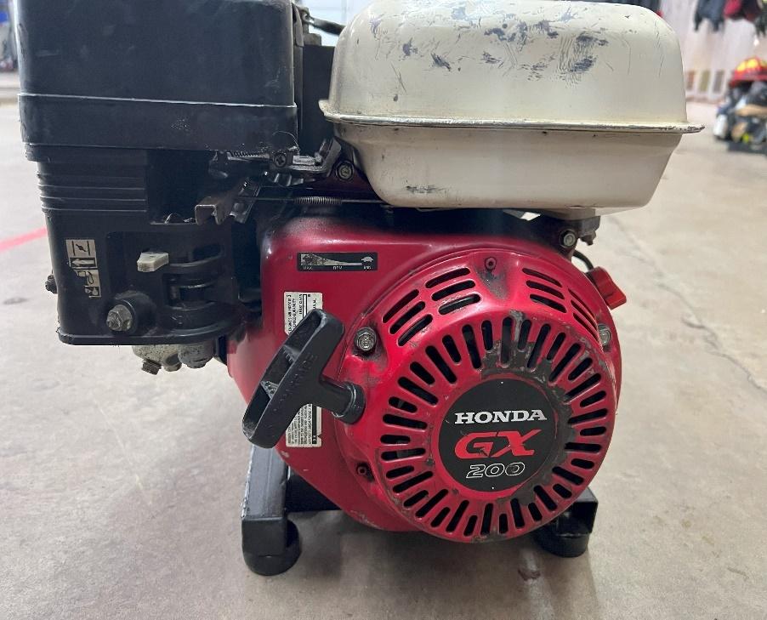
- Place the powerplant fuel switch to the on position as well as the choke.
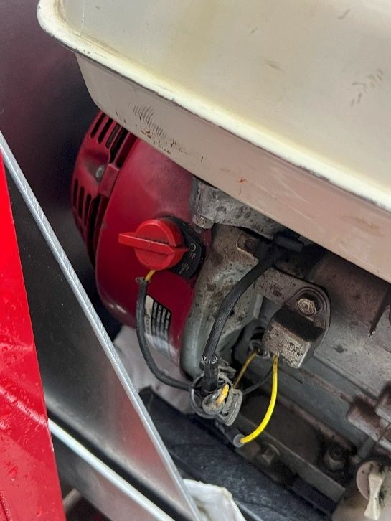
Pull Chord
Choke and Fuel Switch
On/Off Switch

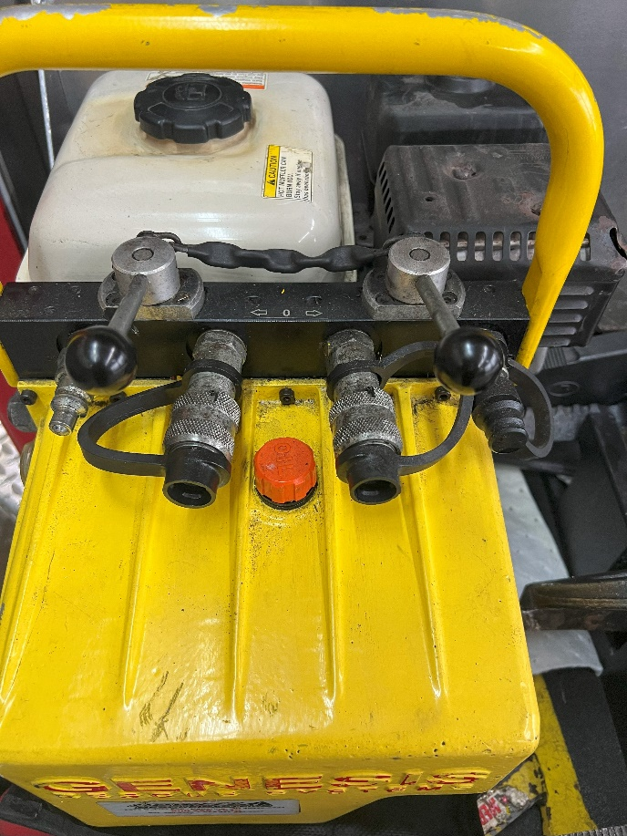
- Use the pull start chord to fire the engine.
- Once the engine is running adequately, shut the choke off and increase the throttle on the motor.
- Connect the colored hose (red or blue) via twist lock fittings to the powerplant and the tool being used.
- Next, use the operating valve to charge the hydraulic line with fluid.
- Currently all Gensis power tools are operated by using the push button.

Hydraulic On/Off

Cutting
Listed below are all options for cutting tools that are on Rescue 23.
- Milwaukee Battery Powered Chain Saw
- Milwaukee Battery Powered Chop Saw
- Milwaukee Battery Band Saw
- Milwaukee Battery Sawzall
- Milwaukee Battery Grinder
- Sthil Gas Powered Chain Saw
- Bolt cutters.
- Windshield cutter
- Air Chisel
- Oxygen Acetylene Torch Kit
- Demo Hammer

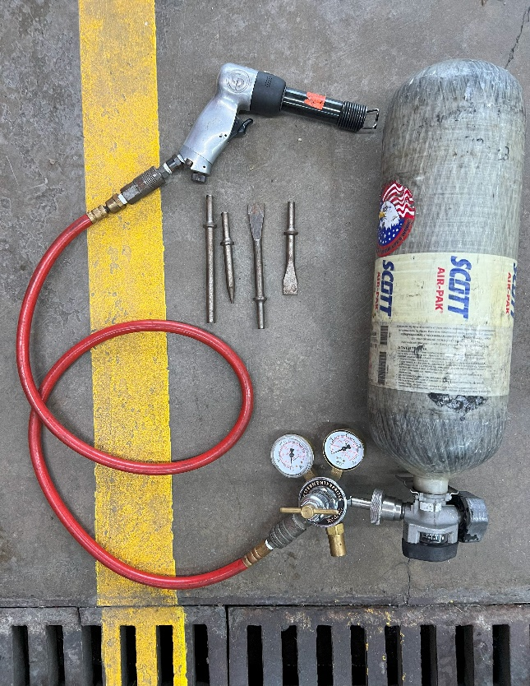
Chisel
Regulator
Air Hose
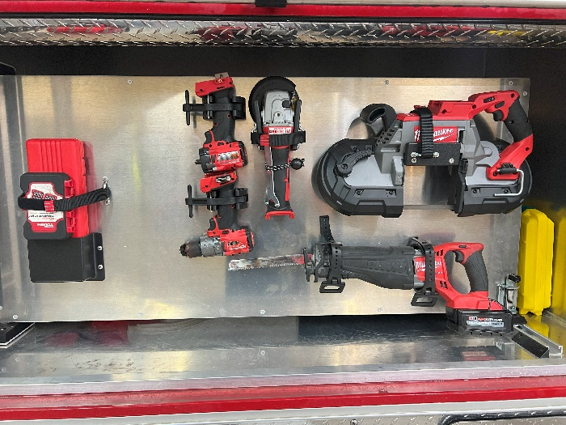
Bits

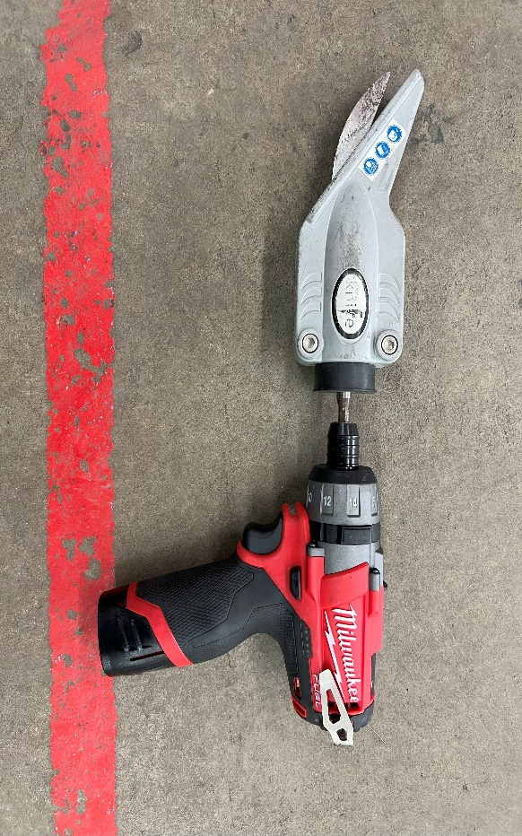

Glass Cutter

Milwaukee Driver

Rescue 23 Special Ops Equipment
This section will cover special operations and equipment that Rescue 23 may encounter and utilize. These calls include Hazardous materials, Lithium Battery Emergencies, Ice and water Rescue, Collapse rescue, Rope rescue and Man in machine. These calls are high risk and low frequency. Regular training is required on these operations to increase success and safety when operating on real scenarios. Specialized calls should only be handled by those who have proper training in that field. At times, manpower may need to be rearranged to handle a run requiring a firefighter that is specially trained. Outside resources such as the county rope trailer, hazmat unit, UTV’s and manpower also should be kept in mind when receiving these runs.

Electric Vehicle Incidents
The presence of electric vehicles and lithium batteries is rapidly increasing in our coverage area. Due to this increase, CTFD is currently acquiring the proper equipment to handle these types of incidents. These incidents involving thermal runaway cause extended on scene time and a variety of resources. Our current specialized equipment for EV and Lithium incidents are listed below.
Emergency Plug

This tool is kept on R23 with the lighting and battery powered tools. When connected to a EV charging port, it sends a signal to the vehicles computer to make it believe it is charging. By doing this, the vehicle in theory should not be able to move while firefighters are operating in or near it.
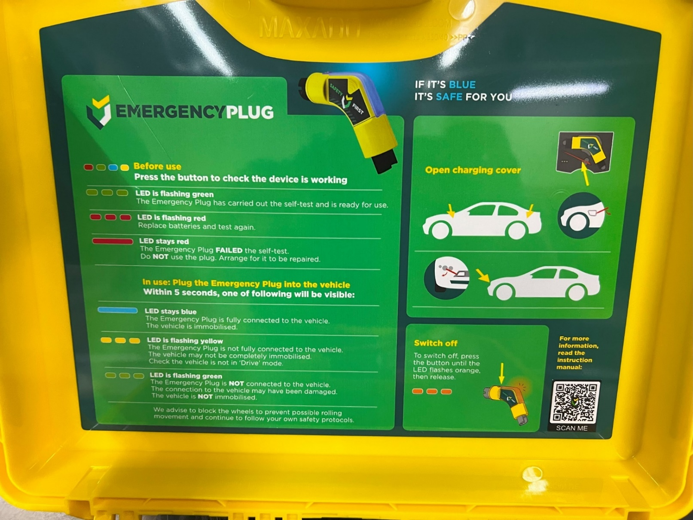

Lithium Battery Overpack-
The lithium battery overpack is kept in the coffin compartments on top of R23. This overpack is a black bucket filled with compacted glass beads. For smaller batteries, secure them in this bucket and seal with attached lid. The overpack must sit for 72 hours and then be sent to proper location listed on the shipping label for disposal.

Man In Machine
Man in Machine calls are complex incidents that require fire departments to have a variety of tools to successfully extricate a patient that is entangled, crushed or entrapped. These tools can simply be workshop tools to disassemble machinery or complex specialized tools. Key steps in any MIM call include finding a subject matter expert- Shutting down power to the machine- Stabilizing the machine- Forming an incident action plan- executing the plan- and treating the patient appropriately.
Man in Machine Box
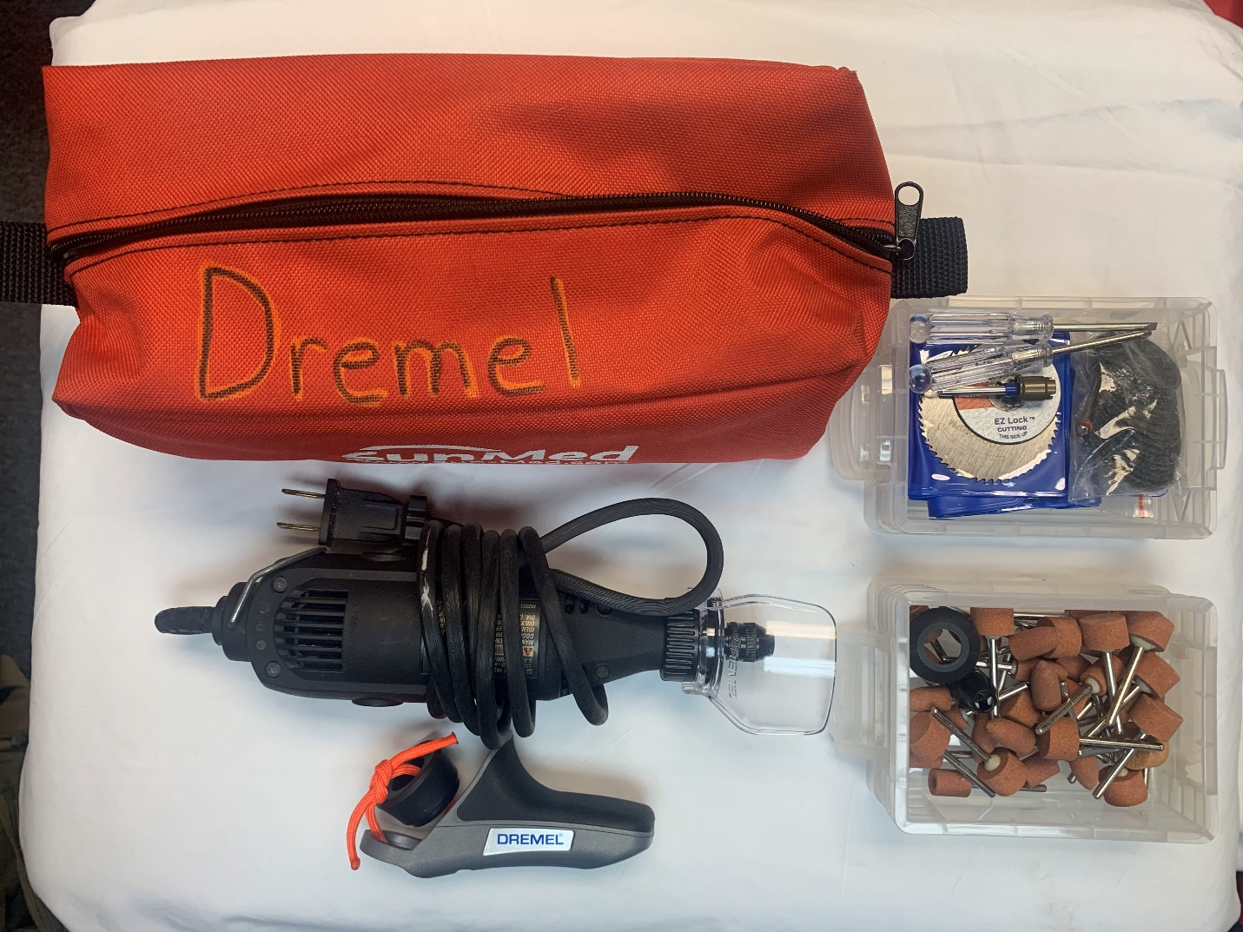
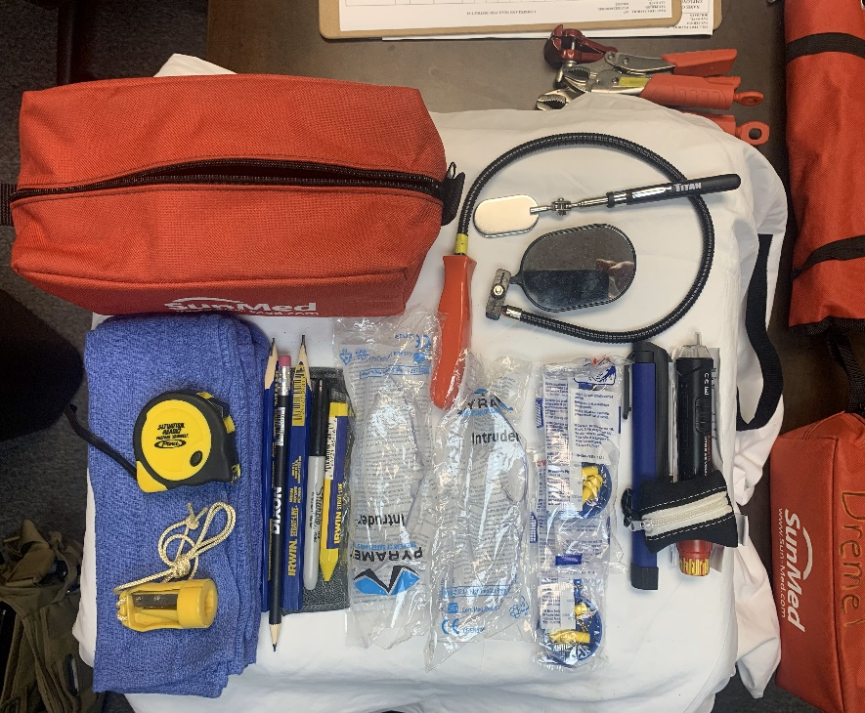
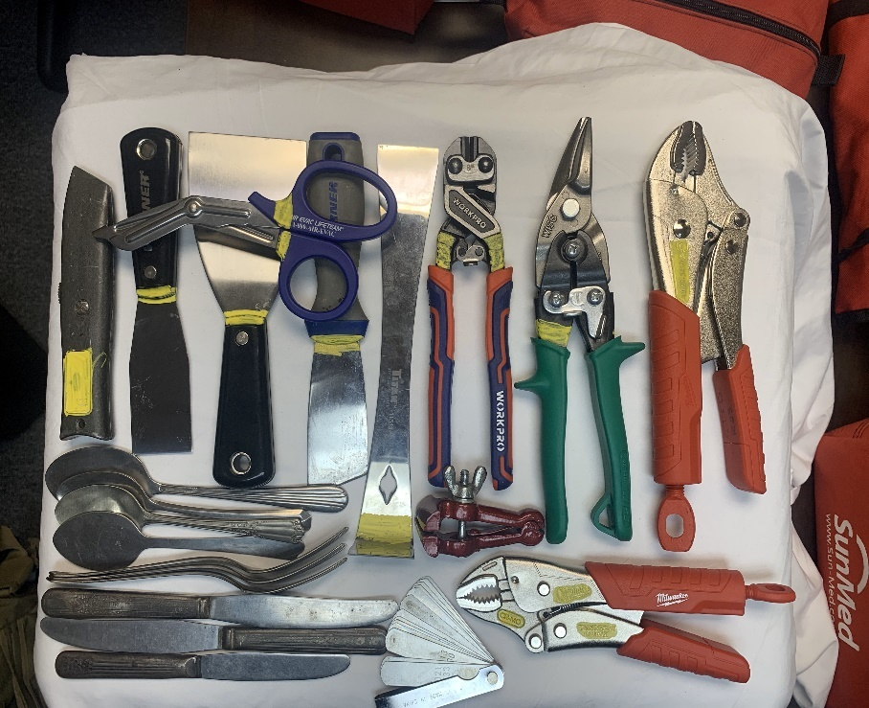

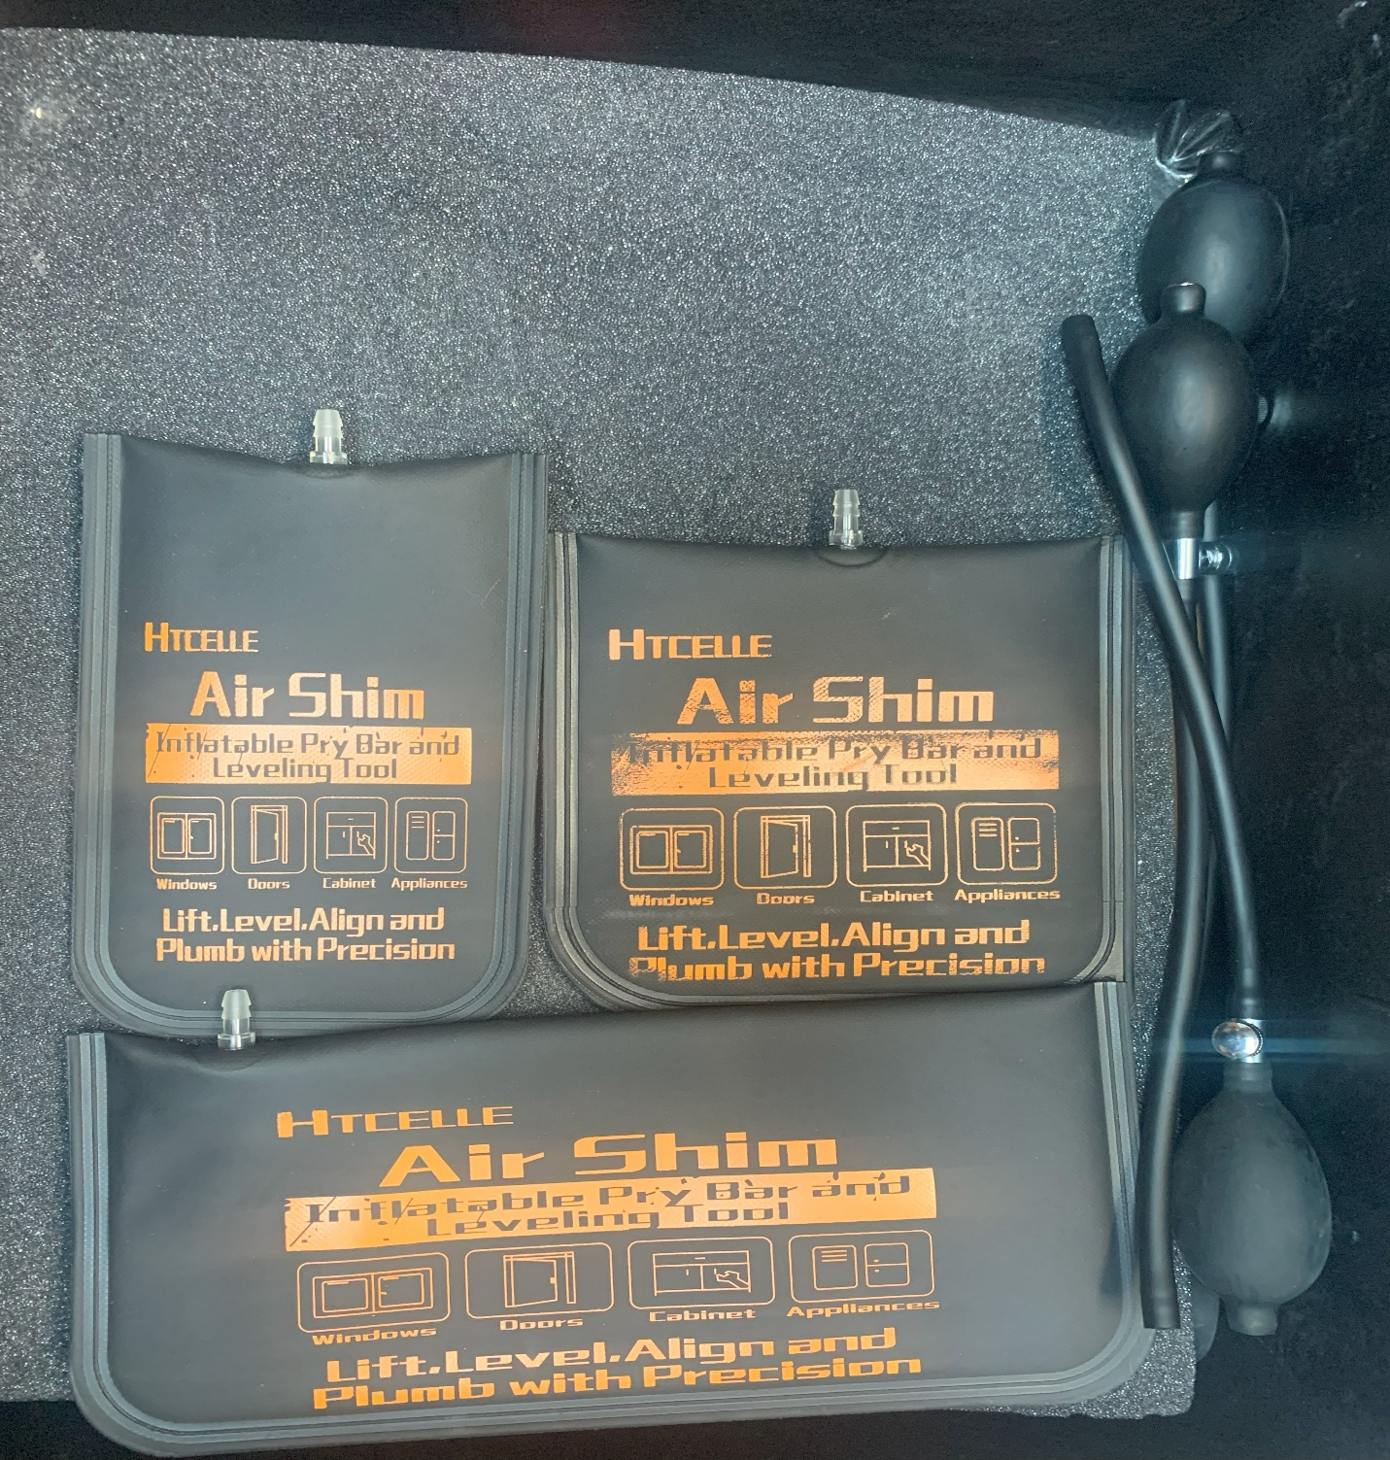

Hazardous Material
Cumberland Trail Fire District covers multiple high traffic roadways as well as businesses that utilize hazardous materials. Numerous households and businesses also use natural gas, and propane for utility purposes. This increases the department’s chances of responding to gas leaks, MVAs with fuel spills and other hazmat calls. R23 has the following basic hazardous material mitigation equipment. Review the following department policies: 11.11, 11.12, 10.06
Floor Dry
On the operator rear compartment, there is a handle above the slide out tray that will open the floor dry hopper below the compartment. R23 rear compartment has buckets to catch and spread this floor dry. To fill the hopper, simply open the floor dry hopper latch on the topside of R23 and fill with floor dry that is stocked in the tool room.

Pads and Pigs
Both absorbent pads and pigs are used to soak up leaking fluid and prevent it from spreading. Both are found in the topside coffin compartment and the officers side compartment behind the Milwaukee hand tools. Plug n dike Pads are also equipped. These pads are moldable to leaking containers and are the following sizes, 24in, 16in, 8in.

Sensit 4 gas monitor
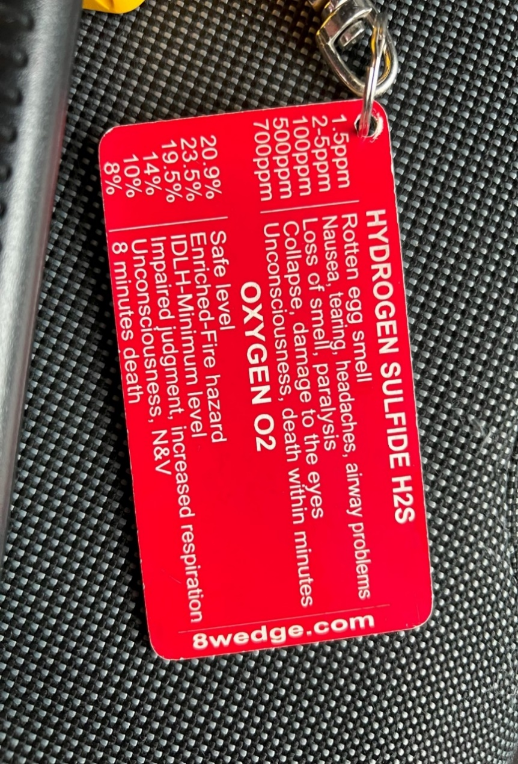
R23 is also equipped with a Sensit Gold 4 Gas monitor. This monitor is located on the officer’s side dashboard. A manual, and spare batteries are in the divider inside a glucometer bag. This monitor shall be turned on and checked daily. Calibration will be completed as necessary when device indicates. Follow manufacture guidelines in monitor manual to calibrate. This monitor evaluates LEL, Leak detection, Carbon Monoxide, Oxygen, and Hydrogen Sulfide. Each 4-gas monitor will have an attached tag that displays our guidelines and procedures for leak detection.

Review SOPs:
11.11
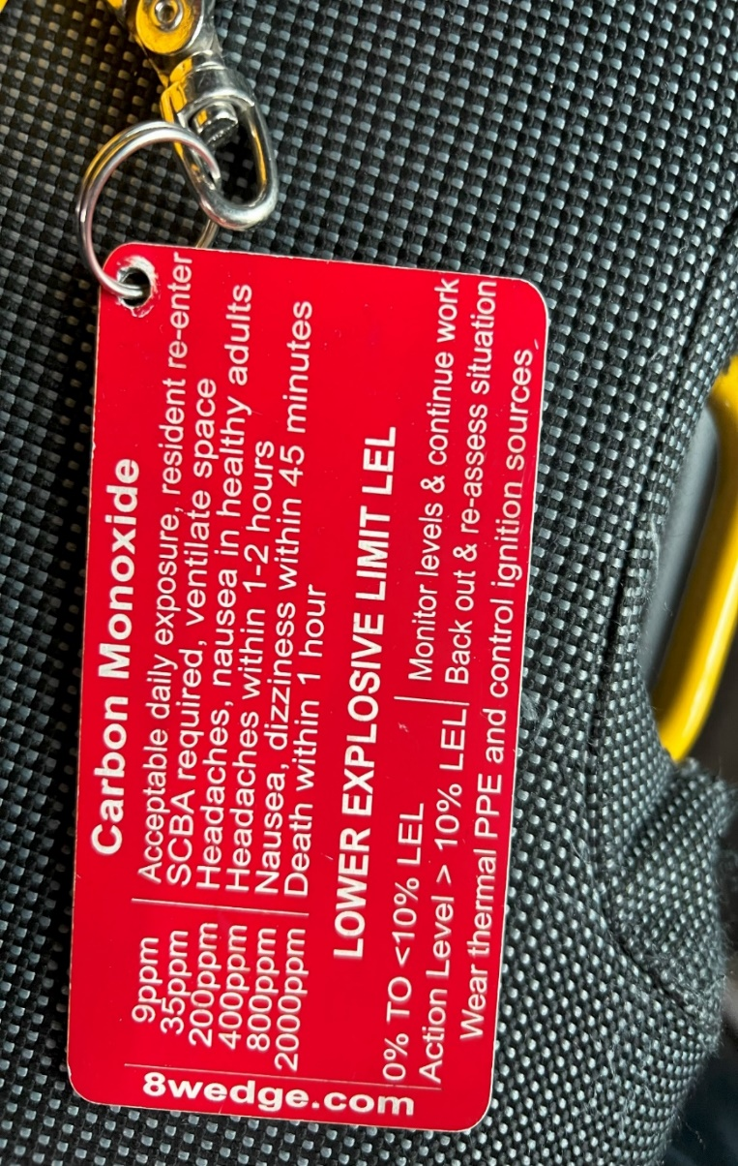

Rope Rescue
Rescue 23 holds a variety of rope rescue equipment in its topside coffin compartments. This equipment can be used for low angle and high angle rescue. All policies for rope rescue can be found in C.T.F.D SOP manual 13.01.

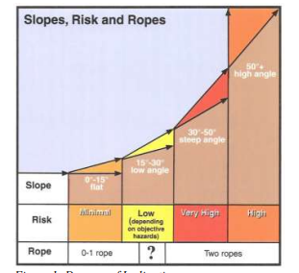

Ice Rescue
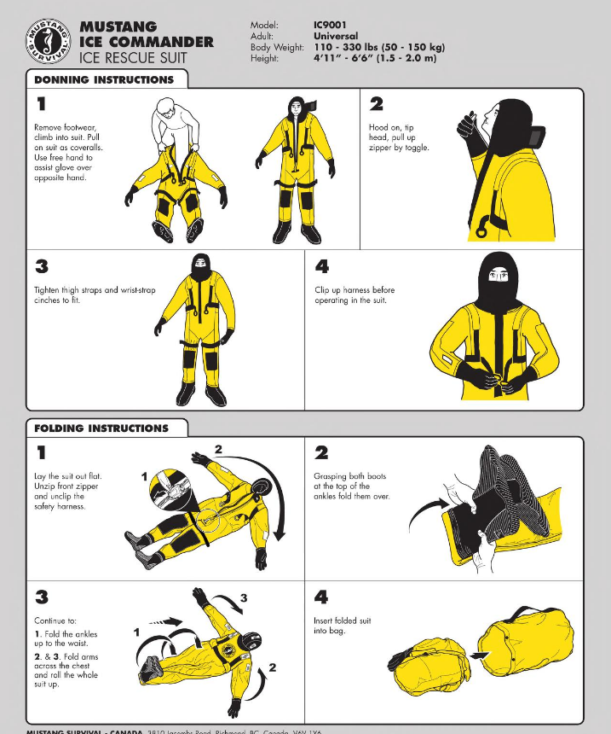
Rescue 23 is equipped with ice rescue equipment located in both the cab and the coffin boxes. This equipment includes our R.I.T craft, PFDs, Throw bags, and Mustang suits. All equipment should be thoroughly reviewed and trained with before use in the field. Review Ice rescue policies as well prior to operation. Water/Ice Rescue Operations 13.03

R.I.T. Craft
Another item included in R23’s ice rescue complement is an inflatable CMC RIT boat. This is in the operator side coffin compartment. To retrieve this equipment, multiple personnel will be needed to lower the craft to the ground. Utilize the appropriate SCBA fill system to inflate. This craft is not to be used for swift water rescue. Follow all manufacturers’ safety and usage guidelines when operating.
https://youtu.be/pQSLLpRkP8o?si=YpLc0t1dmo81pN6q
SOP 13.03

Olsen Portable Torch Kit
Rescue 23 is equipped with a portable torch kit for unique rescue incidents. These torches require thorough training before use, therefore any employee using the torches must be trained and approved by a company officer. Torches can be used for cutting metal in various thicknesses. The torches are secured in the extrication compartment on the officer’s side rear. Refer to manufactures manual for usage instructions.
Safety
- Flame resistant PPE.
- Eye protection
- Gloves
- Ensure all valves and fittings are secured tightly.
- Purge line after using.
- Keep a clean, nonflammable work area.
- Utilize reverse flow valves.
- OXYGEN AND ACETYLENE ONLY
- Use with proper ventilation.
- Keep hoses clear of slag.
- Allow the torch and material to cool before touching.

