Organizational Make Up

CTFD Board of Trustees

Private Citizen- John Slavik

Richland Township Trustee- Greg Clark

St. Clairsville Councilman- Mike Smith

CTFD Administration

Tim Hall- Fire Chief

Daniel Grady- Assistant Fire Chief

Matthew King – Clerk and Fiscal Officer

CTFD Operational Staffing

Two Stations/ Three platoon system: Blue, Red, Green

Unit 1 Blue Platoon

Captain Jeremy Rife

Lieutenant Cody Goff

Firefighter Bryan Hull

Firefighter Mike Lenz

Firefighter Mike Lollini

Firefighter Clay Gilliam

Firefighter Dustin Roe

Unit 2 Red Platoon

Captain Perkins

Lieutenant Aaron Petersen

Firefighter William Morgan

Firefighter Chris Cocca

Firefighter Shane Smolenak

Firefighter Zedd Redd

Firefighter Andrew Riddle

Unit 3 Green Platoon

Captain Curtis Kyer

Lieutenant Alex Gazdik

Firefighter Robert Slevin

Firefighter Nick Jessee

Firefighter Kyle Fogle

Firefighter Paige Everly

Firefighter Ian Bissonnette

Part-Time Staff

Two 48-hour shifts are filled by part-time staff. These shifts can be split into 3 (8) hour shifts or 2 (12) hour shifts.

Pay Periods and Paystubs

C.T.F.D. payday is always on every other Tuesday. The pay period is two weeks from Wednesday to Tuesday. Employees can receive their paystubs via department email or paper copy in their department mailbox.

Station Locations and Mailing Adress

Station 23: 142 South Marietta St.

(740) 695-5147 Fax: (740) 695-6630

Station 23-2 66389 Stewart Dr

(740) 695- 8170 Fax: (740) 695-6260

Mailing Address P.O. Box 505 St. Clairsville, OH 43950

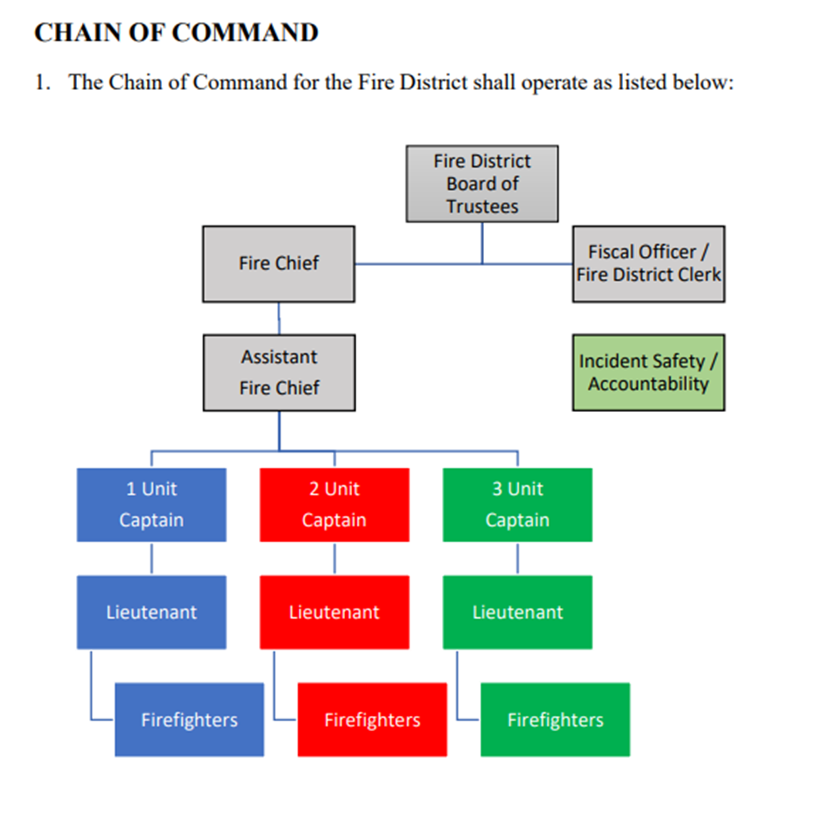

Firefighter Job Description

The Full-time Firefighter Paramedic are hourly employees who shall be scheduled a twenty-four hour tour every third day (56 hours per week) and in accordance to the Collective Bargaining Agreement or the Part-Time Firefighter Paramedic - Basic EMT. Full-time Firefighter Paramedic and the Part-Time Firefighter Paramedic - Basic EMT is appointed by the Cumberland Trail Fire District Board of Trustees and will report and operate under the general direction of the Lieutenant, Captain, Assistant Fire Chief, and Fire Chief

Responsibilities and duties

Responsible for carrying out duties in conformance with Federal and Ohio Revised Code and Local laws as it relates to the services provided by the Cumberland Trail Fire District. Participates and responds to Fire District emergencies which includes firefighting activities, fire suppression, responding to alarms, emergency medical calls, rescue operations, public service, and assistance calls. Participates in public education programs, Fire District training, fire prevention, company fire inspections, and Fire District pre-planning. Must know and maintain knowledge of streets, hydrant locations, major buildings and their pre-plans, routes to alarms, and any conditions which may affect the performance of their duties. Must clean, check, perform routine service work and operational testing of Fire District vehicles and equipment. Shall perform minor repairs to Fire District vehicles, equipment, and property. Shall perform general housekeeping duties and maintenance that is assigned by the Company Officer. Shall be capable of driving and operating all Fire District vehicles. Shall have a thorough knowledge of the location and operation of all Fire District equipment.

Belmont County Cares Program

General Information:

* Belmont County CARES (Community Access Resources Education & Solutions) Program is a county wide service operated by Cumberland Trail Fire District. It is funded by the Belmont County Commissioners, Mental Health Recovery Board and Cumberland Trail Fire District.
* The CARES Program currently has 2 employees:
  + Coordinator, Chad Zambori
* The CARES Program is a Community Paramedicine based initiative that focuses on reducing 911 calls, Emergency Room visits and hospital admissions and readmissions.
* The CARES Program works closely with Fire and EMS Agencies, Child Protective Services, Adult Protective Services, Mental Health Agencies, Law Enforcement, Senior Services and many other agencies to ensure the health and safety of county residents.
* Some of the services provided by the CARES Program include:
  + Home health assistance
  + Education
  + Health Insurance
  + Housing
  + Access to Medication
  + Utilities
  + Transportation
  + Specialty Care
  + Pregnancy Assistance
  + Medical and Dental Care
  + Fall Assessment
  + Smoke Detector Instillation
* Other goals of the program are to ensure that the patient has any needs fulfilled that they may need and place them in contact with the correct agencies that can provide the service. Many patients can easily “slip through the cracks” of the health care system and the CARES Program attempts to coordinate care if needed.
* The director also serves as Health and Safety officer, Coordinator Zambori serves as Training officer. Radio call signs are as noted:
  + Zambori – Safety 23

Making Referrals:

* There are forms that can be found at each firehouse or on the server. The officer in charge will be able to get the form to you if needed. Once the form is filled out, it can be emailed to [cares@cumberlandtrailfire.com](mailto:cares@cumberlandtrailfire.com)
* To get in contact with the CARES Program there are 3 options:
  + 740-827-0004 is the Virtual Attendant. Option 1 goes to Director and Option 2 goes to Coordinator Zambori
  + Director phone number is 740-526-1721
  + Coordinator Zambori phone number is 740-484-9424
* The above numbers are work numbers and may be given to the public if needed. If anyone asks for personal numbers, please follow department policy.

Employee Assistance Program

General Information:

* Cumberland Trail Fire District provides an EAP to all Fire District Employees.
* The EAP is managed by Public Safety EAP
* The EAP can be used at any time and covers multiple areas of concern.
* The EAP can be used 24/7
* The EAP can be reached by calling 888-327-1060 or online at [www.publicsafetyeap.com](http://www.publicsafetyeap.com)
* The EAP is confidential and the only report that the Fire District gets is if it is utilized. There are no names or reason for a call attached to these reports.
* If you have any questions regarding this benefit, please see any of the following:
  + Chief Hall
  + Assistant Chief Grady
  + Health and Safety Officer
  + Training Officer Zambori
  + Shift Captain or Lieutenant
* There is a flier attached with further information regarding the EAP

