**Ladder 23**

First Due to all Commercial Fires/Alarms

First Due to Fires/Alarms in City Limits

Ladder 23 is stationed at Station 23 and is the only Ladder Truck in the District. Ladder 23 responds to all fire related incidents at commercial structures within the district. Ladder 23 also responds to all fire calls within the city limits of St Clairsville. Ladder 23 will also respond to mutual aid departments as requested and/or if specially dispatched.

Special Considerations:

Ladder 23 is the longest apparatus in Station 23’s fleet. Which makes it more difficult to maneuver turns and narrow roadways. Ladder 23 also requires the outriggers to be deployed to safely operate the tower. Each outrigger requires 3 feet of clearance to properly deploy. Ensure the apparatus is in high idle when lowering the outriggers. This must be done in order for the outriggers to lock in place. When placing Ladder 23, you must also avoid power/cable lines, trees, and any other obstruction that may interfere with the operations of the tower. After the incident, it is imperative that you disengage the PTO before attempting to drive the apparatus.

Specs:

* 2009 Sutphen Mini Tower 70’
* Engine: Cummins ISM
* 1750 GPM Hale Pump
* 500 Gallon Water Tank
* On Board Generator
* 70 Foot Mid Mount Tower

Hoseline Compliments:

* Crosslays:
  + **Front Crosslay**: 150ft 1-3/4” handline with removable fog tip
  + **Middle Crosslay**: 150ft 1-3/4” handline with 7/8 smoothbore tip
  + **Rear Crosslay**: 150ft 2-1/2” handline with 1-1/4 smoothbore tip
* Tailboard:
  + **Blitzfire/Supply**: 300ft of 2-1/2” deadman for multi-use
  + **5” Supply Line**: 800ft of 5” Supply line
  + **The 400’**: 400ft 1-3/4 handline with 7/8 smoothbore tip
* Driver Side Compartments:
  + Pump Compartment has 50’ 2-1/2 and (2) 25’ of LDH
  + High Side Compartment: (2) **Mall Packs** 200’ 2” line with 1-1/16” smoothbore tip
* See step-by-step pulling and repacking instructions (attached).

Pumping L23:

1. Place engine transmission in ‘Neutral’, set the parking brake, and allow the engine RPM to reach idle speed.
2. Move Pump Shift Assembly control into ‘Neutral’ position and pause.
   * Lift Yellow Collar on actuator to move knob
3. Move Pump Shift Assembly control into ‘Pump’ position.
   * Lift Yellow Collar on actuator to move knob
4. Place engine transmission into designated pumping gear. Press D for Drive.
5. Look and listen for indications that the pump is in gear.
6. Dismount the apparatus and proceed with pumping operations.

Indications that L23 is in Gear

1. OK to Pump Engage Light is lit on pump shift module
2. Speedometer may change from 0 mph to 10-15 mph
3. Depressing the accelerator slightly results in no RPM change or lurching of the apparatus
4. Motor changes sound
5. Drive shaft is rotating between the transmission and pump gear box
6. Positive pressure indication on discharge gauge

**“Operators need to become familiar with how their apparatus reacts when successfully placed into pump mode. The operator must know the sights and sounds for those times when light bulbs burn out or don’t work”**

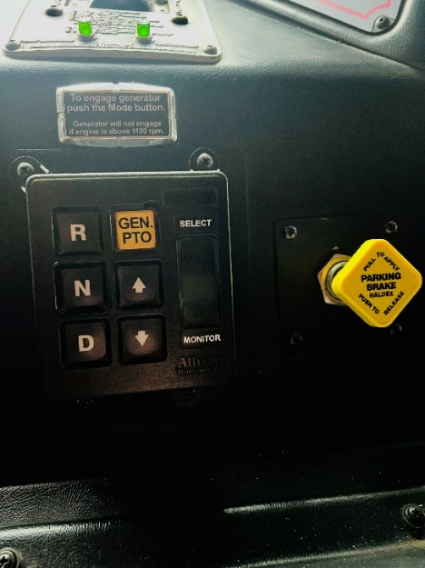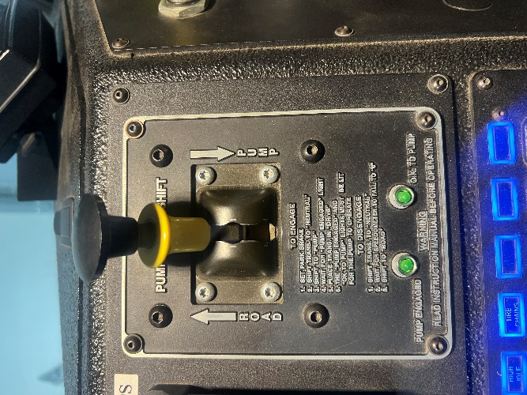

In the cab:

* Back wall
  + Wedges (door chocks)
  + Water can – officer side
  + Box light – one each side
  + Safety vest – one each side
  + 50’ bailout bag – one each side
  + Married irons – operator side
  + Driver SCBA pack – operator side
* Back wall compartment
  + Towels and wipes for decon
  + Bottled water
* Under back wall compartment
  + Extinguishers (1) ABC dry chemical and (1) CO extinguisher
* Rear facing seats
  + (2) pack seats
  + 6 ft New York hook mounted at your feet
* On the dog box
  + Milwaukee battery charger (with spare battery)
  + (2) Portable radio battery chargers (with 2 spare batteries)
  + Scott Pak Tracker
* Driver’s Seat (Operator)
  + Tire chains switch, PTO, Jake brake on/off and low/high
  + Engage switch for pump
  + Transmission/generator pto panel
  + Parking brake

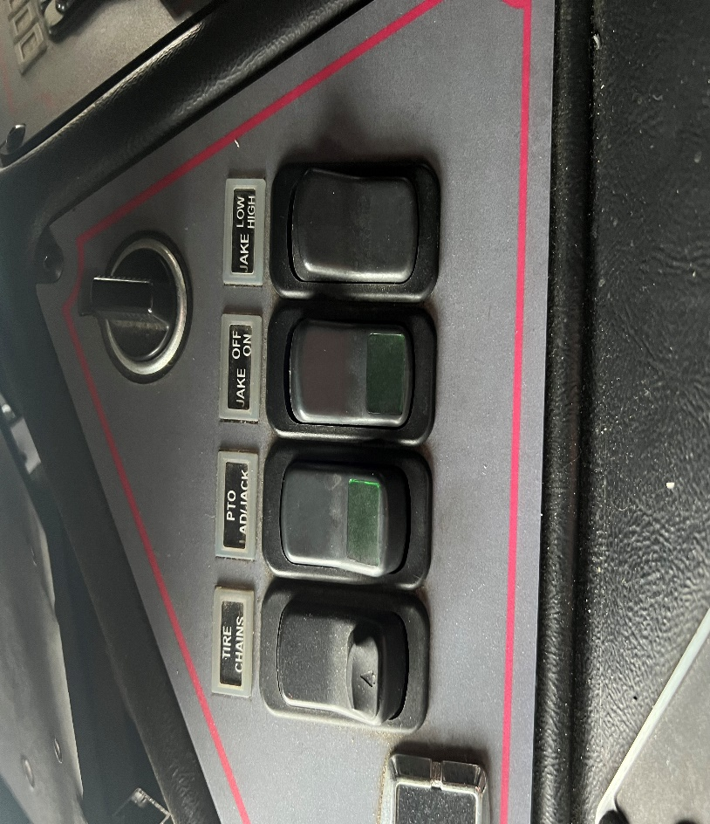

* Officer Seat
  + Mini halligan bar in stair well
  + Windshield wiper fluid reservoir in stair well
  + Spotlight, wedges, and forcible entry tools at your feet
  + Clipboard, caution tape, and flares located under the seat
  + Thermal imaging camera on charger with spare battery
  + Ipad mounted with charger
* Middle Console
  + Safety vests (2)
  + Disinfectant wipes
  + Facial masks
  + 50 ft bailout bag
  + Base radio
  + Master switches for lights and siren brake

Operating L23 Tower (From the ground):

1. Ensure that L23 is properly placed and that there is enough room for the out-riggers.
2. Ensure there are no immediate over-head obstructions or power/utility lines.
3. Place L23 in “N” neutral and apply the parking brake.
4. Engage the “PTO LAD/Jack” switch, located to the right of Pump Engagement lever
5. Place the jack pads on the ground for the out-riggers (approx. 3ft from truck)
6. Press and hold the “Lower” button on the left side panel of the pump panel.
7. Once the jacks lower completely, allow the yellow safety brackets to fall into place.
8. On the left-upper portion of the pump panel, turn all power switches on
9. Utilize the pull-out step located at the pump panel.
10. The controls used to move the tower are under the aluminum box to the left of the pump panel. Lift the lid to expose the controls.
11. Controls are labeled just above each lever. “Feather” the levers for a more controlled motion.
12. Utilize the speaker to communicate with the bucket crew at all times. Use radios if needed or for emergency traffic.
13. Any time that you are descending the tower while not flowing water, ensure that the waterway valve is open. (Located bottom left corner of pump panel)

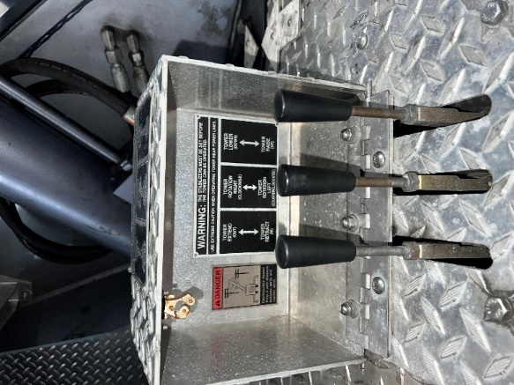 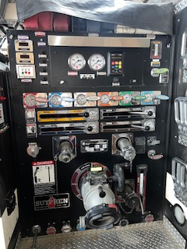 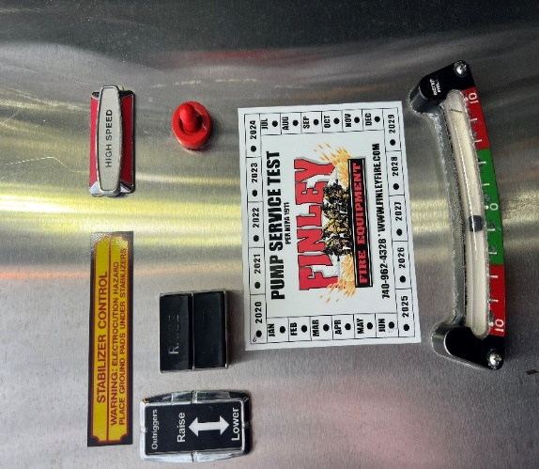

Operating L23 Tower (From the bucket):

1. Before operating from the bucket, ensure the upper power switch is engaged on the pump panel.
2. Personnel operating in the bucket must wear a helmet and ladder belt at all times. When operating in an IDLH environment, full PPE and SCBA must be worn.
3. When the last person enters the bucket, attempt to raise the lower step to avoid damage.
4. Ensure the upper power switch in the bucket is turned on.
5. Make sure that all personnel are secured via ladder belt or safety strap.
6. Utilize the levers on the panel to operate the bucket. Release the safety by lifting the bottom of the knob and then move the lever in the desired direction. “Feather” or slowly move the lever to avoid sudden jerks.
7. High Speed pedal is located on the floor, operator side towards the rear.
8. Microphone is always on, can be heard at the turn table.
9. Black case located in bucket contains 2 SCBA masks and regulators for the on board oxygen supply. (New SCBA masks will not work, currently).
10. Fifty (50) foot section of 1.75in hose with combination nozzle.
11. Fog nozzle for turret use is located on floor, just inside of the bucket door on officer side.
12. Flat-head axe mounted to officer side wall of bucket.
13. Platform Water Curtain valve located on outside of bucket on driver side, purple valve. This is used to protect the platform from heat and fire in the case that conditions worsen rapidly and you are unable to remove yourself from the fire prior to the change in conditions.

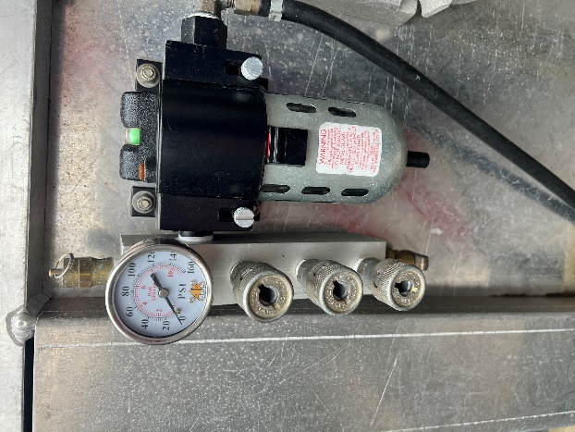 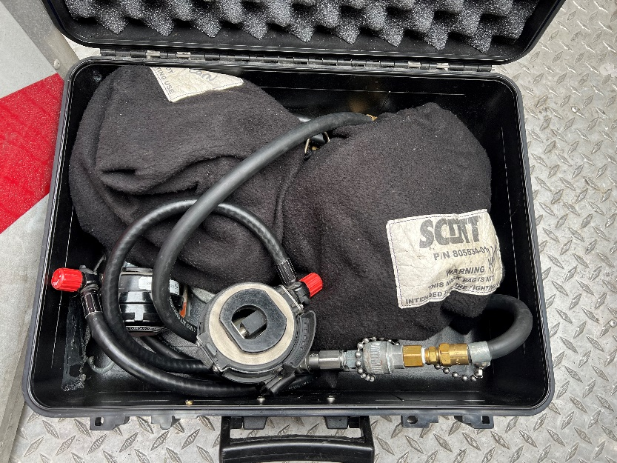

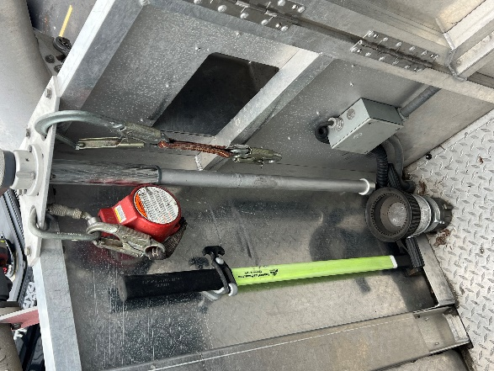 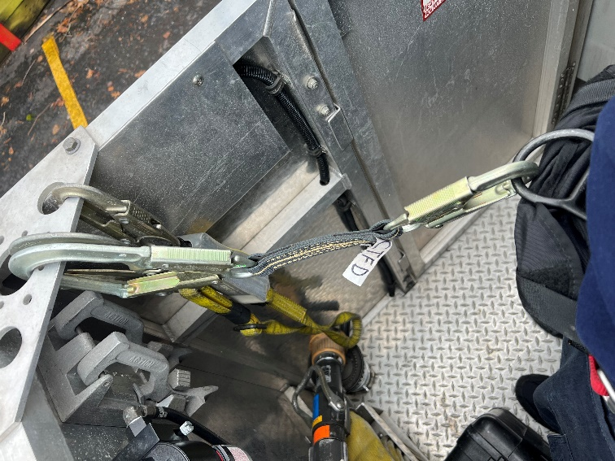

Water flow from bucket:

* Waterway valve located on rear of each side.
* 2.5 and 1.75 inch connection located just after waterway valve.
* The smaller lever at the base of the turret and waterway allows you to control the angle of the turret itself.
* Two turrets mounted, one on each side. Each operates individually by turning the valve on the top side of turret to move the nozzle.
* The turret has three (3) stacked tips: 2 inch, 1.75 inch, and 1.5 inch smooth bore.

Compartment Layouts:

1. L1 Compartment (Pump Compartment)
   1. Breaker box for generator
   2. Miscellaneous fittings of various sizes and threads.
   3. Spare nozzles
   4. Mallets
   5. Flares
   6. Spanner wrenches
   7. Short supply line sections
   8. Pump pressure guide card
2. L2 Compartment (High-side compartment)
   1. RIT pack
   2. Stand-pipe kit (Elkhart Brass)
   3. (2) Mall packs
3. L3 Compartment
   1. Ladder belts
   2. Smaller manifold with 3 outlets
   3. Open space for driver’s turnout gear
4. L4 Compartment
   1. Pigs / pads for fluid cleanup/containment
   2. A-frame ladder
   3. Short section of 2-1/2” hose
   4. Chimney bucket
   5. Vertical slide outs with various hand tools and piercing nozzle
5. Rear Compartment
   1. Electric box fan
   2. Gas powered positive pressure fan
   3. Igloo cooler
   4. Rehab mist fan
   5. Shop vac
   6. Hydrant bag
6. Right Front Compartment
   1. Manual cab tilt handle
   2. \***This door must be open when operating generator**\*
7. R1 Compartment
   1. Electrical cord reels
   2. House plug and 3 prong twist lock capabilities
8. R2 Compartment
   1. Electrical adapters for the cord reels
   2. AED and medical bag
   3. Box lights (Milwaukee battery and corded)
9. R3 Compartment (High-side compartment)
   1. Rope bag (blue utility) 145’
   2. Rope bag (orange utility) 145’
   3. Rope bag (red life safety) 200’
10. R4 Compartment (High-side compartment)
    1. Rope bag – hardware, anchors, and harnesses (2)
    2. Milwaukee tower light
11. R5 Compartment
    1. 2 spare SCBAs
    2. Wheel chocks
    3. Tarps for overhaul
12. R6 Compartment
    1. Stihl chainsaws (2)
    2. Stihl T5 400 cutoff saw
    3. Stihl arborist chainsaw (smaller saw)
    4. Spare wheels for cutoff saw
    5. Socket set
    6. TruFuel 50:1 mix for saws
    7. 1 gal spare no-mix gasoline
    8. PB Blaster
    9. Spare bar oil
    10. Chainsaw repair kit (with new chains)
    11. (2) Spade shovels and (1) square shovel
    12. Tool bag

Rear of Ladder 23

* Top left corner, attic ladder and 300’ bed of 2 ½” deadman load
* Far left side, Blitzfire (unattached)
* Under 300 bed, (3) Pike poles (12ft, 10ft, 8ft)
* Center, LDH bed
* Under LDH bed, Rear compartment (listed in compartment layouts)
* Right side of LDH, the 400 bed of 1 ¾”.

Ground ladder compliment (Officer side):

* 35 ft extension ladder (bottom)
* 24 ft extension ladder (middle)
* 16 ft roof ladder (top)

Ventilation:

* See “Ventilation” SOP (when completed)

Ladder 23 placement:

* Ensure that you have 3 feet of clearance on each side in the area of the outriggers.
* Check for over-head obstructions such as power/cable lines and trees (cut if needed).
* Put the turntable where you need it. Placement is key on arrival. Don’t just park it.
* If applicable, take a corner. Place the turntable in the position to operate on two side of the structure. Make the most of your first due apparatus.