Purpose

The purpose of this section is to cover all C.T.F.D firefighter survival procedures. Studying and frequent training on this section will help prepare firefighters for sudden life-threatening incidents that may occur on the fireground. These incidents are high stress low frequency and require the firefighter to be mentally and physically prepared. Specifics on fire department rapid intervention packs, mayday procedures, techniques for firefighter rescue, and tools used will be covered throughout this section.

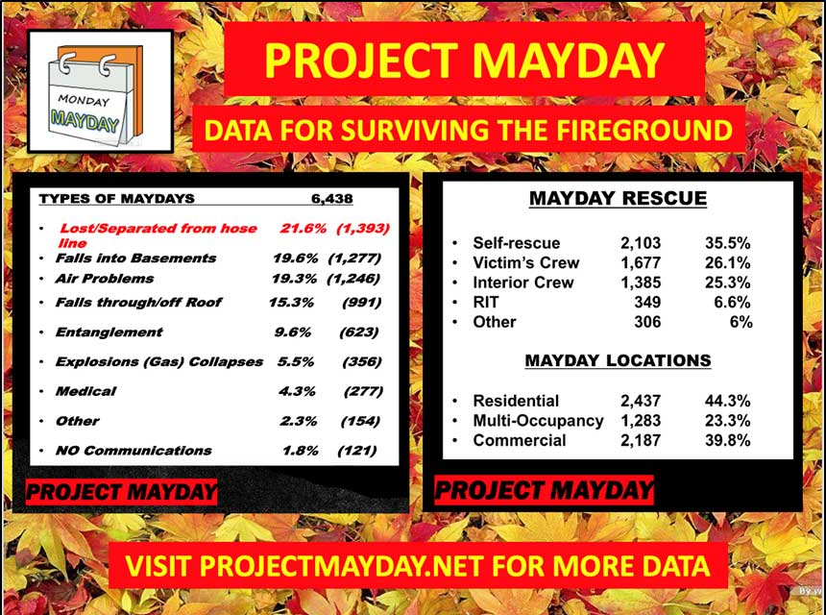

The above picture comes from Projectmayday.net. The statistics range from 2014 to 2020 and include all reported mayday situations nationally.

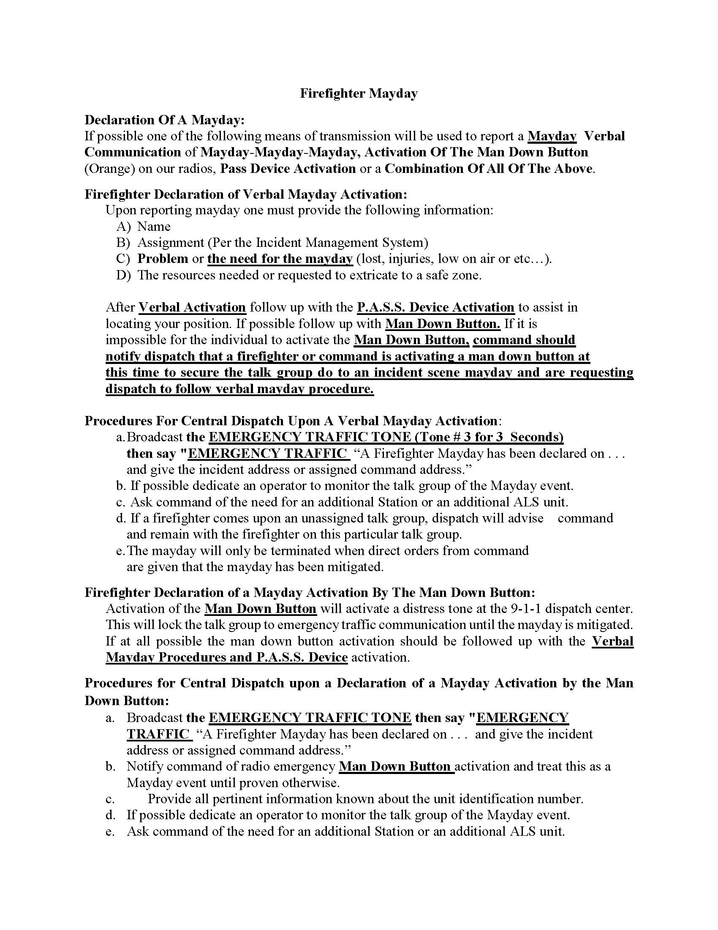

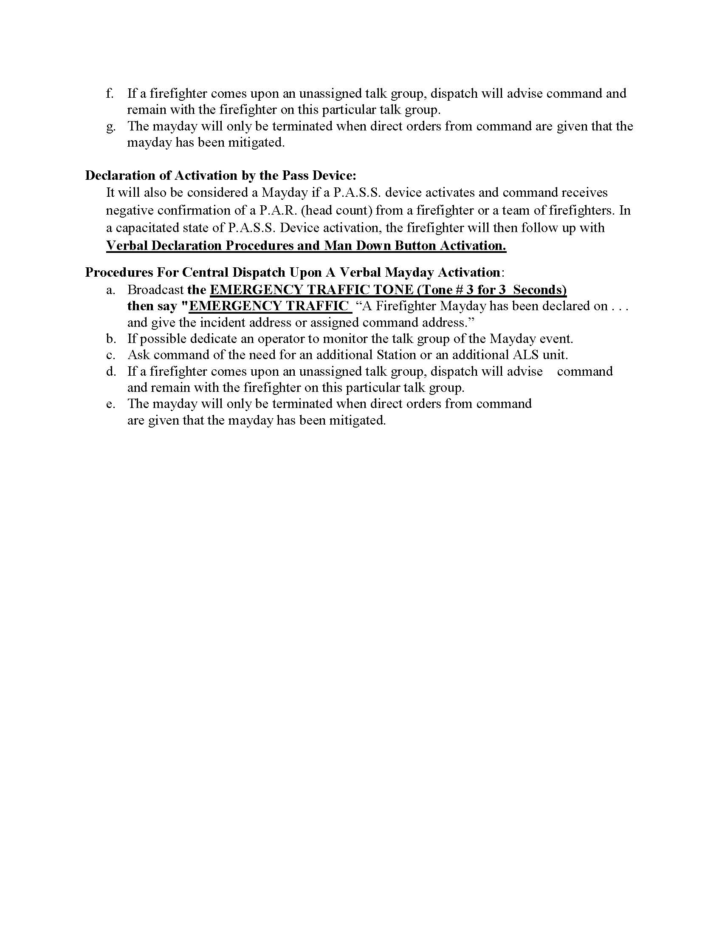

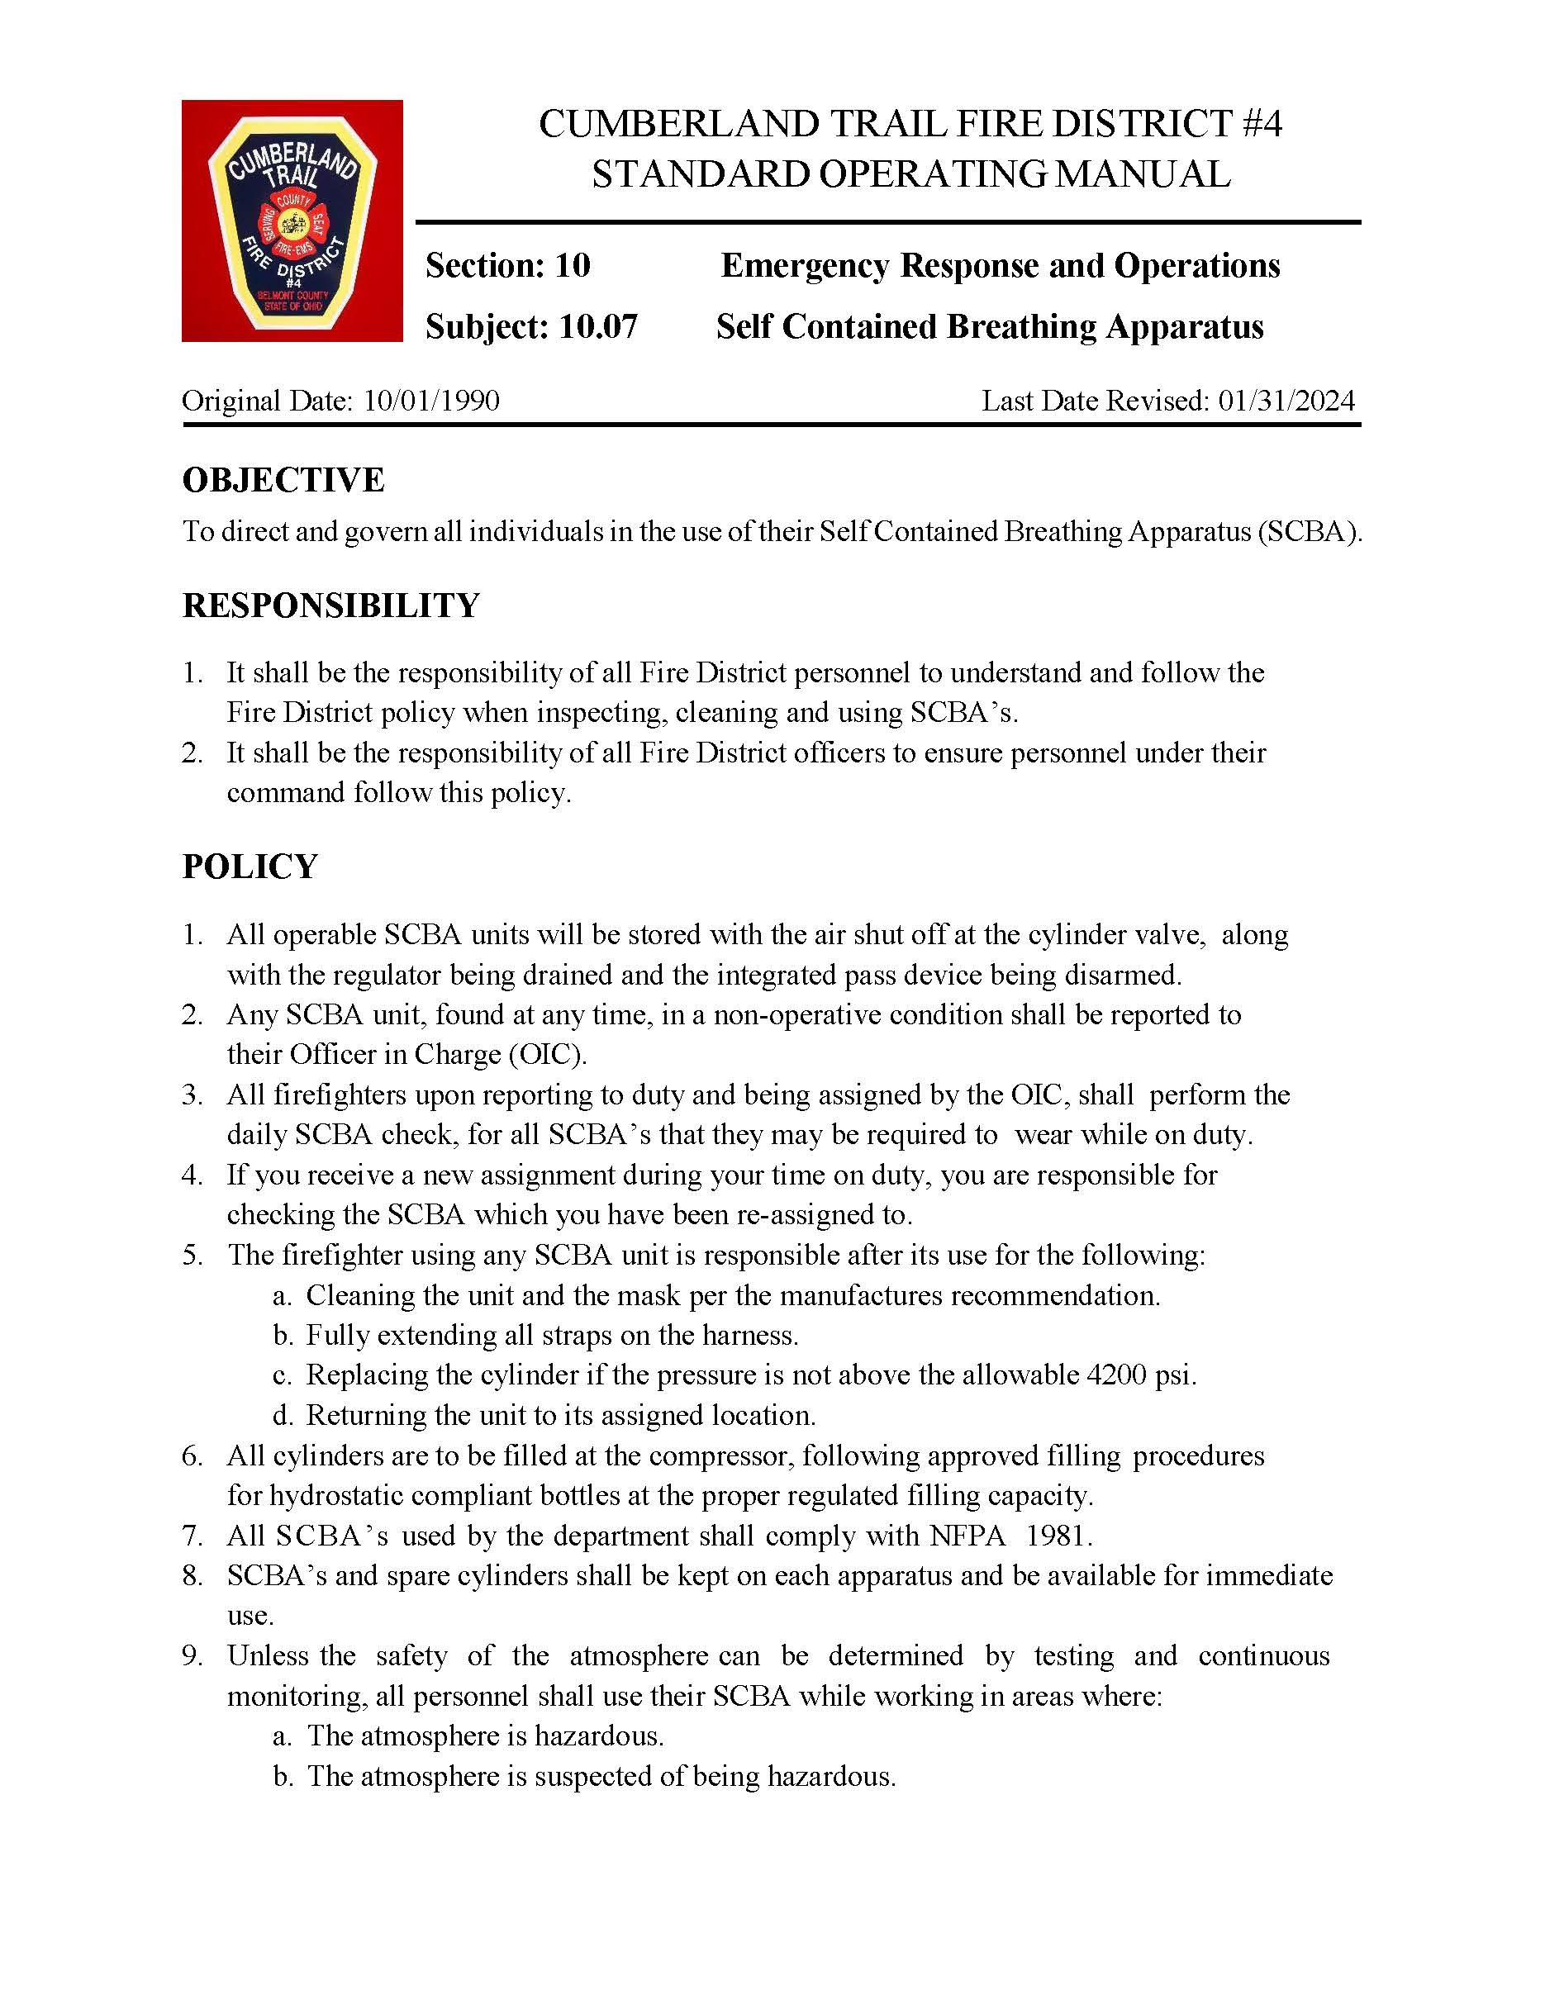

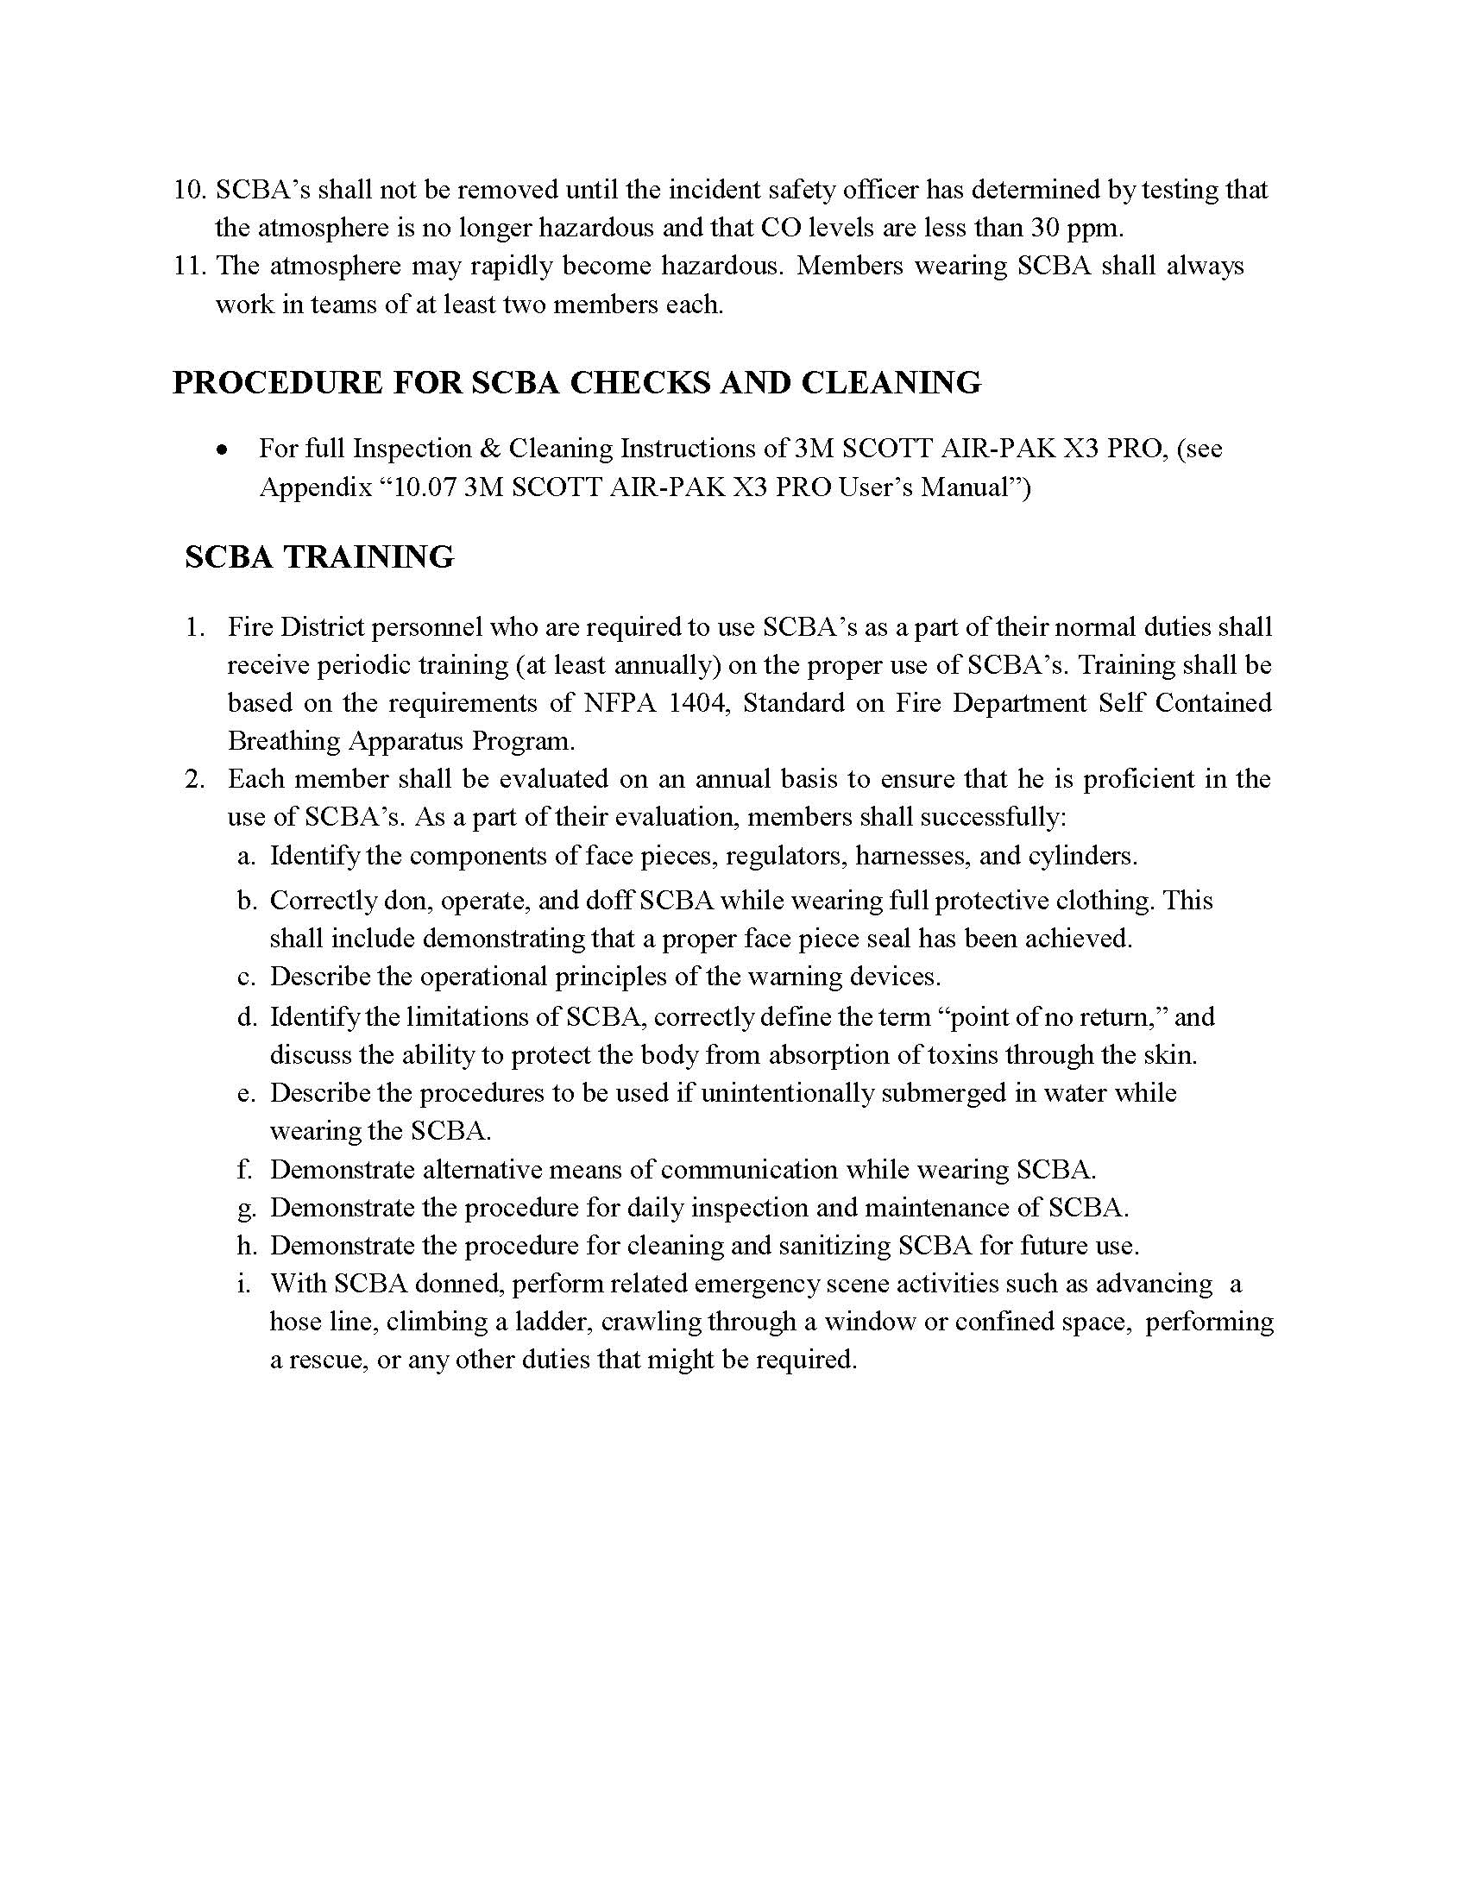

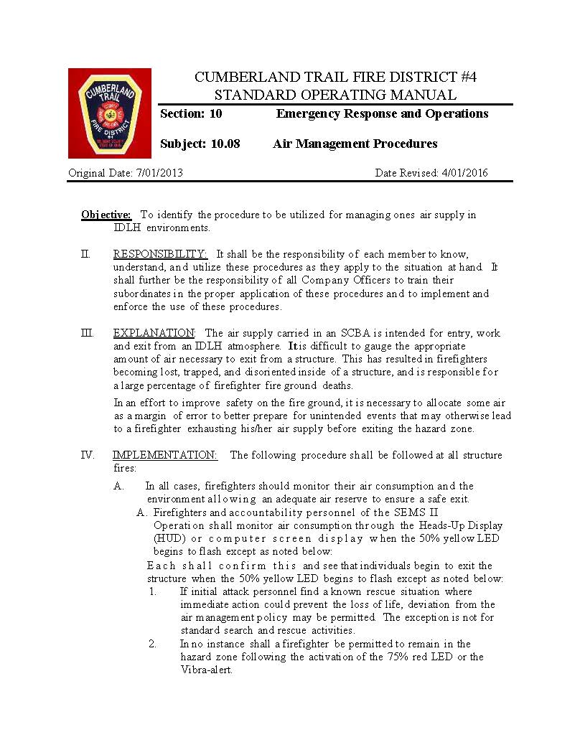

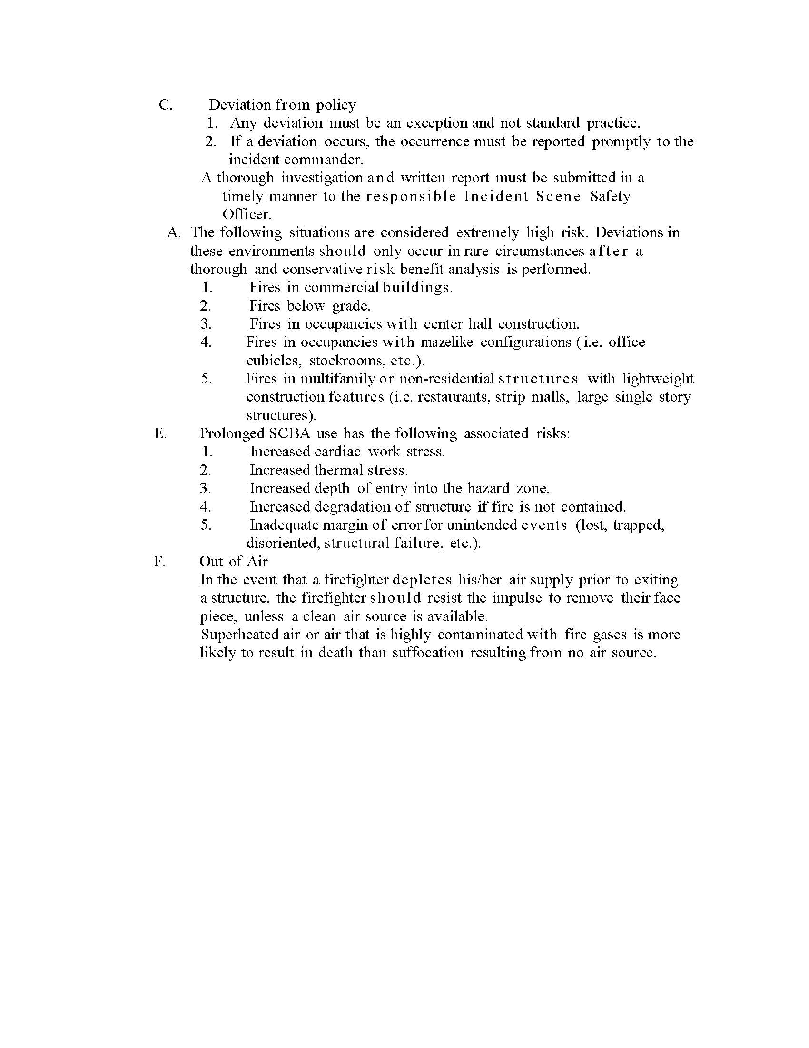

CTFD RIT PACK

Webbing

Tools

Facepiece

Buddy Breather, regulator, and mega mover

Universal Air Connection

All Cumberland Trail Fire District apparatus are equipped with a rapid intervention pack. These packs all contain the same standard equipment that can be used to supply air to a down firefighter. This equipment shall be checked daily and made readily available on the fireground. This pack is designed to be rapidly deployed in an IDLH environment. Identifiers such as a hockey puck, ball and handle are utilized to indicate which compartment is being opened on the pack. The equipment in this pack includes a Scott Facepiece, Scott Regulator, Scott SCBA Bottle, Universal Air connection hose, buddy breathing hose and fitting, webbing sling, tool pack and mega mover.

**Universal Air Connection Buddy Breather to Regulator**

Connections for RIT operations include the following.

* Buddy Breather to Buddy Breather
* UAC to UAC
* Buddy Breather to regulator
* Facepiece Swap

**Tool Pouch**

Firefighter Rescue Operations

The below rescue operations were copied from Columbus Divion of Fire’s saving our own. These videos allow firefighters to visually learn the methods and skills for rescue.

Denver drill - [Denver Drill - ScormFly Video (windows.net)](https://scormfly.blob.core.windows.net/api/v1.0.2/player.htm?id=dd4ccc43-755f-4d89-888a-c34394786a3d&autostart=0&timestamp=00:00:00)

Polaski- [scormfly.blob.core.windows.net/api/v1.0.2/player.htm?id=07c69e42-f671-4a69-a09a-e9691f62920a&autostart=0&timestamp=00:00:00](https://scormfly.blob.core.windows.net/api/v1.0.2/player.htm?id=07c69e42-f671-4a69-a09a-e9691f62920a&autostart=0&timestamp=00:00:00)

Nance drill- https://scormfly.blob.core.windows.net/api/v1.0.2/player.htm?id=167b7d7e-3ba7-402c-a32f-2d00292fd474&autostart=0&timestamp=00:00:00

High Point Anchor- [High Point Anchor System 2 - ScormFly Video (windows.net)](https://scormfly.blob.core.windows.net/api/v1.0.2/player.htm?id=e6fa9c94-faeb-4e78-9779-884118e88ddc&autostart=0&timestamp=00:00:00)