Staffing
- Minimum staffing for the Fire District is 7 Firefighters.
- 5 at station 23
- 2 at station 23-2
- Full staffing is 9 personnel
- 6 at station 23
- 3 at station 23-2
- It is the company officer’s responsibility to notify members of station assignments prior to shift.
Riding Assignments
- Riding Assignments are completed before shift change by the OIC. Reminder that riding assignments may vary depending on the OIC on duty.
- Riding assignments are posted on Sta 23 whiteboard in radio room and Sta23-2 riding assignment board in the hallway.
- Note that due to staffing, employees crossman Squads, Engines, Rescue 23 and L23.
Station 23 Assignments
- Squad 1 (Driver, Medic)
- Squad 2 (Driver, Medic)
- First due apparatus (OIC, Operator, Pack 1 and Pack 2)
Station 23-2 Assignments
- Squad 1 (Driver, Medic)
- First due apparatus (OIC, Operator, Pack1)

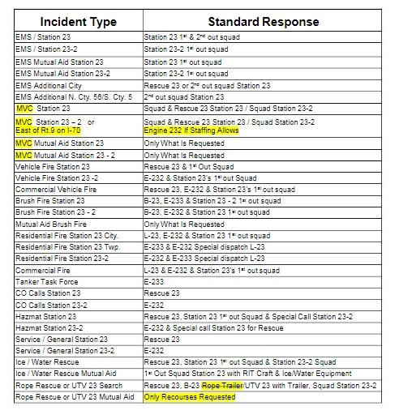
Response Protocol

Apparatus and Equipment Checks
- All apparatus shall be checked after pass on every morning. Apparatus shall be started, and applicable equipment thoroughly checked as well as pumps tested.
- Apparatus operators are responsible for checking their assigned apparatus for the day.
- Further details on checking apparatus and equipment will be included in their respective sections.
- While performing daily apparatus checks, the operator is responsible for turning the exhaust system to manual until all checks are completed.
Weekly Assignments
- Monday- Crews perform radio checks on all apparatus and portables. All SCBAs will be thoroughly inspected, and batteries replaced if needed.
- Tuesday- All lights on apparatus will be checked and replaced if necessary. All medic units cleaned and disinfected.
- Wednesday- Start and operate all gas-powered equipment and tools.
- Thursday- Check all EMS supplies and oxygen. Set up and operate Ladder 23.
- Friday- Clean griddle, gas grills and smoker. Clean out refrigerator.
- Saturday- Wash out bays and ramp.
- Sunday- Mow grass and clean up outside.

House Duties
Each day, the duty crew will be responsible for maintaining cleanliness of the firehouse, and apparatus. These house duties will be completed at the company’s officer’s choice of time. The company officer may also have a preference in rotation or assignments for the house duties. All supplies for house duties are kept in the back supply room and shower room of Station 23. Supplies are kept in the closet at the end of the hall in Sta23-2 and the supply room.
- Sweep and Mop
- Vacuum
- Dust and wipe down tables.
- Clean toilets and restock toilet paper/ paper towels.
- Wash and dry laundry.
- Trash removal.

