**Engine 232**

Station 23-2 First Due Engine

Engine 232 is Station 23-2 only fire apparatus. This engine is responsible for first due response to Station 23-2 district as well as second due to Station 23 district. Engine 232 responds on all mutual aid fires unless L23 is requested.

Specs:

* 2014 Sutphen Custom Pumper
* Cummins Diesel Motor
* DEF System compliant
* Allison Automatic Transmission
* On board generator
* 1750 GPM Hale Pump
* 1000 Gallon Water Tank
* 20 Gallon Class A Foam Tank (Dry)

Hoseline Compliments

* Off the Tailboard
  + 1000 Feet LDH 5 inch, Stortz connections
  + 400 Foot Pre-Connect 1-3/4 Attack Line (Orange)
  + 300 Foot 2-1/2 Supply line (White)
    - Dead Load (Not Connected)
* Crosslays
  + 200 foot 1-3/4 hand line w/ removable fog tip (Red)
    - When fog nozzle tip removed 7/8 smoothbore tip
  + 200 foot 1-3/4 hand line w 7/8 smoothbore tip (Blue)
  + 200 foot 2-1/2 hand line w/ 1-1/4 smoothbore tip(White)
  + 2 100 foot 2-inch-high rise kit w/ 1-1/16 smoothbore tip (Yellow)
* **Front Bumper**
  + 100 foot 1-3/4 hand line w/ fog nozzle (White)
* **Hard Suction**
  + 2 sections of 25-foot Hard Suction beside top hose bed

Pumping E232

1. Place engine transmission in ‘Neutral’, set the parking brake, and allow the engine RPM to reach idle speed.
2. Move Pump Shift Assembly control into ‘Neutral’ position and pause.
   * Lift Yellow Collar on actuator to move knob
3. Move Pump Shift Assembly control into ‘Pump’ position.
   * Lift Yellow Collar on actuator to move knob
4. Place engine transmission into designated pumping gear. Press D for Drive.
5. Look and listen for indications that the pump is in gear.
6. Dismount the apparatus and proceed with pumping operations.

Indications that 232 is in Gear

1. OK to Pump Engage Light is lit on pump shift module
2. Speedometer may change from 0 mph to 10-15 mph
3. Depressing the accelerator slightly results in no RPM change or lurching of the apparatus
4. Motor changes sound
5. Drive shaft is rotating between the transmission and pump gear box
6. Positive pressure indication on discharge gauge

**“Operators need to become familiar with how their apparatus reacts when successfully placed into pump mode. The operator must know the sights and sounds for those times when light bulbs burn out or don’t work”**

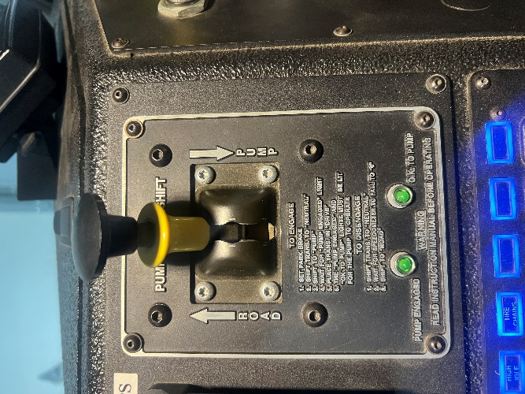

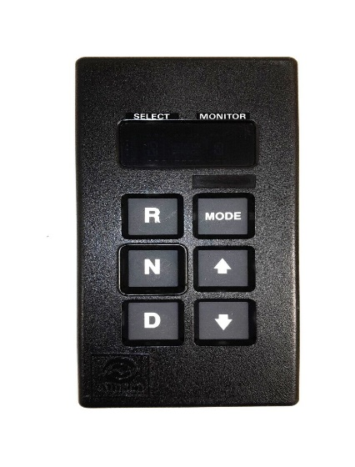

**E232 Allison Pump Module/Pump Shift actuator**

Trident Primer System

E232 has a Trident Air primer system for drafting. This system is easy to use and makes drafting much easier when compared to traditional priming systems.

Manual Trident Systems

Manual systems may be used on the main pump as well as individual intakes as previously described. The manual system requires the operator to physically engage the primer much like traditional rotary vane primers. Instead of a pull handle, the air primer has a push button controller to operate the primer. The operator simply depresses the desired primer button to engage the primer and releases the button to disengage the primer. Unlike traditional mechanical primers, there is no time limitation when engaging the air primer.

Maintenance and Troubleshooting

All of the customary troubleshooting options for drafting apply when using an air primer, i.e. leaking couplings, minimizing vertical lift, closing pump drains, etc. The air primer offers the advantage of overcoming imperfect drafting setups more readily than traditional rotary vane primers due to its unlimited engagement time. Theoretically the air primer can overcome more air trapped or infiltrating the drafting setup.

There is no routine maintenance intervention required by station personnel for the air primer. There are no fluids or moving parts to lubricate. The primer operation should be checked as part of routine pump inspections. The primer body has an integral strainer to reduce the potential for debris entering the primer body and obstructing the air inlets. If priming performance seems to be reduced or impaired the strainer should be checked for debris.



Key Points About Drafting Operations using Trident AirPrime

* Drafting is like painting your living room; it is all in the preparation.
* If the pumper is equipped with an electronic pressure governor, it must be in the RPM mode.
* Don’t put the pumper in pump gear until:
  + You are sure that your positioning is correct and the wheel chock(s) is down.
  + The tank-to-pump valve is closed
  + You are certain that suction hose connections are air tight
  + You are sure all discharges, drains and bleeders are closed and capped
  + You have circulating line ready-Simple as using the deck gun
* It is especially important to not put the pump into gear prematurely if you do not have an intake control valve through which you can draft.
* Allowing the impeller to spin in a pump without water builds up heat and can ruin the impeller, clearance rings and mechanical seals.
* The Auto AirPrime is most efficient at about 1,000 RPM.
* Look for signs of water rising in the hard suction hose:
  + Hose is “dipping” from the weight of the water.
  + Hear the Auto AirPrime operating.
* Once you have completely transitioned to drafting, open the circulating line and cut the tank fill back - but make sure you refill your tank, you can flush if out later if you usually carry clean water

E232 Crosslays and 400 Foot Rear Attack Line

200’ 1-3/4 Cross-lay Repack

1. Begin repacking this load by sitting the poly tray on the side

of the apparatus and dangling the pony section to the side of

the truck.

2. Next, start laying the drag section by placing a female

coupling approximately 4 feet past the edge of the poly tray.

3. Lay one more section flat stopping at the edges of the tray.

4. On the next fold, place a large loop at the end of the tray to be

used to deploy the drag section.

5. Continue laying the 50-foot section ending with the male

coupling on the top.

6. Next, Connect the nozzle to the next section and begin

packing the shoulder load by feeding the hose under the

nozzle to the other end of the tray. On your next lay, wrap the

hose over the nozzle and finish all remaining folds at the end

of the tray.

200’ 1-3/4 Cross-lay Deployment

1. First, roll the hose compartment door up making the cross-lay

accessible.

2. Second, feed the Shoulder section onto your shoulder. The

nozzle should hang at the stomach or waist. Remember to keep

the hose load pressed together tight.

3. Third, step away from the apparatus to allow the shoulder load

to clear the poly tray.

4. Next, using the large loop, pull the Drag section onto the

ground completely clear of the poly tray. (The officer, backup

FF or operator should grab the coupling from the ground and

flake out the drag section.

5. Finally, walk and deploy the shoulder section ending with the

nozzle. If needed, drop the section, and flake out the remaining

hose if space is limited to deploy.

400-foot Attack Line Deployment

1. To deploy the 400, the nozzleman addresses the nozzle load, and

pulls the load, placing it on his shoulder until the nozzle sits at a

comfortable position near his midsection. It is imperative that the

nozzleman then steps away from the apparatus only a few feet and

then stops to await the second member and keeps his hand on top

of the load to prevent losing any hose.

2. The next member shoulder loads the middle section in the same

manner as the nozzle man. If no other members are available for

the evolution, the second member, after clearing the middle load,

turns and pulls the ear of the drag load and clears this load to the

ground.

3. If a third member is available to deploy the drag load, he has the

option of pulling it out to the ground at the rear of the apparatus or

pulling approximately half of the drag load out and inverting it so

the hose will pay off his shoulder for a more efficient stretch.

4. The 400’ line must be laid in a manner that dictates that the nozzle

man is the last member to deploy his shoulder load.

400-foot Attack Line Repack

1. To place the line back on the apparatus, the line is racked starting

with a female being connected to the discharge. After one layer is

placed in the hose bed, the next layer has a large ear to facilitate

deploying the drag load. When this first 50’ is racked, leave the

male end of the hose on top of the load.

2. The next step, and a very vital step in this procedure, is to start

with a male coupling and lay this coupling on the ground and rack

the middle section ending with a female coupling on top at the rear.

3. The next step is to place the nozzle on a male coupling and utilize

a “wrap” while locating the nozzle in the hose bed to allow the

efficient deployment of the nozzle load. After this 50’ is laid in the

bed, leave the female coupling on top of the lay in same manner as

packing the middle load.

4. The next step is to return to the drag load and rack another 50’ to it

leaving the male on top.

5. Next members will add 50’ to the middle load and leave the female

on top.

6. The next step is to add the final 50’ of hose to the nozzle load and

leave the female coupling on top.

7. The final stage starts with last 50’ racked to the drag load and

again leave the male coupling on top.

8. The last section of hose to be racked will be the 50’ added to the

middle section with its female coupling on top.

9. To end the procedure, the couplings will be joined in this specific

order to ensure the hose load is one continuous 400’ line from

discharge outlet to the nozzle. The male coupling that was

dangling to the ground from the middle section is hooked to the

female coupling that is on top of the nozzle load.

10. Finally, the female on top of the middle section is coupled to

the male on top of the drag load to complete the

**Engine 233**

Station 23 Reserve/Township Engine

E233 is Station 23 multi-purpose fire apparatus. E233 responds to non-commercial township fires, brush fires and Tanker Task Force activations. It also serves as a reserve piece of fire apparatus should E232 go out of service.

Specs:

* 2002 E One Enforcer
* Cummins Diesel Motor
* Allison Automatic Transmission
* 1500 GPM Hale Pump
* 1000 Gallon Water Tank

Hoseline Compliments

* Off the tailboard
  + 1300 Feet LDH 5 inch, Stortz connections
  + 400 Foot Pre-Connected 1-3/4 Attack Line (Orange)
  + 300 Foot 2-1/2 Supply Line (White)
  + 200 Foot 2-1/2 Blitz Fire Line
* Front Bumper
  + 100 foot 1-3/4 hand line w/ fog nozzle (White)

Pumping E233

1. Place engine transmission in ‘Neutral’, set the parking brake, and allow the engine RPM to reach idle speed.
2. Move Pump Shift Assembly control into ‘Neutral’ position and pause.
   1. Lift Yellow Collar on actuator to move knob
3. Move Pump Shift Assembly control into ‘Pump’ position.
   1. Lift Yellow Collar on actuator to move knob
4. Place engine transmission into designated pumping gear. Press D for Drive.
5. Look and listen for indications that the pump is in gear.
6. Dismount the apparatus and proceed with pumping operations.

Indications that 233 is in Gear

1. OK to Pump Engage Light is lit on pump shift module
2. Speedometer may change from 0 mph to 10-15 mph
3. Depressing the accelerator slightly results in no RPM change or lurching of the apparatus
4. Motor changes sound
5. Drive shaft is rotating between the transmission and pump gear box
6. Positive pressure indication on discharge gauge

**“Operators need to become familiar with how their apparatus reacts when successfully placed into pump mode. The operator must know the sights and sounds for those times when light bulbs burn out or don’t work”**

Manual Prime Operations

* Establishing the Prime:
  + Use the pump panel throttle to maintain approximately 1000 RPM.
  + Activate the priming pump by pulling the control handle located on the pump panel.
  + The Pump Intake Pressure Gauge begins to read below zero right away.
  + Within 10 to 20 seconds, you see and feel the hard suction stressing under the weight of water.
  + Within approximately 30 seconds the PDP begins to read slight intermittent pressures and a broken stream of water begins to discharge from the primer drain under the apparatus.
  + Continue priming until a constant stream of water discharges from the primer drain and PDP becomes constant, approximately 5 to 10 seconds more.
* Note:
  + If signs of prime do not occur within 30 seconds, do not continue to run the priming pump. Stop the pump and check for air leaks or possible pump trouble.
  + Priming pumps overheat and become damaged if operated longer than 45 seconds dry.

Key Points About Drafting Operations

* Drafting is like painting your living room; it is all in the preparation.
* If the pumper is equipped with an electronic pressure governor, it must be in the RPM mode.
* Don’t put the pumper in pump gear until:
  + You are sure that your positioning is correct and the wheel chock(s) is down.
  + The tank-to-pump valve is closed
  + You are certain that suction hose connections are air tight
  + You are sure all discharges, drains and bleeders are closed and capped
  + You have circulating line ready-Simple as using the deck gun
* It is especially important to not put the pump into gear prematurely if you do not have an intake control valve through which you can draft.
* Allowing the impeller to spin in a pump without water builds up heat and can ruin the impeller, clearance rings and mechanical seals.
* The Prime is most efficient at about 1,000 RPM.
* Look for signs of water rising in the hard suction hose:
  + Hose is “dipping” from the weight of the water.
  + Hear the Primer operating.
* Once you have completely transitioned to drafting, open the circulating line and cut the tank fill back - but make sure you refill your tank, you can flush if out later if you usually carry clean water

CTFD Engine Placement Considerations

This is a guideline for basics of engine placement for residential fire attack. Bear in mind all incidents are different and a competent and confident engineer communicates with his company officer at all times.

Residential Attack:

* The driver/operator and company officer of the first arriving apparatus must observe conditions and determine the best apparatus position based on initial attack strategy and department policy.
* Pull the apparatus past the front of the building, if feasible, when arriving at an incident where no fire is evident (investigation mode). This position allows personnel on the apparatus to view three sides of the building.
* Consider the best access point for personnel and equipment entering the occupancy when parking the apparatus. This will allow personnel efficient access to the building to begin an investigation.
* Remain with the apparatus in the event connections for water supply or fire department connections need to be made or to assist in pulling attack hose lines and operating the pump.
* Even in the case of an alarm it is in the best interest of the crew to place the truck into pump and be ready for an active fire attack
* In many cases, pumpers may arrive before the first aerial apparatus. Pumping apparatus driver/operators must seek a position of best advantage for their apparatus while keeping in mind the needs of aerial apparatus that have yet to arrive. Blocking access for aerial apparatus can seriously jeopardize the outcome of an incident.
* Establishing water supply is a primary concern of the driver/ operator and company officer in the placement of the pumper. If a confirmed fire is located in an area of limited access, such as a narrow driveway or alley, the personnel of the first-arriving pumper should consider laying their own supply line.
* Another important consideration when determining the proper position for an attack pumper is the potential for structural collapse.