Staffing
Minimum staffing for the Fire District is 7 Firefighters with 10 being full staffing.
As staffing increases to a max of 10 firefighters, station staffing shall be as follows
Station 23 | Station 23-2
5 | 2
5 | 3
6 | 3
6 | 4

- It is the company officer’s responsibility to notify members of station assignments prior to shift.
Riding Assignments
- Riding Assignments are completed before shift change by the OIC. Reminder that riding assignments may vary depending on the OIC on duty.
- Riding assignments are posted on Sta 23 whiteboard in radio room and Sta23-2 riding assignment board in the hallway.
- Note that due to staffing, employees Crossman Squads, Engines, Rescue 23 and L23.
Station 23 Assignments
- Squad 1 (Driver, Medic)
- Squad 2 (Driver, Medic)
- First due apparatus (OIC, Operator, Pack 1 and Pack 2)
Station 23-2 Assignments
- Squad 1 (Driver, Medic)
- First due apparatus (OIC, Operator, Pack1)
Apparatus Seat Responsibilities
Rescue 23 Operator
- Driving apparatus to destination
- Proper positioning of apparatus for optimal scene protection and equipment deployment
- Secure water source and pump if applicable
- Scene lighting
Rescue 23 Officer
- Navigation to incident, approaches, scene size up
- Incident action plan
- Executes IAP, ensures scene safety
- Oversee all other positions and utilizes strategies for success
Rescue 23 Pack 1 (Operator Side)
- Attack line deployment if applicable
- Irons if applicable
- Retrieve specialized equipment in rescue scenarios
- Performs tasks to complete IAP
Rescue 23 Pack 2 (Officer Side)
- Attack line deployment if applicable
- Hook and Can
- Retrieve specialized equipment in rescue scenarios
- Perform tasks to complete IAP

Engine 233/232 Operator
- Safely drives apparatus to incident scene
- Positions for optimal access for firefighting tactics
- Secures water source
- Delivers water to attack line and ensures continuous adequate water supply
- Deployment of ground ladders
- Scene lighting

Engine 233/232 Officer
- Navigation to incident, and positioning
- Scene size up
- Incident action plan
- Executes IAP, ensures scene safety
- Oversee all other positions and utilize strategies for success
Engine 233/232 Pack 1 (Operator Side)
- Secures hydrant if applicable
- Deployment of appropriate attack line
- Irons/ forcible entry
- Performs tasks to complete IAP
Engine 233/232 Pack 2 (Officer Side)
- Secures hydrant if applicable
- Deployment of appropriate attack line
- Hook and can
- Perform tasks to complete IAP

Ladder 23 Operator
- Safely drives apparatus to incident scene
- Positions for optimal access for firefighting tactics
- Deploys outriggers and prepares aerial for use
- Secures water source
- Delivers water to attack line and ensures continuous adequate water supply
- Deployment of ground ladders
- Scene lighting
Ladder 23 Officer
- Navigation to incident, and positioning
- Scene size up
- Incident action plan
- Executes IAP, ensures scene safety
- Oversee all other positions and utilize strategies for success

Ladder 23 Pack 1 (Operator Side)
- Secures hydrant if applicable
- Deployment of appropriate attack line
- Irons/ forcible entry
- Operates aerial when applicable
- Performs tasks to complete IAP
Ladder 23 Pack 2 (Officer Side)
- Secures hydrant if applicable
- Deployment of appropriate attack line
- Operates aerial when applicable
- Hook and can
- Perform tasks to complete IAP

Continued Below
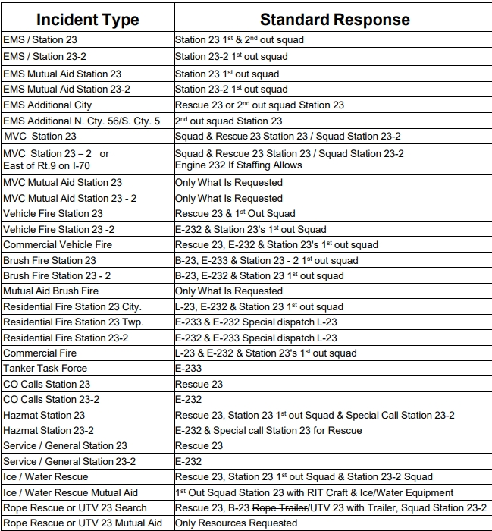
Response Protocol

Apparatus and Equipment Checks
- All apparatus shall be checked after pass on every morning. Apparatus shall be started, and applicable equipment thoroughly checked as well as pumps tested.
- Apparatus operators are responsible for checking their assigned apparatus for the day.
- Further details on checking apparatus and equipment will be included in their respective sections.
- While performing daily apparatus checks, the operator is responsible for turning the exhaust system to manual until all checks are completed.
Weekly Assignments
- Monday- Crews perform radio checks on all apparatus and portables. All SCBAs will be thoroughly inspected, and batteries replaced if needed.
- Tuesday- All lights on apparatus will be checked and replaced if necessary. All medic units cleaned and disinfected.
- Wednesday- Start and operate all gas-powered equipment and tools.
- Thursday- Check all EMS supplies and oxygen. Set up and operate Ladder 23.
- Friday- Clean griddle, gas grills and smoker. Clean out refrigerator.
- Saturday- Wash out bays and ramp.
- Sunday- Mow grass and clean up outside.

House Duties
Each day, the duty crew will be responsible for maintaining cleanliness of the firehouse, and apparatus. These house duties will be completed at the company’s officer’s choice of time. The company officer may also have a preference in rotation or assignments for the house duties. All supplies for house duties are kept in the back-supply room and shower room of Station 23. Supplies are kept in the closet at the end of the hall in Sta23-2 and the supply room.
- Sweep and Mop
- Vacuum
- Dust and wipe down tables.
- Clean toilets and restock toilet paper/ paper towels.
- Wash and dry laundry.
- Trash removal.

Public Relations
At Cumberland Trail Fire District #4, public relations are key to earning trust and support between our department and the public. Each year, members participate in numerous public relation events. It is important to remember that when in public, you represent CTFD and should always show professionalism. Probationary members are encouraged to lead public safety talks, station tours and other similar events to gain experience in speaking and informing the public of our operations.

