Purpose
The purpose of this section is to cover all C.T.F.D firefighter survival procedures. Studying and frequent training on this section will help prepare firefighters for sudden life-threatening incidents that may occur on the fireground. These incidents are high stress low frequency and require the firefighter to be mentally and physically prepared. Specifics on fire department rapid intervention packs, mayday procedures, techniques for firefighter rescue, and tools used will be covered throughout this section.
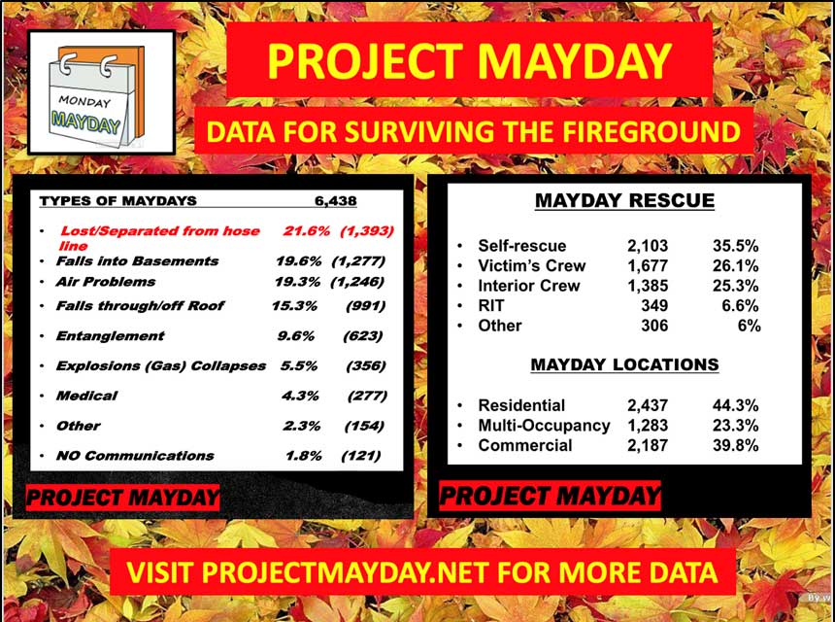

The above picture comes from Projectmayday.net. The statistics range from 2014 to 2020 and include all reported mayday situations nationally.

Firefighter Mayday Policy
This Mayday Policy is designed to prepare all incident scene and dispatching personnel for a sudden life-threatening incident that may occur during operations on any particular incident. It will also serve as the standard for language to be used by all personnel involved when one or more individuals are in trouble and are in need of assistance. 1. Everyone who becomes involved in the Mayday must realize the difficulty involved with in controlling the good intentions of would-be rescuers at a time of a Mayday, the risk and disadvantages associated with not controlling and completing your assigned tasks within this policy may only hinder the operation and it may actually contribute to firefighter fatalities. Everyone remains with your assigned tasks.
Activations:
A mayday will be declared immediately when a firefighter realizes that they, the team or a member of team has become injured, trapped, lost, disoriented and is in need of assistance or upon completion of a “P.A.R.” (Head Count) and Command has individuals or a crew of personnel missing. Examples Are As Follows: Tangled, Pinned, or Stuck; low air alarm Tangled, Pinned, or Stuck and do not extricate self in 60 seconds Fall through floor Fall through roof Caught in a flashover Zero visibility, no contact with hose line, do not know direction to the exit Primary exit blocked by fire or collapse, not at a secondary exit within 30 seconds Low air alarm activation, not at an exit (door or window) in 30 seconds Cannot find exit (door or window) in 60 seconds Individual, team or team member lost Any event or injury that prevents self-extrication of the hazard zone. Missing individuals or crews upon “P.A.R.” (Head Count)

Declaration Of A Mayday:
If possible one of the following means of transmission will be used to report a Mayday Verbal Communication of Mayday-Mayday-Mayday, Activation Of The Man Down Button (Orange) on our radios, Pass Device Activation or a Combination Of All Of The Above.
Firefighter Declaration of Verbal Mayday Activation:
Upon reporting mayday one must provide the following information:
A) Name
B) Assignment (Per the Incident Management System)
C) Problem or the need for the mayday (lost, injuries, low on air or etc…).
D) The resources needed or requested to extricate to a safe zone.
After Verbal Activation follow up with the P.A.S.S. Device Activation to assist in locating your position. If possible follow up with Man Down Button. If it is impossible for the individual to activate the Man Down Button, command should notify dispatch that a firefighter or command is activating a man down button at this time to secure the talk group due to an incident scene mayday and are requesting dispatch to follow verbal mayday procedure.

Procedures for Central Dispatch Upon A Verbal Mayday Activation:
a. Broadcast the EMERGENCY TRAFFIC TONE (Tone # 3 for 3 Seconds) then say "EMERGENCY TRAFFIC “A Firefighter Mayday has been declared on . . . and give the incident address or assigned command address.”
b. If possible dedicate an operator to monitor the talk group of the Mayday event.
c. Ask command of the need for an additional Station or an additional ALS unit.
d. If a firefighter comes upon an unassigned talk group, dispatch will advise command and remain with the firefighter on this particular talk group.
e. The mayday will only be terminated when direct orders from command are given that the mayday has been mitigated.
Firefighter Declaration of a Mayday Activation By The Man Down Button:
Activation of the Man Down Button will activate a distress tone at the 9-1-1 dispatch center. This will lock the talk group to emergency traffic communication until the mayday is mitigated. If at all possible the man down button activation should be followed up with the Verbal Mayday Procedures and P.A.S.S. Device activation.
Procedures for Central Dispatch upon a Declaration of a Mayday Activation by the Man Down Button:
Broadcast the EMERGENCY TRAFFIC TONE then say "EMERGENCY TRAFFIC “A Firefighter Mayday has been declared on . . . and give the incident address or assigned command address.”
b. Notify command of radio emergency Man Down Button activation and treat this as a Mayday event until proven otherwise.
c. Provide all pertinent information known about the unit identification number.
d. If possible dedicate an operator to monitor the talk group of the Mayday event.
e. Ask command of the need for an additional Station or an additional ALS unit.
f. If a firefighter comes upon an unassigned talk group, dispatch will advise command and remain with the firefighter on this particular talk group.
g. The mayday will only be terminated when direct orders from command are given that the mayday has been mitigated.
Declaration of Activation by the Pass Device:
It will also be considered a Mayday if a P.A.S.S. device activates and command receives negative confirmation of a P.A.R. (head count) from a firefighter or a team of firefighters. In a capacitated state of P.A.S.S. Device activation, the firefighter will then follow up with Verbal
Procedures For Central Dispatch Upon A Verbal Mayday Activation:
a. Broadcast the EMERGENCY TRAFFIC TONE (Tone # 3 for 3 Seconds) then say "EMERGENCY TRAFFIC “A Firefighter Mayday has been declared on . . . and give the incident address or assigned command address.”
b. If possible dedicate an operator to monitor the talk group of the Mayday event.
c. Ask command of the need for an additional Station or an additional ALS unit.
d. If a firefighter comes upon an unassigned talk group, dispatch will advise command and remain with the firefighter on this particular talk group.
e. The mayday will only be terminated when direct orders from command are given that the mayday has been mitigated.

Air Management Procedures
RESPONSIBILITY:
It shall be the responsibility of each member to know, understand, and utilize these procedures as they apply to the situation at hand. It shall further be the responsibility of all Company Officers to train their subordinates in the proper application of these procedures and to implement and enforce the use of these procedures.
EXPLANATION:
The air supply carried in an SCBA is intended for entry, work and exit from an IDLH atmosphere. Itis difficult to gauge the appropriate amount of air necessary to exit from a structure. This has resulted in firefighters becoming lost, trapped, and disoriented inside of a structure, and is responsible for a large percentage of firefighter fire ground deaths. In an effort to improve safety on the fire ground, it is necessary to allocate some air as a margin of error to better prepare for unintended events that may otherwise lead to a firefighter exhausting his/her air supply before exiting the hazard zone.
IMPLEMENTATION:
The following procedure shall be followed at all structure fires:
A. In all cases, firefighters should monitor their air consumption and the environment allowing an adequate air reserve to ensure a safe exit.
B. Firefighters and accountability personnel of the SEMS II Operation shall monitor air consumption through the Heads-Up Display (HUD) o r c o m p u t e r s c r e e n d i s p l a y w hen the 50% yellow LED begins to flash except as noted below: E a c h s h a l l c o n f i r m t h i s and see that individuals begin to exit the structure when the 50% yellow LED begins to flash except as noted below:
1. If initial attack personnel find a known rescue situation where immediate action could prevent the loss of life, deviation from the air management policy may be permitted. The exception is not for standard search and rescue activities.
2. In no instance shall a firefighter be permitted to remain in the hazard zone following the activation of the 75% red LED or the Vibra-alert.
C. Deviation from policy
1. Any deviation must be an exception and not standard practice.
2. If a deviation occurs, the occurrence must be reported promptly to the incident commander.
A thorough investigation a n d written report must be submitted in a timely manner to the responsible Incident Scene Safety Officer.
A. The following situations are considered extremely high risk. Deviations in these environments should only occur in rare circumstances a f t e r a thorough and conservative risk benefit analysis is performed.
1. Fires in commercial buildings.
2. Fires below grade.
3. Fires in occupancies with center hall construction.
4. Fires in occupancies with mazelike configurations (i.e. office cubicles, stockrooms, etc.).
5. Fires in multifamily or non-residential s t r u ct ure s with lightweight construction features (i.e. restaurants, strip malls, large single story structures).
E. Prolonged SCBA use has the following associated risks:
1. Increased cardiac work stress.
2. Increased thermal stress.
3. Increased depth of entry into the hazard zone.
4. Increased degradation of structure if fire is not contained.
5. Inadequate margin of errorfor unintended events (lost, trapped, disoriented, structural failure, etc.).
F. Out of Air In the event that a firefighter depletes his/her air supply prior to exiting a structure, the firefighter should resist the impulse to remove their face piece, unless a clean air source is available. Superheated air or air that is highly contaminated with fire gases is more likely to result in death than suffocation resulting from no air source.

Rapid Intervention Team SOP
This standard was promulgated to ensure the safety and rapid rescue of members operating on the fire ground, should they become trapped, injured or otherwise unable to remove themselves from a place of danger. The incident commander is responsible for providing this RIT whenever necessary. This includes using responding automatic aid companies to this function. The personnel acting as the RIT are responsible for being properly outfitted with protective gear and tools, so that they may rapidly go into action.
Policy
1. Whenever personnel are operating in positions that would subject them to immediate danger or injury, at minimum a two man RIT shall be provided. This will include all working fires.
2. The RIT Team leader must be a Cumberland Trail Fire District personnel and be equipped with the Scott Pak Tracker.
3. To complete the RIT Team automatic aid personnel may be used.
4. A RIT Team will be assembled as soon as an initial entry is made by a crew into the IDLH area. A back up crew will be assembled next then the RIT crew.
5. A rapid intervention team shall consist of at least two members and shall be available for the rescue of firefighters or team if the need arises.
6. Rapid intervention teams, (a.k.a. RIT) shall be fully equipped with the appropriate protective clothing and equipment, including SCBA.
7. The RIT shall have at their immediate disposal any tools necessary to affect a rescue for the type of situation at hand. (thermal imaging camera and the “CTFD RIT” pack, saws, axe, halligan, hose line, etc.)
8. All RIT members shall have a portable radio with them at all times.
9. RIT shall place ladders to roofs and second floor windows, in the event that they are needed. 10. The composition and structure of the RIT shall be permitted to be flexible based on the size and complexity of the operations. The IC shall evaluate the situation and the risks to personnel, and provide one or more RIT based on his evaluation.
11. In the early stages of the incident the RIT shall be either:
• On scene members designated as the backup crew will dedicated as a RIT.
• On scene members performing other functions, but ready to redeploy as a RIT without delay.
12. As the incident expands in size and complexity the RIT shall be either:
• On scene members dedicated as RIT
• On scene companies, or automatic aid companies dedicated as RIT

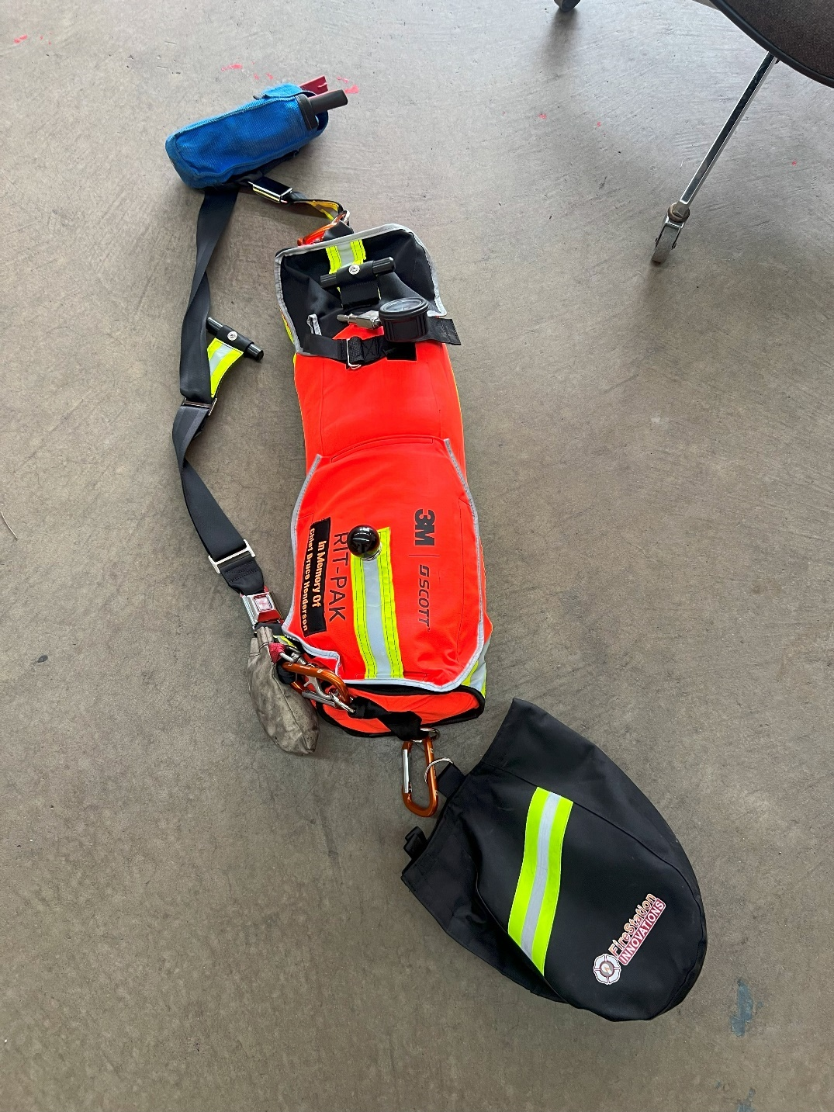
CTFD RIT PACK
Webbing
Tools
Facepiece
Buddy Breather, regulator, and mega mover
Universal Air Connection

All Cumberland Trail Fire District apparatus are equipped with a rapid intervention pack. They are located in a specific compartment on each apparatus marked with a RIT sticker. These packs all contain the same standard equipment that can be used to supply air to a down firefighter. This equipment shall be checked daily and made readily available on the fireground. This pack is designed to be rapidly deployed in an IDLH environment. Identifiers such as a hockey puck, ball and handle are utilized to indicate which compartment is being opened on the pack. The equipment in this pack includes a Scott Facepiece, Scott Regulator, Scott SCBA Bottle, Universal Air connection hose, buddy breathing hose and fitting, webbing sling, tool pack and mega mover.

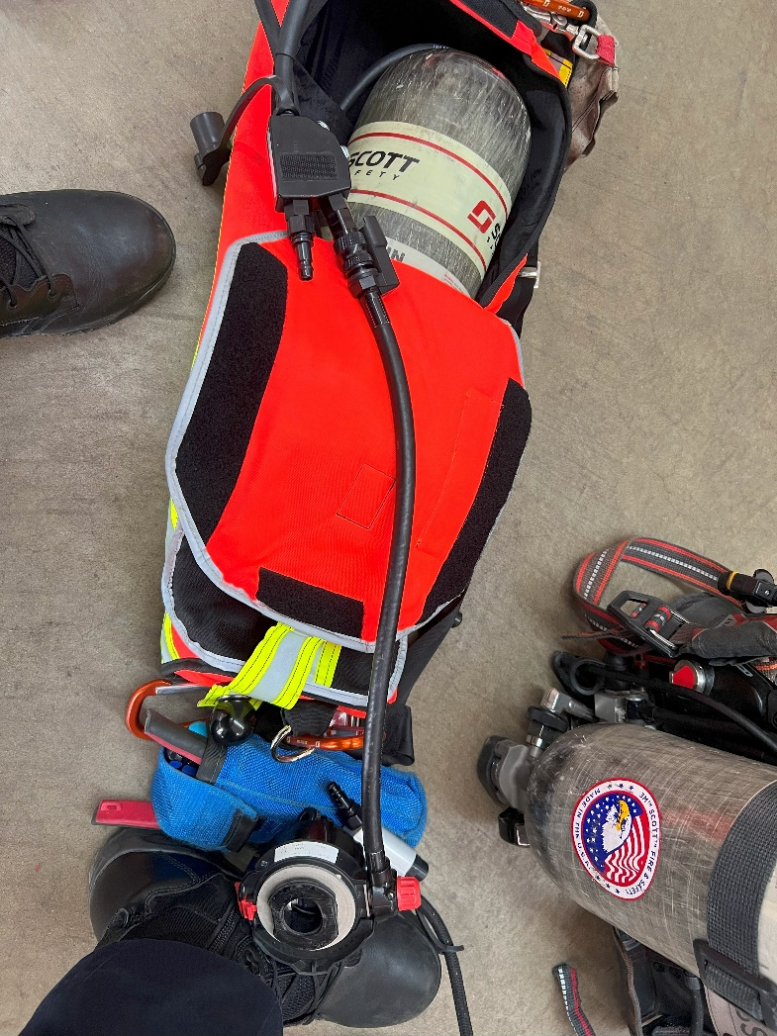
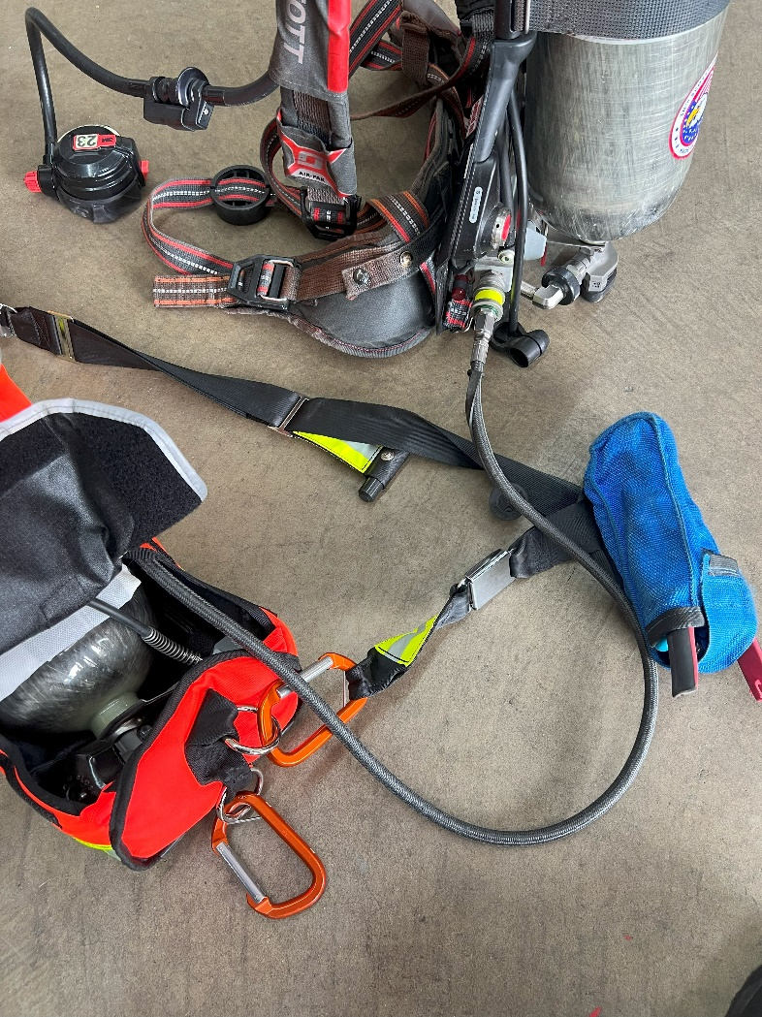
Universal Air Connection Buddy Breather to Regulator
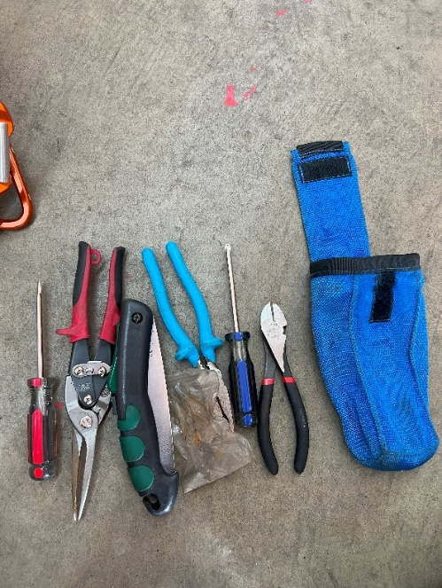
Connections for RIT operations include the following.
- Buddy Breather to Buddy Breather
- UAC to UAC
- Buddy Breather to regulator
- Facepiece Swap

Tool Pouch

Firefighter Rescue Techniques and Procedures
Firefighter High Anchor Rescue
Primary use is to assist Rapid Intervention Teams with removing a downed firefighter from elevated positions such as a second-floor window, third floor window, or a basement after doing a cutdown from the exterior of the building. System is composed of basic rope components used to construct a 2:1 mechanical advantage. System is kept pre-rigged in a labeled tool bag. This is kept with all CTFD RIT bags.
Equipment needed
1. 2 Large Carabiners:1 Red, 1 Blue
2. 2 Pulleys: 1 Red 1 Blue
3. 75-100 ft of Rescue Rope
4. 1-2 Ground Ladders
5. CTFD RIT Pack
6. Webbing
7. 4 Rescuers (2 Inside, 2 Outside) May adapt to resources available.
Operation
1. Gather all necessary equipment.
2. Assign roles, inside and outside rescuers.
3. Inside rescuers can ascend ground ladder and enter to find and package downed firefighter.
4. Exterior crew then rolls rescuer ladder out of the way and places an extended 24-foot extension
ladder over the window.
5. One exterior firefighter will open the High Anchor Haul System and grab both carabiners.
6. The exterior firefighter will ascend the extension ladder, carrying the carabiners on the back
side of the ladder, and connect the red carabiner to the rung (Red to Rung).
a. This firefighter will remain on the ladder and be the In-charge rescuer.
7. While the system is being set up outside, the interior crew will locate the firefighter and
perform any emergency SCBA operations needed.
8. The interior crew will then perform a waist strap conversion on the downed firefighter.
9. Next, they will drag the firefighter to the bottom of the window with his or her back against
the window.
10. The interior firefighters will then retrieve the blue carabiner from the exterior firefighter (Blue
to Body).
11. The interior crew then will connect the carabiner in one of the following ways:
a. Drag rescue lanyard (DRL), avoiding the storage snap loop.
b. DRD (Drag Rescue Device)
c. Girth Hitched Webbing
d. Webbing Rescue Sling
12. Upon command from the in-charge rescuer, interior and exterior crews will use the system to
lift the firefighter over the window sill and lower them to the ground.
13. While lifting, firefighters should use the hand over hand method.
14. Verbal commands shall be as follows:
a. In-charge rescuer (Ready?)
b. Interior crew (Ready)
c. In-charge rescuer (Go).
15. After the downed firefighter is removed, exterior crews will remove the ladder used for High
Anchor and roll the entry ladder back into place for the interior crew to exit.

Waist Strap Conversion
Purpose
To convert your gear and equipment into a harness to proactively address what may prevent you from being removed while you are being rescued.
Procedure
- Loosen all straps, both the shoulders and waist.
- Lift one leg up towards your chest.
- Feed the waist strap from the side of the lifted leg from behind the leg and up towards your groin area.
- Feed the opposite waist strap over your groin and connect the two via the buckle mechanism.
- Tighten down all straps, both shoulders and waist. Place an overhand knot in each shoulder strap to prevent the shoulder straps from loosening while you are being dragged or hauled during removal.

