**Snipping X-Rays to save them in the Document Center:**

1. Open your x-ray on your screen (via email, your x-ray software, etc.)
2. Open the Snipping tool (You can always search for this by clicking the Windows Icon if you don’t already have it open) 
3. Click “New” in the Snipping Tool
4. Use your mouse to select the x-ray (I prefer to show the date in the snip so I don’t have to add it later)

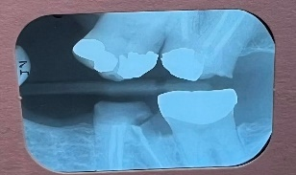

1. Open up the Document Center and search for the patient you want to attach the x-ray to.
2. Click on the Paste from Clipboard Icon 
3. Once the pop-up screen comes up, drop down your document type and choose x-rays.
4. Add your description and click Save.
5. Pat yourself on the back, you did it! 😊