**GOOGLE CLASSROOM: Session starts from Feb 10: For 20 Hrs on mutually convenient time.**

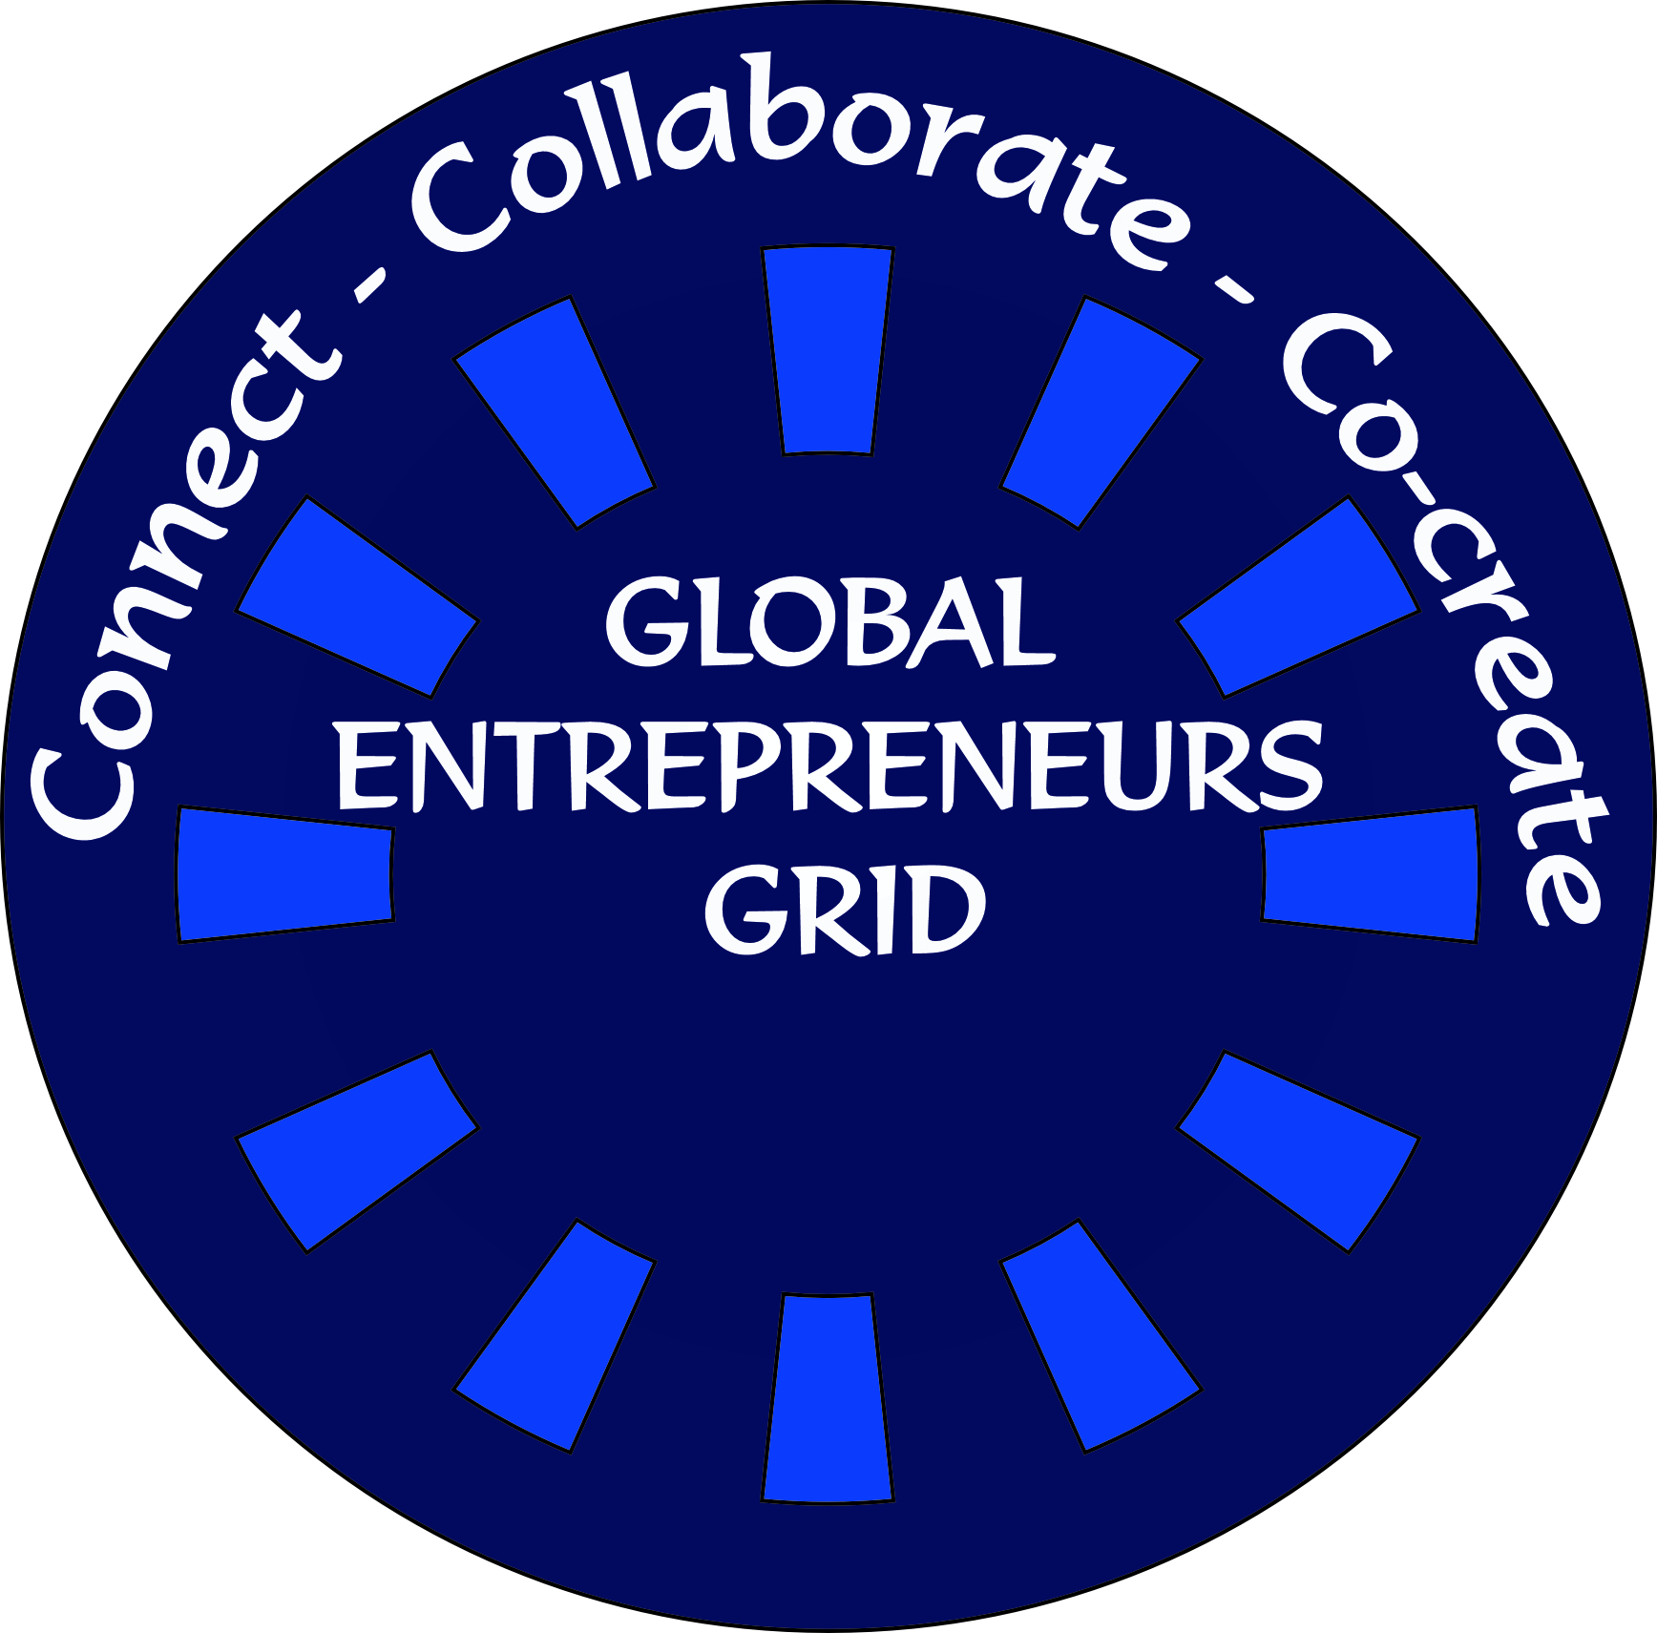

Soft copy of Candidate Picture

GLOBAL ENTREPRENEURS GRID (GEG)

**APPLICATION FORM: Entrepreneurship, Creativity & Innovation**

**Applicant Name**

Certificate Course in Entrepreneurship, Creativity & Innovation

**Course Name**

**Fee Details**

**: Cheque/DD/NEFT**

**Correspondence Address**

Please mention only Gmail id

**Email id**

**Contact No**

**Date:**

**Place:**

**Signature**

**ADMISSION PROCEDURE**

**ON-DEMAND PERSONALIZED ONE-TO- ONE MODEL**

Google Classroom: Soft copy of the study materials will be provided. Interaction in Google Class Room If required telephone call / conference call will be added as an additional features to facilitate learning.

Admission Fee INR: 1000/- USD 100.

GEG will issue Certificates to all the participants after successful completion of the course.

**PAYMENT TO BE MADE IN THE FOLLOWING ACCOUNT**

**NEFT Details:**

**MTC GOBAL A/C DETAILS**

Account Holder's Name                 :   MTC Global Trust

Account Number                                :   6063000100011431

Account Type : Savings A/C

Bank Name                                         :   PUNJAB NATIONAL BANK

IFSC Code                                          :   PUNB0606300

Branch                                                 :   Mahadevpura Branch, Rajapallya, ITPL Road, Bangalore-560 048, India

**Payment Details**: Please mention the payment made for the course.

**Overseas Students: Transfer through Bank / Western Union.**

**Green Policy: Hard copy is discouraged. Please apply through email.**