# **Casper Fermentables voted best bakery in ATX**



[Raveena Devjee](https://medium.com/@rdevjee?source=post_page---byline--de24b4554b84--------------------------------)

3 min read

On September 15th, 2023, I ventured out to the Jewish owned bakery, Casper Fermentables which was voted best bakery in Austin earlier this year. I documented the staff during their daily morning bake sessions and their preparation before the restaurant was open for the day. Bakers usually come in around 3am to start the bake and will usually get done by around 8am. This bakery has a small staffed kitchen with only 10 employees including the two managers Ben Hollander and Phoebe Raileanu. With a homey feel inside and amazing food, it’s no wonder why they were voted the best!

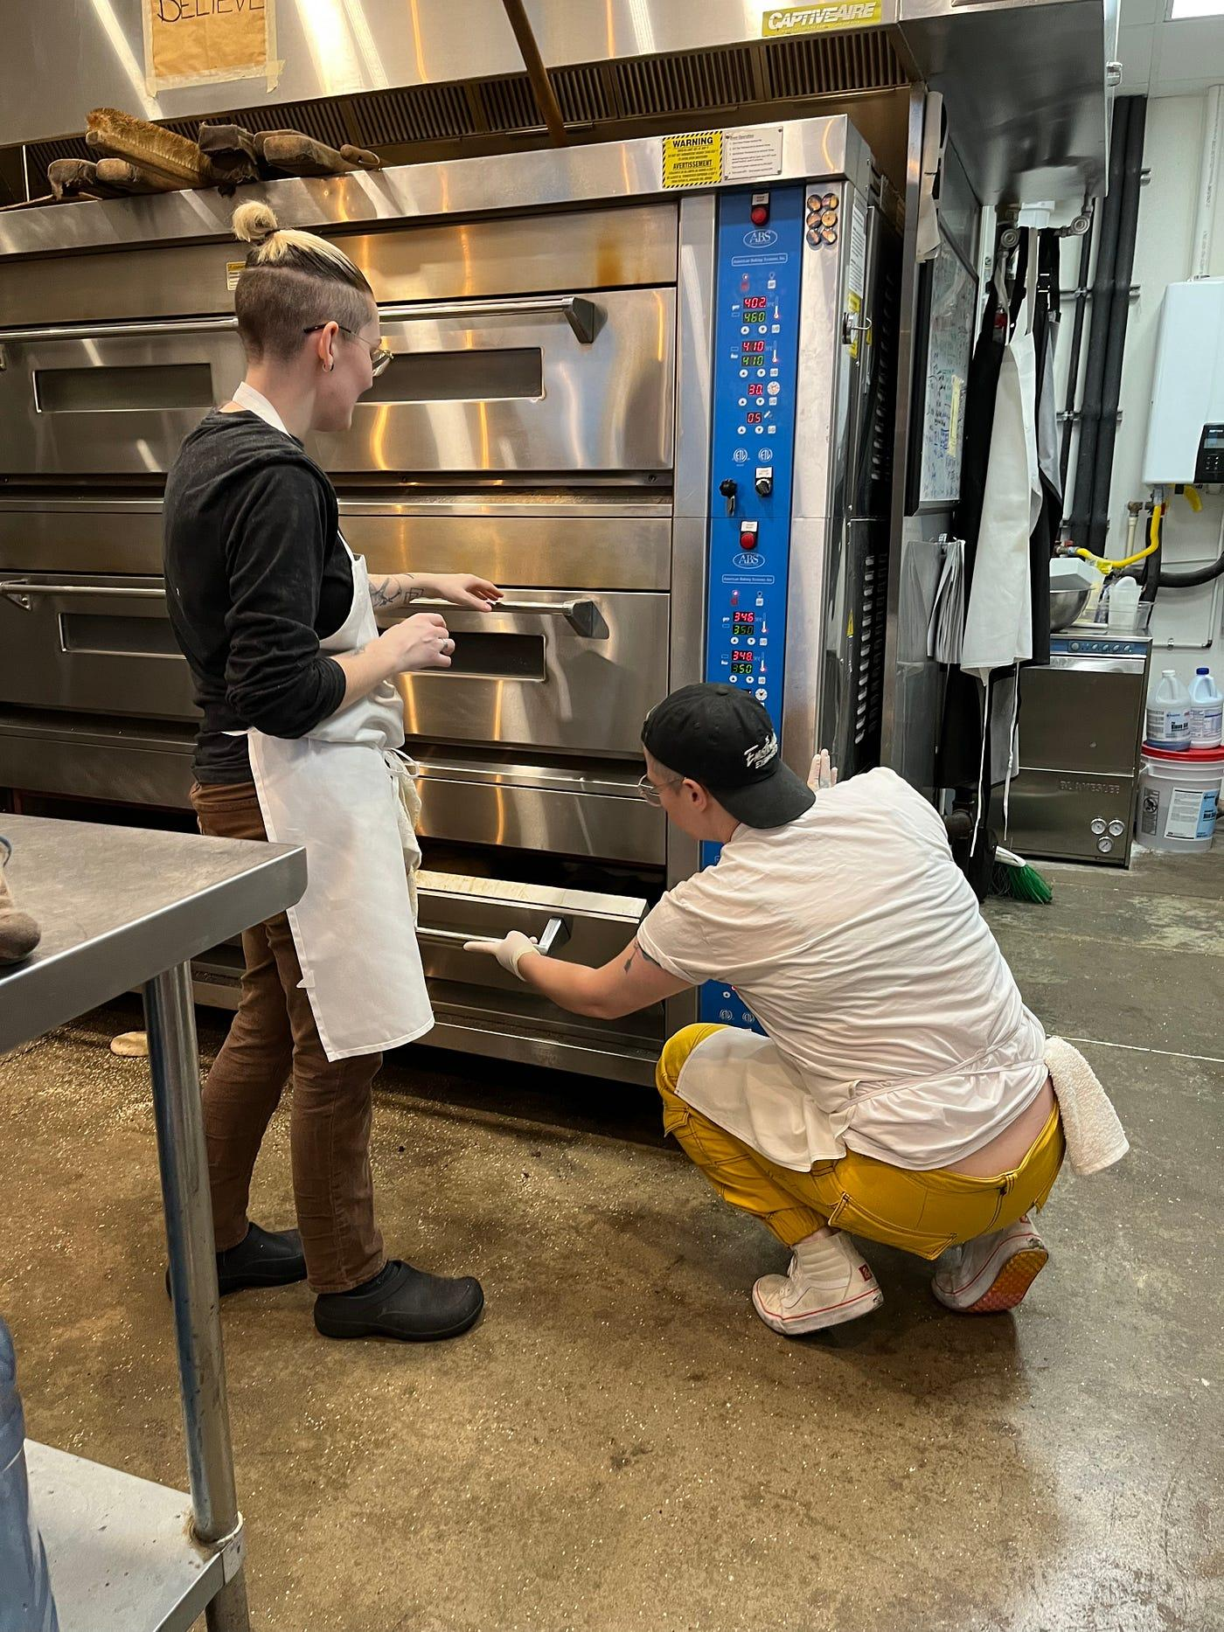

Courtney (left) and Riley (right), discussing how much longer the baked goods need to be in the oven for.

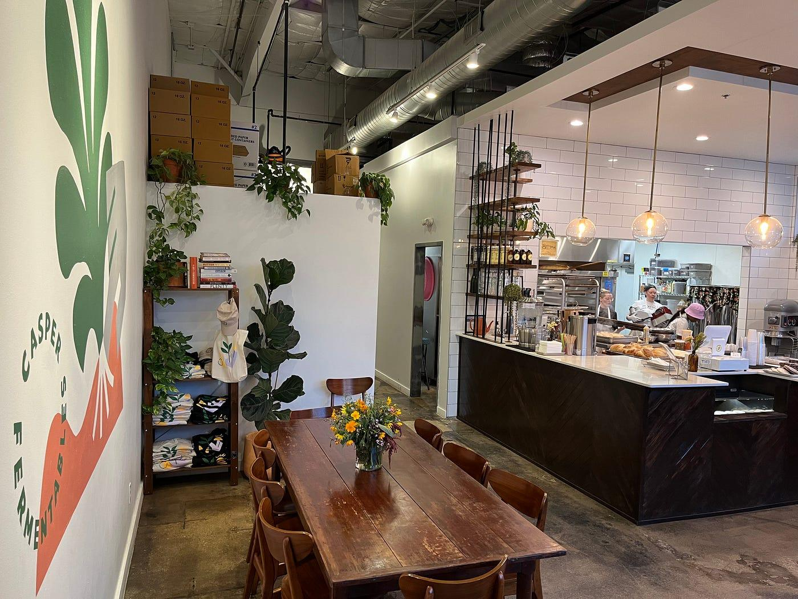

Casper Fermentables early in the morning. Having an open kitchen, customers are able to see exactly what’s happening with no secrets.

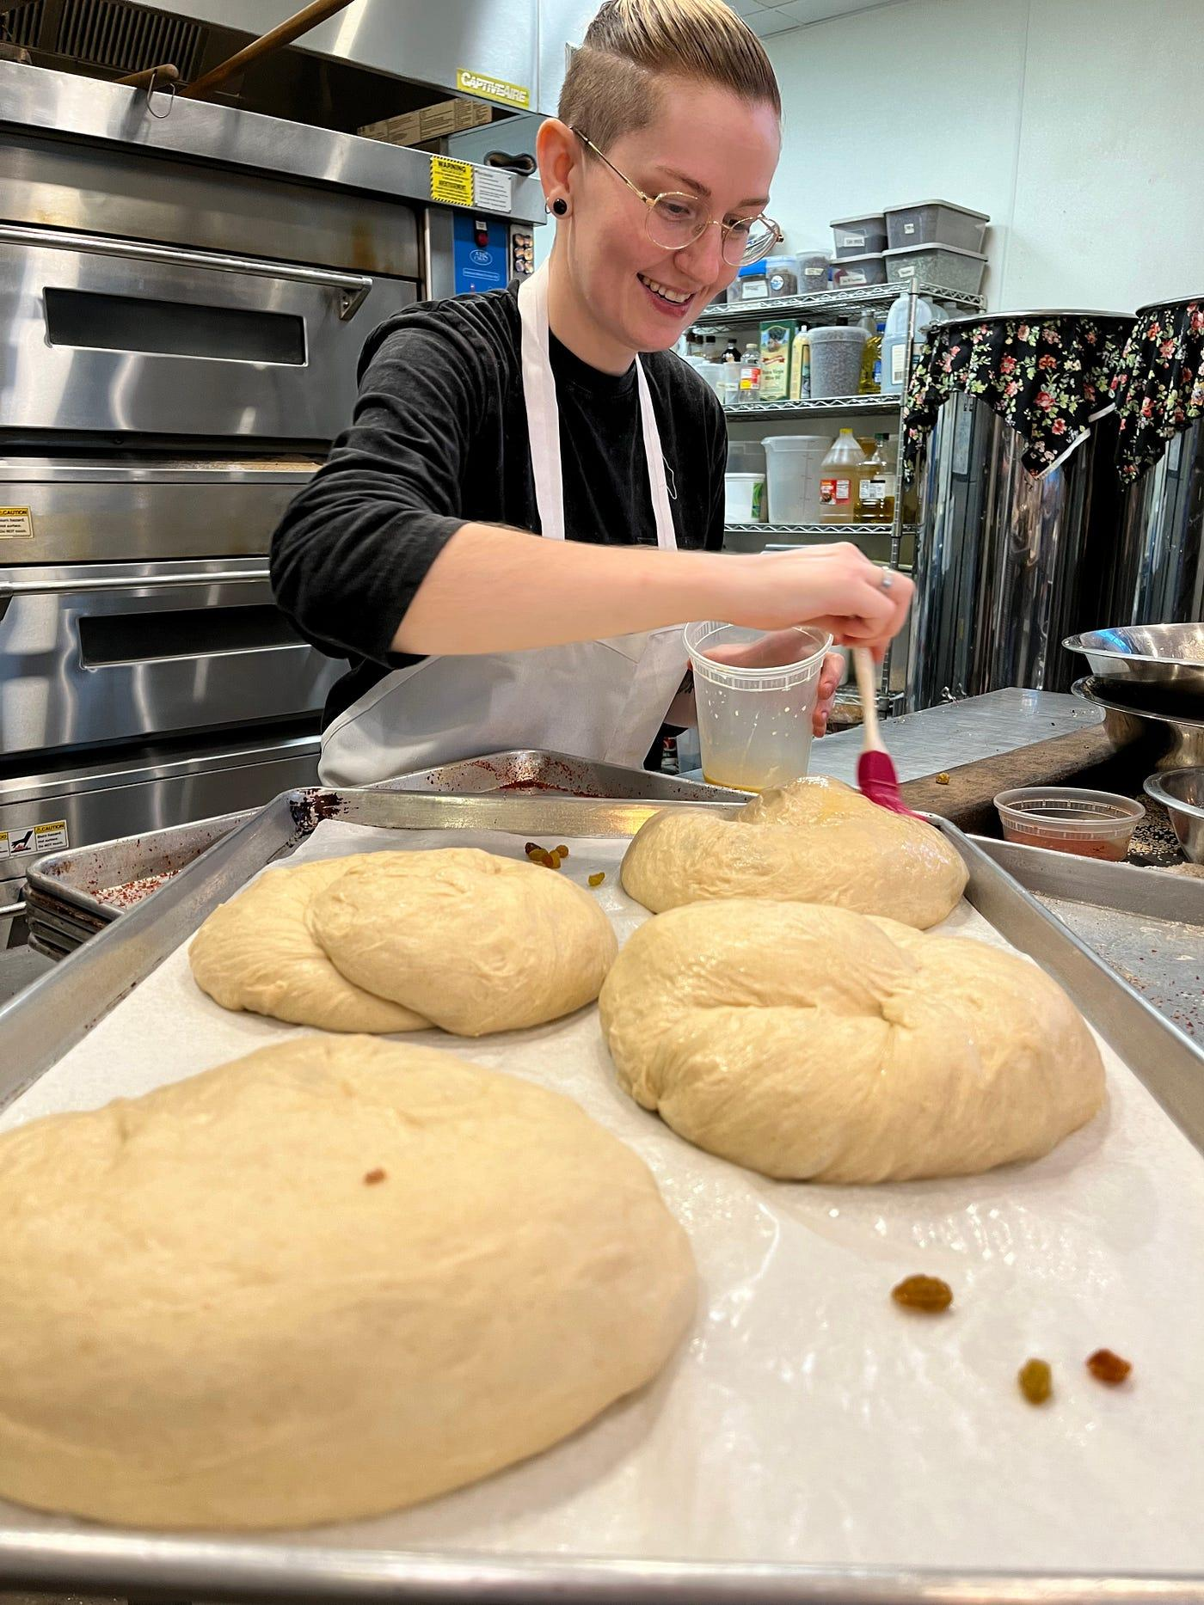

Courtney preparing round Challah bread for the Jewish holiday known as Rosh Hashanah. Shana Tova!

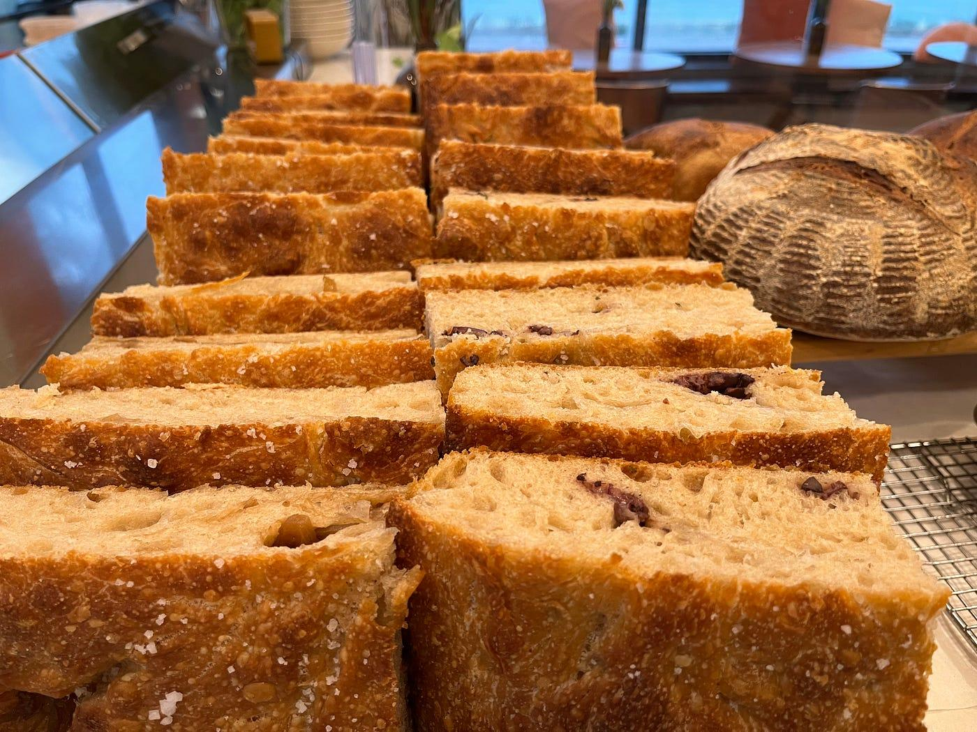

Olive focaccia bread and caramelised onion focaccia bread displayed by the window next to the whole wheat sourdough country loaf.

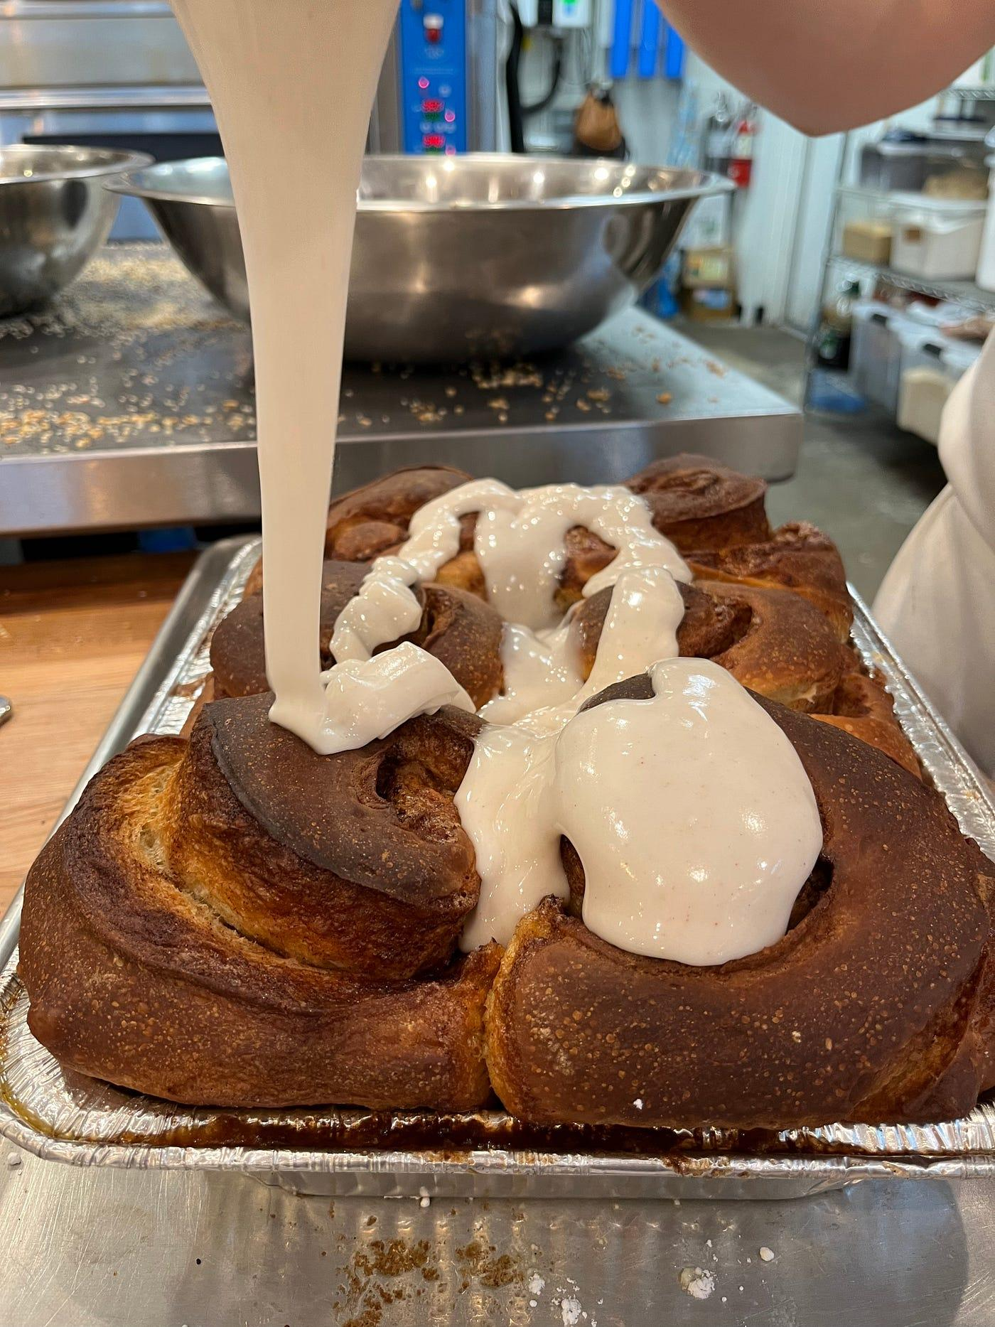

Massive cinnamon rolls being drizzled with the delicious frosting.

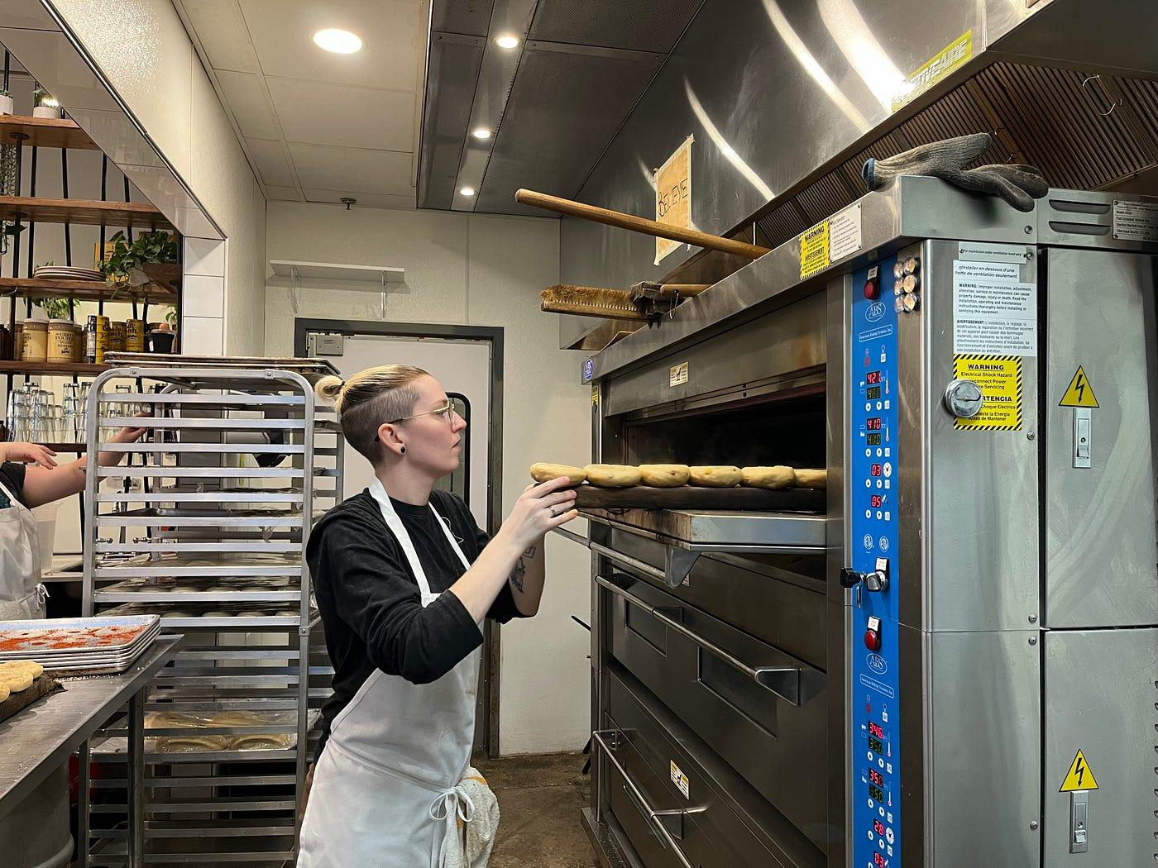

Courtney putting in the freshly boiled bagels into the oven to bake.

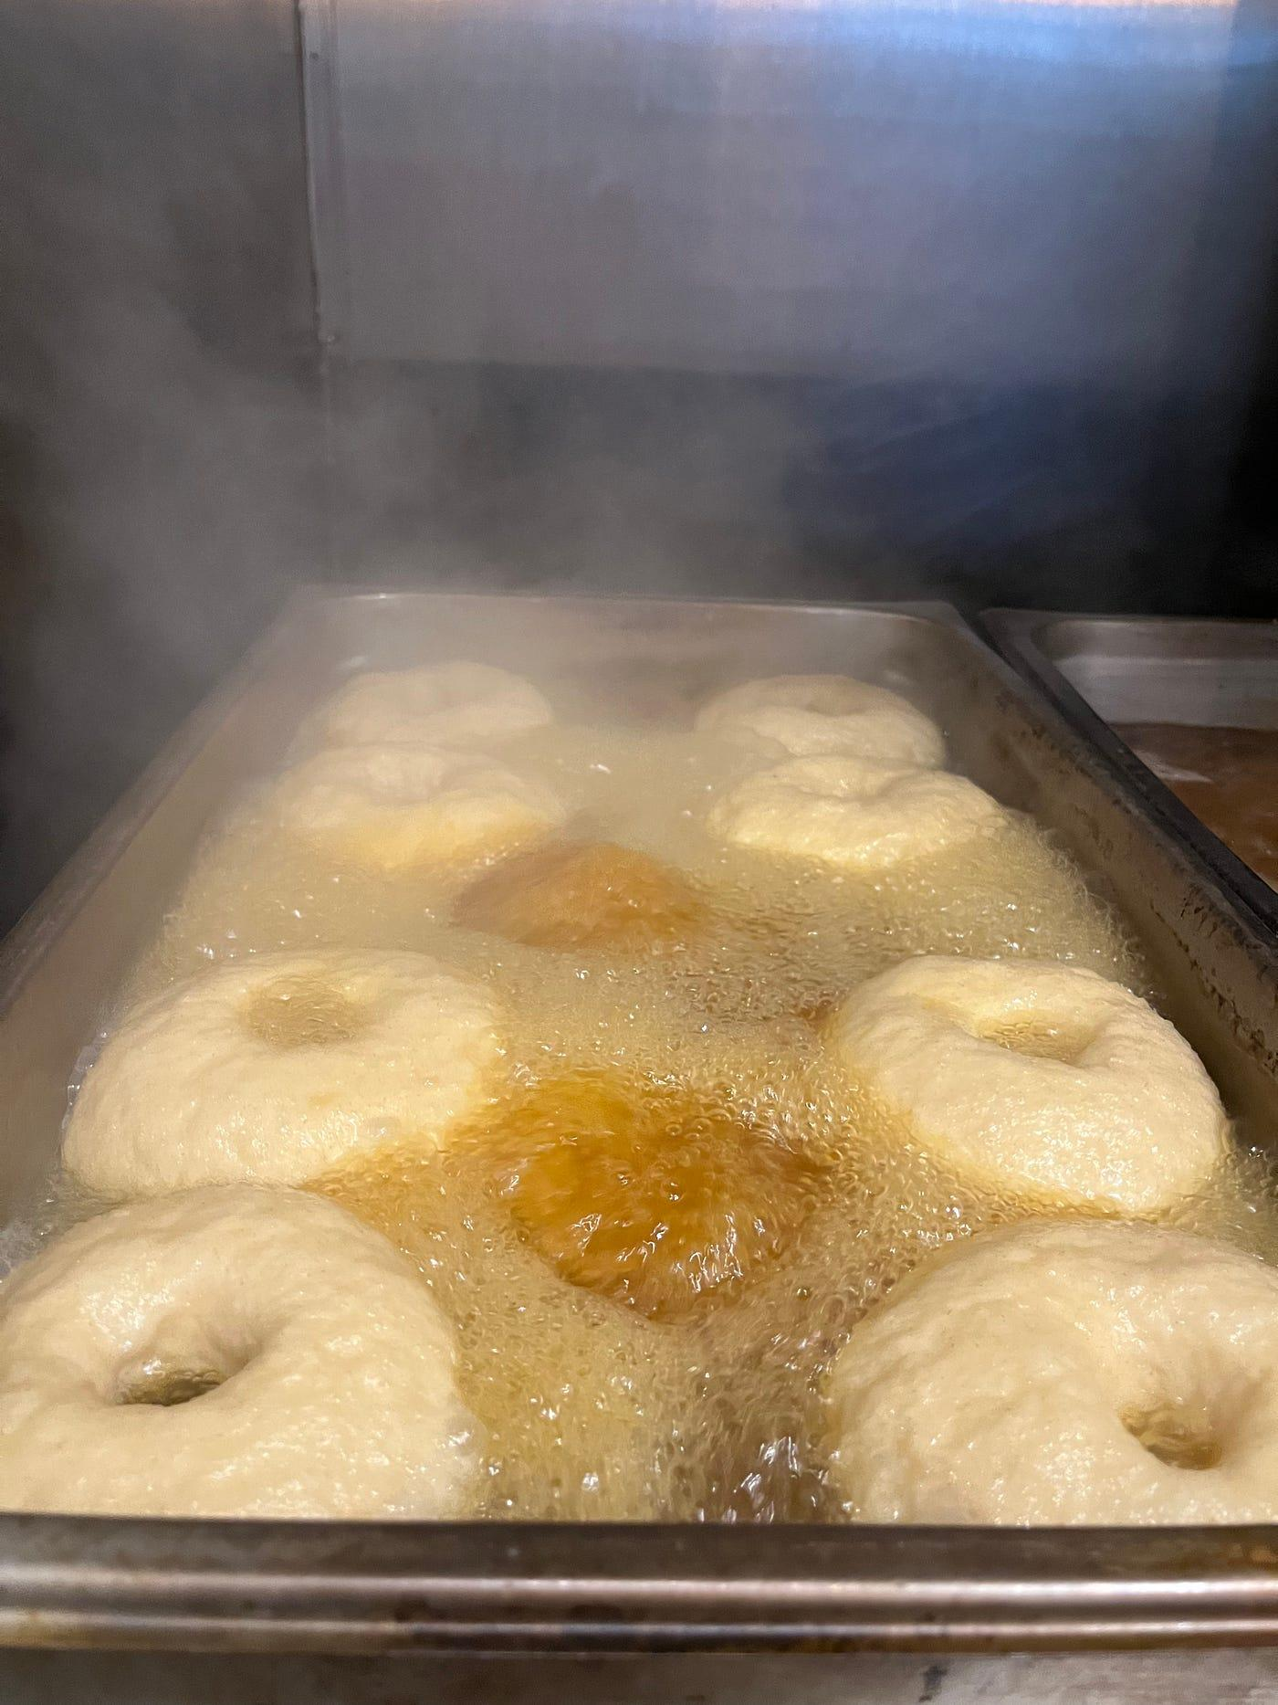

A close up of the bagels being boiled before going into the oven to bake. this creates the chewy texture with the crunchy outside bagels usually have!

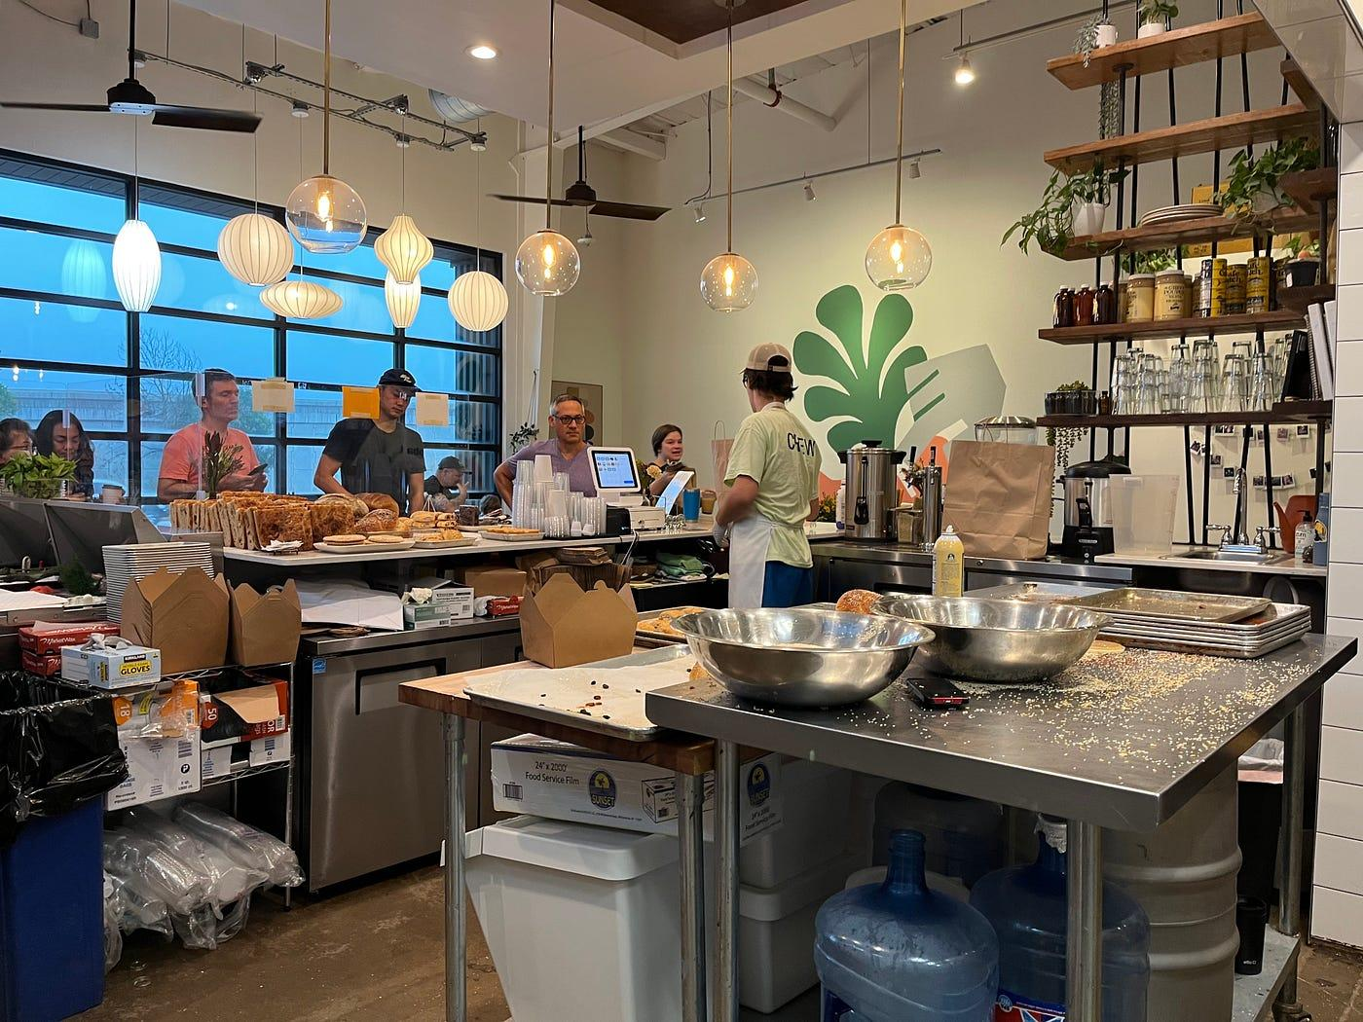

The restaurant is open for business! Ben (referred by the staff as Maes because they have two Bens!) serving customers who are lined up to purchase the freshly baked goodies.

For more information on this amazing bakery check out their website at https://www.casperfermentables.com/ or head over to their instagram page @casperfermentables