Raveena Devjee

COMM 4380 01

Dr. King

3 December, 2024

Essay #2: Online Social Justice Public Memory Project (RBG Mural)

Right across the street from an event building in San Antonio, there is a bright blue mural of a very important woman in American history and culture in general, especially in law. Her name was Ruth Bader Ginsberg (RBG) and she passed away in 2020. She is known for fighting for equal rights and equal rights for women as well. She was an activist who was a former associate justice of the Supreme Court of the United States. The mural is located on South Flores street and was done by an artist named Nik Soupè, who is a part of an artist duo who call themselves Los Otros Murals. Throughout American history, women have had to fight for the autonomy of their own body, the right to vote and to be treated as equal citizens of the country. RBG was someone who fought for those rights and in this essay I will be examining how memory and identity impacts how people can perceive a certain type of material rhetoric, in this case it will be a mural. I argue that murals like these help empower many young girls as well as grown women, and help show them that they matter and so does their voice. My main focus of this essay will be to analyze how social justice comes into play when we look at material rhetoric and how that impacts people's memory and identity memory.

The mural is painted on a wall of an art gallery called Gravelmouth Gallery. The mural stretches across the entire building and is painted a light almost sky blue color with little black bugs along to the top of the wall. The words “united we” in a cream color right next to a very iconic painting of RBG. The photo I am referencing is the photo taken by The New Yorker in their piece for remembering RBG after her death. This photo was taken in black and white and so the painting of her is also painted in black and hits of gray. Directly next to her face to the right, there are words painted in black that say “WOMEN BELONG IN ALL PLACES/WHERE DECISIONS/ARE BEING MADE/JUSTICE RUTH BADER GINSBURG/1933-2020” (Each of the dashes represents a new line.). At the bottom of the RBG painting, in silver, there are the social media tags of an artist platform and sustainable garden community, “@weare1906/@southtownsatx”. At the very bottom, in smaller writing, we have the social media tags of both the artists who contributed to creating this artwork which are “@SoupLAWS/@LosOtrosMurals”. I would also like to note that the blue in the wall does not match up as there are some spots where patches are darker than the others, but still overall a light sky blue.

(Mendoza, 2020)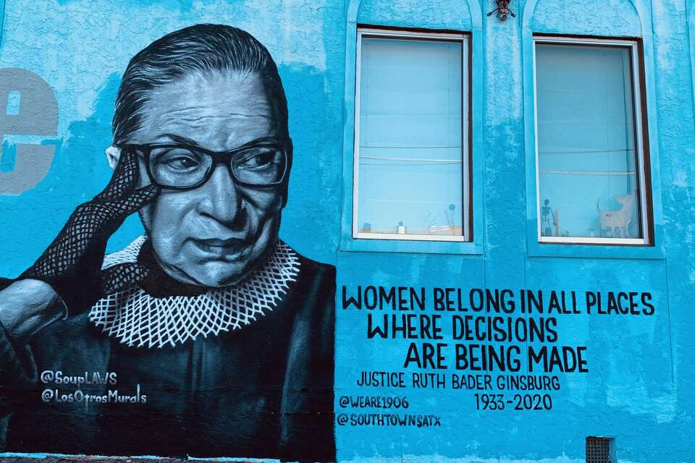

Now that I have given a detailed description of the mural, I would like to go into why this mural is important when it comes to the idea of social justice and material rhetoric. One of the reasons why this mural is so important, especially in a place like Texas and within the times we are living in today, is so that people can understand the history of women's rights and some of the important figures who did work behind the scenes. As of right now women do not have the right to an abortion in Texas, and this is something that RBG fought for. When it comes to the color choices, I believe that the use of blue and black as the two main colors was to catch the eye of the viewer, particularly the words. The quote is one of the most impactful things about the mural and allows people to be curious about RBG in order to read up on her more or just learn a little bit more about what she did for the people of America. The simplicity of the choice of photo is something to note as well. This allows people to focus purely on RBG’s face and nothing more. The face of a woman who fought for women.

This brings me to my next point about the idea that memory and material rhetoric impacts a person's identity. Using this mural as an example, a lot of people will be able to identify with the quote alone. The idea that women belong is something that is crucial, now more than ever before as we go through times that are scary for a lot of people. Being a woman is part of people's identity, and so when people see that not only do women belong, but they belong in places where decisions get made, it resonates with a lot of people. RBG made a huge impact on people, specifically women. People have stickers of her on their laptops, phones and water bottles because not only has she made an impact in the government and law system, but she made a cultural impact as well. She is one of the most recognizable figures from the supreme court and because of that, choosing to have her words as something for people to focus on, arguably more than the actual mural, only proves further that RBG was someone with immense power and people really identify with her. Women are not the only people who identify with this mural though. Men who may consider themselves to be feminists may identify themselves with this mural. Or in some cases as well, a father who has daughters, a mother, a wife or a sister who believes that these women deserve the same opportunities that he does.

I would now like to take a different approach to how people may view this mural. In reality, there are most likely people who do not like this mural or do not identify with the mural. There are reasons as to why this is the case. The first reason is because a man may look at this mural and think absolutely nothing of it, however, when a woman looks at this mural, they may feel seen, safe and empowered. This has nothing to do with whether or not the man is a bad person, but more about the fact that they simply do not have the same struggles as a woman has and therefore does not constantly think about similar things. The second reason is that a man is misogynistic or does not believe that women should or can be in power. This is a less likely but still highly plausible option as to why a man would not identify with this mural. The quote itself may upset this type of man and because of this, material rhetoric gets put at risk.

As discussed in class, material rhetoric has a history of being vandalized or destroyed by people who disagree with the intention or rhetoric itself. Unlike other forms of rhetoric such as music or written rhetoric, material or physical rhetoric runs the risk of being destroyed and because of that, a lot of material rhetoric does not stay around for long, or is constantly getting remade and put back up.

As of right now, we are currently moving towards a new presidency, and because of this, a lot of people are feeling a lot of fear, sadness and hopelessness. When we have material rhetoric like this, things that relate to social justice and the remembering of someone who has done a lot for social justice in the past, it allows for conversation. Not only does it allow for conversation, but it also allows for education and understanding. Considering a lot of women and gender non-conforming peoples rights are at risk for the next four years, it is important for people to have a place to have hope and a place to engage with people who have similar concerns and similar views as them.

To summarize some of the things I touched on, having a mural like this in Texas is especially important due to the times we are currently living in and some of the laws that are talked about being put into place. It is important to make sure that we have material rhetoric that represents social justice figures and events. Of course, there are always going to be people who do not want that to be the case, and so I provided a gendered perspective to examine the possible feelings people may have towards a mural like this. I touched on the idea of public memory and how it ties into identity. Lastly, I touched on the idea that there is a certain sense of vulnerability for material rhetoric and there is always a chance that it could get vandalized.

To conclude this essay, I would like to talk about some of the limitations that come with conducting this analysis on a digital platform. The first limitation I was able to come across was I was not able to ask anyone who has visited the mural in the past or was currently at the mural how they felt about it. Women, men or gender non-conforming individuals may all actually have different opinions than what I essentially assumed in this article. By not being able to conduct interviews, I am losing the voices of people's real time experiences of the mural and so therefore cannot actually make any accurate guesses about how people may feel about the mural, other than what I may think they will feel about it from personal experience and personal beliefs. The next is that I do not get to really see a lot of the real texture of decay if there is any of the mural. Upkeep is important when it comes to material rhetoric, and so when all I have is a picture, I have to take what I am looking at digitally as face value and nothing more or nothing less. When it comes to some of my key takeaways from this essay, I would say that the first one is that no matter how much people try to express love and compassion, there are always going to be people who would rather express hate and indifference. One of the things that I have found out not just through writing this essay but with general life experience is that no matter what, people will always be who they really are when it really matters, and there is nothing you can do about it. There are people who will tell you that they love you and care about you, and then turn around and do something that will inevitably affect the people in your community in a negative way, purely because it will not affect them, and that is not love, nor is it compassion. That is why I wrote this essay on Joan Ruth Bader Ginsburg. She fought and stood up for the people who could not or did not have a voice to express themselves and she took it into her own hands to do so. She was the voice for the voiceless.