Reviving Austin’s Rap Scene

Raveena Devjee
5 min read
Digital Media Production And Design Final Project
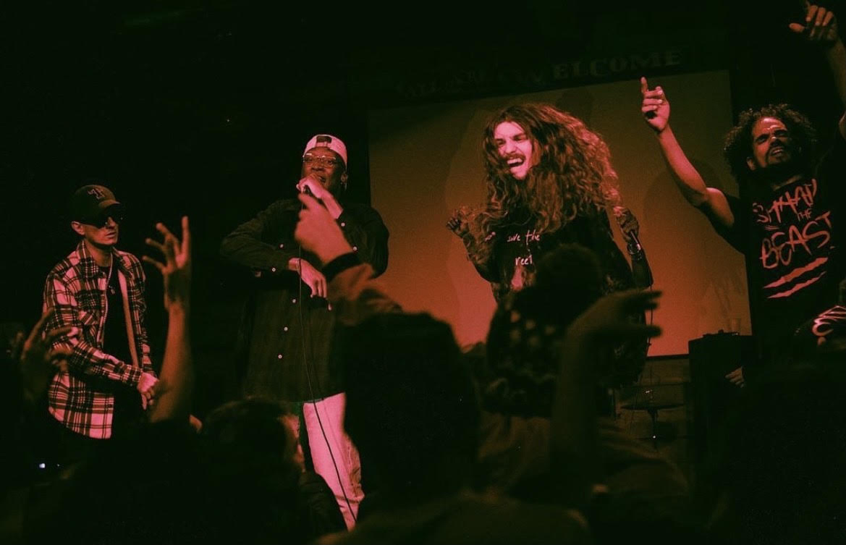
Header: Rap collective Space Goonz takes the stage at an open mic night in Austin, Texas, on Dec. 4th. Grassroots events like these are part of a drive to invigorate Austin’s rap scene.
What comes to mind when you think “Austin”? If you live here, it’s probably live music– yet in the live performance capital of the world, one genre is nearly invisible amidst the town’s omnipresent blues-rock and country music: hip-hop. And that is why the city’s rappers and artists gather every Monday for the Show-N-Prove open-mic night.
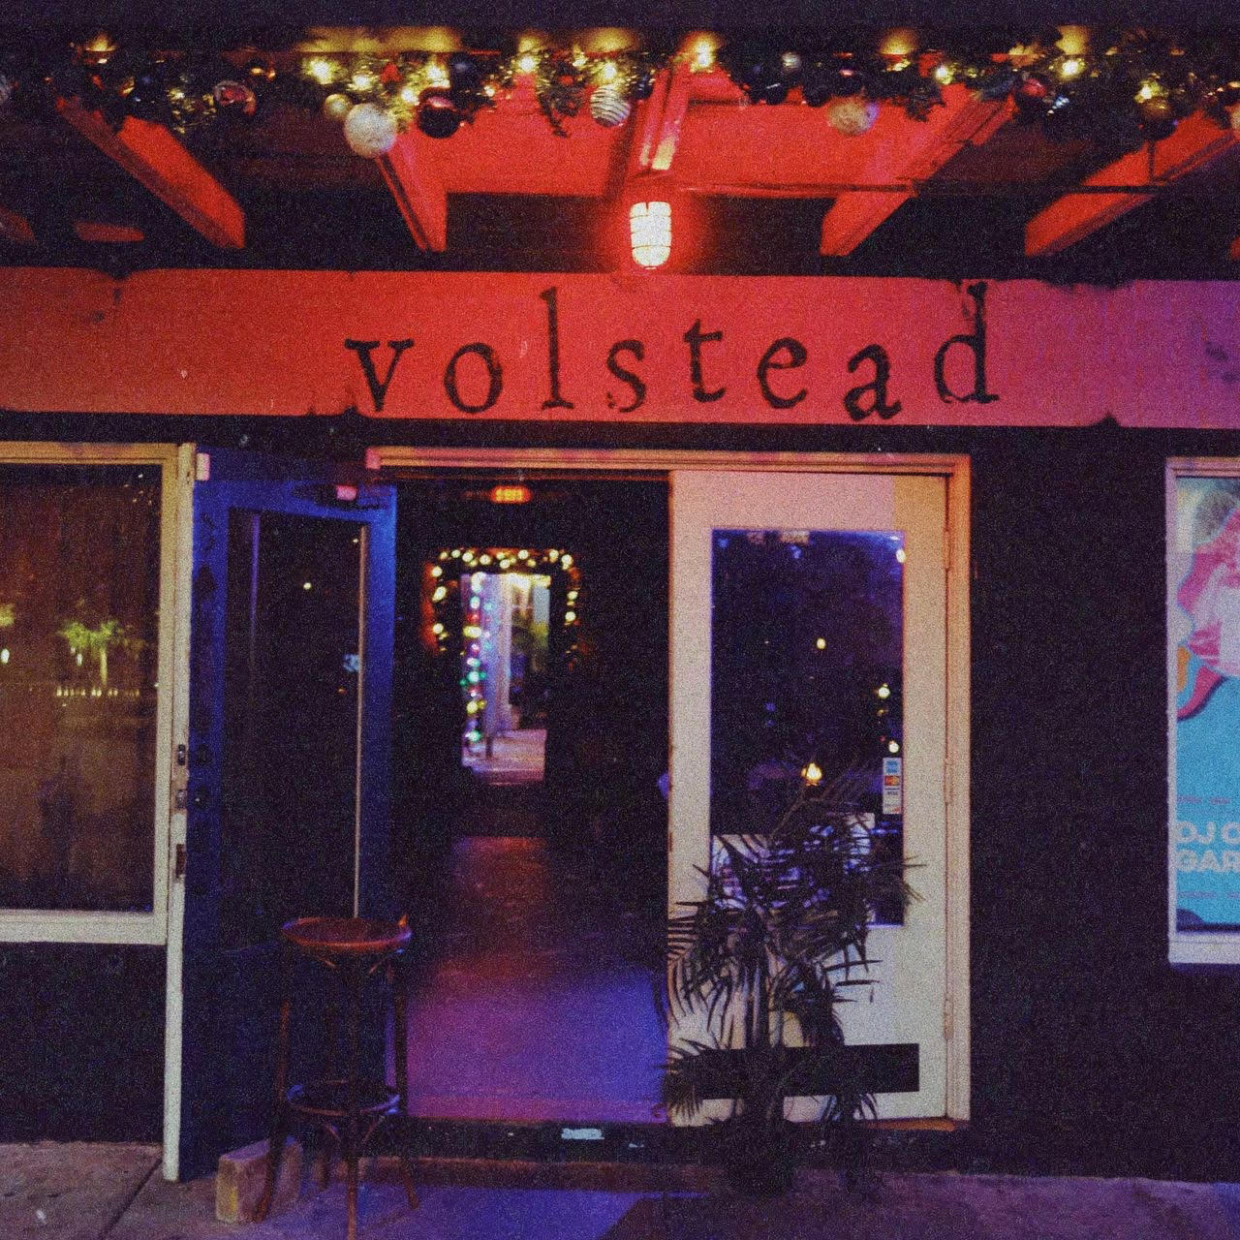
Front entrance to Volstead Lounge in downtown Austin, where the open-mic night is held. A location like this provides the community with somewhere reliable to convene.
The open-mic event is put on by Underground Voices, who are– according to their website– “an independent creative platform based out of Austin, Texas, dedicated to giving new and upcoming artists a voice.”
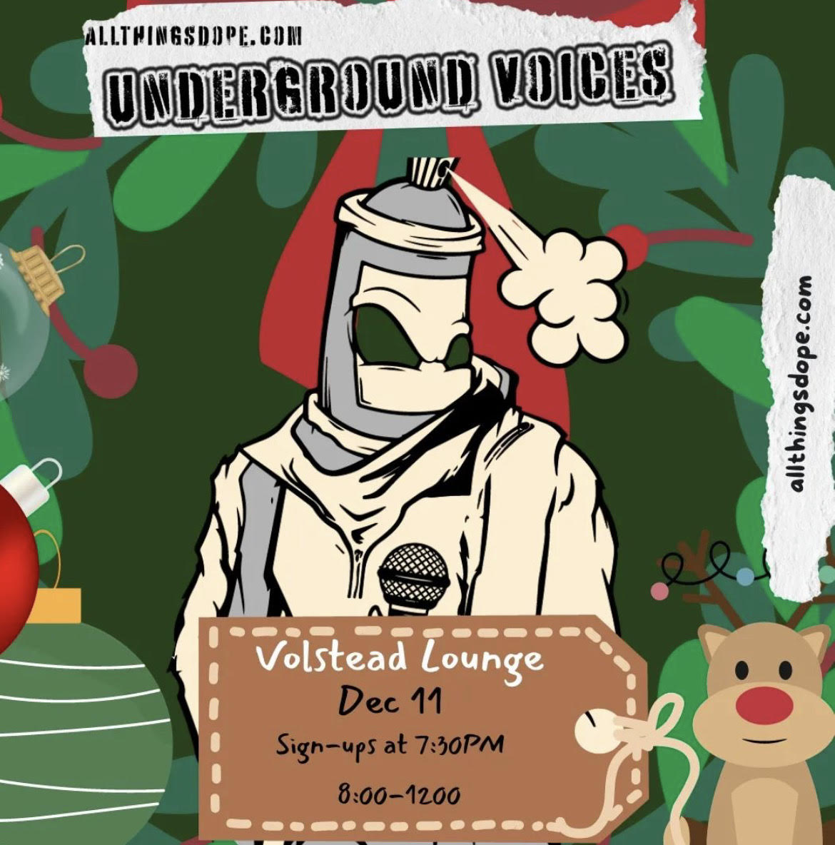
Event poster for the Show-N-Prove open mic night. Image by Underground Voices.
One frequent performer– Star Umbra of the rap collective, Space Goonz– said this about the organization: “Underground Voices is this platform, here in Austin, that allows any artist or creative to show their creativity and give their soul. So at Volstead, on Sixth Street, we have this open mic every Monday where…you come up and do your shit, but it’s not like any other open mic. This open mic is a concert. You will be shown love, you will be given love, you will be given critiques.”
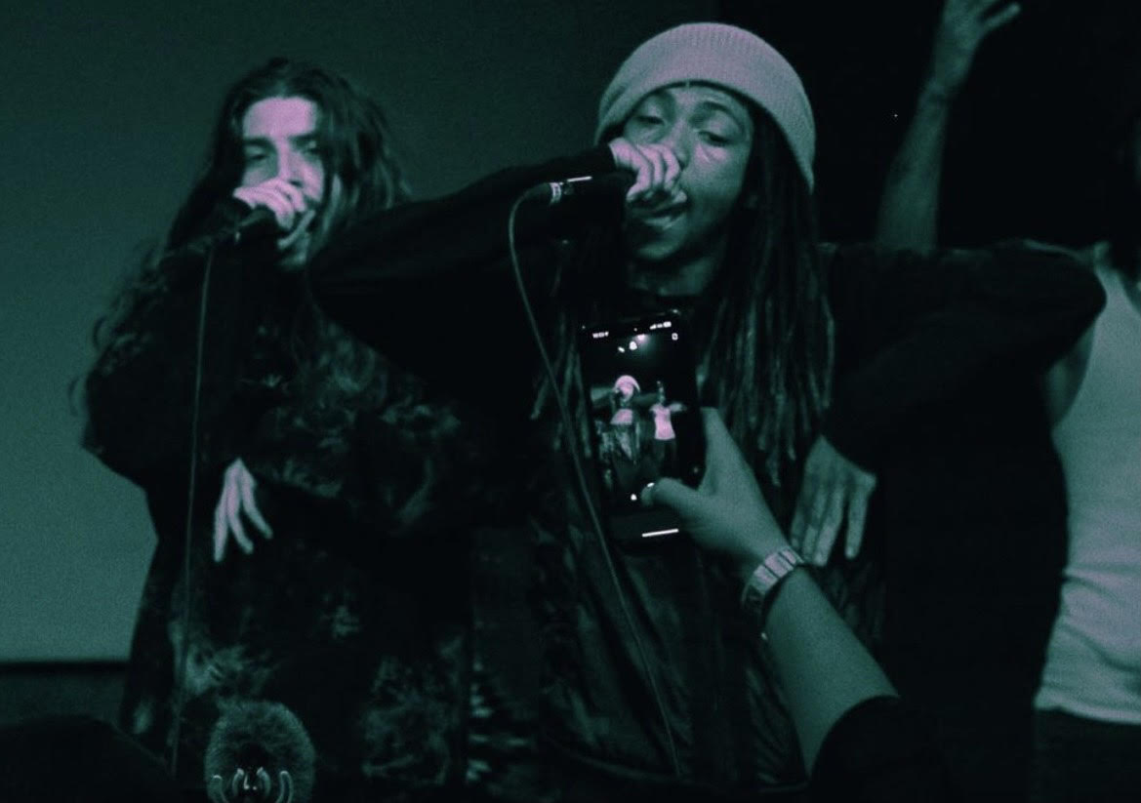
Star Umbra performing at Show-N-Prove as a part of rap collective Space Goonz. The collective wants to use Austin’s lack of big rap names to establish themselves.
But why is a platform like this so essential in the so-called “live music capital of the world?” Although artists have the opportunity to spread their name and use their voices to change the music scene here, according to the Austin Music Census, only 22.7% of Austin musicians are full-time; which means the other 77.3% are working elsewhere. 56% of Austin musicians are working a job in a non-music-related industry to keep themselves afloat since most of them will make less than $10,000 a year from music. Now, this may sound upsetting and disheartening– but also according to The Austin Music Census, “There are a healthy percentage of new entrants to the local Music Industry job market- 18.2% of the respondents [from the survey] have been working in the industry for two years or less. This could be a steady indication of steady job growth in certain segments of the Austin music industry.” A little less depressing, right?
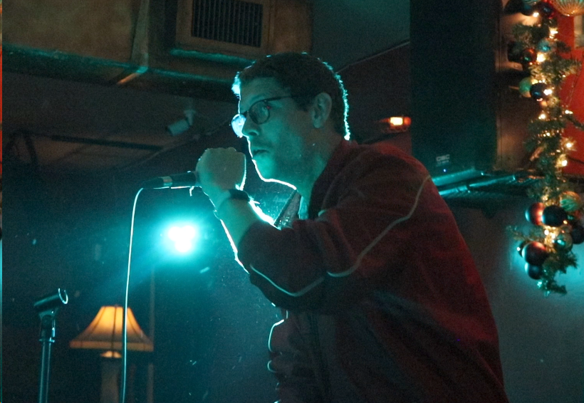
A DJ at Show-N-Prove warms up the crowd for the night. The nature of an open-mic night means that anyone, professional or otherwise, can give the stage a shot.
But musicians alone are only part of the picture. According to Trey Gutierrez of Texas Monthly, a staggering 54% of Texas’ COVID-related venue closures occurred in Austin. This data indicates an unfortunate truth regarding the situation– after all, what good is a musician without anywhere to record or perform?
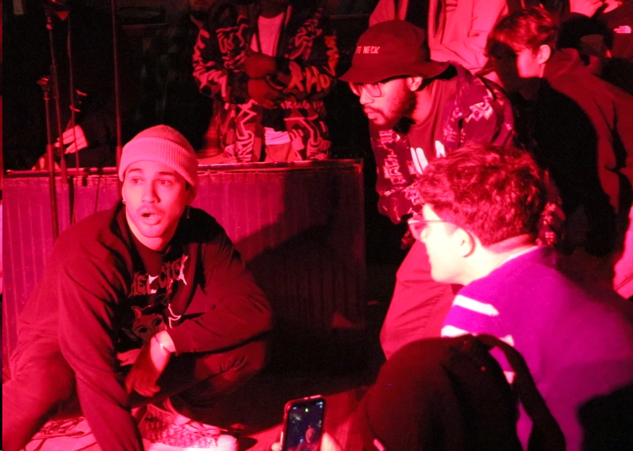
A performer “bringing it in” with the crowd during his set at Show-N-Prove. Intimate performance spaces like this one remove the barriers between artist and audience, which encourages healthy growth of the scene.
Grassroots organizations like Underground Voices present opportunities to artists not because of an established place in the Austin music industry, but despite a lack of it. It is not a matter of selling tickets, and it’s not just about putting on a show either. The open-mic night serves its performers first and foremost, giving them a place to convene and a platform from which to pursue the goal of bringing rap into Austin once-and-for-all. Volstead is giving artists, like Space Goonz, a platform to create a fan base, a voice, and hype around their upcoming projects. This type of publicity can help create a group of people who enjoy the same type of music that the collective has been craving to see all along in beautiful Austin, Texas… the equally beautiful genre of hip hop.
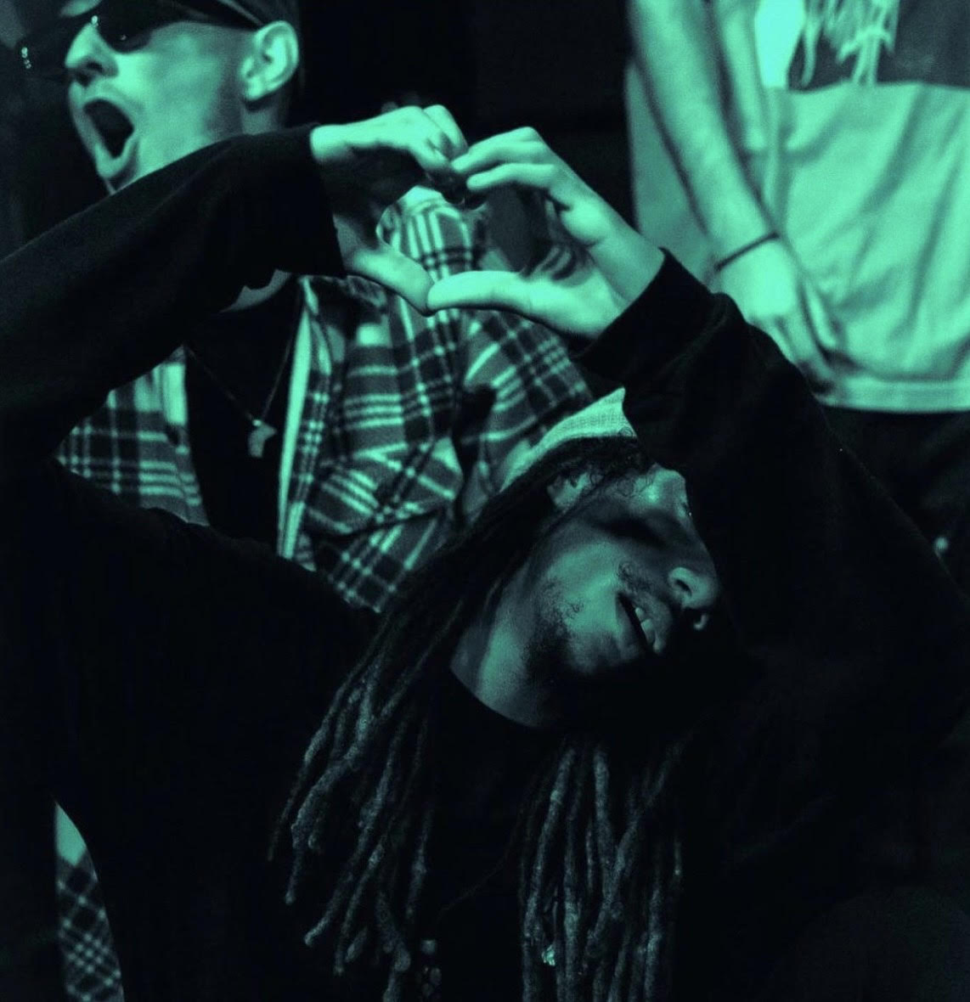
Star Umbra in the audience showing support to another performer. Numerous members of Space Goonz first met the others at Show-N-Prove and cited the sense of community there as being beneficial to their creative process.
Don’t believe me? Take it from the Space Goonz themselves.
CITATIONS
Veterans and Upstarts Alike Are Optimistic That Austin Hip-hop Will Finally Get Its Due — Even During a Pandemic — Texas Monthly
Underground Voices — allthingsdope.com
A Data-Driven Assessment of Austin’s Commercial Music Economy
SCRIPT
Completed Video Script

