Raveena Devjee

COMM 4380 01

Dr. King

6 December, 2024

Essay #3: Fieldwork Social Justice Public Memory Project

The Tejano people are a group of people who descended from Spanish speaking explorers who eventually ended up settling down in Texas. They were originally led by Spanish explorer Alvar Nunez Cabeza De Vaca who was one of the first people to describe the Native Americans and their language and cultures in 1519 (The Tejano Monument Committee, 2012). The word Tejano derives from the Hasinai Indian word Tejas, which means friends or allies (Texas State Historical Association, n.d.). However, there is a reason that the Tejano people are memorialized. According to John N. Seguín, “Even though many Tejanos had fought for Texas independence, they soon found themselves reduced to second-class social, political, and economic status. At first, Tejanos took an important political role in the new Texas republic. Lorenzo de Zavala was chosen the first vice-president and Juan Seguin became mayor of San Antonio. But especially after Mexico attempted to invade Texas twice in 1842, Tejanos found themselves stigmatized as aliens in their own land. After he was accused of supporting Mexico's attempted invasion, Juan Seguin was forced to flee south to Mexico.” (*Digital History*, n.d.). This then led to the Texas Government making sure that any Tejanos who left Texas during the Texas Revolution would be considered aliens. This then caused a spread of mass violence towards Mexican American landowners and Tejanos, including lynchings, beatings, riots and murder. Tejanos also served at the Alamo, and died for Texas. Essentially, the Tejano people were displaced and had a loss of power. The Spanish also took the Tejano people from Nacogdoches to Goliad, a 309.5 mile trail by foot, and brought them all to San Antonio. The Spanish killed four males every day for 270 days. That is 1,080 men and essentially eradicated the Tejano population, whilst also leaving the female population behind in 1814 (Wikipedia contributors, 2024).

Throughout this paper, I will examine the Tejano monument located at the Capitol in Austin, Texas and will discuss the idea of deliberate forgetting and why it is important that we have monuments like this, especially in the state that it happened in. The reason I chose to examine and talk about this monument is because I find it quite interesting that a community who tried to get rid of these people are the same people who decided to memorialize the Tejano community. I intend to argue that Texas has not done a good job at remembering the Tejano people correctly and why that is harmful for past, present and future generations .

As stated previously, the Tejano Monument is located in Austin, Texas at the Capitol grounds and is one of the largest monuments at those grounds. From what I was able to gather just by looking at it in person, it seems that the multiple bronze statues are placed on top of a large granite base, with other multiple granite slabs for height. There are ten separate statues, each representing something or someone different with a bar around the whole monument. Looking at it head on, you will see on the far right towards the back there are statues of a man and a woman, presumably a couple looking at each other lovingly, as the woman holds a baby and the man holds a branding iron. Lower down, in front of the couple, there is a statue of a young girl giving a sheep some water from what looks like it would have been some sort of clay flask and the sheep is drinking from a puddle on the ground. A little more in front of the girl, there is a young boy playing with a goat. He is pulling one of the goats horns as the goat tries to pull away, so it is possible that he was trying to take it somewhere, but the actual reason is unclear. Right behind the boy, on a higher level of granite, there is a Texas longhorn. While I was there in person, unfortunately someone had put some a pair of socks on the longhorns horns but apart from that, it also looked as though there was a branding on the left side of the longhorns back leg, assumably from the branding iron of the man who was holding it as I previously described. There is a second longhorn located right behind the first longhorn as well. After some further research, I found out that the specific type of longhorn in the statues were actually “The longhorn cattle and the mustang are shown with the specific conformation of the original stock peculiar to South Texas.” (Texas State Historical Association, n.d.). Moving towards the right hand side of the statue, (Assuming you are facing it head on), located a little higher on a platform of stone, there is a statue of a Spanish cowboy sitting on a horse. There also appeared to be a piece of clothing on top of the monument, which was not a part of the monument but something that was either thrown or placed there by someone in the public. Just like the two longhorns, the horse is branded as well. At the highest level of the monument, there is a statue of a Spanish explorer, looking out into the distance with a sword by his hip. Everything in this monument is meant to represent the real lives of the people as stated by the Texas Historical Association “All of the statues are life-sized and sculpted to reflect historically accurate features and artifacts of the early to mid-nineteenth century…. The saddle, the brand, spurs, and other accoutrements of the *Tejano* statues are meticulously sculptured to depict artifacts of *Tejano* ranch life.” (Texas State Historical Association, n.d.). At the bottom of the monument, there are five separate plaques, each with a different title and the history of the respective topics.

At first when I arrived at the monument, due to the fact that before this paper, I was unfamiliar with the Tejano people, I was unsure about what was going on. However, after reading the five plaques that were provided at the bottom of the monument, I was able to gain a better understanding about who the Tejano people were and how they ended up in Texas, as well as how they were involved in the Texas Revolution. I will say that without a Google search there would be no way for me to have known that the Tejano people were eradicated in Texas because it did not say anything about that in the plaques about the men being killed off etc.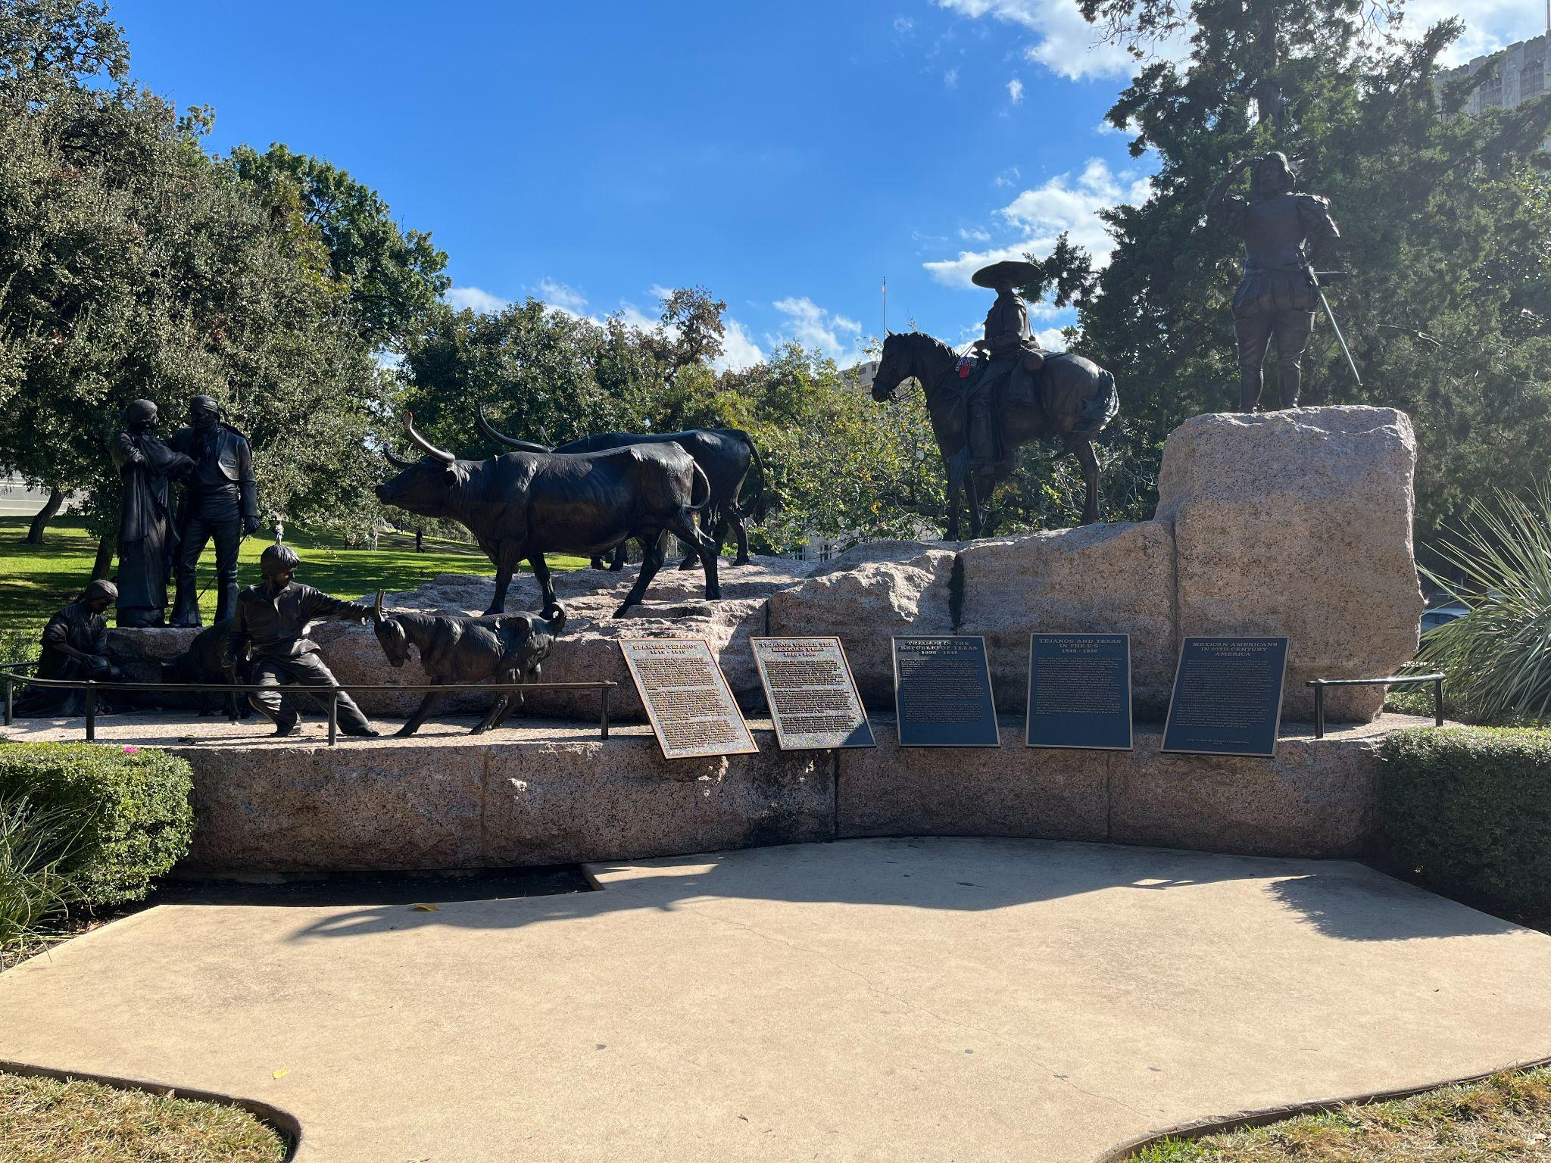

I will now discuss what it means to me as a person who has no connection to the Tejano people and then take a deeper look into what it may mean to people who are descendants or have a family history with the Tejano people. As someone who has no connection or even any previous knowledge with or about the Tejano people, this monument at first look, was great. Although it did not portray any hardships that the Tejano people went through, I thought it was a really beautiful homage to a community of people that contributed so much to the state of Texas. However, not adding the fact that the Tejano people suffered a lot while also contributing to the state seems to be a part of my first example of deliberate forgetting. Violence and intimidation towards the Tejano people to leave the state caused a lot of them to leave, but it also created a lot of murder of the people and that was not talked about at all in these plaques. I believe this was done in order to highlight the good impact the Tejano people had on Texas and for that to be the main focus and not the murdering and displacement of them. From an outsider's perspective, this may seem like a good thing. The fact that Texas is trying to show that the Tejano people were more than an eradicated group of people is a good thing, however, people who have ancestors and Tejano blood in them may not feel the same. Of course, I cannot speak on behalf of all people who have Tejano ancestors, but I would be willing to assume that some of them would feel like a part of their history, identity and culture has been erased in this monument or more specifically the plaques. This could be due to the fact that these people experience generational trauma, through storytelling and other types of rhetoric, and this stays with them, even if they are not aware of it.

I will now discuss how this monument perpetuates forgetting but how this monument is something that has tried to remedy that. Understandably, not every memorial monument is perfect and so with that in mind, I do not want to be too harsh, however, I feel that it is necessary to critique when necessary. As stated in my purpose argument statement, I do not believe that Texas has correctly remembered the Tejano people and I feel like there was a certain level of erasure within this monument. I am not at all saying that Texas did not have the right intentions. However, I do not think that they really had the Tejano people in mind when creating this monument and I believe that it was more for themselves to look good rather than for the Tejano people to feel welcomed and have some representation. I think that it is really important and helpful that Texas decided to give so much information of the importance and impact the Tejano people had on Texas, but what I do not agree with is the erasure of the murder and hardships that the community went through.

In conclusion, as I stated in my argument, I find it hard to believe that this monument has done more good than bad. However, I am not negating that this monument has at least done some good. I think this monument has done a great job at representing the Tejano people historically accurately and it does a great job at explaining the history of them from the beginning. Although, there was no mention of the displacement and murder and violence this community faced, and I feel like that only maintains the idea of deliberate forgetting. Texas has tried to cover up an ugly part of their history which, presumably, they are not proud of, but I think the first step of progression is taking accountability and being able to admit to your mistakes. Without accountability, there is no room for improvement and I think that this only allows for more mistakes like this to happen again and again, especially when we think of past genocides and past mass murders. There are always going to be people who do not agree that monuments like this are important and that they do not do anything for a community, but I would disagree. Monuments like this create representation and representation makes all the difference to communities who may not have a lot of exposure in the first place. Sometimes the only thing a community wants is to be seen and heard, and that is the first step to making this world a better, safer and more accepting one.

In regards to my experience conducting field work, I enjoyed the trip. After my classes on a Monday afternoon I drove down to the Capitol where I could not find any parking nearby, so I had to park about a 15 minute walk away and arrived at the monument around 1:30pm. I then took some pictures of the monument from different angles and took pictures of all the plaques and pulled out my notebook to take notes about what I saw and experienced at the time and did this while I sat on the grass right in front of the monument. Two things that I immediately noticed was that there was a piece of clothing on the statue of the man on the horse and then again, there was a pair of socks on each of the longhorns horns and my first thought was, “I wonder how long those have been there.”. After conducting my first impressions and noting down what I saw, I took a walk over to the information center and asked the lady at the desk if they had anymore information on the Tejano monument or just the Tejano people in general and she said they did not but told me to ask the history department inside the capitol building, so I walked over and did that. I explained to the man inside that I was a student at St. Ed’s conducting some research on a public memory paper I was going to be writing about the Tejano monument and asked if they had any more information, to which he replied that they did, but the public was not allowed access to it. When I asked why he told me he was not allowed to answer that question and wished me luck on my paper. I found this really interesting because why would the public not be allowed access to history itself? Some of the field work tips I took with me from the first project was to not be afraid of what people may think of you while you take notes etc. While conducting field research at the Tejano monument, I had a little kid come up to me and ask me what I was doing so I explained it to him while his mother listened, because I think she may have been curious too. I also think it taught me that it is important to ask questions when you can because you may not get that chance or that information if you do not.

References

Texas State Historical Association. (n.d.). *Tejano*. Retrieved December 5, 2024, from <https://www.tshaonline.org/handbook/entries/tejano>

Wikipedia contributors. (2024, November 21). *Tejanos*. Wikipedia. <https://en.wikipedia.org/wiki/Tejanos>

*Digital history*. (n.d.). Retrieved December 5, 2024, from <https://www.digitalhistory.uh.edu/disp_textbook.cfm?smtID=3&psid=549>

Texas State Historical Association. (n.d.). *Tejano monument*. Retrieved December 5, 2024, from <https://www.tshaonline.org/handbook/entries/tejano-monument>

THE INSTITUTE OF TEXAN CULTURES. (2014). The Tejanos. In *THE INSTITUTE OF TEXAN CULTURES* (Revised 2013, pp. 1–2). <https://www.depts.ttu.edu/international/intlopr/k-12geo/documents/prepost_resources/GTT/GTTPreVisitActivitySpanish.pdf>