RENTAL INFORMATION FOR 50 PEOPLE OR LESS

MOMENCE PARK DISTRICT
RATES EFFECTIVE 1-1-2021
RATES SUBJECT TO CHAGE AT ANY TIME
GROUPS OVER 50 PEOPLE REQUIRE A MINIMUM OF 60 DAYS NOTICE, BOARD APPROVAL AND SECURING CERTIFICATES OF INSURNACE; THIS APPLIES TO ALL RENTALS INVOLVING EXTRA EQUIPMENT INCLUDING BUT NOT LIMITED TO: INFLATABLES, SERVING ALCOHOL, PRIVATE SECURITY, POWER AND WATER ACCESS TO OUTDOOR SPACES. PLEASE CHECK THE WEBSITE: momenceparkdistrict.org, CALL OR COME INTO THE OFFICE WHEN PLANING YOUR EVENT. ALL PARK RULES APPLY DURING RENTALS. THE PARK DISTRICT CAN NOT PROCESS CREDIT OR DEBIT CARDS. CHECKS, CASH OR MONEY ORDERS ARE ACCEPTED.
NO GLASS CONTAINERS AT ANYTIME.
 | IN DISTRICT | DEPOSIT | TOTAL  TO  RESERVE | OUT  OF  DISTRICT | DEPOSIT | TOTAL  TO REERVE
ALL OF  ISLAND PARK | 2,200.00 | 1000.00 | 3,200.00 | 3,300.00 | 1,000.00 | 4,300.00
EAST PAVILION | 200.00 | 100.00 | 300.00 | 275.00 | 100.00 | 375.00
ROD & RAIL PAVILION | 100.00 | 35.00 | 135.00 | 150.00 | 35.00 | 185.00
EAST HALF OF ISLAND PARK | 550.00 | 300.00 | 850.00 | 700.00 | 300.00 | 1,000.00
WEST PAVILION  (BANDSTAND) | 175.00 | 100.00 | 275.00 | 250.00 | 100.00 | 350.00
FIELD HOUSE | 125.00 | 75.00 | 200.00 | 200.00 | 75.00 | 275.00
**ADITIONAL FEES ADDED TO RENTAL RATE FOR: *RETURNED CHECK FEE 75.00*
*EACH INFLATABLE | 50.00 | 50.00 | 100.00 | 50.00 | 50.00 | 100.00
*EACH INFLATABLE  WITH WATER | 100.00 | 50.00 | 150.00 | 100.00 | 50.00 | 150.00
*PICNIC TABLE RELOCATION | 1-5  50.00 | 6-10  100.00 | 11-15 (MAXIMUM)  200.00
*OVERPASS ACCESS PER OCCOURANCE  (NOT RECCOMENDED) | 225.00
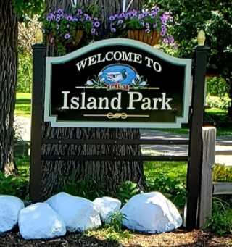
Momence Park District 815-472-2670
79 MILL STREET BOX 665
MOMNCE, IL 60954 momenceparkdistrict.org
momenceparkdist@sbcglobal.net

