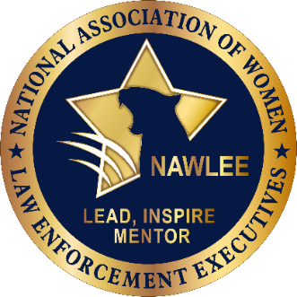
486 Main Street
West Townsend, MA 01474
913-579-0003
www.nawlee.org

NAWLEE 28th Annual Conference Registration Now Open!

The NAWLEE 28th Annual Conference is fast approaching and we are counting on you being there to make this the most successful conference in NAWLEE’s history. The 2024 conference will take place April 23-26, 2024 at the Mirage Hotel in Las Vegas, Nevada. Now is the time to ensure you will be in attendance at the premiere educational and networking event focused on women in policing and the most pressing issues facing agencies in today’s complex law enforcement environment. Join your colleagues from across the country and our international partners to learn and collaborate with women and men representing the full spectrum of policing including; state, local, tribal, federal, school, hospital, corrections, and campus agencies.

Registration Rates and Information

Member Rate: $625
Non-Member Rate: $725 (Join NAWLEE today to receive the discounted rate.)

In addition to three days of educational opportunities (over 40 breakout sessions and keynote speakers) with subject matter experts from across the country, you receive three breakfasts, three lunches, an opening reception, admission to the awards banquet and reception, and networking opportunities with your peers and our sponsors and vendors.

To register and for more information click here.

For questions, please contact NAWLEE at conference@nawlee.org.

We look forward to seeing you at the Mirage in April!

Sincerely,

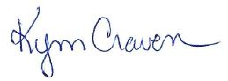
Executive Director

