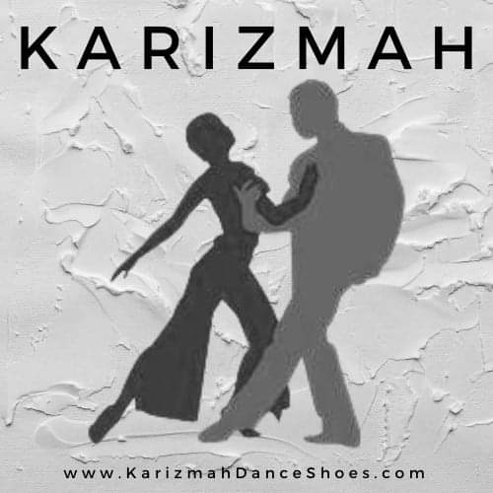
Twitter: @KarizmahShoes TikTok: @karizmahshoes Instagram: karizmah.danceshoes

Karizmah Dance Shoes & Boots
Re: Teacher Referral Program
Welcome to our Teacher Referral Program here at Karizmah Dance Shoes & Boots.
First, we want to take a minute and recognize you, a teacher, as one of our best advertisers. Your students pay attention to how you carry yourself and what attire you wear when you do so.
We try to stay in tune with both your shoe/costume needs as an instructor /performer, as well as the requirements you have for your students. Communication with us is valuable in this sense.
So, if you ever desire a particular shoe style, heel height, color, fit, etc. for your students, please don’t hesitate to let us know. We can also make ourselves available to take shoes to you at certain times throughout the year as necessary, or for special events. With a little planning, we can work out many solutions.
We try to inquire from all the students here in the store as to their teacher and dance styles (helpful in which selection we steer the customers), but sometimes, especially during peak hours, it can get overlooked. Be sure the student gives us your name at check-out, or for online purchases puts your name in the Notes Selection.
One of the benefits we offer our teachers is a gift certificate/store credit for $85 after 10 pairs of full priced shoes are purchased under your name. We keep a tally of those purchases, which we refer to as “credits’”.
Noteworthy: Teacher credits are NOT valid on Sale or other discounted items, consignment, and other promotions. We have found this to be a source of confusion.
I want to thank you for sending us your information to be added to our teacher base. Please don’t hesitate to contact us for your Dance Shoes!

