The Lift Industry Mental Health Charter Snowdon Event
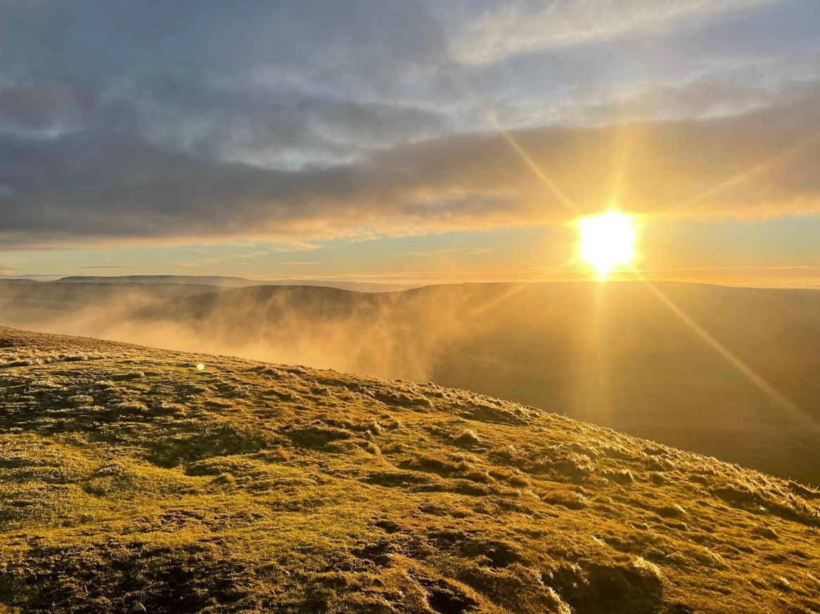
Entry Form

THE EVENT OVERVIEW
The Lift Industry mental Health Charter is proudly hosting the Snowdon event. An event to promote good mental health through exercise and bringing people together through the camaraderie of the lift industry. The event takes place on Friday the 5th of July through to Sunday the 7th of July. We plan to stay at the event campsite for 2 nights, Friday the 5th and Saturday the 6th of July. Returning home on Sunday the 7th of July. The walk-up Snowdon will be on Saturday the 6th of July where we will meet at the back of the Café at the top of Snowdon at 13:00. Each person is expected to bring a company flag showing their logo on one side and a mental health message on the reverse. You can join us for the walk and 1 night, or stay for the 2 nights, the choice is yours!
The event will cost £75 per person which will include the campsite for 2 nights (Bring your own tent), breakfast on the Saturday morning, and dinner on the Saturday night. There will be non-alcoholic drinks available at the campsite throughout the event, but of course you can bring your own.
50 Places available!! So book your place soon!

The Campsite Accommodation
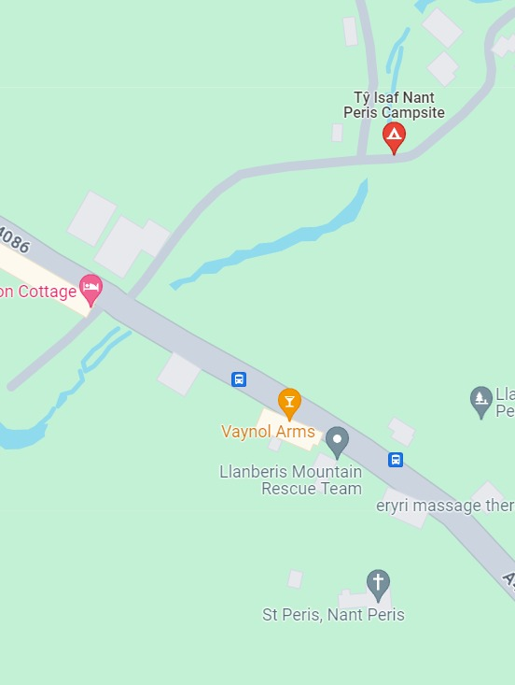
The Ty Isaf Nant Peris campsite is only a few miles from the foot of the lamberis path, but only a short walk away is the local sherpa bus service which takes you to the foot of the lamberis path. So, you can start your walk with a bus ride on the Saturday morning. There are basic facilities at the campsite and barbecues are welcome.
More importantly the pub, Vaynol arms is only a short walking distance away. Further plans will be released regarding food and drinks on the Saturday night at a later date, along with meeting on the Friday.

Campsite Address:
Gwersyll Ty Isaf Campsite,
Nant Peris,
Gwynedd
LL554UN
Bus Timetable
https://snowdoninfo.com/wp-content/uploads/2023/03/parkride-S5-S1-S2-summer-2023.pdf

The Meeting Point
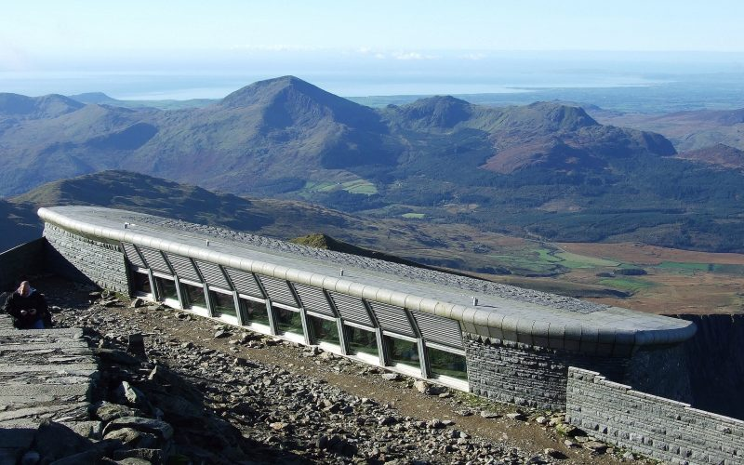

We plan to meet at the back of the Snowdon café at 13:00 on Saturday the 6th of July. As part of the event, you must have a company flag with your company logo on one side and a mental health message the other. There will be a photo opportunity once we are all together.

Further details will be released in the coming weeks!

PLEASE SEE OVER FOR FAQ’s

FAQS so far

When’s the event?
Friday the 5th, Saturday 6th and Sunday the 7thJuly 2024.

What time can I get to the campsite on the Friday?
No later than 20:00 is preferable?

Can I have a barbecue at the campsite?
Yes, but not homemade, it has to be safe

Where are we meeting at the top of Snowdon?
Behind the Café at 13:00

Can I just turn up to do the walk on Saturday and go home?
Yes, of course you can, with no charge.

Can I turn up Saturday morning and stay 1 night and have dinner?
Yes, but the entry fee still applies.

Do I have to bring my own tent?
Yes, you’ll need somewhere to sleep.

What is the charter providing?
The charter is providing soft drinks/water, breakfast on Saturday morning and dinner on Saturday night. You will have to pay for any drinks in the pub.

What about alcohol?
The charter will not be paying for alcohol, but you’re quite welcome to bring your own.

ENTRY FORM - Send your completed form to: help@liftmentalhealthcharter.co.uk
£75 per person entry, any additional sponsorship which can be gained for taking part in the event is greatly appreciated.
There is currently a maximum entry per company of 4 people. This is to ensure as many companies as possible can take part. There are only 50 places available at present, more may become available.
Entry date:……………………………………………………………………………………………………
How many people entering?:……………………………………………………………………………
Name (s):……………………………………………………………………………………………………...
Company:……………………………………………………………………………………………………..
Emergency Contact (s):…………………………………………………………………………………..
Is any of your team a trained first aider? Would they be willing to help if required?.....................................................................................................................
Does any of your team have climbing experience?......................................................
Which nights do you plan to stay?...............................................................................
Will you require breakfast on Saturday morning?........................................................
Will you require dinner on the Saturday night?............................................................
Do any members of your team have any medical conditions or allergies?.....................................................................................................................
……………………………………………………………………………………………………………………
Optional question: - Would any of your team members like to become a mental health first aider in the future? …………………………………………………………………………………………

£75 per person payment can be made via our Just Giving site here, although please note, just giving does take a percentage : Crowdfunding to support mental health courses within the lift industry and to promote mental health with events and team building on JustGiving
Or Direct into our account stating a reference of the ‘Snow Event’ and company name ‘abbreviated’.
Virgin Money Bank
Name : The Lift Industry Mental Health Charter
Sort Code : 82-11-07
Account No : 10477652

