**Dive Flag Jewelry**

**Necklace: $35 Ring: $50**

**Key Ring: $35**

**O-Ring Bracelet/Anklet: $45**

**Hat/Lapel/Tie Pin: $20**

**Earrings: Posts-$40/Wires-$65**

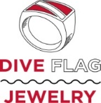

**Each item features the dive flag inlaid into *durable, tarnish-free,* rhodium-plated brass. The inlay is extremely durable, since the dive flag is not painted or baked on; it is inlaid into channels cut into each item. *Use of simulated inlay protects our reefs!***