Charles Thurman
06 Feb 1760 to 16 Dec 1848

06 FEB 1760 Charles Thurman is born in Buckingham County in the State of Virginia; at the beginning of the Revolutionary War, he was 16 years old and by the end, he was 23.
Charles Thurman was call to serve an initial three-month tour of duty in the Virginia militia under the command of Captain Thomas Redd of the Buckingham Co. Militia. The company was ordered to Albemarle Barracks where it was employed in guarding Burgoyne's prisoners. The company joined the Convention Army Guard Regiment about 25 Oct 1779.
How was this duty? From E.M. Sanchez – Saaverda “A Guide to Virginia Military Organizations in the American Revolution 1774-1787”…pg 120. Sites the Buckingham Co. militia serving with the Convention Guard Regiment and provides the following description of life at the camp:
“Life for the convention troops became more pleasant as they finished their cabins, built churches, planted gardens, and cleared roads. By June for recreational huts containing billiard tables had been built, as were a theatre, a coffeehouse, and a sutler’s store. There were still major discomforts, the worst of which were the weather, rattlesnakes, and sporadic food shortages. In some respects, the men of the guard regiment suffered more than the prisoners. They went months without pay, fresh food, or essential clothing. On 8 April, 1780, 121 were without shoes of any kind, and by July 1, 38 were reported “naked”.
Crockett’s Western Battalion relieved the militia drafts beginning in April 1780. It is likely that Charles Thurman was extended in duty at the Barracks till his unit was relieved as there is no record of militia units rotating at this time.
29 May 1780……The Battle of the Waxhaws occurred resulting in significant losses to the Virginia Regiment under Col. Abraham Buford. The effect was a call for more militiamen to make up the losses. Charles Thurman under the command of Captain John Mosely marched from Buckingham County to Petersburg (Petersburg acting as a central organizational depot for the army). At Petersburg Charles was transferred to Captain Thomas W. Ewell’s company which in a short time joined Col. Buford’s reorganizing command. It is known that Charles Thurman enrolled on 17 AUG 1780 in Col. George Gibson’s 1st Rgt. Virginia State Line on the Continental Establishment in Capt. Thomas Ewell’s Company. Charles was later discharged on April 17, 1781. However, in 1780 numerous units sent detachments south to reinforce the Southern Army under Gen Greene. It is highly likely that Ewell’s company also severed under Col. Buford’s command while marching to the Southern Army.
07 Oct 1780…..Battle of Kings Mountain
26 DEC 1780…..Gen Greene with his part of the Southern Army arrived at their new camp across the Pee Dee River from Cheraw, SC.
While these events were unfolding in the Southern theater Charles Thurman was marched from Petersburg, VA to Hillsboro, NC a march of about 159 miles. Something we drive in about three hours by road today. Then by foot march on to Salisbury, NC another 103 miles. Then to Charlotte, NC another 53 miles. And finally, to the Cheraw Hills, SC. Another 80 miles for a total deployment march of 395 miles across unpaved sandy dirt trails….on a good day.
Charles’ unit joined Gen. Greene’s command and it is likely he could have been “task organized” again serving under yet another company commander. Charles notes he served on Captain Webb in his pension statement. The company of Captain Isaac Webb at this time and place was called the "Eight Months Company" from the fact that it included militiamen who had been sentenced to eight month’s service under Continental discipline for fleeing at the Battle of Camden SC on 16 Aug 1780.
02 JAN 1781…..Arnold’s VA Raid…..one fourth of Buckingham County’s Militia Called up.
17 JAN 1781……Battle of Cowpens.
19 JAN 1781….. British Army begins pursuit of Morgan.
30 JAN 1781…..Greene and Morgan join forces. Gen, Isaac Huger was left in charge of the Main Army and ordered to march to Salisbury to linkup with Morgan.
From Cheraw Hills Charles noted marching under General Greene to Salisbury (which most likely was Gen Huger and the main army). He remained with the main army as it raced for the Dan river.
03 FEB 1781…..At Trading Ford on the Yadkin River. BG Steven’s conducted rear guard action at the ford which Charles most likely was involved in. Green’s army camped near Guilford Courthouse with militia units coming and going over the next three weeks.
10 MAR 1781…..Greene’s army reinforced by Militia and he is ready to give battle.
14 MAR 1781…..Greene marches his army south toward Guilford Courthouse, Cornwallis prepares to march to confront Greene. Skirmish between Tarleton and Lee’s Cavalry on the New Garden Road
15 March 1781….Battle Guilford Court House.
Charles Thurman notes he served under Captain Nathan Cunningham and fought at the Battle of Guilford Court House. Captain Nathan Cunningham’s company was organized as part of Col. Nathaniel Cocke’s Militia battalion of BG Edward Stevens 1st VA Militia Brigade.
Maryland’s Col. Otho H. Williams later recalled:
"The Virginia Brigade of militia commanded by Generals Stevens and Lawson gave the enemy so warm a reception, and continued their opposition with such firmness... during which time the roar of musquetry and crackling of rifles were almost perpetual and has heavy as any I ever heard."
A vicious battle ensued between the forces of Col. Nathaniel Cocke's regiment and Col. George Moffett's regiment against the British 71st Regiment of Foot (Frazer’s Highlanders). The 71st Regiment had already been bloodied on the first line, but lost even more men fighting the Virginians. The Guards also taking severe losses with any other officers beside Brigadier General Charles O'Hara received serious wounds or being killed. In short order, the Guards Grenadiers Company lost all of their officers, while the Guards 2nd Battalion lost half their company grade officers. After Brigadier General Edward Stevens was wounded, he gave the command to fall back, and the Virginia Militia south of the road went streaming to the rear. Shortly, the other Virginia regiments followed.
At the end of the second line fighting, the British army was very weakened and very tired, and their ammunition was greatly diminished. The next round would be against fresh Patriot Continentals.
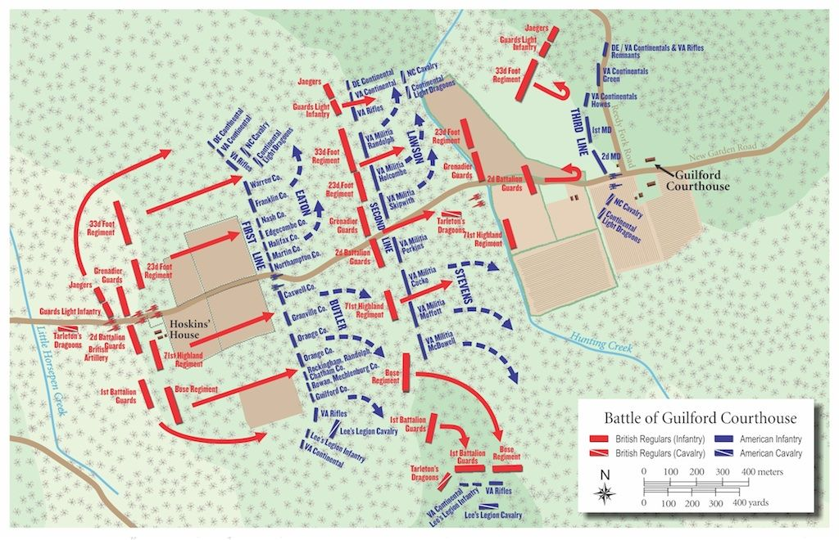

17 Apr 1781……Discharged from Captain Thomas Ewell’s Company, Col. George Gibson’s Rgt.
After the Battle of Guilford, Charles Thurman entered the service in Albemarle County under the
command of Captain John Mosely (as substitute for William Gowen) and marched to the Siege of York where he remained in service and was in the battle.
Sep – 19 Oct 1781 Siege of Yorktown.
Most all of the VA militia was part of the Intermediate American Line on the Left flank. The 1st VA State Rgt. Is known to have been in this position. The VA militia during the Siege was vital to extending the American line and securing the left flank preventing the British from escaping or getting help or resupply. The militia performed numerous duties including digging and extending the siege lines, protected the lines of supply with the cattle herds and by performing general local area security. Almost immediately after the surrender Charles was transferred to Captain Nathaniel Cunningham's Company with the mission to guard the prisoners. Under Captain Cunningham he marched the British POWs to Winchester barracks where he was finally discharged on 07 NOV 1781.
Charles ended his war service almost where he had his first active mission on 25 OCT 1779.
Charles Thurman moved from Buckingham County to Washington County Virginia where he lived in the neighborhood of Kings salt works about sixteen years. He then removed to Rhea County, Tennessee where he lived one-year and from there to Bledsoe County Tennessee where he lived for about sixteen or seventeen years prior to applying for pension.
Today we meet to honor an American Patriot in a place of his choice to rest not far from his home.

