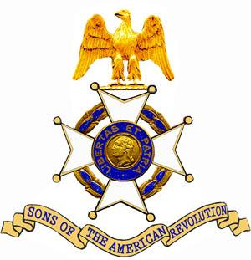
The Col. Robert Anderson Chapter
South Carolina Society
Sons of The American Revolution

Cordially invites you to attend the Patriot Grave Marking and Wreath Laying Ceremony honoring

Patriot Jeffrey Beck

To be held on Saturday, May 18, 2019 at 1:30 pm at the
Stamp Creek Baptist Church
1008 Stamp Creek Road
Salem, South Carolina 29676

Please make plans to attend this ceremony honoring this Revolutionary War Soldier.

