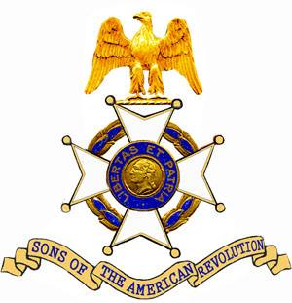
The John Sevier Chapter
Tennessee Society
Sons of The American Revolution
Cordially invites you to attend the Patriot Grave Marking and Wreath Laying Ceremony honoring

Patriot Charles Thurman

To be held on Saturday, August 29, 2020 at 11:00 am at the
Old Lone Cedar Cemetery (Inactive / N35.65397 W085.04685)
Rally Point is the intersection of
Summer City Rd and JB Swafford Rd, Bledsoe Co., TN
(Parking is in a nearby pasture about 300 meters along a power line access trail to the cemetery. The ceremony will be part of the Thurman Family reunion. Additional information can be found at: https://johnsevierchapter.org/patriot-honors)
The land owner has requested all ceremony participates sign a Hold Harmless Agreement (See the Agreement)
Please make plans to attend this ceremony honoring this Revolutionary War Soldier.

