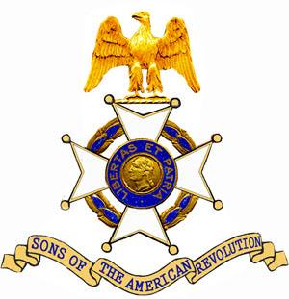
JOHN SEVIER Chapter, Tennessee Society
Sons of The American Revolution
Cordially invites you to attend a Patriot Grave Marking and Wreath Laying Ceremony honoring

Patriot William Jefferson Moore
And
Patriot Thomas Palmer

To be held on Saturday, October 12, 2019 at 11:00 AM at the
Conner Cemetery
13825 Birchwood Pike
Birchwood, Tennessee 37308

Please arrive at the noted address by 10:30 AM in order to “convoy/car pool” to the cemetery.

