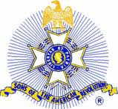
13 OCT 2019

For Immediate Release

American Revolution Patriot Remembered
Hamilton County, Tennessee, At 11:00 A.M., Saturday, October 12, 2019, the John Sevier Chapter of the Tennessee Society Sons of the American Revolution in coordination with the Conner-Roake Cemetery Association and Mr. Ronald Johnson conducted a traditional Son’s of the American Revolution grave marking ceremony to honor and remember the Revolutionary War service of Patriots William Jefferson Moore and Thomas Palmer. A Patriotic Memorial marker was unveiled for each patriot at their grave site in the Conner Cemetery, Birchwood, Tennessee.

The SAR marker dedication service was attended by numerous organizational representatives from the Tennessee Daughters of the American Revolution and Tennessee Society of the Sons of the American Revolution. The dignity of the occasion was highlighted by the TNSSAR’s Color Guard presentation of colors, musket volley salute and the playing of Taps by John Sevier Chapter member Evan Kent.

Direct descendants Mrs. Robin Christmas from New Jersey and Mr. Gene Johnson of Tennessee made official remarks for the families of the Patriots.

The grave site was marked with a distinctive granite marker which depicts the familiar Continental soldier with his musket, ready to defend the country. The marker consists of four arms and eight points, each point being decorated by a representative gold head. The source of the cross is the ancient chivalric Order of St. Louis. The cross is connected with a circular laurel wreath, a Napoleonic symbol recognizing faithful service and merit. The year 1775 is inscribed at the base – the year the “shot heard round the world” was fired at Lexington Green, Massachusetts. An American “Betsy Ross” flag was appropriately placed at the marker.

John Sevier Registrar Mr. Charles Dammann the master of ceremony presented the military service biography for both Patriot Benjamin Jones and Patriot Thomas Palmer – true American heroes.

For additional information on the ceremony to include pictures, the full service biographies and our ceremonial “campaign” biographies visit the John Sevier Chapter’s web site page that honors Patriots at https://johnsevierchapter.org/patriot-honors or contact the Chapter’s 2nd Vice President Cliff Kent at dogwoodlodge@epbfi.com .

-30-

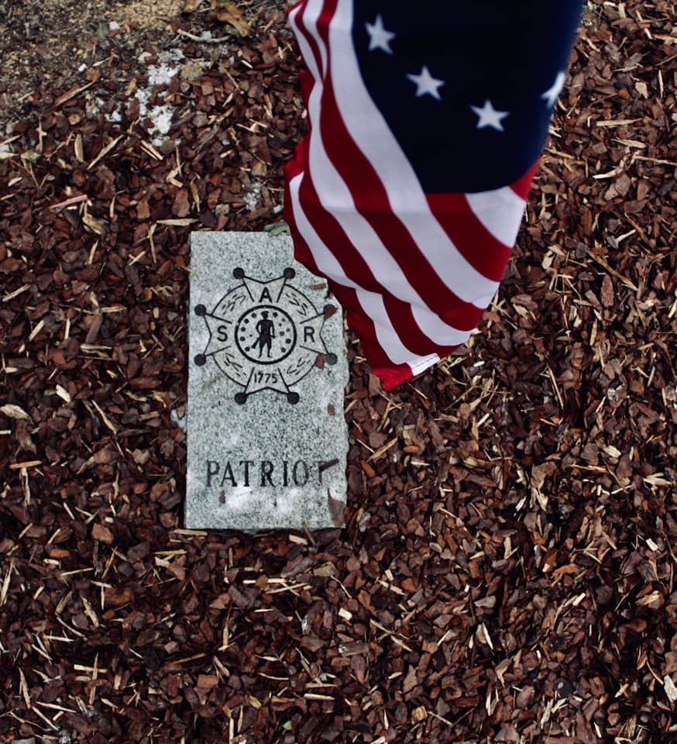
Caption

Sons of the American Revolution granite Patriot grave site marker installed at the Conner Cemetery graves of Patriots William Jefferson Moore and Thomas Palmer. The John Sevier Chapter Sons of the American Revolution of Hamilton County conducted an unveiling and dedication ceremony of the markers honoring Revolutionary War Patriots William Jefferson Moore and Thomas Palmer at 11:00 A.M. Saturday, October 12, 2019, at their grave site in the Conner Cemetery, Birchwood, Tennessee.
Picture by Ms. Olivia Beck, daughter of 1st Vice President Bryan Beck, John Sevier Chapter, TNSSAR

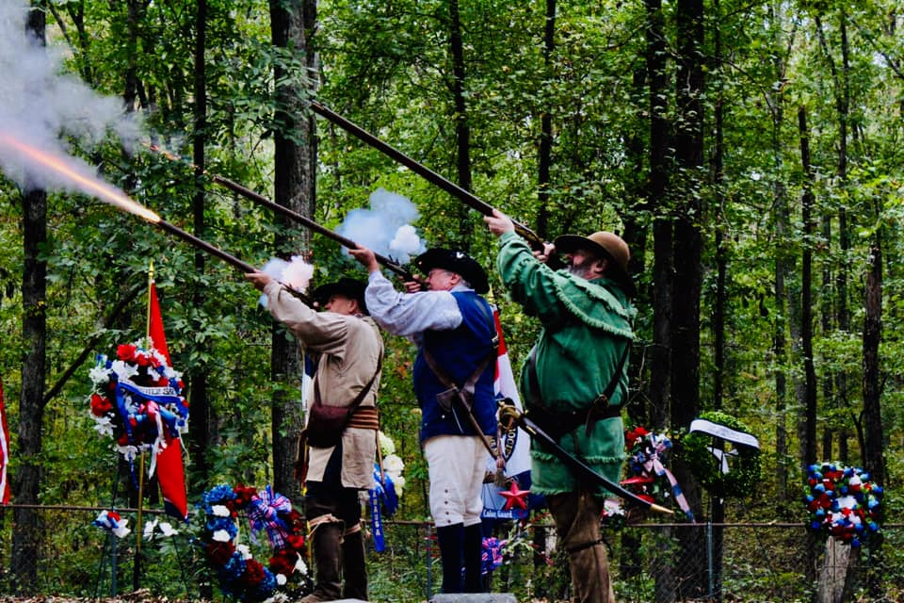Caption

Members of the Tennessee Society Sons of the American Revolution state color guard (in period uniforms) under the command of Mr. John Clines (green hunting shirt) demonstrated the difficulty of loading period muskets and then honored the Patriots with musket volleys followed by TAPs during the 12 OCT 19 Patriot Grave Marking ceremony at the Conner Cemetery. The John Sevier Chapter Sons of the American Revolution of Hamilton County conducted the unveiling and dedication ceremony of the markers honoring Revolutionary War Patriots William Jefferson Moore and Thomas Palmer at 11:00 A.M. Saturday, October 12, 2019, at their grave site in the Conner Cemetery, Birchwood, Tennessee.

Picture by Ms. Olivia Beck, daughter of 1st Vice President Bryan Beck, John Sevier Chapter, TNSSAR

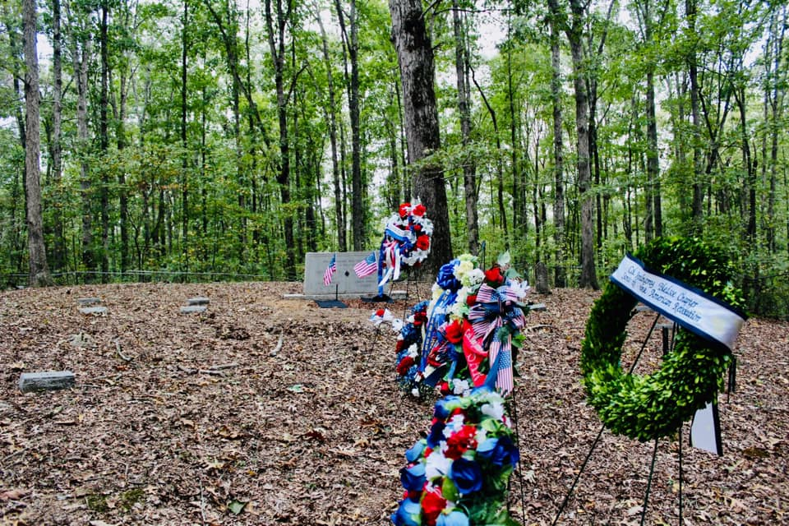
Caption

The John Sevier Chapter Sons of the American Revolution of Hamilton County conducted an unveiling and dedication ceremony of SAR Patriot Grave Markers (in background front of the headstone under the Betsy Ross flags as seen prior to the start of the ceremony) honoring Revolutionary War Patriots William Jefferson Moore and Thomas Palmer at 11:00 A.M. Saturday, October 12, 2019, at their grave site in the Conner Cemetery, Birchwood, Tennessee. Several chapters from the Sons or Daughters of the American Revolution were represented including special guest Mr. John Satterthwaite Chapter President of the Col. Robert Anderson Chapter, SCSSAR and Mrs. Sharon Satterthwaite representing the Nathanael Greene Chapter, SCDAR.

Picture by Ms. Olivia Beck, daughter of 1st Vice President Bryan Beck, John Sevier Chapter, TNSSAR

