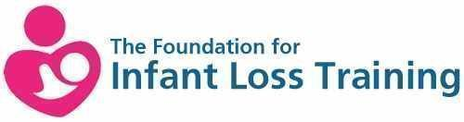

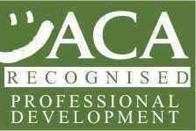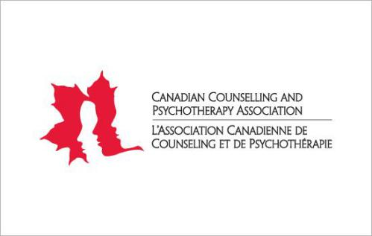

**This is to certify that: Kate Blakemore**

**Has completed The Foundation for Infant Loss Accredited Provider Training Course**

**On: 1 April 2018**

**CPD: 14 hours**

**Signed:** 

**Dr Chantal Lockey**

**Chief Executive**

**The Foundation for Infant Loss Training**