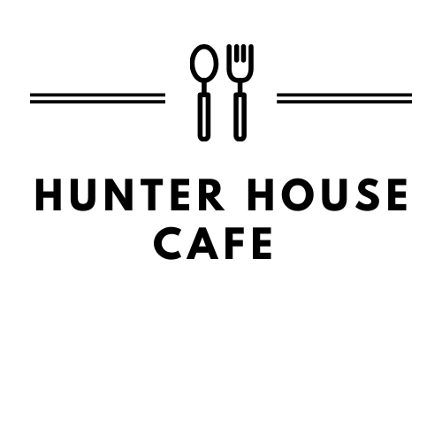
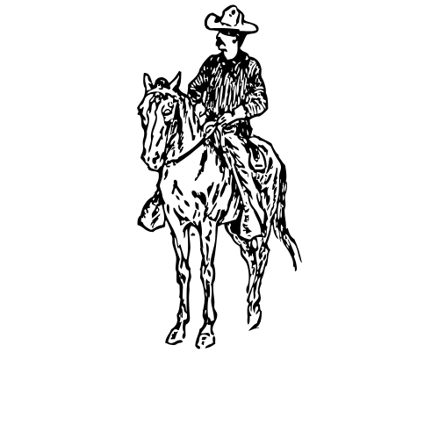
316 Hwy 39, Ingram, Texas 78025
(830) 367-3069
Open 7 Days a Week
7am-2pm.
Family-owned and operated since 2012.
“Every plate made with passion.”
Breakfast, All Day
Served w/ a side and bread of your choice
Classic- One egg, any style 5.95 w/ meat 7.95
Double Classic- Two eggs, any style 6.95 w/ meat 8.95
Oatmeal Special- Choice of meat and bread Cup 8.50 Bowl 10.50
Chicken Fried Steak ‘n Eggs- Cubed steak fried golden,
topped with cream gravy 13.95
Pork Chop ‘n Eggs- 6oz chop, grilled 13.95
Flat Iron Steak ‘n Eggs- 6oz steak, cooked to your temperature choice 16.95
French Toast- Texas toast topped w/ powdered sugar 7.00 ½ 5.00
Stuffed French Toast- Texas Toast w/ cream cheese, fruit, whip cream, powdered sugar 9.95 ½ 7.95
Hunter House Breakfast- Pancakes, eggs, any style, and a choice of meat
Large(3) 13.95 Medium(2) 11.95 Small(1) 9.95
French Breakfast- French toast, eggs, any style, and a choice of meat
Large(3) 14.95 Medium(2) 12.95 Small(1) 10.95 Add Fruit and Whip Cream- 2.50
Additional Eggs- $1.00/each
Breakfast Tacos
Served w/ flour or corn tortillas, and w/ refried beans
Sub hashbrowns- .50 Extra Tortilla- .25 Add Vegetable- .25 Add Meat-1.50
Bean and Cheese 2.50 Egg and Cheese 3.00
Potato, Egg, and Cheese 3.75 Meat, Egg and Cheese 4.50
Double Barrel Taco- Egg, bell pepper, tomato, onion, mushroom, hashbrown, smoked sausage, ham, and cheese 9.25 ½ order 7.25
Diablo Taco- Egg, ground beef, jalapeno, onion, salsa, cayenne pepper and cheese 7.25
Breakfast Sides
Meat 4.25 ½ Meat 2.50 Pork Chop 6.95 CFSTK 6.95
Flat Iron Steak 9.95 Cup of Fruit 4.00 Bowl of Fruit 8.00 Hashbrowns 2.25
Grits or Refried Beans 2.00 Gravy 2.00 Sausage Gravy 3.25
Cup of Oatmeal 3.25 Bowl of Oatmeal 5.00 Toast & Jelly 2.00 Biscuit 2.00
Cake- 2.50 Short Stack- 4.50 Stack- 6.50
*Eating raw or undercooked meat, poultry, seafood, shellfish or eggs can increase the risk of foodborne illness*
Omelets
Served w/ a side and bread of your choice
Add Vegetable- .25 Add Cheese- .50 Home Fries- .75 Add Meat- 2.00 Egg white omelet- 2.00
½ options are available for 2.00 off menu price
Omelet Only- 2.00 off menu price
All Meat Omelet- Bacon, Ham, and Sausage 11.95
Cheese Omelet- American cheese 8.25
Chorizo Omelet- Alamo Brand Chorizo 9.75
Double Barrel Omelet- Bell pepper, onion, tomato, mushroom, potato, ham, smoked sausage, American cheese 11.95
Denver Omelet- Ham, bell pepper, onion, and tomato 9.75
Meat omelet- Bacon, ham, or sausage 9.75
Spanish Omelet- Bell pepper, onion, ham, salsa, and American Cheese 9.75
Veggie Omelet- Bell pepper, onion, tomato, mushroom, American cheese 9.75
Western Omelet- Sausage, bell pepper, onion, American cheese 9.75
Hill Country Favorites
Cowboy Platter- Egg mixed w/ spices, ground beef, bell pepper, onion, and tomato 13.95
Served w/ hashbrowns or grits, and a biscuit covered in gravy
Huevos Rancheros- Two eggs, any style, covered in salsa, served w/ hashbrowns, refried beans, and tortillas 7.95
Migas- Two scrambled eggs, cut corn tortilla, Pico de Gallo, salsa and cheese, served w/ refried beans and tortillas 8.75
2 Biscuits w/ white gravy 6.00 1 Biscuit with w/ gravy 4.00
2 Biscuits w/ sausage gravy 8.50 1 Biscuit w/ sausage gravy 5.50
Egg Sandwich- Egg, any style, on bread of your choice, w/ cheese and
choice of bacon, ham or sausage
Sandwich only 6.95 w/ hashbrown or grits 8.95

*Eating raw or undercooked meat, poultry, seafood, shellfish or eggs can increase the risk of foodborne illness*
Bread Selection:
Biscuit, English Muffin, Wheat, White, Raisin, Rye, Tortillas
Sourdough (+.75)
Pancake (+1.50)
Side Selection:
Refried Beans, Grits,
Hash Browns, Sliced Tomato,
(+2.00) Avocado, (+2.00) Mixed Fruit

South of the Border
Nachos- Corn tortilla chips covered in refried beans, meat of your choice and shredded cheese.
- Guacamole, Pico De Gallo, sour cream and jalapenos served on side plate.
Chicken- 10.95 ½ 8.95 Taco Meat-11.45 ½ 9.45 Beef Fajita-12.95 ½ 10.45
Bean and Cheese Nachos- 8.45 ½ 6.45
Quesadilla- Served with guacamole, Pico de Gallo, sour cream and jalapenos
Beef Fajita-13.95 Chicken-11.95 Cheese- 8.95
Country Classics
Served w/ mash potatoes, vegetables
Choice of Soup or Salad
Sub Okra/Onion Rings/French Fries 1.00 extra
Breast of Chicken, Grilled or Fried- 14.95 ½ order 10.95
Chicken Fried Steak – Hand-breaded and deep fried 15.95 ½ order 12.95
Fried Catfish – Dredged in a corn meal and flour mix, fried to golden perfection
*Grilled option available for 1.25 extra* 15.95 ½ order 12.95
Chicken Fingers- Fried until golden brown 13.95 ½ order 10.95
Hamburger Steak- 8oz burger w/ grilled onions and brown gravy
12.95 ½ order 9.95
Pepper Steak- 12oz of ground beef stuffed w/ American cheese and jalapenos, topped w/ brown gravy and onions- 16.95 ½ order 13.95
Pork Chops, Grilled or Fried- Two 6oz chops- 13.95 ½ order- 10.95
Shrimp Plate, Grilled or Fried- 10 pieces of Shrimp- 17.95 ½ order 13.95
Grilled Atlantic Salmon- 8oz fillet topped w/ melted butter 18.95

*Eating raw or undercooked meat, poultry, seafood, shellfish or eggs can increase the risk of foodborne illness*

Burgers
1/2lb beef patties served w/ fries- Onion Rings/Okra 1.00 extra
Served w/ mayo, lettuce, tomato, onion and pickles
Classic Burger- 10.95
- Bacon- 1.50 Chili- 2.00 Cheese -.50 (American, Cheddar, Swiss, Monterey) Pickled Jalapeno- .50 Grilled onions/mushrooms- .25
Pollo Burger- Grilled Chicken breast topped w/ bacon, jalapenos and Monterey cheese 13.45 *Fried- Served with Cheddar cheese 13.45
Patty Melt- Grilled onions and Swiss cheese on Rye- 12.95
Super Burger- Two patties 15.95 w/ cheese 16.95
Sandwiches
All Served w/ chips. Sub French Fries/Onion Rings for 1.00
Sub a cup of soup or side salad for 2.50
Sandwich only – 1.50 off menu price
BLT – Bacon, lettuce, tomato, and mayo 8.95
Classic Club- Bacon, ham and turkey, w/ lettuce, tomato, mayo, American and Swiss cheese 11.95
Chicken Fried Steak Sandwich- 12.45
Grilled Cheese - w/ bacon or ham 7.45 Only Cheese- 5.95
Grilled/Fried Chicken Sandwich – 11.45
Tuna Salad Sandwich- 8.50 Ham or Turkey Sandwich- 8.95
Salads
Served with fresh cut green leaf, iceberg, red cabbage, carrot,
a boiled egg, shredded cheese and cucumber
Chef Salad – Ham, turkey, crumbled bacon 11.95
Crispy or Grilled Chicken Salad – 11.95
Grilled or Fried Shrimp- 10 pieces of shrimp 17.95
Side Salad- Salad w/ cherry tomatoes and cucumber 3.50
Soup and Salad- Cup of soup and a side salad 6.95
Sides
Sour Cream 1.00 Guacamole 3.00 Pico De Gallo 1.00
Side of Avocado 3.00 Side of Vegetables 2.00
Pickled Jalapeno .50 Fresh Serrano .50
Bread Roll .50 Fresh Salsa 12oz 4.00 24oz 8.00


