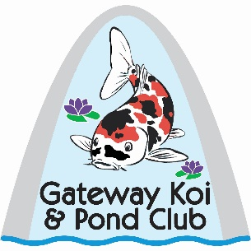
Gateway Koi and Pond Club
SPONSORSHIP APPLICATION 2025

Company/Business Name: ______________________________________________________
Owner’s Name(s): _____________________________________________________________
Mailing Address: ______________________________________________________________
Preferred Phone Number: ________________ Alternate Phone Number: _________________
Date: ________________ E-Mail Address: ________________________________________
How did you hear about Gateway Koi and Pond Club? ________________________________

____________________________________________________________________________

Annual dues $50 for 2024. Includes two general memberships. Additional memberships $25.

Please Venmo or remit check payable to Gateway Koi and Pond Club and mail to:
Pam Jokerst, 305 Wyndmoor Terrace Court, St. Louis, MO 63141

With consent, all sponsors and members will appear in a membership directory. Use of this directory is for club purposes only and will not be used as an email, phone or postal mailing list.
Improper use will terminate sponsorship and/or membership with no refund and immediate removal of any and all sponsorship information on website, newsletters and Facebook.

______ Yes, please include my information in the directory.

______ No, do not list my information in the directory.

For more information, please contact Gateway Koi and Pond Club at pamjokerst@gmail.com. …………………………………………………………………………………………………………………………………………………..
For Club Use Only: Sponsorship Paid on ___________ Year(s) _____________ Cash ______
Venmo ________ Check # ________ Check Name _________________________________
Renewal _____________________________Renewal _______________________________
Gateway Koi and Pond Club
Full Sponsorship Benefits 2024

- Introduction at first general members’ meeting attended and 3 minutes to promote business/organization.

- Acknowledgement at all general meetings and other events, when appropriate, by president, moderator, organizer, or chairperson.

- Invitation to provide a program, demonstration, or mini-talk at a meeting or special event, as appropriate, by president or chairperson.

- Included in sponsor directory on each monthly club newsletter, including Logo, sent to over 180 members.

- Included on sponsor page on public club website, including Logo.

- Can post on public club Facebook once per month with photo, video, or ad.

- Permission to distribute flyers, coupons, business cards, etc. at general members’ meetings by placing on sponsor table.

- Tour and event consideration, when appropriate, by chairperson, i.e. including ponds on tours or retail business as a tour stop.

- Vendor space consideration at koi show or other events, when appropriate, by chairperson. Additional costs may be incurred.

- Includes two general memberships with all benefits. Additional memberships for employees and/or family members are $25 each and include general membership benefits only.

Annual Cost is $50 for 2024.

