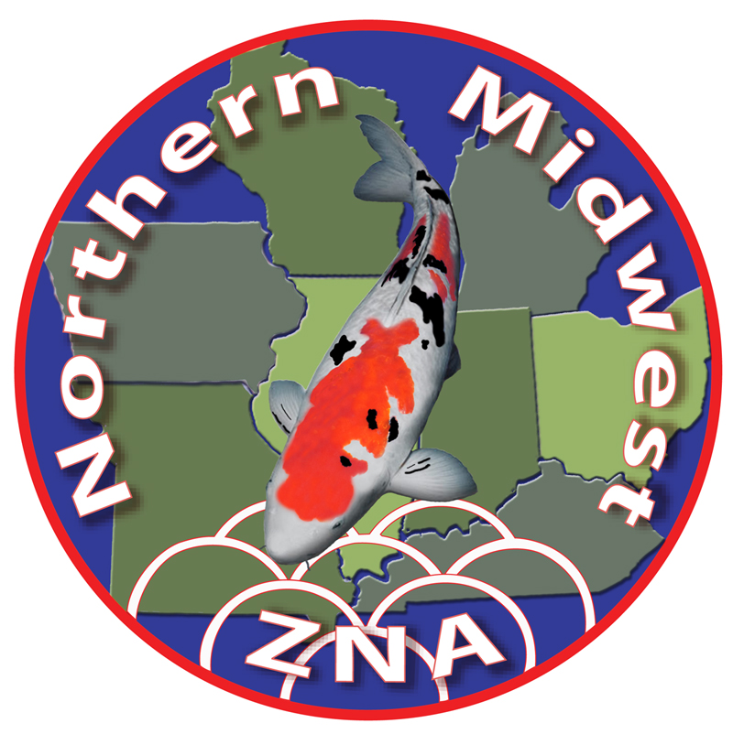
Northern Midwest ZNA
Nineteenth Annual Koi Show
Saturday, September 25th, 2021

2021 Banquet Reservations

The Awards Banquet will be held at the Club host hotel, DoubleTree Hilton-Chesterfield in the Great Room. The banquet menu includes sit-down plated service of Chicken Marsala & London Broil, Field Greens Salad w/ Assorted Dressings, Roasted New Potatoes, Seasonal Vegetable(s), Rolls & Butter, Water, Tea & Coffee and Chocolate Seduction Cake. Private cash bar available in The Great Room. Specialty drinks available at lobby bar. Casual attire. If special diet is required, gluten-free, vegetarian, etc., contact Pam Jokerst. Please register by August 24th, 2021.

Mail this form with your check to address below.
Include on Show Tank Reservation form, if applicable.

6:30 PM … Conversation and drinks
7:00 PM … Welcome and Dinner in the Great Room
After Dinner … Awards Presentation with Judges’ Commentary and Live & Silent Auctions
---------------------------------------------------------------------------------------------------------------------

Name(s) __ ________________________________________________________________

Child(ren) Name(s) _________________________________________________________

Price: $50.00 per person (age 16 and under $25.00). Make check payable to NMZNA.
Please include total on Show Tank or Vendor Registration form, if applicable.

Number of Tickets: Adult________ Child_________ Total paid: $_________________

Mail to:
Bill Doyle, NMZNA Treasurer
1438 Winchester Court
Naperville, IL 60563

