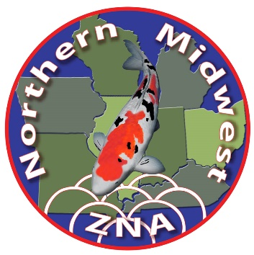
Northern Midwest ZNA Nineteenth Annual Koi Show September 24th – 26th, 2021 Timberwinds Nursery, Ellisville, MO

HOTEL INFORMATION

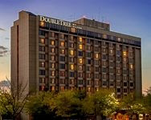
DoubleTree by Hilton--Chesterfield
16625 Swingley Ridge Road
Chesterfield, Missouri 63017
Tel: +1-636-532-5000
Fax: +1-636-530-1149

The link to our group reservation page is: https://www.hilton.com/en/book/reservation/deeplink/?ctyhocn=STLSCDT&groupCode=CDTSLK&arrivaldate=2021-09-24&departuredate=2021-09-26&cid=OM,WW,HILTONLINK,EN,DirectLink&fromId=HILTONLINKDIRECT
$119.00 per night (9/24 -9/26) for a King or Double Queen room. Book by August 24th to reserve your room at this rate!
All rates are subject to applicable taxes. Hotel check-in time is after 3:00PM on the day of arrival. Check-out time is before 12:00PM on the day of departure. If needing to extend reservation to Thursday or Monday, contact Pam if rate is different than $119 when you book.
Please use this information if experiencing difficulty with reservation link above.
Group Name: St. Louis Koi Show
Group Code: SKS
Check-in: 24-SEP-2021
Check-out: 26-SEP-2021
Hotel Name: DoubleTree by Hilton Hotel St. Louis - Chesterfield
Additional Host Hotel Information:
Room rates good thru August 24, 2021. Gourmet breakfast buffet is $16 per person per day. Complimentary access to the Athletic Club indoor pool and fitness center. Complimentary parking and internet access. Complimentary hotel shuttle with 5-mile radius, if available. Airport shuttle service available at approx. $50 one-way or contact Pam for host club pickup arrangements. Awards Banquet will be held in the Great Room on Saturday night. See Banquet Form.
Pet-friendly Alternate Hotel:
Hampton Inn-St. Louis/Chesterfield by Hilton, 16201 Swingley Ridge Road, Chesterfield, MO 63017, tel. 636-537-2500, www.hampton.com. Rate is approx. $117 for Senior, AAA and Hilton Honors. No pet fee, free hot breakfast, free wi-fi, indoor pool. No rooms have been reserved.

