Zen Nippon Airinkai – Northern Midwest Chapter
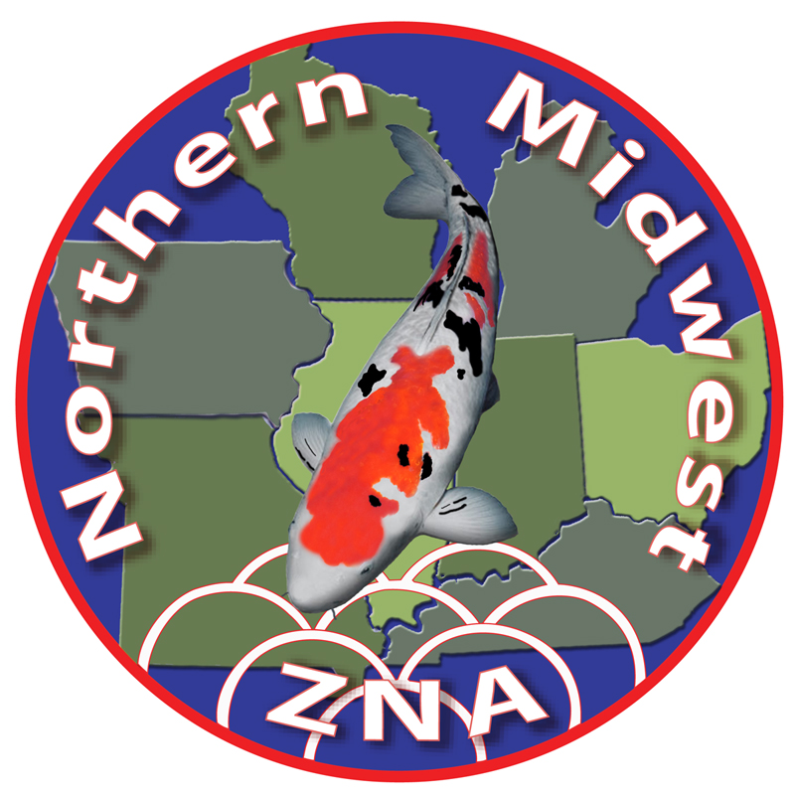


Nineteenth Annual Open Koi Show
Timberwinds Nursery, Ellisville, MO
September 24th - 26th, 2021

Show Rules and Entry Forms

THIS IS AN OPEN KOI SHOW – ENGLISH STYLE JUDGING – ACCEPTING ALL HOBBYIST ENTRIES – DEALER OWNED KOI WILL NOT BE ALLOWED – THE KOI’S OWNER MUST BE PRESENT AT CHECK IN TO SIGN THE OFFICIAL REGISTRATION FORM.
THERE WILL BE NO EXCEPTIONS TO THE RULES THAT ARE LISTED BELOW, WHICH WILL BE STRICTLY ADHERED TO.

- Registration (must be received by August 24th, 2021) entry fee: 6’ tank $60.00, 8’ tank $75.00. Make checks payable to NMZNA and mail with a copy of the signed, Show Tank Reservation Form and the Koi Show Entry Form to the Club Treasurer.

- Due to the currently limited show tank space at our host facility, and the number of hobbyists wanting to enter, only one (1) tank per hobbyist will be allowed – first come, first served. This rule may be relaxed IF extra display space is created.

- Koi husbandry is a very large part of the hobby. How the koi are cared for is critical and related to how the fish develops over time and its condition at the time it is entered into the show. In support of this, only fish that have been brought to the show from the owner’s pond can be entered into the koi show. Exception: fish purchased at the show – only size 1 and 2 up to 11.77” or 29.9cm (less than 12 inches or 30 cm) can be entered into the koi show.

- Show vat “Fish Load” chart will be strictly enforced. See separate sheet included.

- Refrain from feeding fish for at least five days prior to the show. This is critical to the health and welfare of your koi. Water quality is difficult to maintain if your fish are littering the bottom of the tank with waste. A dirty tank also presents a negative image to the judges and viewing public.

- We ask that every attempt be made to ensure fish be checked in and benched between 2:00 p.m. and 7:00 p.m. (CDT) on Friday. Fish check-in will be permitted after 7:00 p.m. by pre-arrangement ONLY. All fish must be checked in and benched by 10 a.m. on Saturday. Participants are required to bring their own blue show bowl and koi net. The Club will supply show tank covers.

- The Benching Committee reserves the right to reject fish of questionable health from participation.

- All fish entered will be benched at show site for proper classification and length. If necessary, fish measurements and classification corrections will be made by the judging committee.

- Past Champions - Once a koi (A and B) has been awarded Grand Champion at a NMZNA show, the Grand Champion fish is not eligible to compete the following year but is eligible any year after that.

- Class “A” will include Kohaku, Sanke, Showa and all Utsurimono. Gin Rin types of these varieties will be benched as Gin Rin “A”.

- Baby Champion is from Sizes 1 & 2, Junior Champion is from sizes 3 & 4 and Mature Champion is from Sizes 5 & 6.

- Prior to show check-in, each entrant will be assigned a number corresponding to his/her show tank.

- Fish will be handled during the show BY AUTHORIZED SHOW PERSONNEL ONLY.

- In accordance with ZNA rules, koi dealers or their immediate family members are not allowed to enter fish.

- It is our intent that judging will begin at 10:00 AM on Saturday. Participants are asked to refrain from holding conversations with the judges until the Koi Show Chairman has announced that the judging has been completed and all the decisions are final.

- Only authorized personnel determined by the Koi Show Chairman will be allowed with the judges during the judging of the koi. This will be adhered to strictly and NO EXCEPTIONS ALLOWED.

- Every necessary and reasonable precaution will be taken by the Koi Show Chairman, the benching staff, the water quality chairman, and the judging team to ensure the safety and welfare of all fish on exhibit. Therefore, all participants in the show will agree to hold the clubs, its officers, and members blameless against any loss or injury of fish.

- Any contingencies not covered in these rules will be subject to the decision of the Koi Show Committee.

- Any club wanting to present a Friendship Award will complete and turn in the form available at the show by 3 p.m. Saturday.

- The KOI SHOW concludes at 2:00 p.m. on Sunday. Anyone traveling over 200 miles may check out at 1:00 p.m. (CDT) on Sunday afternoon. NO EARLY CHECK-OUT EXCEPTIONS!

Entries are accepted with the understanding that the participant agrees to hold the Clubs, Club Officers, Club Directors, NMZNA and GKPC members, Timberwinds Nursery and its employees harmless against any loss or injury to the fish.

Pam Jokerst Dick Thomas
NMZNA 2021 Koi Show Chairman NMZNA 2021 Koi Show Co-Chairman and NMZNA 2021 Koi Show Committee

Northern Midwest ZNA
Nineteenth Annual Koi Show
September 24th - 26th, 2021

Show Tank Reservation Form

Koi Owner’s Name: ________________________________________________________________________
Address: ________________________________________________________________________________
City/State/Zip: ___________________________________________________________________________
Phone #: ___________________________ Cell #: _____________________________________________
Email: __________________________________________________________________________________

Show tanks subject to availability…don’t wait to register! Registration deadline: August 24th, 2021
Exhibitor Fees:
8 foot show tank = ____ @ $75 = $_________
6 foot show tank = ____ @ $60 = $_________

Exhibitor Fees Total…………………= $_________
Trophy Sponsorship Total..……...= $_________
Judges’ Sponsorship Total………..= $_________
Banquet Tickets Total.……………..= $_________

Total amount enclosed = $_________
Entries are accepted with the understanding that the participant understands and agrees to the Show Rules, and hold the Clubs, Club Officers, Club directors, NMZNA and GKPC members, Timberwinds Nursery and its employees harmless against any loss or injury to the fish.

Koi Show Exhibitor’s Signature _________________________________________________ Date __________________

Registrants should mail one check made out to NMZNA, with the Koi Show Entry form, and this signed Show Tank Reservation form, along with Banquet form and Trophy and/or Judges’ Sponsorship forms to:

Bill Doyle, NMZNA Treasurer
1438 Winchester Court
Naperville, IL 60563

Northern Midwest ZNA
Nineteenth Annual Koi Show
September 24th - 26th, 2021

Koi Show Entry Form

Exhibitor’s name: ________________________________________________________________

Enter the number of fish entered in the appropriate Variety and Size categories.

Size 1 Size 2 Size 3 Size 4 Size 5 Size 6 Size 7 Size 8
Variety | Up to 19.9cm | 20 – 29.9cm | 30 – 39.9cm | 40 – 49.9cm | 50 – 59.9cm | 60 – 69.9cm | 70 – 79.9cm | Over 80cm
Kohaku | _______ | ______ | _______ | _______ | _______ | _______ | _______ | _______
Showa | _______ | ______ | _______ | _______ | _______ | _______ | _______ | _______
Sanke | _______ | ______ | _______ | _______ | _______ | _______ | _______ | _______
Utsurimono | _______ | ______ | ______ | _______ | _______ | _______ | _______ | _______
Bekko | _______ | ______ | _______ | _______ | _______ | _______ | _______ | _______
Asagi | _______ | ______ | _______ | _______ | _______ | _______ | _______ | _______
Shusui | _______ | ______ | _______ | _______ | _______ | _______ | _______ | _______
Goshiki | _______ | ______ | _______ | _______ | _______ | _______ | _______ | _______
Koromo | _______ | ______ | _______ | _______ | _______ | _______ | _______ | _______
H. Moyomono | _______ | ______ | _______ | _______ | _______ | _______ | _______ | _______
H. Mujimono | _______ | _______ | _______ | _______ | _______ | _______ | _______ | _______
H. Utsurimono | _______ | ______ | _______ | _______ | _______ | _______ | _______ | _______
Tancho | _______ | ______ | _______ | _______ | _______ | _______ | _______ | _______
Ginrin A | _______ | ______ | _______ | _______ | _______ | _______ | _______ | _______
Ginrin B | _______ | ______ | _______ | _______ | _______ | _______ | _______ | _______
Kawarimono | _______ | ______ | _______ | _______ | _______ | _______ | _______ | _______
Mujimono | _______ | ______ | _______ | _______ | _______ | _______ | _______ | _______

Northern Midwest ZNA
STANDARD POINT SYSTEM FOR DETERMINING
SHOW VAT LOAD

Please use the following point system as a guide in determining how many koi can be placed in a six or eight foot show vat. Exhibitors will not be allowed to exceed the point maximums.
Determine the total number of points in your vat by adding the points assigned to each fish by using this guideline. Fish are measured from the tip of the nose to the end of the tail. Metric number in parenthesis is for sizing reference only and not an exact length equivalent in inches.
Size 1, up to 8” (20 cm) =0.3 point
Size 2, up to 12” (30 cm) = 1 point
Size 3, up to 16” (40 cm) = 2 points
Size 4, up to 20” (50 cm) = 5 points
Size 5, up to 24” (60 cm) = 8 points
Size 6, up to 27” (70 cm) = 12 points
Size 7, up to 32” (80 cm) = 16 points
Size 8, over 32” (80+ cm)=20 points
The recommended total points for a six and eight foot vat is as follows:
Six foot vat - optimum is 20 points, maximum is 25 points
Eight foot vat – optimum is 35 points, maximum is 45 points
If your total points exceed the above maximum points, you will be required to reduce the total load number by renting another vat, if one is available, or taking some fish home. The water quality team cannot risk the health of your koi due to overstocking.

