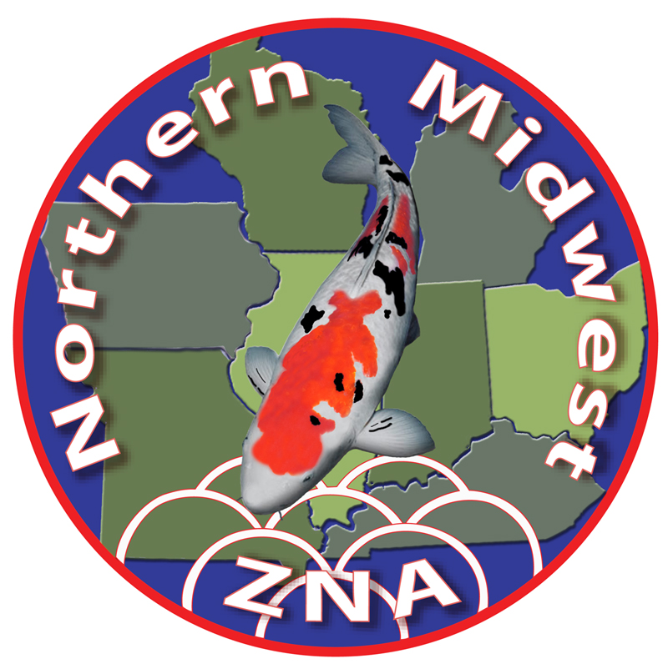
Northern Midwest ZNA
Nineteenth Annual Koi Show
September 24th - 26th, 2021

Vendor Registration Form
(Please Print or Type)

Company Name:
Contact Person:
Address: ____________
____________
Phone: (Bus) _____ (Cell) ___________ (Fax) ______
Email: ____________

Booth (10 ft x 10 ft) under canopy ------------------------------ Quantity: _____ x $225 $_______
(1) 8 ft table w/cover + 2 chairs -------------------------------- Quantity: _____ x $ 25 $_______
Extra tables w/cover ---------------------------------------------- Quantity: _____ x $ 25 $_______
Wet Vendors, 6’ vendor vat, less air pump & air stones ------- Quantity: _____ x $100 $_______
Wet Vendors, 6’ dealer vat for show entries, size 1-2 by 10am Sat.-----1 Tank @ $ 60 $_______
Vendor Fees Total: $_______

Show Program Advertising: (Circle option) -------------------------------------- Ad Fees: $_______
Color Centerfold (2 Full Pages) $175, Full Page Color $100, Half Page Color $75

Trophy Sponsorship Total: $_______

________________________ Other Sponsorships: $_______

Banquet Amount: $_______

Total amount due by August 24th, 2021: $_________

Trophy Sponsorships: (X) = Sponsorship reservation has been received. Circle award desired, subject to availability.
Grand Champion “A” $200 (x) Grand Champion “B” $175 (x) Reserve Grand Champion $150 (x)
Mature Champion $125 (x) Junior Champion $125 “A”(x) “B”(x) Baby Champion $100 “A”(x) “B”(x)
Best Tategoi $75 (x) Best Male $50 (x) People’s Choice $50 (x) Best in Size 1-2-3-4-5-6-7-8 $85 ea. ( )
Major Variety S-B-T (xxx) $75 ea. Best in Variety (17 trophies) $50 ea. ( ) List_____________________________

If placing an ad in the program, please note we need artwork by Aug 15th, 2021. Have completed artwork sent to designs4today@gmail.com in JPG, TIF or PDF format. Artwork should include full bleed allowance of .25” on all sides or send your logo and info and we can create your ad for you.

Return this form with your check made payable to NMZNA to: Bill Doyle, NMZNA Treasurer
1438 Winchester Court
Naperville, IL 60563

