

**1757 S Old Hwy 94 St. Charles, MO 63303 636-946-2242**

**October—7 days—9am-6pm Winter—Nov.-Feb.—Fri/Sat/Sun—10am-5pm**

**WINTER WEATHER TIPS**

**Make sure your De-Icer and/or AIR PUMP(s) are working properly:**

If they are completely encased in ice, check your GFCI on the outlet. If it has power, but still frozen in the ice, then it's time to replace it with a new one once you have enough open water to put it in place.

We prefer AIR PUMPS over De-Icers (Heaters) for keeping the pond healthy. They don't keep the surface open by heating the water but instead, rely on pumping fresh air under the ice. An Air Pump is HEALTHIER for the fish and will save on your Electric Bill.

NOTE: Do Not try breaking the ice with a hammer, axe, etc., as it is very harmful to the fish and liner, not to mention you. Instead, melt a hole with hot water and then insert the De-Icer and/or Air Tubing for the AIR PUMP.

**If you leave your Waterfall running:**

This can be a very HIGH-RISK method during extreme weather conditions. As the ice builds up on top, the water level can drop. Keep a close eye on it. If the water level in the pond is dropping too far, shut it off. Likewise, the ice can build up in streams/waterfalls in ways which can change the flow and potentially drain the pond.

A De-Icer can HELP to keep the waterfall running at lower temperatures when positioned near your pump/skimmer.

**Check your FISH:**

Fish DO NOT care how cold it is outside. The only danger to them is poor water quality and lack of oxygen.

An AIR PUMP should give them plenty of oxygen as well as keep the water quality as healthy as possible. The vent hole left open by a De-Icer and/or Waterfall should do the same but are at higher risk of failure during extreme weather conditions. If you are worried that what you have isn't enough, we'd recommend adding an AIR PUMP for peace of mind.

**Recommended Products for Winter Pond Care**

**Insulated Gloves—Stay Warm and Dry!**

Shoulder length and heavily insulated, Atlas Gloves are a MUST HAVE for winter pond work. They are shoulder length and easy to put on with an elastic band at the top to keep them from sliding down no matter how you move. They are available in different sizes.

**Air-Pumps & Heaters**

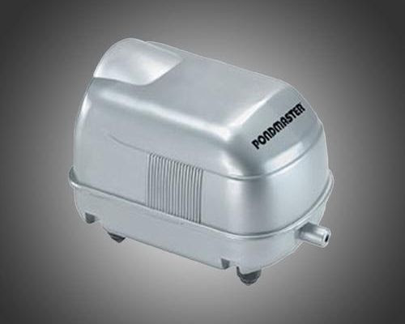 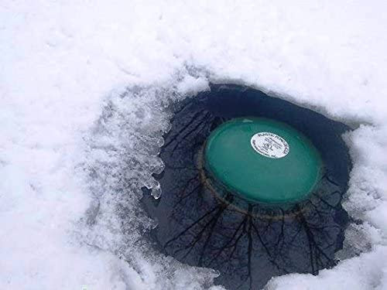

Air-Pumps are the Healthiest option for keeping a hole in the ice throughout the winter.

Air-Pumps' oxygen exchange is the most important aspect of a Healthy Environment for your Fish to thrive.

Air-Pumps are the most economical option as they will not strain your GFCI in extreme weather conditions and consume a fraction of the electricity compared to other options.

Heaters are a very traditional option for keeping a hole in the ice throughout the winter.

Heaters can consume a considerable amount of wattage. They will cycle on/off as needed during extreme weather conditions.

Heaters can be a Higher Risk option as they strain your outlets GFCI which, can shut your power off to the pond. It's important to be mindful of this possibility and check on it often.